Appendix
Table S1
Segregation, origin and number of bearded vultures Gypaetus barbatus samples used for the STRUCTURE analysis; locality number given for indication on figures.
Locality number | Regional grouping | Country/region of origin | Number of individuals
1 | Southern Africa | South Africa, Lesotho | 52
2 | Northern Africa | Ethiopia | 24
3 | Northern Africa | Yemen | 7
4 | Northern Africa | Morocco | 1
5 | Northern Africa | Algeria | 7
6 | Europe | Spain | 6
7 | Europe | France | 11
8 | Europe | Switzerland | 35
9 | Europe | Austria | 1
10 | Europe | Corsica | 3
11 | Europe | Sardinia | 30
12 | Europe | Albania | 1
13 | Europe | Crete | 1
14 | Europe | Turkey | 1
15 | Asia | Caucasus | 7
16 | Asia | Turkestan | 5
17 | Asia | Kyrgyzstan | 2
18 | Asia | Russia | 15
19 | Asia | India | 8
20 | Asia | Tibet | 1

Table S2
Estimates of genetic diversity across 14 amplified loci in the southern African population of bearded vultures Gypaetus barbatus; where N_{A} is average number of alleles; N_{E} is number of effective alleles; H_{O} is observed heterozygosity; H_{E} is expected heterozygosity, A_{R} is Allelic richness and F_{IS} is gene diversity and inbreeding statistic.

Locus | Observed allele size |  | N_{A} |  | N_{E} |  | H_{O} |  | H_{E} |  | A_{R} |  | Gene Diversity |  | F_{IS}
BV2 |  | 108 - 136 | 7.25 |  | 3.61 |  | 0.54 |  | 0.72 |  | 5.94 |  | 0.73 |  | 0.26
BV5 |  | 154 - 194 | 9.00 |  | 3.82 |  | 0.41 |  | 0.68 |  | 7.25 |  | 0.70 |  | 0.49
BV6 |  | 105 - 201 | 8.75 |  | 4.12 |  | 0.50 |  | 0.73 |  | 7.11 |  | 0.75 |  | 0.31
BV8 |  | 103 - 117 | 3.25 |  | 1.52 |  | 0.17 |  | 0.27 |  | 2.73 |  | 0.27 |  | 0.32
BV9 |  | 135 - 221 | 5.25 |  | 2.59 |  | 0.72 |  | 0.61 |  | 4.25 |  | 0.61 |  | -0.17
BV11 |  | 143 - 193 | 8.75 |  | 4.81 |  | 0.53 |  | 0.72 |  | 7.46 |  | 0.73 |  | 0.33
BV12 |  | 231 - 271 | 9.75 |  | 4.53 |  | 0.85 |  | 0.76 |  | 7.75 |  | 0.77 |  | -0.11
BV14 |  | 157 - 191 | 8.50 |  | 4.46 |  | 0.88 |  | 0.76 |  | 6.61 |  | 0.77 |  | -0.15
BV17 |  | 183 - 197 | 3.75 |  | 1.73 |  | 0.34 |  | 0.39 |  | 3.26 |  | 0.39 |  | 0.17
Gf3f3 |  | 138 - 180 | 4.25 |  | 2.00 |  | 0.15 |  | 0.49 |  | 3.37 |  | 0.51 |  | 0.75
Gf3h3 |  | 111 - 189 | 6.50 |  | 3.10 |  | 0.55 |  | 0.64 |  | 5.29 |  | 0.65 |  | 0.16
Gf8g |  | 164 - 280 | 4.50 |  | 1.37 |  | 0.12 |  | 0.20 |  | 2.86 |  | 0.20 |  | 0.56
Gf9c |  | 206 -268 | 7.25 |  | 3.33 |  | 0.28 |  | 0.67 |  | 5.16 |  | 0.68 |  | 0.59
Gf11a4 |  | 125 - 160 | 3.50 |  | 1.29 |  | 0.16 |  | 0.17 |  | 2.42 |  | 0.17 |  | 0.17
Total |  |  | 6.45 |  | 3.02 |  | 0.44 |  | 0.56 |  | 5.11 |  | 0.57 |  | 0.26

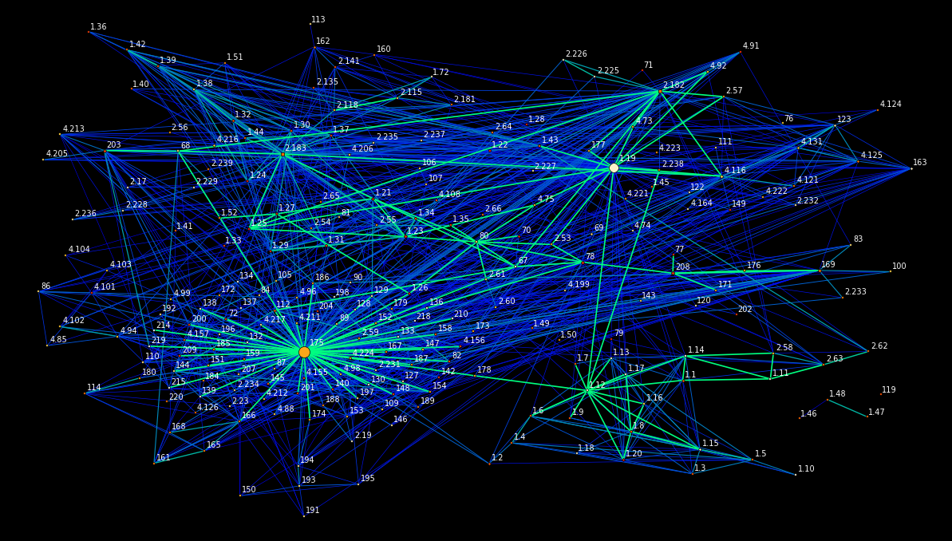
Appendix Fig. 1 Network constructed of all individual bearded vultures Gypaetus barbatus (n = 236) in EDENetworks. Populations (nodes) are named based on broad geographic region and are linked by edges which are weighted in proportion to the strength of the genetic linkage. Individuals are named according to their population, ie. 4.126 is individual 126 from population 4 (1- southern Africa, 2- northern Africa, 3- Europe, 4- Asia).

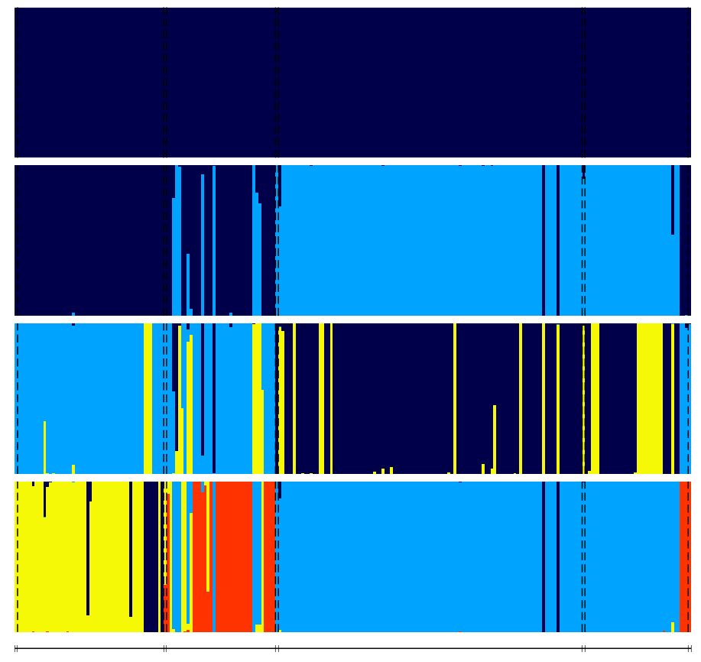
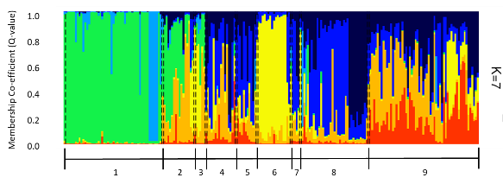
Southern Africa
Northern Africa
Europe
Asia

Appendix Fig. 2 Probabilistic population structure under the No Admixture model given for 236 bearded vultures Gypaetus barbatus collected from across the global distribution of the species. Individual vultures have been grouped into broad geographically delineated regions along the x-axis, and are represented by vertical lines which are partitioned into (K = 2 - 4) coloured segments which represent the estimated membership coefficients (Q-value) of each cluster represented in their genetics.

Table S3
Summary statistics of the 14 microsatellite loci amplified from 236 bearded vultures Gypaetus barbatus. Percentage missing data (MD), number of alleles (N_{A}), null allele frequency (No), fixation index (F_{ST}), observed heterozygosity (Ho), unbiased expected heterozygosity (uHe), deviation from Hardy-Weinberg (HWD).
Locus | MD | N_{A} | N_{O} | F_{ST} | H_{O} | uH_{E} | HWD
BV2 | 11 | 7.25 | 0.21 | 0.33 | 0.54 | 0.85 | ***
BV5 | 32 | 9.00 | 0.23 | 0.32 | 0.41 | 0.81 | ***
BV6 | 18 | 8.75 | 0.20 | 0.35 | 0.50 | 0.80 | ***
BV8 | 13 | 3.25 | 0.24 | 0.41 | 0.17 | 0.29 | ***
BV9 | 15 | 5.25 | 0.04 | -0.25 | 0.72 | 0.61 | ***
BV11 | 25 | 8.75 | 0.14 | 0.27 | 0.53 | 0.85 | ***
BV12 | 16 | 9.75 | 0.03 | 0.001 | 0.85 | 0.88 | ***
BV14 | 13 | 8.50 | 0.02 | -0.09 | 0.88 | 0.83 | ***
BV17 | 11 | 3.75 | 0.13 | 0.17 | 0.34 | 0.49 | ***
Gf3f3 | 14 | 4.25 | 0.44 | 0.77 | 0.15 | 0.57 | ***
Gf3h3 | 34 | 6.50 | 0.16 | 0.25 | 0.55 | 0.69 | ***
Gf8g | 16 | 4.50 | 0.33 | 0.50 | 0.12 | 0.18 | ***
Gf9c | 13 | 7.25 | 0.38 | 0.61 | 0.28 | 0.68 | ***
Gf11a4 | 16 | 3.50 | 0.12 | 0.25 | 0.16 | 0.15 | ***
Total |  | 6.45 | 0.19 | 0.28 | 0.44 | 0.62 | ***
*** P<0.001

Table S4
Linkage disequilibrium per pair of loci with associated p-values

BV9 x Gf11a4 | 0.003 | Gf11a4 x BV12 | 0.502 | Gf3f3 x Gf8g | 0.001 | BV6 x BV17 | 0.024
BV9 x BV14 | 0.001 | Gf11a4 x BV17 | 0.154 | Gf3f3 x BV6 | 0.001 | Gf3h3 x Gf9c | 0.015
BV9 x BV2 | 0.001 | BV14 x BV2 | 0.001 | Gf3f3 x Gf3h3 | 0.002 | Gf3h3 x BV5 | 0.224
BV9 x Gf3f3 | 0.005 | BV14 x Gf3f3 | 0.001 | Gf3f3 x Gf9c | 0.001 | Gf3h3 x BV8 | 0.001
BV9 x Gf8g | 0.001 | BV14 x Gf8g | 0.005 | Gf3f3 x BV5 | 0.002 | Gf3h3 x BV11 | 0.001
BV9 x BV6 | 0.049 | BV14 x BV6 | 0.001 | Gf3f3 x BV8 | 0.001 | Gf3h3 x BV12 | 0.057
BV9 x Gf3h3 | 0.001 | BV14 x Gf3h3 | 0.012 | Gf3f3 x BV11 | 0.009 | Gf3h3 x BV17 | 0.001
BV9 x Gf9c | 0.001 | BV14 x Gf9c | 0.008 | Gf3f3 x BV12 | 0.099 | Gf9c x BV5 | 0.001
BV9 x BV5 | 0.013 | BV14 x BV5 | 0.018 | Gf3f3 x BV17 | 0.001 | Gf9c x BV8 | 0.001
BV9 x BV8 | 0.001 | BV14 x BV8 | 0.002 | Gf8g x BV6 | 0.171 | Gf9c x BV11 | 0.001
BV9 x BV11 | 0.008 | BV14 x BV11 | 0.002 | Gf8g x Gf3h3 | 0.001 | Gf9c x BV12 | 0.097
BV9 x BV12 | 0.012 | BV14 x BV12 | 0.001 | Gf8g x Gf9c | 0.001 | Gf9c x BV17 | 0.001
BV9 x BV17 | 0.001 | BV14 x BV17 | 0.001 | Gf8g x BV5 | 0.290 | BV5 x BV8 | 0.001
Gf11a4 x BV14 | 0.198 | BV2 x Gf3f3 | 0.001 | Gf8g x BV8 | 0.001 | BV5 x BV11 | 0.001
Gf11a4 x BV2 | 0.882 | BV2 x Gf8g | 0.004 | Gf8g x BV11 | 0.003 | BV5 x BV12 | 0.296
Gf11a4 x Gf3f3 | 0.001 | BV2 x BV6 | 0.027 | Gf8g x BV12 | 0.059 | BV5 x BV17 | 0.006
Gf11a4 x Gf8g | 0.235 | BV2 x Gf3h3 | 0.002 | Gf8g x BV17 | 0.001 | BV8 x BV11 | 0.001
Gf11a4 x BV6 | 0.392 | BV2 x Gf9c | 0.001 | BV6 x Gf3h3 | 0.078 | BV8 x BV12 | 0.018
Gf11a4 x Gf3h3 | 0.805 | BV2 x BV5 | 0.245 | BV6 x Gf9c | 0.024 | BV8 x BV17 | 0.001
Gf11a4 x Gf9c | 0.016 | BV2 x BV8 | 0.026 | BV6 x BV5 | 0.689 | BV11 x BV12 | 0.210
Gf11a4 x BV5 | 0.511 | BV2 x BV11 | 0.002 | BV6 x BV8 | 0.185 | BV11 x BV17 | 0.001
Gf11a4 x BV8 | 0.020 | BV2 x BV12 | 0.001 | BV6 x BV11 | 0.326 | BV12 x BV17 | 0.009
Gf11a4 x BV11 | 0.289 | BV2 x BV17 | 0.001 | BV6 x BV12 | 0.005

Table S5
Details of 236 bearded vulture Gypaetus barbatus samples used in the study. Samples were collected in the field by Sonja Krüger (SK) or were sampled from museum collection: Durban Natural Sciences Museum (DNSM, South Africa), Natural History Museum, Tring (NHMT, United Kingdom), Naturalis Biodiversity Centre (RMNH, Netherlands), Stiftung Pro Bartgeier (SPB) Switzerland, and American Museum of Natural History (AMNH, United States).
Provided by | Sample name |  | Storage Facility Catalogue no. | Broad locality | Precise locality if available | Collection date
AMNH |  | A1 | 268806 | Ethiopia | Kaka Mt., Arussi | 1929
AMNH |  | A4 | 535811 | Sardinia | Urgulei, Ogliastra | 1902
AMNH |  | A5 | 535812 | Sardinia | Iglesias | 1905
AMNH |  | A6 | 535813 | Sardinia | Ascuentu (Guspini) | 1903
AMNH |  | A7 | 535815 | Sardinia | Aritzo | 1903
AMNH |  | A8 | 535817 | Greece | Parnes, Attica | 1900
AMNH |  | A9 | 535821 | Greece | Parnass, Velitza | 1900
AMNH |  | A11 | 535824 | Russia | Goudan, Transcaspian | 1900
AMNH |  | A12 | 535826 | Kyrgyzstan | Tian-Shan Mts. | 1911
AMNH |  | A13 | 535830 | Yemen | Sôk al Khamis | 1913
AMNH |  | A14 | 535829 | Yemen | Sôk al Khamis | 1913
AMNH |  | A16 | 535832 | India | Simla, N.W. Himilayas | 1913
AMNH |  | A17 | 535836 | Morocco | Djebel Tixa (Atlas) | 1905
AMNH |  | A18 | 535837 | Algeria | Djebel Taya, Meskoutine | 1909
AMNH |  | A19 | 535839 | Algeria | Kerrata | 1904
AMNH |  | A20 | 535840 | Algeria | El Kantara | 1909
AMNH |  | A21 | 535848 | Ethiopia | Yeka Hill, Addis Ababa | 1926
AMNH |  | A22 | 535855 | Ethiopia | Addis Ababa | 1914
AMNH |  | A23 | 535856 | Ethiopia | ddis Ababa | 1914
AMNH |  | A25 | 535858 | Ethiopia | Addis Ababa | 1914
UKZN |  | BV001 | G22911 | South Africa | Southern Drakensberg | 2006
UKZN |  | BV002 | G27343 | South Africa | Southern Drakensberg | 2007
UKZN |  | BV003 | G27341 | South Africa | Southern Drakensberg | 2007
UKZN |  | BV004 | G27307 | South Africa | Southern Drakensberg | 2009
UKZN |  | BV005 | G27313 | South Africa | Southern Drakensberg | 2010
UKZN |  | BV006 | G27306 | South Africa | Southern Drakensberg | 2009
UKZN |  | BV007 | G27378 | Lesotho | Lesotho | 2012
UKZN |  | BV008 | G27308 | South Africa | Southern Drakensberg | 2009
UKZN |  | BV009 | G27376 | South Africa | Northern Drakensberg | 2011
UKZN |  | BV010 | G27314 | South Africa | Northern Drakensberg | 2010
UKZN |  | BV011 | BV14 inside | South Africa | NE Free State | 2004
UKZN |  | SBV012 | BV2002 | South Africa | Central Drakensberg | 2002
UKZN |  | BV013 | G27302 | Lesotho | Lesotho | 2008
UKZN |  | BV014 | BV2009 | South Africa | Central Drakensberg | 2009
UKZN |  | BV015 | G27375 | South Africa | Southern Drakensberg | 2011
UKZN |  | BV016 | G27305 | South Africa | Southern Drakensberg | 2009
UKZN |  | BV017 | G27303 | Lesotho | Lesotho | 2008
UKZN |  | BV018 | G27309 | South Africa | Southern Drakensberg | 2009
UKZN |  | BV019 | 12 | South Africa | Southern Drakensberg | 2003
UKZN |  | BV020 | 6 | Lesotho | Lesotho | Not provided
UKZN |  | BV021 | 25 | South Africa | Northern Drakensberg | 2011
UKZN |  | BV022 | 13 | South Africa | Central Drakensberg | 2008
UKZN |  | BV023 | 19 | South Africa | Northern Drakensberg | 2009
UKZN |  | BV024 | 27 | South Africa | Southern Drakensberg | 2010
UKZN |  | BV025 | 11 | South Africa | Southern Drakensberg | 2000
UKZN |  | BV026 | 10 | South Africa | Southern Drakensberg | 2007
UKZN |  | BV027 | 31.1 | South Africa | Southern Drakensberg | 2010
UKZN |  | BV028 | 31.2 | South Africa | Southern Drakensberg | 2010
UKZN |  | BV029 | 30 | South Africa | Northern Drakensberg | 2010
UKZN |  | BV030 | 9 | South Africa | Southern Drakensberg | 2009
UKZN |  | BV034 | G27382 | South Africa | Central Drakensberg | 2012
UKZN |  | BV035 | 2.8.12 | South Africa | Eastern Cape | 2012
UKZN |  | BV036 | G27377 | South Africa | Northern Drakensberg | 2012
UKZN |  | BV037 | G27379 | South Africa | Central Drakensberg | 2012
UKZN |  | BV038 | G27381 | South Africa | Northern Drakensberg | 2012
UKZN |  | BV039 | G27383 | South Africa | Central Drakensberg | 2012
UKZN |  | BV040 | G27384 | South Africa | Central Drakensberg | 2012
UKZN |  | BV031 | Kolo | Ethiopia | Not provided | 2001
UKZN |  | BV032 | Mutt | Ethiopia | Not provided | 2001
UKZN |  | BV033 | Putin | Ethiopia | Not provided | 2001
UKZN |  | G27380 | G27380 | South Africa | Not provided | 2011
UKZN |  | 34 | 34 | South Africa | Not provided | Not provided
UKZN |  | G27319 | G27319 | South Africa | Northern Drakensberg | 2010
UKZN |  | G27310 | G27310 | South Africa | Central Drakensberg | 2010
UKZN |  | G27311 | G27311 | South Africa | Northern Drakensberg | 2010
UKZN |  | G27315 | G27315 | South Africa | Northern Drakensberg | 2010
UKZN |  | G27316 | G27316 | South Africa | Northern Drakensberg | 2010
UKZN |  | G27342 | G27342 | South Africa | Southern Drakensberg | 2007
UKZN |  | BV6 | BV6 | Lesotho | Lesotho | 2009
UKZN |  | BV7 | BV7 | Lesotho | Lesotho | 2009
UKZN |  | BV8 | BV8 | Lesotho | Lesotho | 2009
UKZN |  | BV10 | BV10 | Lesotho | Lesotho | 2009
UKZN |  | BV12 | BV12 | Lesotho | Lesotho | 2009
UKZN |  | g | g | South Africa | Drakensberg | Not provided
DNSM |  |  | DNSM 2 | South Africa | KZN, Kamberg | 1961
RMNH |  | L1 | L1 | Switzerland | Switzerland | Not provided
RMNH |  | L2 | L2 | Sardinia | Sardinia | Not provided
RMNH |  | L3 | L3 | Sardinia | Sardinia | Not provided
RMNH |  | L4 | L4 | Sardinia | Sardinia | Not provided
RMNH |  | L5 | L5 | Pyrenees | Not provided | Not provided
RMNH |  | L6 | L6 | Turkey | Not provided | Not provided
RMNH |  | L7 | L7 | Greece | Not provided | Not provided
SPB |  | SB1 | BG178 | Greece | Greece | Not provided
SPB |  | SB2 | BG725 | Pyrenees | Pyrenees | Not provided
SPB |  | SB3 | BG131 | Russia | Former Soviet Union | Not provided
SPB |  | SB4 | BG680 | Pyrenees | Aragon Pyrenean | Not provided
SPB |  | SB5 | BG065 | Crete | Crete | Not provided
SPB |  | SB6 | BG132 | Russia | Former Soviet Union | Not provided
SPB |  | SB7 | BG652 | Pyrenees | Aragon Pyrenees | Not provided
SPB |  | SB8 | BG551 | Pyrenees | Spanish Pyrenees | Not provided
SPB |  | SB9 | BG151 | Russia | Former Soviet Union | Not provided
SPB |  | SB10 | BG482 | Kyrgyzstan | Kyrgyzstan | Not provided
SPB |  | SB13 | BG022 | Russia | Former Soviet Union | Not provided
SPB |  | SB16 | BG201 | Turkestan | Tadzhikistan | Not provided
SPB |  | SB18 | BG003 | Central Asia | West-middle Asia | Not provided
SPB |  | SB19 | BG199 | Russia | Former Soviet Union | Not provided
SPB |  | SB20 | BG232 | Pyrenees | Spanish Pyrenees | Not provided
SPB |  | SB21 | BG014 | Russia | Not Provided | Not provided
SPB |  | SB22 | BG204 | Russia | Not provided | Not provided
SPB |  | SB23 | BG153 | Russia | Not provided | Not provided
SPB |  | SB24 | BG009 | Russia | Not provided | Not provided
SPB |  | S1.1 | 1 | Spain | Sierra Magina | Not provided
SPB |  | S1.2 | 2 | Spain | Sierra Magina | 1930
SPB |  | S1.3 | 3 | Switzerland | Glarus | 1830
SPB |  | S1.4 | 4 | Caucasus | Caucasus, North Side | 1900
SPB |  | S1.6 | 6 | Greece | Greece | 1905
SPB |  | S1.7 | 7 | Pyrenees | Pyrenees | 1904
SPB |  | S1.9 | 9 | Switzerland | Basel Zoo | 1987
SPB |  | S1.10 | 10 | Switzerland | Oberhasli | 1805
SPB |  | S1.11 | 11 | Switzerland | Brienzersee | 1823
SPB |  | S1.12 | 12 | Switzerland | Zuoz | 1854
SPB |  | S1.14 | 14 | Algeria | Algeria | Not provided
SPB |  | S1.15 | 15 | Russia | Russia | 1979
SPB |  | S1.16 | 16 | Ethiopia | Abyssinia | 1959
SPB |  | S1.17 | 17 | Ethiopia | Abyssinia | 1959
SPB |  | S1.18 | 18 | Corsica | Asco, Haute Corse | 1957
SPB |  | S1.19 | 19 | Albania | Lamentite | 1920
SPB |  | S1.20 | 20 | Caucasus | Petrowsk | 1900
SPB |  | S1.24 | 24 | Greece | Parnio Chasia Ciocha | 1899
SPB |  | S1.25 | 25 | Greece | Parnis Chasia Ciocha | 1899
SPB |  | S1.26 | 26 | India | Khalatase Ladakh | 1929
SPB |  | S1.27 | 27 | India | Ladka | 1930
SPB |  | S1.29 | 29 | Caucasus | Nislam | 1900
SPB |  | S1.30 | 30 | Sardinia | Ogliastra | 1902
SPB |  | S1.31 | 31 | Sardinia | Sardinia | 1905
SPB |  | S1.32 | 32 | Sardinia | Sardinia | 1901
SPB |  | S1.33 | 33 | Sardinia | Uzzulei | 1911
SPB |  | S1.36 | 36 | Central Asia | Thian Shan | 1900
SPB |  | S1.39 | 39 | France | Bagnerre de bigore | Not provided
SPB |  | S1.43 | 43 | Spain | South Spain "gaitanes" | 1869
SPB |  | S1.44 | 44 | Switzerland | Ftan, Val Tasua | 1859
SPB |  | S1.50 | 50 | Ethiopia | Ethiopia | 1887
SPB |  | S1.51 | 51 | Sardinia | Sardegna | Not provided
SPB |  | S1.52 | 52 | Sardinia | Colle di Tena, Conoraza | 1885
SPB |  | S1.54 | 54 | Sardinia | Sardegna | 1901
SPB |  | S1.56 | 56 | Sardinia | Sardegna | 1907
SPB |  | S1.57 | 57 | Sardinia | Sardegna | 1907
SPB |  | S1.60 | 60 | Ethiopia | Abyssinia | 1900
SPB |  | S1.61 | 61 | Greece | Greece | 1899
SPB |  | S1.63 | 63 | Spain | Sierra | 1899
SPB |  | S1.66 | 66 | Pyrenees | Tardet | 1896
SPB |  | S1.71 | 71 | Sardinia | Sardinia | 1906
SPB |  | S1.73 | 73 | France | Presles. Pont en Royans | Not provided
SPB |  | S1.74 | 74 | Spain | Sierra Magina | 1920
SPB |  | S1.77 | 77 | Switzerland | Tessin | 1903
SPB |  | S1.78 | 78 | Switzerland | Zermatt, Wallis | 1839
SPB |  | S1.79 | 79 | Switzerland | Wallis | 1886
SPB |  | S1.80 | 80 | Sardinia | Not provided | 1915
SPB |  | S1.81 | 81 | Spain | Not provided | 1940
SPB |  | S1.84 | 84 | Switzerland | Oberland | 1850
SPB |  | S1.85 | 85 | Switzerland | Brig, Wallis | 1833
SPB |  | S1.88 | 88 | Caucasus | Caucasus | 1905
SPB |  | S1.89 | 89 | Turkestan | Naryn | 1913
SPB |  | S1.90 | 90 | Turkestan | Naryn | 1910
SPB |  | S2.92 | 92 | Switzerland | Switzerland | 1881
SPB |  | S2.93 | 93 | Switzerland | Switzerland | 1891
SPB |  | S2.95 | 95 | Switzerland | Not provided | 1981
SPB |  | S2.98 | 98 | Greece | Naundes, Tirol | 1871
SPB |  | S2.99 | 99 | Greece | Parnassus | 1885
SPB |  | S2.101 | 101 | Sardinia | Not provided | 1917
SPB |  | S2.105 | 105 | Caucasus | Caucasus | 1904
SPB |  | S2.106 | 106 | Austria | Vorarlberg | Not provided
SPB |  | S2.107 | 107 | Sardinia | Not provided | Not provided
SPB |  | S2.109 | 109 | Switzerland | Andeer | Not provided
SPB |  | S2.110 | 110 | Switzerland | Wattensburg | 1852
SPB |  | S2.111 | 111 | Switzerland | Winterthur | 1850
SPB |  | S2.113 | 113 | Ethiopia | Abyssinia | 1911
SPB |  | S2.114 | 114 | Sardinia | Sardinia | 1911
SPB |  | S2.115 | 115 | Corsica | Corsica | Not provided
SPB |  | S2.116 | 116 | Switzerland | Not provided | Not provided
SPB |  | S3.2 | 2 | Switzerland | Andeer | 2000
SPB |  | S3.6 | 6 | Switzerland | Wattensburg (GR) | 1852
SPB |  | S3.7 | 7 | Switzerland | Prättigau | 1850 / 1851
SPB |  | S3.8 | 8 | Switzerland | Not provided | 2000 / 2001
SPB |  | S3.10 | 10 | Switzerland | Glarus | 1830
SPB |  | S3.15 | 15 | Switzerland | Brienzersee | 1823
SPB |  | S3.17 | 17 | Switzerland | Zuoz | 1854
SPB |  | S3.19 | 19 | Algeria | Algeria | 2000
SPB |  | S3.27 | 27 | Ethiopia | Abyssinia | 1959
SPB |  | S3.29 | 29 | Ethiopia | Abyssinia | 1959
SPB |  | S3.30 | 30 | Corsica | Asco, Haute Corse | 1957
SPB |  | S3.32 | 32 | Switzerland | Brig, Wallis | 1833
SPB |  | S3.35 | 35 | Switzerland | Oberland, GR | 1850
SPB |  | S3.36 | 36 | Switzerland | Switzerland | 1881
SPB |  | S3.39 | 39 | Switzerland | Switzerland | 1891
SPB |  | S3.45 | 45 | Spain | Sierra nevada | 1879
SPB |  | S3.49 | 49 | Ethiopia | Abyssinia | 1990
SPB |  | S3.53 | 53 | Spain | Sierra, Spain | 1899
SPB |  | S3.55 | 55 | Greece | Greece | 1899
SPB |  | S3.58 | 58 | Switzerland | Lausanne, Wallis | 1886
SPB |  | S3.60 | 60 | Switzerland | Zermatt, Wallis | 1839
SPB |  | S3.62 | 62 | Switzerland | Not provided | 1886
SPB |  | S3.65 | 65 | Spain | Benasque | 1966
SPB |  | S3.69 | 69 | Sardinia | Sardinia | 1915
SPB |  | S3.72 | 72 | Greece | Greece | 1904
SPB |  | S3.74 | 74 | Caucasus | Caucasus, North | 1900
SPB |  | S3.77 | 77 | Switzerland | Tessin | 1903
SPB |  | S3.87 | 87 | Spain | South Spain "gaitanes" | 1869
SPB |  | S3.88 | 88 | Greece | Greece | 1904
SPB |  | S3.90 | 90 | Pyrenees | Pyrenees | 1904
SPB |  | S4.97 | 97 | Switzerland | Ftan, Val Tasua | 1859
SPB |  | S4.99 | 99 | India | Kashmir, Ladakh | 1929
SPB |  | S4.100 | 100 | India | Kashmir, Ladka | 1930
SPB |  | S4.101 | 101 | Sardinia | Sardinia | 1905
SPB |  | S4.105 | 105 | Greece | Smolika | 1921
SPB |  | S4.106 | 106 | Sardinia | Sardegna | 1901
SPB |  | S4.107 | 107 | Sardinia | Sardegna | 1907
SPB |  | S4.108 | 108 | Turkestan | Naryn | 1910
SPB |  | S4.109 | 109 | Central Asia | Caucasus | 1905
SPB |  | S4.120 | 120 | Caucasus | Dagestan | 1900
SPB |  | S4.122 | 122 | Sardinia | Not provided | Not provided
SPB |  | S4.125 | 125 | Sardinia | Uzulei | 1911
SPB |  | S4.130 | 130 | Central Asia | Not provided | Not provided
SPB |  | S4.133 | 133 | Turkestan | Naryn | 1913
SPB |  | S4.138 | 138 | Sardinia | Ogliastra | 1902
SPB |  | S4.145 | 145 | Sardinia | Sardinia | 1901
SPB |  | S4.147 | 147 | Sardinia | Sardinia | 1885
NHMT |  | T1 | 1905.12.31.62 | China | Tibet | 1905
NHMT |  | T2 | 1965.M.1301 | India | India | 1965
NHMT |  | T3 | 1948.19.369 | India | India | 1948
NHMT |  | T4 | 1948.19.368 | India | India | 1948
NHMT |  | T6 | 1939.12.9.3409 | Algeria | Algeria | 1939
NHMT |  | T7 | 1939.12.9.3408 | Algeria | Algeria | 1939
NHMT |  | T8 | 1912.10.15.167 | Ethiopia | Abyssinia | 1912
NHMT |  | T9 | 1912.10.15.165 | Ethiopia | Abyssinia | 1912
NHMT |  | T10 | 1912.10.15.166 | Ethiopia | Abyssinia | 1912
NHMT |  | T11 | 1912.1.28.115 | Yemen | Yemen | 1912
NHMT |  | T12 | 1912.1.28.116 | Yemen | Yemen | 1912
NHMT |  | T13 | 1912.1.28.117 | Yemen | Yemen | 1912
NHMT |  | T14 | 1912.1.28.118 | Yemen | Yemen | 1912
NHMT |  | T15 | 1912.1.28.119 | Yemen | Yemen | 1912
NHMT |  | T16 | 1924.7.14.4 | Ethiopia | Abyssinia | 1924
NHMT |  | T17 | 1927.9.21.1 | Ethiopia | Abyssinia | 1927
NHMT |  | T18 | 1927.9.21.2 | Ethiopia | Abyssinia | 1927
NHMT |  | T19 | 1934.12.16.156 | Ethiopia | Abyssinia | 1934
NHMT |  | T20 | 1900.1.3.261 | Ethiopia | Abyssinia | 1900

