Vanden Abeele et al. 2021 – Supplementary material
(A)
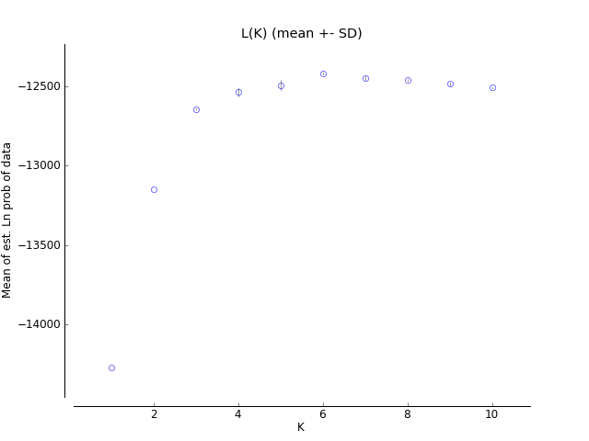
(B)
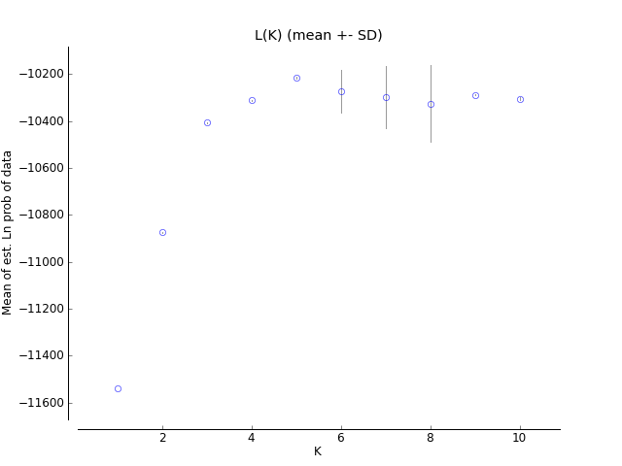
Suppl. Fig. 1: Likelihood of the Scorodophloeus zenkeri SSR dataset as a function of the assumed number of genetic clusters (K) according to the Bayesian clustering algorithm implemented in STRUCTURE, using the admixture model and the independent allele frequencies model as in a previous study on Scorodophloeus zenkeri [1]. Two different datasets were used to assess the impact of overrepresented geographical areas [2]. (A) The complete SSR dataset (n = 465) or (B) the subsampled SSR dataset (n = 368) obtained by subsampling a maximum of three individuals per square area with a side of 0.01° (approximately 1 km²). The circle represents the mean log-likelihood over 10 runs, while the vertical bars show the standard deviation among runs.
Lower Guinea
Congolia
Congo east
Congo west
LG northwest
LG west
LG east
LG southwest
Suppl. Fig. 2: The bar plots for K = 2 to K = 6 representing the assignment probabilities (y-axis) inferred using STRUCTURE, for the complete Scorodophloeus zenkeri SSR1 dataset (n = 465).

(A)
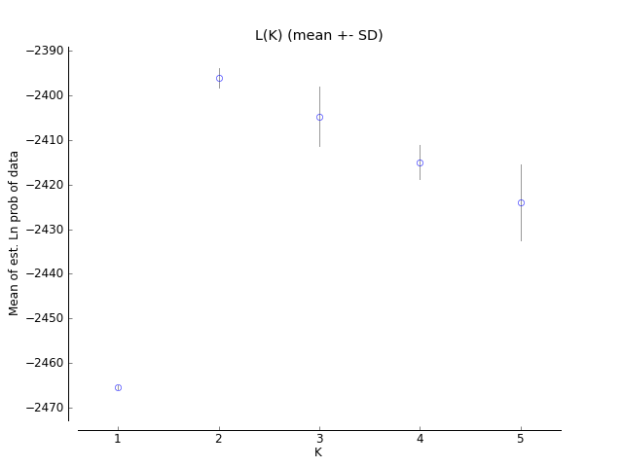
(B)

Suppl. Fig. 3: (A) Likelihood of the Scorodophloeus zenkeri SSR dataset, only including samples from Congolia (i.e. with longitude > 16° east, n = 95), as a function of the assumed number of genetic clusters (K) according to the Bayesian clustering algorithm implemented in STRUCTURE, using the same parameters as in a previous study on Scorodophloeus zenkeri [1]. (B) The bar plot for K = 2 representing the assignment probabilities inferred using STRUCTURE.

(A)
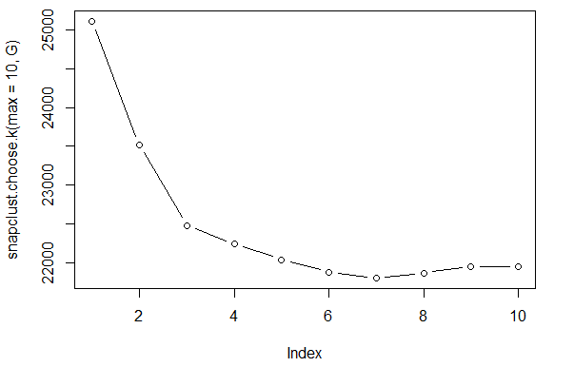
(B)
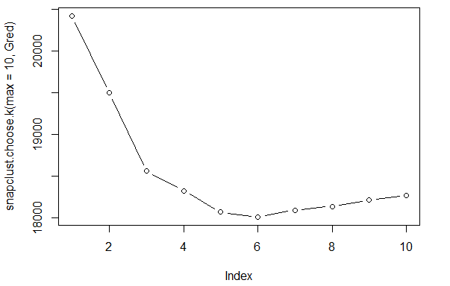
Suppl. Fig. 4: Likelihood of the Scorodophloeus zenkeri SSR dataset as a function of the assumed number of genetic clusters (index), using an expectation-maximization (EM) algorithm for maximum-likelihood based clustering implemented in the snapclust function of the adegenet [3] package in R [4]. Two different datasets were used to assess the impact of overrepresented geographical areas [2]. (A) The complete dataset (SSR1, n = 465) or (B) the subsampled dataset (SSR2, n = 368) obtained by subsampling a maximum of three individuals per square area with a side of 0.01° (approximately 1 km²).

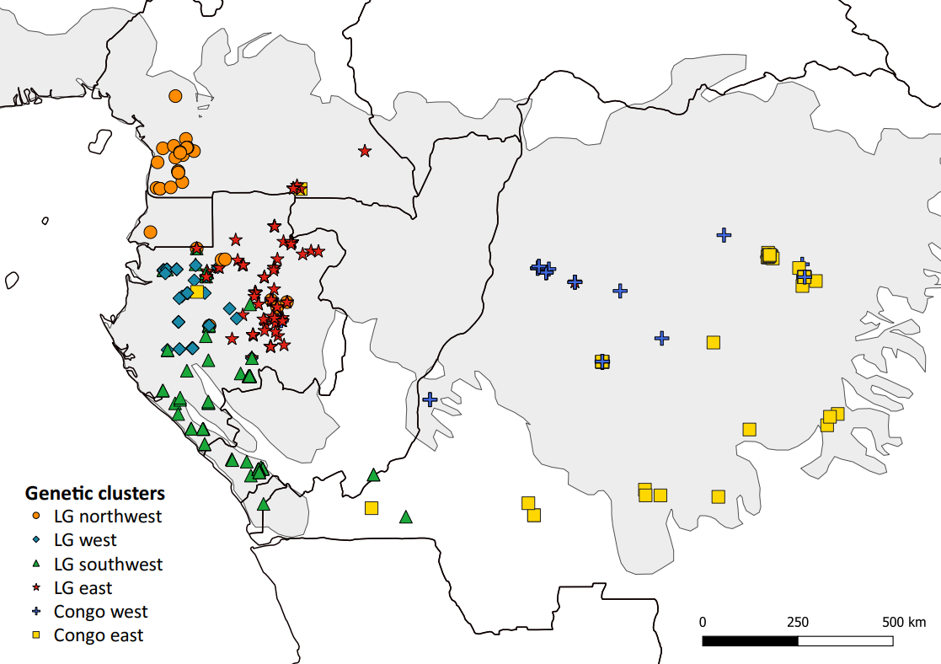
Suppl. Fig. 5: Distribution of genetic clusters in Scorodophloeus zenkeri as inferred with the snapclust function of the R package adegenet, for the most likely scenario at K = 6. The grey area depicts the natural distribution of rainforests in Central Africa. The map was made using QGIS 3.4 [5].
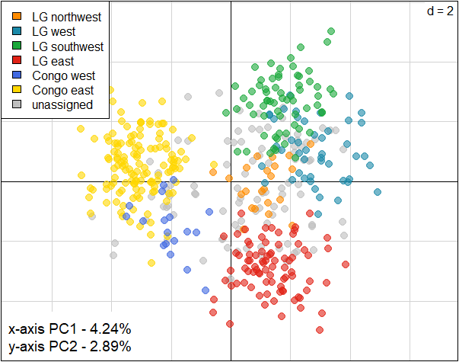
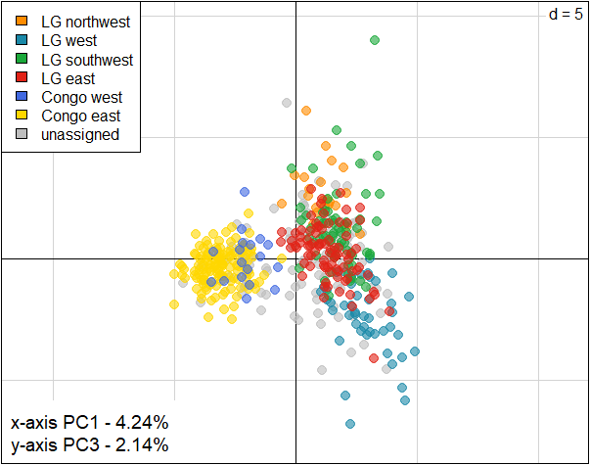
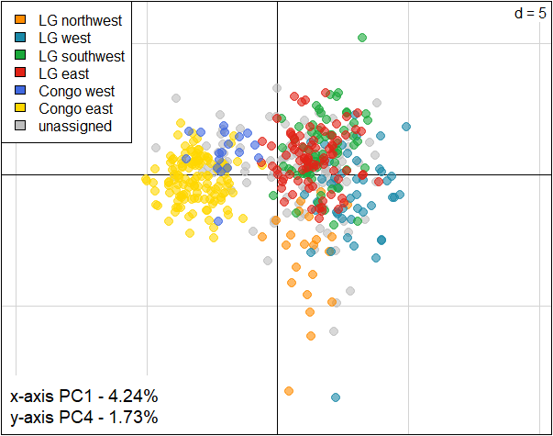
Suppl. Fig. 6: Scatterplots visualizing the Principal Component Analysis (PCA) of the genetic diversity in the Scorodophloeus zenkeri SSR dataset. Groups assignments of the individuals (coloured dots) correspond to the genetic clusters inferred with STRUCTURE at K = 6 (assignment probability q ≥ 0.8). Axes are rescaled in each scatterplot to allow the visualization of all data points (d = width between gridlines). PC stands for Principal Component.
Suppl. Table 1: Gene dispersal distance (σ_{g}) and neighbourhood size (Nb) estimates for the best represented genetic clusters and localities, using three estimates of effective densities (De = D/2, D/4 and D/10) and considering the regression between σ_{g} and 100 σ_{g}. na indicates that the iterative method did not converge. The standard error by jacknifing over loci (SE) is given unless convergence was not achieved.
Cluster/locality | n | De | Trees/km² | σ_{g} (m) (± SE) | Nb (± SE)
LG northwest | 22 | D/2 | 7 | na | na
 |  | D/4 | 3.5 | 1,861 | 152
 |  | D/10 | 1.4 | 2,334 | 105
LG east | 83 | D/2 | 225.5 | na | na
 |  | D/4 | 112.8 | na | na
 |  | D/10 | 45.1 | na | na
LG west | 46 | D/2 | 67.5 | 299 (± 51) | 76 (± 26)
 |  | D/4 | 33.8 | 358 (± 102) | 54 (± 34)
 |  | D/10 | 13.5 | 533 (± 245) | 48 (± 51)
LG southwest | 66 | D/2 | 56 | 394 (± 42) | 113 (± 23)
 |  | D/4 | 28 | 505 (± 181) | 90 (± 69)
 |  | D/10 | 11.2 | 1,136 (± 251) | 182 (± 89)
Yangambi & Yoko | 113 | D/2 | 900 | 105 (± 41) | 125 (± 106)
(Congo east) |  | D/4 | 450 | 154 (± 53) | 134 (± 97)
 |  | D/10 | 180 | 241 (± 92) | 132 (± 108)

References
1. Piñeiro R, Dauby G, Kaymak E, Hardy OJ. Pleistocene population expansions of shade-tolerant trees indicate fragmentation of the African rainforest during the Ice Ages. Proc R Soc B Biol Sci. 2017;284:20171800. doi:10.1098/rspb.2017.1800.
2. Puechmaille SJ. The program structure does not reliably recover the correct population structure when sampling is uneven: Subsampling and new estimators alleviate the problem. Mol Ecol Resour. 2016;16:608–27.
3. Jombart T. adegenet: a R package for multivariate analysis of genetic markers. Bioinformatics. 2008;24:1403–5.
4. R Development Core Team. R: A language and environment for statistical computing. 2011.
5. QGIS.org. QGIS Geographic Information System. 2021. https://www.qgis.org/.

