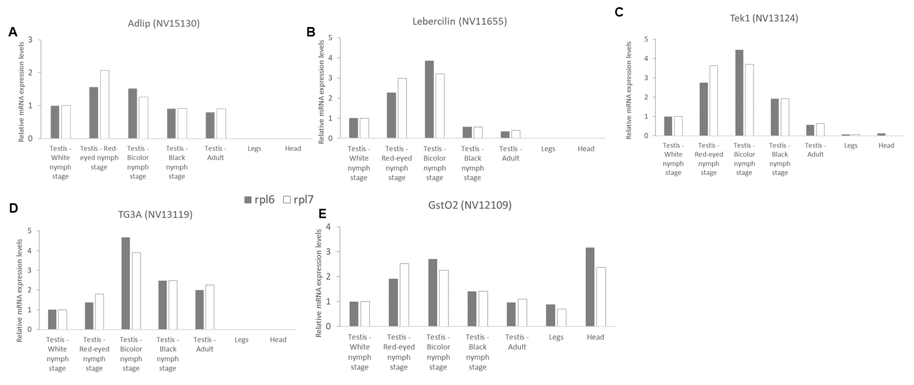
Figure S1: Relative mRNA expression levels of the 5 candidate genes in the testis (developmental stages: white stage, white stage with red eyes, bicolor stage, and adult), legs, and head of Nasonia vitripennis (n = 60 individuals) as determined by qRT-PCR (reference = levels of testicular expression during the white nymph stage). These results are representative of the numerous other experiments carried out with these biological samples

