Additional Files
Using SSR-GBAS to infer the population structure of Cingula trifasciata (Gastropoda: Rissoidae) in the Azores Archipelago (NE Atlantic Ocean)
Baptista L^{1,2,3,4}, Meimberg H¹, Ávila SP^{2,3,4,5}, Santos AM^{3,6}, Curto M^{1,7}
¹ Institute for Integrative Nature Conservation Research, University of Natural Resources and Life Sciences (BOKU), Vienna, Austria; ² CIBIO, Centro de Investigação em Biodiversidade e Recursos Genéticos, InBIO Laboratório Associado, Pólo dos Açores, 9501-801 Ponta Delgada, Azores, Portugal; ³ MPB-Marine Palaeontology and Biogeography lab, University of the Azores, Rua da Mãe de Deus, 9501-801 Ponta Delgada, Azores, Portugal; ⁴ Faculdade de Ciências da Universidade do Porto, Rua do Campo Alegre 1021/1055, 4169-007 Porto, Portugal; ⁵ Departamento de Biologia, Faculdade de Ciências e Tecnologia, Universidade dos Açores, 9501-801 Ponta Delgada, Azores, Portugal; ⁶ CIBIO, Centro de Investigação em Biodiversidade e Recursos Genéticos, InBIO Laboratório Associado, Universidade do Porto, Campus de Vairão, Rua Padre Armando Quintas, no. 7, 4485-661 Vairão, Portugal; ⁷ MARE, Marine and Environmental Sciences Centre, Faculdade de Ciências, Universidade de Lisboa, Campo Grande, Lisboa, 1749-016 Portugal

Table S1 - Complete list of all SSR primers designed in this study. Includes sequence of forward and reverse primers (5’-3’), the repetition motif, and number of repeats in the original sequence used for the primer design, the primer mix in which it was included for the Multiplex PCR, and allele length range (bp).
Primer/ Loci | Forward (5’-3’) | Reverse (5’-3’) | Repetition motif | Mix | Allele length range (bp)
CT1_ATGA | CCCTACTTTCAGCAGGAGAA | TGCGATCCTTATACCGCTTT | (TGTT)5 | 4 | Failed (>60 % missing data)
CT3_GAATA | CCGGACAGTGTAATTATAGCA | ACGGCGGTTGAATTGACTA | (GAATA)7 | 3 | Failed (>60 % missing data)
CT5_TGAA | CCTGGTTAATTTTCAGCGCA | GGTGGCGGTATATTCAGCTA | (TGAA)6 | 3
CT6_TTGT | TAGTGTTCGCTTGCTTGTTG | TAGTGTTCGCTTGCTTGTTG | (TTGT)5 | 1 | Failed (non-specific marker)
CT10_GTTT | TCTATCGGTGATGTGTTGCA | GGACTAGACAGAATCCGAGC | (GTTT)5 | 2 | Failed (>60 % missing data)
CT11_GTTT | GATCTGCTCAGTGAACATGC | GGGTGAGACAGGTTGAGAAA | (GTTT)5 | 4
CT13_GTTG | ATACTGGGATGCACAGGAAC | ACGGAATTAAAACAAGCGCA | (GTTG)5 | 2
CT14_CAGA | AGAAACGAGCTCATTCTTGT | CGTGGCCTTGCTTTTCTAAA | (CAGA)9 | 4
CT15_TTTG | AAGCTCCATATCAACAGCCA | TCCTGTTGTCGAGAAGATGG | (TTTG)5 | 1
CT16_TTTG | TGACACGAGTCTGACGTAAG | CCCCACTTATACTGTGCCTT | (TTTG)5 | 3
CT17_TTTG | AAGCGTTCTAGGACTGAACC | TTCTGAACATCGACACCACA | (TTTG)5 | 2 | Failed (non-specific marker)
CT18_AAAG | GACAGAAGGTCCAGACATTTT | TGACACGAGTCTGACGTAAG | (AAAG)5 | 3
CT19_GACA | ACTGGCAAAGTCCTTCTCAA | CCCAATCATCACGGTCAAAC | (GACA)6 | 4
CT21_CAAA | GAACGAAAGGGAAACGGATG | GAGACGGGTTCTCTGACATT | (CAAA)5 | 1
CT22_ACAG | AACTCCATCCGCCATGTAAT | TTGCTCACATTTCACTGTGC | (ACAG)7 | 2
CT23_TTTA | AACTTTTGATCTTGCTGCCG | TCTGAATTCGGGGTTTGTCA | (TTTA)5 | 3
CT24_CAAA | CAATGGTGCTAGCTTTCTGC | AGGCTTTGGATCTGGATCTG | (CAAA)6 | 2
CT26_TGTT | CCTCACAGGCTCAAGATACA | GCGACAGAACAACGTTGTAA | (TGTT)5 | 4
CT28_CTGT | ATTAACAGCTGGGTGGACC | TGAGCATAAGTGACCTGCAT | (CTGT)5 | 2
CT29_AAAT | CCCAGAAAGAAAACCTTCACC | GCAAGCAACCTGTACTATGC | (AAAT)6 | 1
CT30_TGTC | TGATCAGATGCCCACATTCA | GCGCACTTTAAGTTGAGAGA | (TGTC)5 | 2
CT31_AATA | GGGGTTCATTCAGTGTTTACA | TGACATCCACTGAACAGGAG | (AATA)5 | 1
CT32_TTTG | GGCGAGCTTTAAGTGACATC | ACATTCAGCATTCAGACCAA | (TTTG)6 | 4
CT33_CATT | CTCCATGCAAAATTCCCAGG | CCACCCTCGTCCATTTAGAA | (CATT)5 | 3
CT34_ACCA | TCTTGGGTTTGATGTGTGGA | ATGGTTAGGTGCAAGGGATC | (ACCA)5 | 1
CT35_TTTG | GTGCCACTTTAAGAAACGCT | CGAAATTTGGAATCCGATACG | (TTTG)12 | 1
CT37_AAAT | ACAGCCACAAGTTTGTCAAC | GTCCTTCTGTCTCTGCCTG | (AAAT)5 | 2
CT38_TCAT | GTCCTTTACACAGCAAAGCT | TAGGATCGCCATCGGAGTT | (TCAT)8 | 3
CT39_CATT | ATACTTCAGGCCGGAAAGAG | CTAAGCCTCAGCAGAGACTG | (CATT)6 | 1
CT40_ATCC | GAGAACGAACTCTCAGCTACT | CTTCAAAGCACAGTGTAGGG | (ATCC)5 | 3
CT42_TAAA | GCCAGTCCTCATACGAACAT | CTGCGTCTCAGATGTTTCAC | (TAAA)5 | 4
CT2_TGTT | TGGCGCAATGAATAGAATGTC | AAAGAGGGCGCTATGTACTC | (TGTT)5 | - | Failed in single PCR test
CT4_TAGAA | TGCTTTTCATCAGTATCGTCA | TGATGCATTTGTGATCATTGA | (TAGAA)5 | - | Failed in single PCR test
CT7_TTATG | CCCCTTAAACGATTTCTGAGA | CTGGTAGGGAGGTTTACGAA | (TTATG)6 | - | Failed in single PCR test
CT8_AACAT | CTGCAGTGTCAAGTATGCAG | CGGTGGCAAGTTTCTGTATC | (AACAT)5 | - | Failed in single PCR test
CT9_GTCAA | TGGATACATCACGAGATCGG | TCACCTGTTGCACAAATCAT | (GTCAA)5 | - | Failed in single PCR test
CT12_GTTG | ATGGGTTACAAGATACGCGT | AGTGCACATTCAGTCCATCA | (GTTG)7 | - | Failed in single PCR test
CT20_ATAC | ACATCTGTCGTTCGTCTTCA | ACCGTTACCTCTCAATAGACT | (ATAC)5 | - | Failed in single PCR test
CT25_AAGA | GCCAGATGTATGTTTTCCCG | GTTGGGATTCAGGTCAGCTA | (AAGA)6 | - | Failed in single PCR test
CT27_CATT | GTGATGGAAGTACTCATGCG | TGGAATGGAAAGAGACGGAT | (CATT)10 | - | Failed in single PCR test
CT36_AGAC | GTAGTGTGCATGCCTAAGTG | CACAATTGTTTATGCCTTGGT | (AGAC)7 | - | Failed in single PCR test
CT41_TCAA | GCAAGGAGAGTGGAGGTTAC | ACGGAGTGATTATGGAAGGG | (TCAA)6 | - | Failed in single PCR test

Table S2 - Estimates of evolutionary divergence (raw p-distances) between COI haplotypes of Cingula trifasciata. The analysis, performed on MEGA v7 [1], considered 44 haplotypes and 658 bp after excluding positions containing gaps and/or missing data for each sequence pair analysed. Populations of the sequences collapsed within each haplotype is referred in the “Pops” column, as follows: SMA-Santa Maria, CAL-Caloura, MOS-Mosteiros, GRW-Graciosa, PIX-Pico, FSC-São Jorge, FLW-Flores, VIG-Vigo.
Pops | Hap | 1 | 2 | 3 | 4 | 5 | 6 | 7 | 8 | 9 | 10 | 11 | 12 | 13 | 14 | 15 | 16 | 17 | 18 | 19 | 20 | 21 | 22 | 23 | 24 | 25 | 26 | 27 | 28 | 29 | 30 | 31 | 32 | 33 | 34 | 35 | 36 | 37 | 38 | 39 | 40 | 41 | 42 | 43
SMA | 1
SMA | 2 | 0.011
SMA | 3 | 0.002 | 0.009
SMA | 4 | 0.021 | 0.014 | 0.02
SMA | 5 | 0.011 | 0.003 | 0.009 | 0.011
SMA | 6 | 0.018 | 0.011 | 0.017 | 0.011 | 0.011
CAL | 7 | 0.014 | 0.006 | 0.012 | 0.011 | 0.006 | 0.009
CAL | 8 | 0.017 | 0.009 | 0.015 | 0.014 | 0.009 | 0.012 | 0.006
CAL | 9 | 0.015 | 0.008 | 0.014 | 0.012 | 0.008 | 0.011 | 0.005 | 0.008
CAL | 10 | 0.012 | 0.008 | 0.014 | 0.012 | 0.008 | 0.011 | 0.005 | 0.008 | 0.006
CAL | 11 | 0.021 | 0.014 | 0.02 | 0.003 | 0.014 | 0.011 | 0.011 | 0.014 | 0.012 | 0.012
CAL | 12 | 0.023 | 0.015 | 0.021 | 0.008 | 0.015 | 0.012 | 0.012 | 0.015 | 0.014 | 0.014 | 0.008
CAL | 13 | 0.014 | 0.009 | 0.015 | 0.014 | 0.009 | 0.012 | 0.006 | 0.009 | 0.008 | 0.005 | 0.014 | 0.015
MOS, GRW | 14 | 0.021 | 0.014 | 0.02 | 0.003 | 0.014 | 0.011 | 0.008 | 0.014 | 0.012 | 0.012 | 0.003 | 0.008 | 0.014
MOS | 15 | 0.018 | 0.011 | 0.017 | 0.015 | 0.011 | 0.012 | 0.008 | 0.008 | 0.009 | 0.006 | 0.015 | 0.017 | 0.011 | 0.015
MOS, FSC,  PIX, GRW | 16 | 0.02 | 0.012 | 0.018 | 0.002 | 0.012 | 0.009 | 0.009 | 0.012 | 0.011 | 0.011 | 0.002 | 0.006 | 0.012 | 0.002 | 0.014
MOS | 17 | 0.026 | 0.018 | 0.024 | 0.008 | 0.018 | 0.015 | 0.015 | 0.018 | 0.017 | 0.017 | 0.008 | 0.012 | 0.018 | 0.008 | 0.02 | 0.006
MOS | 18 | 0.02 | 0.012 | 0.018 | 0.017 | 0.012 | 0.014 | 0.008 | 0.009 | 0.011 | 0.008 | 0.017 | 0.018 | 0.012 | 0.017 | 0.002 | 0.015 | 0.021
MOS | 19 | 0.02 | 0.012 | 0.018 | 0.008 | 0.012 | 0.009 | 0.008 | 0.012 | 0.011 | 0.011 | 0.008 | 0.009 | 0.012 | 0.008 | 0.014 | 0.006 | 0.012 | 0.015
MOS | 20 | 0.021 | 0.014 | 0.02 | 0.003 | 0.014 | 0.011 | 0.009 | 0.014 | 0.012 | 0.012 | 0.003 | 0.008 | 0.014 | 0.003 | 0.015 | 0.002 | 0.008 | 0.017 | 0.005
MOS | 21 | 0.011 | 0.003 | 0.009 | 0.014 | 0.003 | 0.011 | 0.006 | 0.009 | 0.008 | 0.008 | 0.014 | 0.015 | 0.009 | 0.014 | 0.008 | 0.012 | 0.018 | 0.009 | 0.012 | 0.014
PIX | 22 | 0.024 | 0.017 | 0.023 | 0.006 | 0.017 | 0.014 | 0.014 | 0.017 | 0.015 | 0.015 | 0.006 | 0.011 | 0.017 | 0.006 | 0.018 | 0.005 | 0.011 | 0.02 | 0.008 | 0.006 | 0.017
PIX | 23 | 0.021 | 0.014 | 0.02 | 0.003 | 0.014 | 0.011 | 0.011 | 0.014 | 0.012 | 0.012 | 0.003 | 0.008 | 0.014 | 0.003 | 0.015 | 0.002 | 0.008 | 0.017 | 0.008 | 0.003 | 0.014 | 0.006
PIX | 24 | 0.021 | 0.014 | 0.02 | 0.003 | 0.014 | 0.011 | 0.011 | 0.014 | 0.012 | 0.012 | 0.003 | 0.008 | 0.014 | 0.003 | 0.015 | 0.002 | 0.008 | 0.017 | 0.008 | 0.003 | 0.014 | 0.006 | 0.003
PIX | 25 | 0.017 | 0.009 | 0.015 | 0.014 | 0.009 | 0.012 | 0.006 | 0.009 | 0.008 | 0.008 | 0.014 | 0.015 | 0.009 | 0.014 | 0.011 | 0.012 | 0.015 | 0.012 | 0.012 | 0.014 | 0.009 | 0.017 | 0.014 | 0.014
FSC | 26 | 0.021 | 0.014 | 0.02 | 0.003 | 0.014 | 0.011 | 0.011 | 0.014 | 0.012 | 0.012 | 0.003 | 0.008 | 0.014 | 0.003 | 0.015 | 0.002 | 0.008 | 0.017 | 0.008 | 0.003 | 0.014 | 0.006 | 0.003 | 0.003 | 0.014
FSC | 27 | 0.021 | 0.014 | 0.02 | 0.003 | 0.014 | 0.011 | 0.011 | 0.014 | 0.012 | 0.012 | 0.003 | 0.008 | 0.014 | 0.003 | 0.015 | 0.002 | 0.008 | 0.017 | 0.008 | 0.003 | 0.014 | 0.006 | 0.003 | 0.003 | 0.014 | 0.003
FSC | 28 | 0.018 | 0.011 | 0.017 | 0.015 | 0.011 | 0.014 | 0.008 | 0.008 | 0.009 | 0.006 | 0.015 | 0.017 | 0.011 | 0.015 | 0.006 | 0.014 | 0.02 | 0.008 | 0.014 | 0.015 | 0.011 | 0.018 | 0.015 | 0.015 | 0.011 | 0.015 | 0.015
GRW1 | 29 | 0.024 | 0.017 | 0.023 | 0.006 | 0.017 | 0.014 | 0.011 | 0.017 | 0.015 | 0.015 | 0.006 | 0.011 | 0.017 | 0.003 | 0.018 | 0.005 | 0.008 | 0.02 | 0.011 | 0.006 | 0.017 | 0.009 | 0.006 | 0.006 | 0.011 | 0.006 | 0.006 | 0.018
GRW1 | 30 | 0.015 | 0.011 | 0.017 | 0.012 | 0.011 | 0.014 | 0.008 | 0.009 | 0.009 | 0.003 | 0.012 | 0.014 | 0.008 | 0.012 | 0.009 | 0.011 | 0.017 | 0.011 | 0.014 | 0.012 | 0.011 | 0.015 | 0.012 | 0.012 | 0.011 | 0.012 | 0.012 | 0.009 | 0.015
GRW1 | 31 | 0.002 | 0.01 | 0.003 | 0.021 | 0.01 | 0.018 | 0.013 | 0.016 | 0.014 | 0.011 | 0.021 | 0.022 | 0.013 | 0.021 | 0.018 | 0.019 | 0.026 | 0.018 | 0.018 | 0.019 | 0.01 | 0.022 | 0.021 | 0.021 | 0.016 | 0.021 | 0.021 | 0.018 | 0.024 | 0.014
GRW2 | 32 | 0.021 | 0.014 | 0.02 | 0.003 | 0.014 | 0.011 | 0.011 | 0.012 | 0.012 | 0.012 | 0.003 | 0.008 | 0.014 | 0.003 | 0.015 | 0.002 | 0.008 | 0.017 | 0.008 | 0.003 | 0.014 | 0.006 | 0.003 | 0.003 | 0.014 | 0.003 | 0.003 | 0.015 | 0.006 | 0.009 | 0.021
GRW2 | 33 | 0.023 | 0.015 | 0.021 | 0.005 | 0.015 | 0.012 | 0.009 | 0.015 | 0.014 | 0.014 | 0.005 | 0.009 | 0.015 | 0.002 | 0.017 | 0.003 | 0.009 | 0.018 | 0.006 | 0.005 | 0.015 | 0.005 | 0.005 | 0.005 | 0.015 | 0.005 | 0.005 | 0.017 | 0.005 | 0.014 | 0.022 | 0.005
GRW2 | 34 | 0.017 | 0.009 | 0.015 | 0.014 | 0.009 | 0.012 | 0.006 | 0.009 | 0.002 | 0.008 | 0.014 | 0.015 | 0.009 | 0.014 | 0.011 | 0.012 | 0.018 | 0.012 | 0.012 | 0.014 | 0.009 | 0.017 | 0.014 | 0.014 | 0.009 | 0.014 | 0.014 | 0.011 | 0.017 | 0.011 | 0.016 | 0.014 | 0.015
GRW2 | 35 | 0.018 | 0.011 | 0.017 | 0.006 | 0.011 | 0.011 | 0.008 | 0.011 | 0.009 | 0.009 | 0.006 | 0.008 | 0.011 | 0.006 | 0.012 | 0.005 | 0.011 | 0.014 | 0.008 | 0.006 | 0.011 | 0.009 | 0.006 | 0.006 | 0.011 | 0.006 | 0.006 | 0.012 | 0.009 | 0.009 | 0.018 | 0.006 | 0.008 | 0.011
FLW | 36 | 0.015 | 0.008 | 0.014 | 0.012 | 0.008 | 0.011 | 0.005 | 0.005 | 0.006 | 0.003 | 0.012 | 0.014 | 0.008 | 0.012 | 0.003 | 0.011 | 0.017 | 0.005 | 0.011 | 0.012 | 0.008 | 0.015 | 0.012 | 0.012 | 0.008 | 0.012 | 0.012 | 0.003 | 0.015 | 0.006 | 0.014 | 0.012 | 0.014 | 0.008 | 0.009
FLW | 37 | 0.017 | 0.009 | 0.015 | 0.014 | 0.009 | 0.012 | 0.006 | 0.006 | 0.008 | 0.005 | 0.014 | 0.015 | 0.009 | 0.014 | 0.005 | 0.012 | 0.018 | 0.006 | 0.012 | 0.014 | 0.009 | 0.017 | 0.014 | 0.014 | 0.009 | 0.014 | 0.014 | 0.005 | 0.017 | 0.008 | 0.014 | 0.014 | 0.015 | 0.009 | 0.011 | 0.002
FLW | 38 | 0.02 | 0.012 | 0.018 | 0.017 | 0.012 | 0.015 | 0.009 | 0.009 | 0.011 | 0.008 | 0.017 | 0.018 | 0.012 | 0.017 | 0.005 | 0.015 | 0.021 | 0.006 | 0.015 | 0.017 | 0.009 | 0.02 | 0.017 | 0.017 | 0.012 | 0.017 | 0.017 | 0.008 | 0.02 | 0.011 | 0.019 | 0.017 | 0.018 | 0.012 | 0.014 | 0.005 | 0.006
FLW | 39 | 0.02 | 0.012 | 0.018 | 0.017 | 0.012 | 0.015 | 0.009 | 0.009 | 0.011 | 0.008 | 0.017 | 0.018 | 0.012 | 0.017 | 0.008 | 0.015 | 0.021 | 0.009 | 0.015 | 0.017 | 0.012 | 0.02 | 0.017 | 0.017 | 0.012 | 0.017 | 0.017 | 0.008 | 0.02 | 0.011 | 0.019 | 0.017 | 0.018 | 0.012 | 0.014 | 0.005 | 0.006 | 0.003
FLW | 40 | 0.017 | 0.009 | 0.015 | 0.014 | 0.009 | 0.012 | 0.006 | 0.006 | 0.008 | 0.005 | 0.014 | 0.015 | 0.009 | 0.014 | 0.005 | 0.012 | 0.018 | 0.006 | 0.012 | 0.014 | 0.009 | 0.017 | 0.014 | 0.014 | 0.009 | 0.014 | 0.014 | 0.005 | 0.017 | 0.008 | 0.016 | 0.014 | 0.015 | 0.009 | 0.011 | 0.002 | 0.003 | 0.006 | 0.006
FLW | 41 | 0.021 | 0.014 | 0.02 | 0.017 | 0.014 | 0.012 | 0.012 | 0.012 | 0.014 | 0.011 | 0.017 | 0.018 | 0.015 | 0.017 | 0.009 | 0.015 | 0.021 | 0.011 | 0.018 | 0.017 | 0.014 | 0.02 | 0.017 | 0.017 | 0.015 | 0.017 | 0.017 | 0.011 | 0.02 | 0.011 | 0.021 | 0.017 | 0.018 | 0.015 | 0.014 | 0.008 | 0.009 | 0.006 | 0.006 | 0.009
VIG | 42 | 0.043 | 0.041 | 0.044 | 0.046 | 0.041 | 0.043 | 0.037 | 0.041 | 0.036 | 0.036 | 0.046 | 0.047 | 0.038 | 0.044 | 0.04 | 0.044 | 0.047 | 0.041 | 0.044 | 0.046 | 0.041 | 0.046 | 0.046 | 0.046 | 0.038 | 0.046 | 0.046 | 0.043 | 0.044 | 0.04 | 0.043 | 0.046 | 0.046 | 0.038 | 0.043 | 0.04 | 0.041 | 0.044 | 0.041 | 0.041 | 0.046
VIG | 43 | 0.044 | 0.043 | 0.046 | 0.047 | 0.043 | 0.044 | 0.039 | 0.043 | 0.038 | 0.038 | 0.047 | 0.049 | 0.04 | 0.046 | 0.041 | 0.046 | 0.049 | 0.043 | 0.046 | 0.047 | 0.043 | 0.047 | 0.047 | 0.047 | 0.04 | 0.047 | 0.047 | 0.044 | 0.046 | 0.041 | 0.045 | 0.047 | 0.047 | 0.04 | 0.044 | 0.041 | 0.043 | 0.046 | 0.043 | 0.043 | 0.047 | 0.002
VIG | 44 | 0.046 | 0.044 | 0.047 | 0.049 | 0.044 | 0.046 | 0.04 | 0.044 | 0.04 | 0.04 | 0.049 | 0.05 | 0.041 | 0.047 | 0.043 | 0.047 | 0.05 | 0.044 | 0.047 | 0.049 | 0.044 | 0.049 | 0.049 | 0.049 | 0.041 | 0.049 | 0.049 | 0.046 | 0.047 | 0.043 | 0.046 | 0.049 | 0.049 | 0.041 | 0.046 | 0.043 | 0.044 | 0.047 | 0.044 | 0.044 | 0.049 | 0.003 | 0.002

Table S3 – Pairwise F_{ST} values between populations of Cingula trifasciata, based on the COI dataset.
 | Santa Maria | Caloura | Mosteiros | Graciosa | Pico | São Jorge | Flores | Vigo
Santa Maria
Caloura | 0.222**
Mosteiros | 0.262** | 0.048
Graciosa | 0.361** | 0.153** | 0.061
Pico | 0.527** | 0.293 | 0.129 | 0.083
São Jorge | 0.419** | 0.186 | 0.041 | 0.056 | -0.014
Flores | 0.433** | 0.308** | 0.346** | 0.712** | 0.611** | 0.529**
Vigo | 0.855** | 0.852** | 0.848** | 0.869** | 0.944** | 0.929** | 0.949**
Significance tests derived from 1023 permutations; ** p<0.01.

Table S4 - Pairwise F_{ST} values between populations of Cingula trifasciata, based on the complete WAI dataset.
 | Santa Maria | Caloura | Mosteiros | Graciosa | Pico | São Jorge | Vigo
Santa Maria
Caloura | 0.177**
Mosteiros | 0.198** | 0.173**
Graciosa | 0.143** | 0.142** | 0.119**
Pico | 0.193** | 0.222** | 0.110** | 0.122**
São Jorge | 0.166** | 0.212** | 0.169** | 0.138** | 0.178**
Vigo | 0.359** | 0.382** | 0.430 ** | 0.393** | 0.442** | 0.365**
Significance tests derived from 1000 permutations; ** p<0.01.

Table S5 - Estimates of evolutionary divergence (raw p-distances) between COI sequences of several Rissoidae species. The analysis, performed on MEGA v7 [1], considered 18 sequences and 658 bp after excluding positions containing gaps and/or missing data for each sequence pair analysed. Sequences retrieved from GenBank [2], accession Number (AN) and species identification are provided in the table. Highlighted in bold is the divergence level between the recognized species Alvania formicarum and A. mediolittoralis, and between Cingula trifasciata from the Azores and Vigo.
Species | AN | 1 | 2 | 3 | 4 | 5 | 6 | 7 | 8 | 9 | 10 | 11 | 12 | 13 | 14 | 15 | 16 | 17
Alvania angioyi | MG652373
Alvania beani | FN650144 | 0.139
Alvania formicarum | MG652380 | 0.144 | 0.125
Alvania mediolittoralis | MG652385 | 0.144 | 0.123 | 0.029
Alvania punctura | FN650148 | 0.141 | 0.153 | 0.178 | 0.172
Alvania sleursi | MG652386 | 0.15 | 0.116 | 0.106 | 0.096 | 0.176
Alvania subsoluta | FN650150 | 0.151 | 0.146 | 0.15 | 0.148 | 0.168 | 0.15
Cingula trifasciata Azores | MG652397 | 0.128 | 0.152 | 0.147 | 0.147 | 0.15 | 0.152 | 0.137
Cingula trifasciata Vigo | MW518858 | 0.125 | 0.149 | 0.140 | 0.146 | 0.160 | 0.158 | 0.145 | 0.044
Crisilla postrema | MG652392 | 0.141 | 0.207 | 0.202 | 0.198 | 0.158 | 0.207 | 0.188 | 0.152 | 0.149
Onoba semicostata | FN650151 | 0.176 | 0.177 | 0.17 | 0.167 | 0.201 | 0.176 | 0.162 | 0.173 | 0.176 | 0.199
Pseudosetia sp. | FN650172 | 0.178 | 0.155 | 0.169 | 0.166 | 0.196 | 0.17 | 0.132 | 0.167 | 0.172 | 0.191 | 0.176
Pseudosetia semipellucida | FN650154 | 0.202 | 0.182 | 0.187 | 0.193 | 0.187 | 0.191 | 0.174 | 0.191 | 0.148 | 0.199 | 0.187 | 0.179
Pusillina inconspicua | FN650157 | 0.176 | 0.188 | 0.188 | 0.181 | 0.195 | 0.185 | 0.164 | 0.181 | 0.179 | 0.205 | 0.185 | 0.188 | 0.216
Pusillina sarsii | FN650160 | 0.176 | 0.191 | 0.195 | 0.187 | 0.198 | 0.188 | 0.167 | 0.181 | 0.179 | 0.208 | 0.185 | 0.187 | 0.219 | 0.009
Rissoa auriscalpium | HQ623175 | 0.197 | 0.206 | 0.202 | 0.193 | 0.204 | 0.201 | 0.215 | 0.213 | 0.218 | 0.221 | 0.204 | 0.208 | 0.215 | 0.199 | 0.208
Rissoa guernei | MG652409 | 0.19 | 0.21 | 0.202 | 0.207 | 0.219 | 0.196 | 0.217 | 0.205 | 0.195 | 0.213 | 0.21 | 0.213 | 0.229 | 0.196 | 0.199 | 0.199
Setia subvaricosa | MG652429 | 0.144 | 0.161 | 0.16 | 0.157 | 0.184 | 0.182 | 0.157 | 0.164 | 0.167 | 0.179 | 0.173 | 0.179 | 0.201 | 0.170 | 0.173 | 0.210 | 0.188

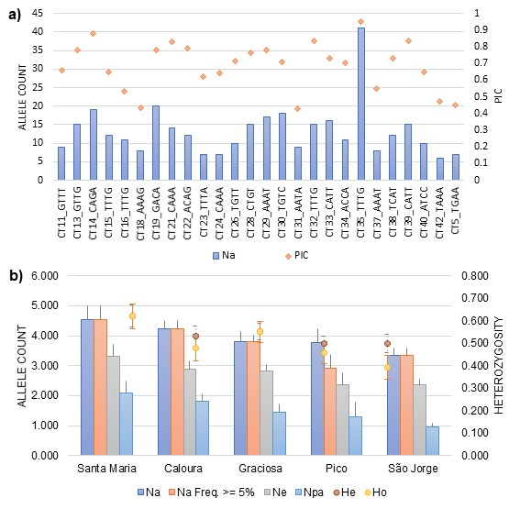
Figure S 1 – Genetics diversity of the SSR dataset in study. a) Variability measures estimated for each of the 26 SSR loci in study in complete whole amplicon information (WAI) dataset: number of alleles (Na) and polymorphic information content (PIC); b) Genetic diversity patterns across the five populations of Cingula trifasciata with more than five individuals: number of alleles (Na), number of different alleles with frequency over 5 %, number of effective alleles (Ne), number of private alleles (Npa), expected (He) and observed (Ho) heterozygosity.

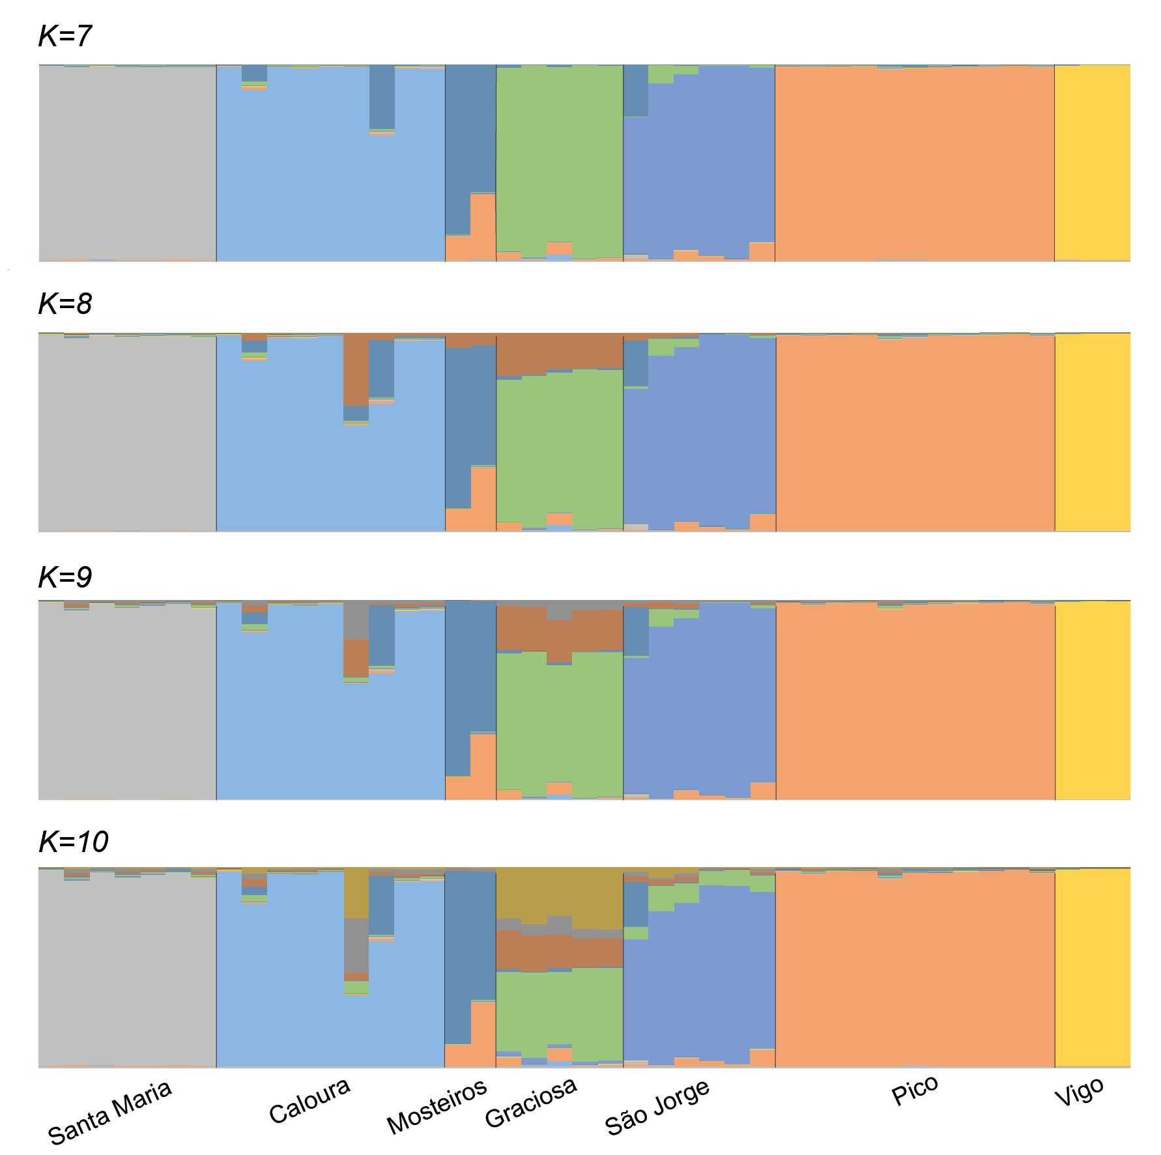
Fig. S 2 – Genetic structure analysis of the complete WAI dataset of Cingula trifasciata. Inferred with STRUCTURE v2.3.4 [5,6], reporting the results from K=7 to K=10.

References

[1] Kumar S, Stecher G, Tamura K. MEGA7: Molecular Evolutionary Genetics Analysis version 7.0 for bigger datasets. Mol Biol Evol. 2016;33:1870–4. doi:10.1093/molbev/msw054.
[2] GenBank Database, National Center for Biotechnology Information. https://www.ncbi.nlm.nih.gov/genbank/. Accessed 5 May 2020.
[3] Peakall R, Smouse PE. GENALEX 6: genetic analysis in Excel. Population genetic software for teaching and research. Mol Ecol Notes. 2006;6:288–95. doi:10.1111/j.1471-8286.2005.01155.x.
[4] Peakall R, Smouse PE. GenAlEx 6.5: genetic analysis in Excel. Population genetic software for teaching and research-an update. Bioinformatics. 2012;28:2537–9. doi:10.1093/bioinformatics/bts460.
[5] Pritchard JK, Stephens M, Donnely P. Inference of population structure using multilocus genotype data. Genetics. 2000;155:945–59.
[6] Hubisz M, Falush D, Stephens M, Pritchard JK. Inferring weak population structure with the assistance of sample group information. Mol Ecol Res. 2009;9:1322–32. doi:10.1111/j.1755-0998.2009.02591.x.

