List of supplementary figures/table
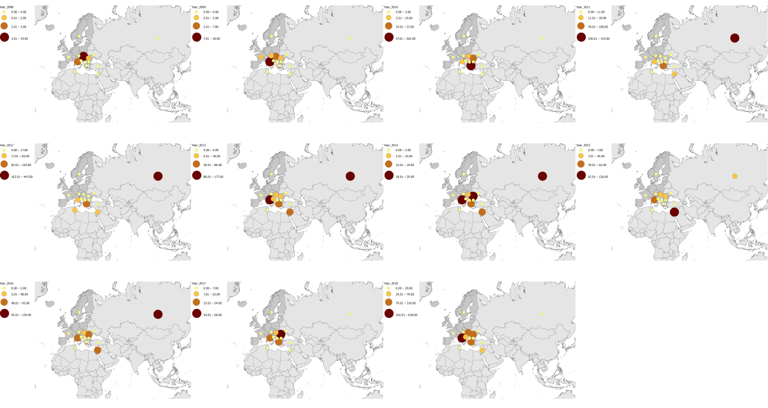
Figure S1. Available data of WNV-2 sequences collected from 2008 until October 2018.

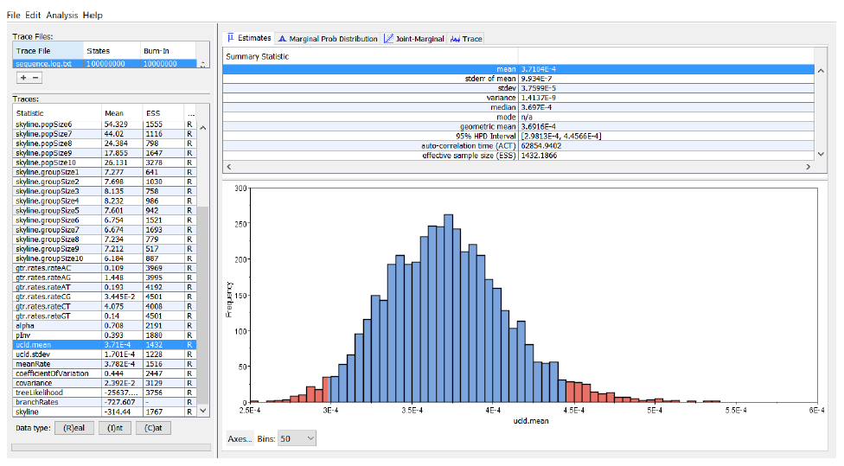

Figure S2. Obtained results when we repeated our analyses excluding the sample of Senegal as a possible outlier.

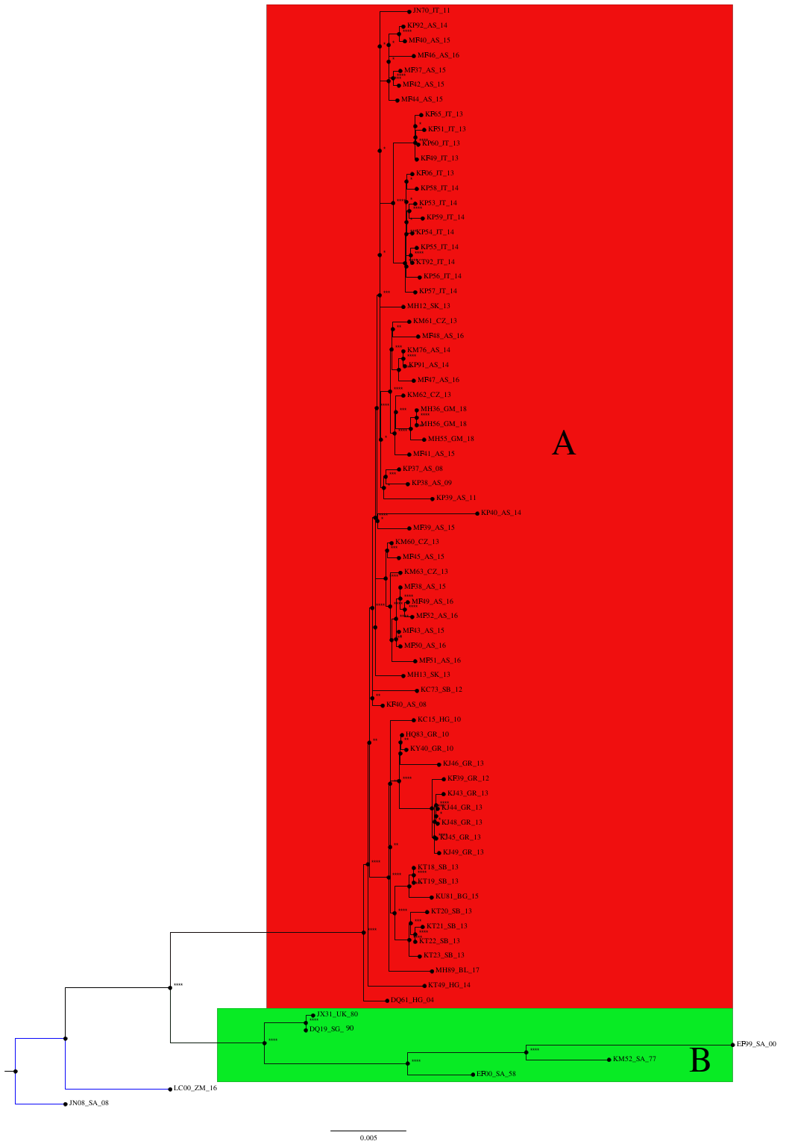
Figure S3. The two highly significant clades (A and B) identified with Maximum-likelihood tree. Clade A represents the majority of the European isolates, whereas clade B includes African isolates and one isolate from Ukraine. Two isolates, collected from South Africa (2008) and Zambia (2016), represent an outgroup outside the two main clades.

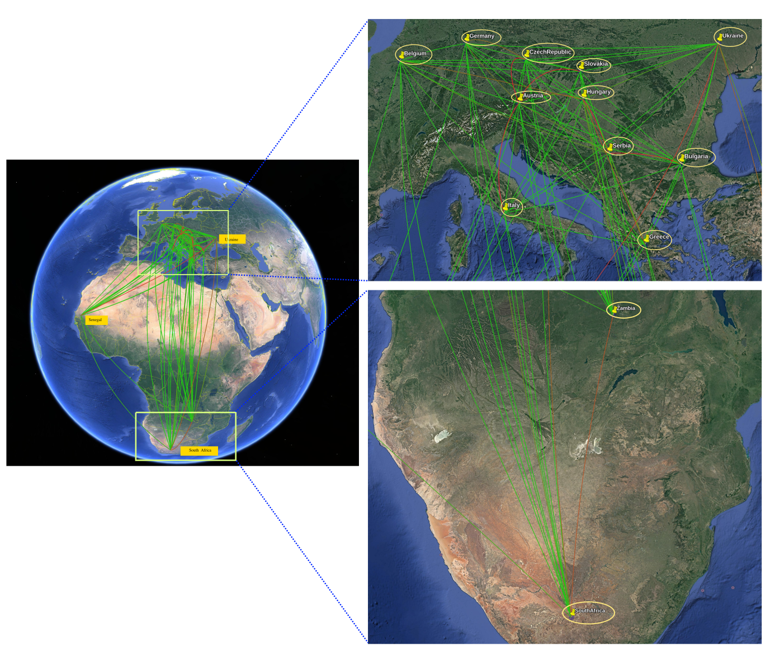

Figure S4. The transmission routes of the WNV-2 mapped and visualized using the SPREAD3 software.

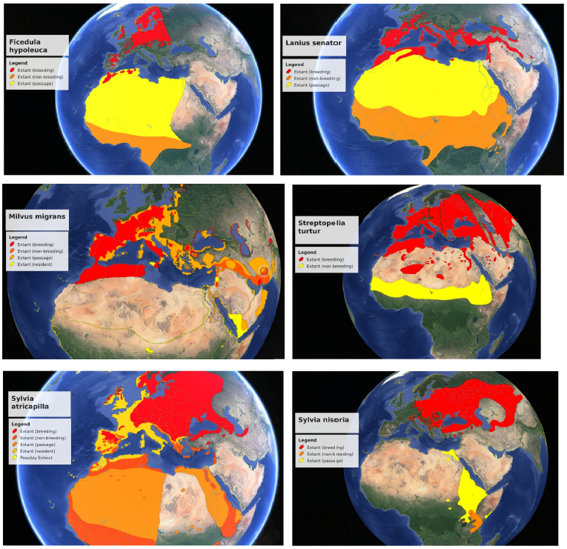
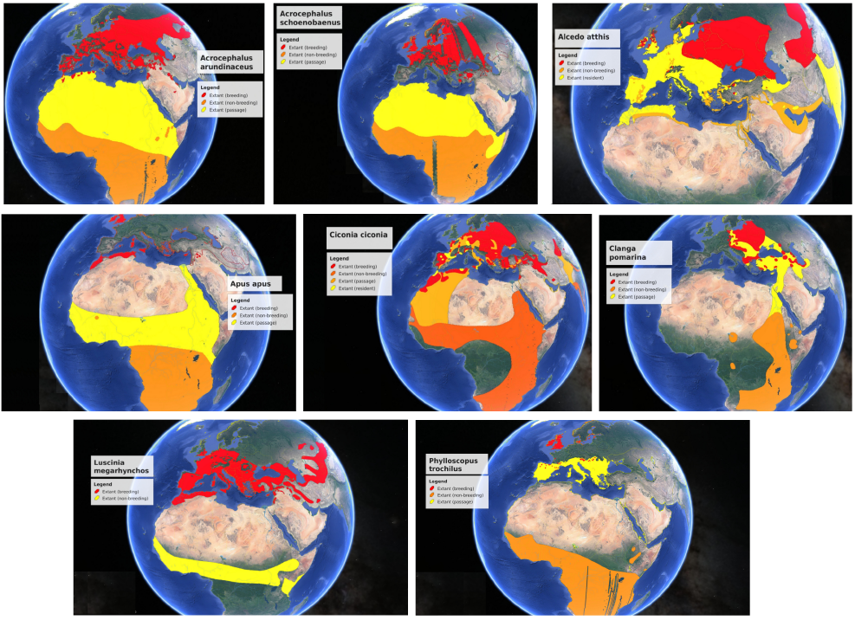

Figure S5. Combination of the distribution of the reported infected bird species with the results obtained in the present study.

Table S1
Nucleotide sequence accession numbers | Country | Collection date | Host
JN393308 | SouthAfrica | 2008 | Horse
JN858070 | Italy | 2011 | Homo sapiens
JX041631 | Ukraine | 1980 | Bird
KC407673 | Serbia | 2012 | Northern goshawk
KC496015 | Hungary | 2010 | Horse
HQ537483 | Greece | 2010 | Culex pipiens
KF179639 | Greece | 2012 | Homo sapiens
KF179640 | Austria | 2008 | goshawk
KF588365 | Italy | 2013 | Homo sapiens
KF647249 | Italy | 2013 | Homo sapiens
DQ116961 | Hungary | 2004 | Goshawk
DQ318019 | Senegal | 2006 | Mosquito: (Mimomyia lacustris)
EF429199 | SouthAfrica | 2000 | Homo sapiens
EF429200 | SouthAfrica | 1958 | Homo sapiens
KF647251 | Italy | 2013 | Homo sapiens
KF823806 | Italy | 2013 | Homo sapiens
KJ883343 | Greece | 2013 | Homo sapiens
KJ883344 | Greece | 2013 | Homo sapiens
KJ883345 | Greece | 2013 | Homo sapiens
KJ883346 | Greece | 2013 | Homo sapiens
KJ883348 | Greece | 2013 | Homo sapiens
KJ883349 | Greece | 2013 | Homo sapiens
KM052152 | SouthAfrica | 1977 | Horse
KM203860 | CzechRepublic | 2013 | Culex modestus
KM203861 | CzechRepublic | 2013 | Culex modestus
KM203862 | CzechRepublic | 2013 | Culex modestus
KM203863 | CzechRepublic | 2013 | Culex modestus
KM659876 | Austria | 2014 | Homo sapiens
KP109691 | Austria | 2014 | Homo sapiens
KP109692 | Austria | 2014 | Culex pipiens
KP780837 | Austria | 2008 | Nestor notabilis (kea)
KP780838 | Austria | 2009 | Nestor notabilis (kea)
KP780839 | Austria | 2011 | Nestor notabilis (kea)
KP780840 | Austria | 2014 | Nestor notabilis (kea)
KP789953 | Italy | 2014 | Homo sapiens
KP789954 | Italy | 2014 | Homo sapiens
KP789955 | Italy | 2014 | Homo sapiens
KP789956 | Italy | 2014 | Homo sapiens
KP789957 | Italy | 2014 | Homo sapiens
KP789958 | Italy | 2014 | Homo sapiens
KP789959 | Italy | 2014 | Homo sapiens
KP789960 | Italy | 2013 | Homo sapiens
KT207792 | Italy | 2014 | Mosquito
KT359349 | Hungary | 2014 | Homo sapiens
KT757318 | Serbia | 2013 | Culex pipiens
KT757319 | Serbia | 2013 | Culex pipiens
KT757320 | Serbia | 2013 | Culex pipiens
KT757321 | Serbia | 2013 | Culex pipiens
KT757322 | Serbia | 2013 | Culex pipiens
KT757323 | Serbia | 2013 | Culex pipiens
KU206781 | Bulgaria | 2015 | Homo sapiens
KY594040 | Greece | 2010 | Homo sapiens
LC318700 | Zambia | 2016 | Culex quinquefasciatus
MF984337 | Austria | 2015 | Homo sapiens
MF984338 | Austria | 2015 | Homo sapiens
MF984339 | Austria | 2015 | Homo sapiens
MF984340 | Austria | 2015 | Homo sapiens
MF984341 | Austria | 2015 | Homo sapiens
MF984342 | Austria | 2015 | Homo sapiens
MF984343 | Austria | 2015 | Homo sapiens
MF984344 | Austria | 2015 | Goshawk
MF984345 | Austria | 2015 | Falcon
MF984346 | Austria | 2016 | Homo sapiens
MF984347 | Austria | 2016 | Homo sapiens
MF984348 | Austria | 2016 | Homo sapiens
MF984349 | Austria | 2016 | Horse
MF984350 | Austria | 2016 | Horse
MF984351 | Austria | 2016 | Culex pipiens
MF984352 | Austria | 2016 | Culex pipiens
MH021189 | Belgium | 2017 | Homo sapiens
MH244512 | Slovakia | 2013 | Northern goshawk
MH244513 | Slovakia | 2013 | Eurasian sparrow hawk
MH924836 | Germany | 2018 | Strix nebulosa
MH986055 | Germany | 2018 | Turdus merula
MH986056 | Germany | 2018 | Turdus merula

