Supplementary material
Table S1. Environmental covariates and MPA attributes used in this study, with a definition and reference to their source.
Attribute | Definition | Source
SSTA_DHW | SSTA_DHW, sum of previous 12 weeks when SSTA is greater than or equal to 1 degree C. | https://www.ncei.noaa.gov/products/coral-reef-temperature-anomaly-database
SSTFilled | The weekly average SST value in Kelvin
MPA_AGE | The calculated age based on the year the protected region was implemented, minus the year of the reef check survey. | https://www.iucn.org/theme/protected-areas/our-work/world-database-protected-areas
REP_M_AREA | Covers the extent of the protected area which falls within the marine environment in square kilometres. Information is supplied by the data provider for the specified protected area.
GIS_M_AREA | Covers the extent of the protected area which falls within the marine environment in square kilometres. Calculated by UNEP-WCMC using Mollweide projection.
REP_AREA | Covers the entirety of the protected region (marine, freshwater and terrestrial environments). Supplied by the data provider.
GIS_AREA | Covers the entirety of the protected region (marine, freshwater and terrestrial environments). Calculated by UNEP-WCMC using Mollweide projection.
NO_TK_AREA | The area within the marine environment designated as a no-take zone. Reported by the data provider.
Kd490_value | The light attenuation coefficient as a measure of turbidity. | https://oceandata.sci.gsfc.nasa.gov/MODIS-Aqua/Mapped/Monthly/4km/Kd_490/

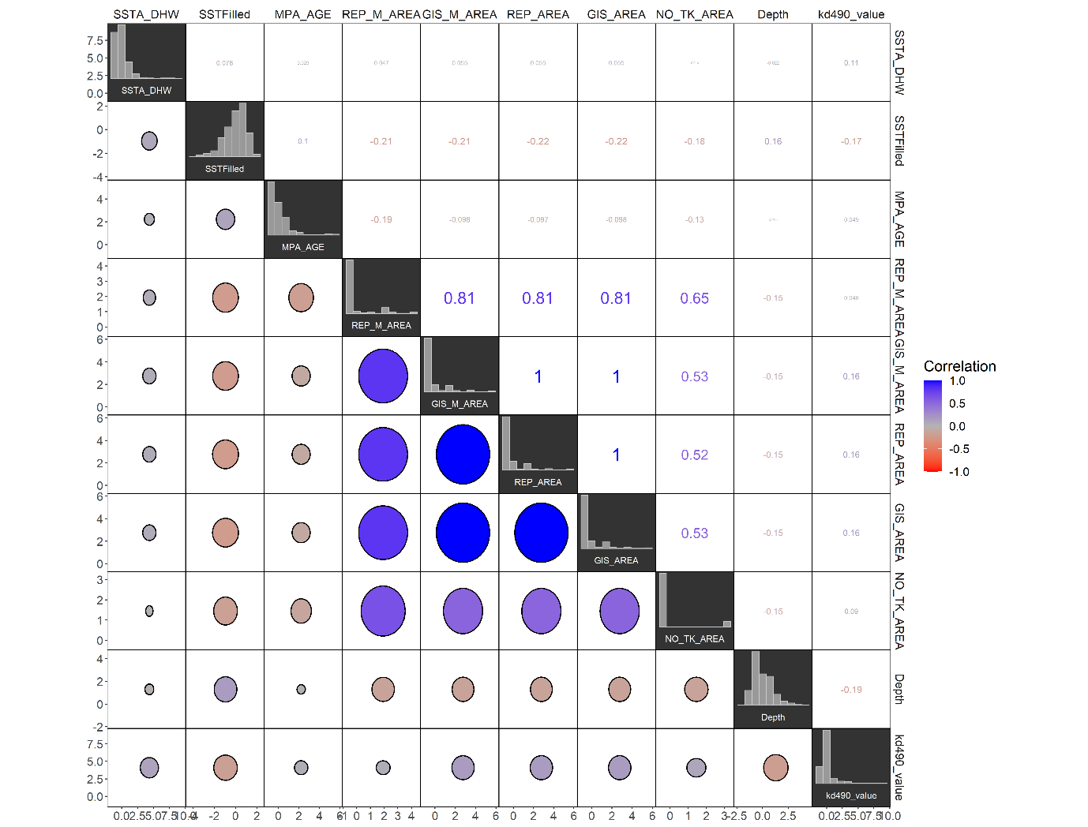

Fig. S1 Collinearity matrix of explanatory variables for coral bleaching from the Coral Reef Temperature Anomaly Database (CoRTAD V6) and the World Database of Protected Areas (WDPA). Attributes with 0.65 collinearity score or higher were excluded from the Bayesian model.

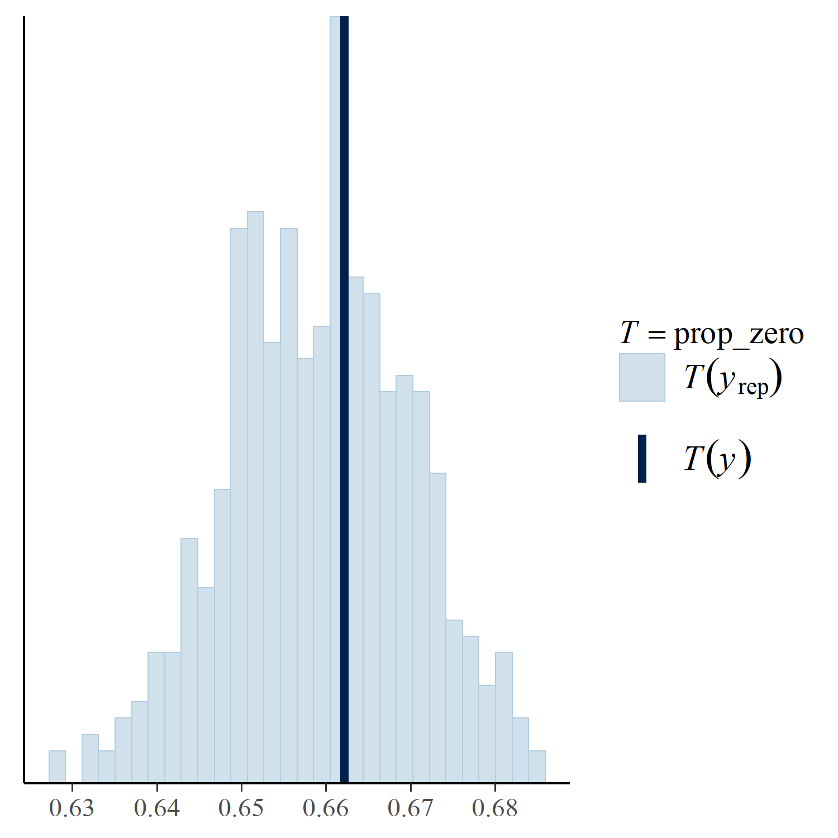

Fig. S2 Posterior predictive checks of Bayesian model fit with our bleaching data.

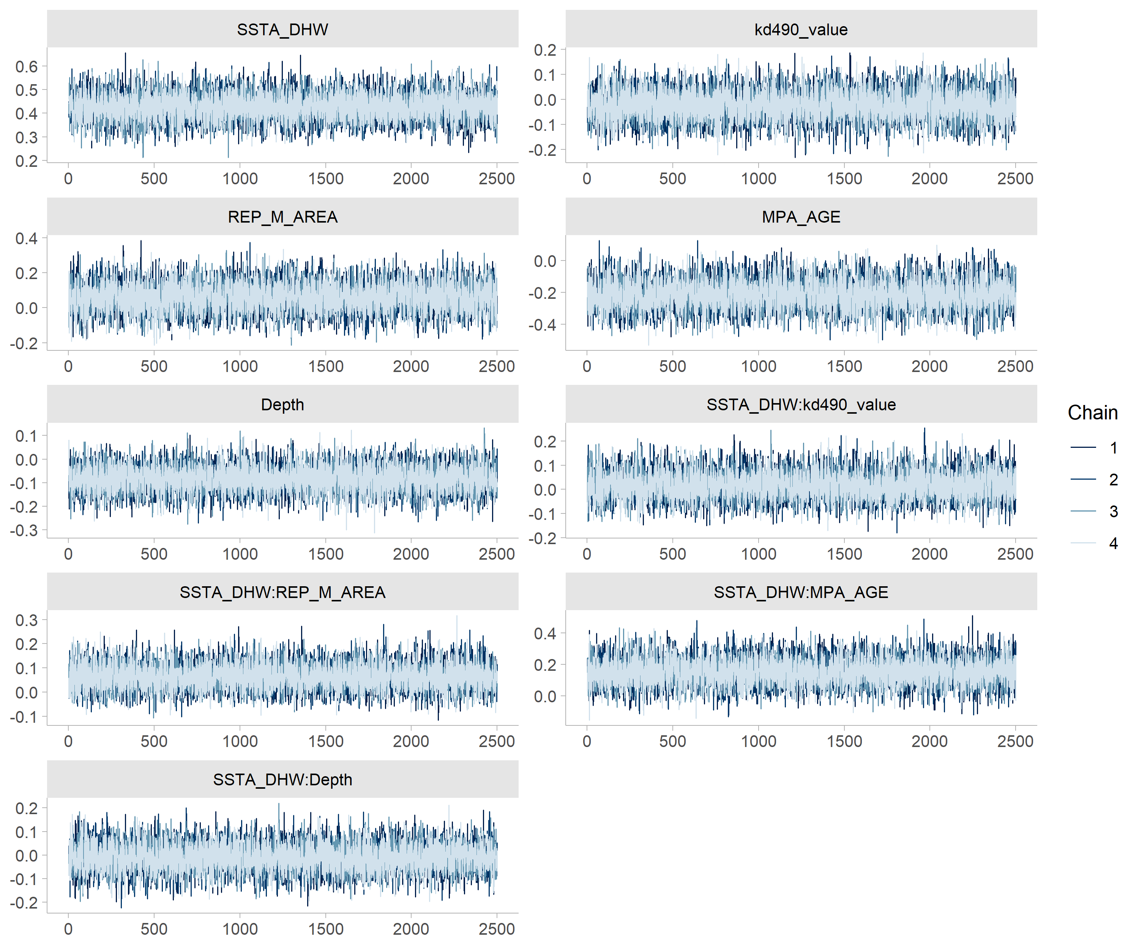
Figure S3. Trace plots after burnins discarded from the Bayesian Generalized linear model with group specific terms ran through STAN for each covariate analyzed in the model.
Figure S4. Intercept variance for each ecoregion ran as a random effect within the STAN Bayesian model.

