Supplementary Information
Additional file 2
Morphospecies and molecular diversity of ‘lace corals’: the genus Reteporella (Bryozoa: Cheilostomatida) in the central North Atlantic Azores Archipelago

Lara Baptista^{1,2,3,4,5 *}, Björn Berning^{1,6}, Manuel Curto^{5,7}, Andrea Waeschenbach ^{8,} Harald Meimberg⁵, António M. Santos^{4,9}, Sérgio P. Ávila^{1,2,3,4,10}

¹ CIBIO, Centro de Investigação em Biodiversidade e Recursos Genéticos, InBIO Laboratório Associado, Pólo dos Açores, 9501-801 Ponta Delgada, Açores, Portugal. ² BIOPOLIS Program in Genomics, Biodiversity and Land Planning, CIBIO, Campus de Vairão, 4485-661 Vairão, Portugal. ³ MPB-Marine Palaeontology and Biogeography Lab, Universidade dos Açores, 9501-801 Ponta Delgada, Açores, Portugal. ⁴ Faculdade de Ciências da Universidade do Porto, Rua do Campo Alegre 1021/1055, 4169-007 Porto, Portugal. ⁵ Institute for Integrative Nature Conservation Research, University of Natural Resources and Life Sciences (BOKU), Vienna, Austria. ⁶ Oberösterreichische Landes-Kultur GmbH, Geowissenschaftliche Sammlungen, Leonding 4060, Austria. ⁷ MARE, Marine and Environmental Sciences Centre, Faculdade de Ciências, Universidade de Lisboa, Campo Grande, Lisboa, 1749-016 Portugal. ⁸ Natural History Museum, London, United Kingdom.⁹ CIBIO, Centro de Investigação em Biodiversidade e Recursos Genéticos, InBIO Laboratório Associado, Campus de Vairão, Universidade do Porto, 4485-661 Vairão, Portugal. ¹⁰ Departamento de Biologia, Faculdade de Ciências e Tecnologia, Universidade dos Açores, 9501-801 Ponta Delgada, Açores, Portugal

*Corresponding author: L. Baptista (laracbaptista@hotmail.com); ORCID: 0000-0002-4429-9855

Table S2 – Estimates of evolutionary divergence (mean raw p-distances) between Reteporella species and additional phidoloporids. a) mitochondrial COI marker (552 bp); b) mitochondrial 16S rRNA marker (332 bp); and c) nuclear 28S rRNA marker (427 bp). The analysis, using MEGA v11 [2], was performed after exclusion of positions containing gaps and/or missing data for each sequence pair analysed. Intraspecific mean p-distances were calculated among haplotypes for each species. Hyphen (-) indicates species represented by a single haplotype. Samples R. atlantica (BRY16; Flores) and Reteporella sp. 5 (BRY257; Formigas) are distinguished in a) and b) due to their differentiation when compared to conspecifics. Pairwise comparisons of other phidoloporid genera highlighted in yellow.
a) | R. atlantica | R. atlantica (BRY16) | R. oceanica | R. sp. 5 | R. sp. 6 | R. sp. 7 | R. sp. 7 (BRY257) | R. sp. 1 | R. tristis | R. beaniana | R. sp. 2 | R. sp. 3 | R. cf. grimaldii | R. sp. 4 | R. cf. graeffei | R. tuberosa | P. avicularis | Schizoretepora sp. | Schizotheca sp. | H. novaezelandiae | T. arcuatum | I. yaldwyni | I. violaceum
R. atlantica | 0.021
R. atlantica (BRY16) | 0.033 | -
R. oceanica | 0.067 | 0.082 | -
Reteporella sp. 5 | 0.083 | 0.098 | 0.038 | -
Reteporella sp. 6 | 0.087 | 0.097 | 0.066 | 0.071 | 0.012
Reteporella sp. 7 | 0.070 | 0.078 | 0.083 | 0.083 | 0.057 | 0.017
Reteporella sp. 7 (BRY257) | 0.089 | 0.101 | 0.089 | 0.091 | 0.063 | 0.034 | -
Reteporella sp. 1 | 0.179 | 0.183 | 0.178 | 0.183 | 0.185 | 0.187 | 0.194 | -
R. tristis | 0.201 | 0.205 | 0.206 | 0.201 | 0.193 | 0.196 | 0.202 | 0.097 | 0.012
R. beaniana | 0.178 | 0.183 | 0.183 | 0.183 | 0.191 | 0.194 | 0.201 | 0.172 | 0.162 | -
Reteporella sp. 2 | 0.170 | 0.171 | 0.174 | 0.176 | 0.166 | 0.171 | 0.172 | 0.152 | 0.168 | 0.132 | -
Reteporella sp. 3 | 0.175 | 0.174 | 0.190 | 0.181 | 0.164 | 0.180 | 0.181 | 0.156 | 0.176 | 0.147 | 0.062 | 0.005
R. cf. grimaldii | 0.172 | 0.172 | 0.176 | 0.170 | 0.159 | 0.180 | 0.179 | 0.165 | 0.180 | 0.134 | 0.042 | 0.061 | -
Reteporella sp. 4 | 0.138 | 0.147 | 0.132 | 0.130 | 0.134 | 0.143 | 0.138 | 0.179 | 0.195 | 0.190 | 0.182 | 0.181 | 0.175
R. cf. graeffei | 0.135 | 0.143 | 0.129 | 0.132 | 0.136 | 0.142 | 0.138 | 0.176 | 0.196 | 0.192 | 0.185 | 0.187 | 0.181 | 0.002 | -
R. tuberosa | 0.222 | 0.228 | 0.232 | 0.234 | 0.226 | 0.216 | 0.225 | 0.210 | 0.224 | 0.236 | 0.205 | 0.216 | 0.199 | 0.222 | 0.221 | -
Phidolopora avicularis | 0.209 | 0.203 | 0.228 | 0.225 | 0.218 | 0.235 | 0.241 | 0.219 | 0.232 | 0.219 | 0.210 | 0.210 | 0.201 | 0.238 | 0.236 | 0.197 | -
Schizoretepora sp. | 0.240 | 0.232 | 0.252 | 0.25 | 0.243 | 0.238 | 0.246 | 0.241 | 0.235 | 0.232 | 0.234 | 0.239 | 0.234 | 0.263 | 0.259 | 0.216 | 0.170 | -
Schizotheca sp. | 0.203 | 0.205 | 0.219 | 0.208 | 0.209 | 0.218 | 0.23 | 0.210 | 0.214 | 0.208 | 0.223 | 0.231 | 0.221 | 0.233 | 0.230 | 0.205 | 0.194 | 0.201 | -
Hippellozoon novaezelandiae | 0.215 | 0.216 | 0.241 | 0.23 | 0.230 | 0.218 | 0.23 | 0.205 | 0.231 | 0.212 | 0.212 | 0.226 | 0.210 | 0.242 | 0.245 | 0.188 | 0.181 | 0.174 | 0.194 | -
Triphyllozoon arcuatum | 0.255 | 0.257 | 0.259 | 0.255 | 0.241 | 0.246 | 0.252 | 0.236 | 0.244 | 0.243 | 0.223 | 0.231 | 0.226 | 0.263 | 0.259 | 0.207 | 0.228 | 0.25 | 0.23 | 0.228 | -
Iodictyum yaldwyni | 0.252 | 0.261 | 0.255 | 0.257 | 0.242 | 0.242 | 0.255 | 0.221 | 0.224 | 0.23 | 0.228 | 0.240 | 0.230 | 0.261 | 0.248 | 0.194 | 0.236 | 0.246 | 0.234 | 0.208 | 0.217 | -
Iodictyum violaceum | 0.241 | 0.241 | 0.252 | 0.261 | 0.242 | 0.252 | 0.257 | 0.234 | 0.253 | 0.228 | 0.210 | 0.216 | 0.219 | 0.250 | 0.261 | 0.217 | 0.219 | 0.219 | 0.221 | 0.187 | 0.225 | 0.178 | -

b) | R. atlantica | R. atlantica (BRY16) | R. sp. 5 | R. sp. 6 | R. sp. 7 | R. sp. 7 (BRY257) | R. sp. 1 | R. tristis | R. sp. 2 | R. sp. 3 | R. cf. grimaldii | R. cf. graeffei | R. tuberosa | I. yaldwyni | H. novaezelandiae | T. arcuatum | P. avicularis
R. atlantica | 0.002
R. atlantica (BRY16) | 0.003 | -
Reteporella sp. 5 | 0.022 | 0.020 | -
Reteporella sp. 6 | 0.013 | 0.011 | 0.010 | 0.005
Reteporella sp. 7 | 0.016 | 0.010 | 0.008 | 0.007 | 0.002
Reteporella sp. 7 (BRY257) | 0.012 | 0.013 | 0.009 | 0.005 | 0.003 | -
Reteporella sp. 1 | 0.085 | 0.083 | 0.085 | 0.081 | 0.081 | 0.080 | -
R. tristis | 0.085 | 0.083 | 0.080 | 0.080 | 0.077 | 0.080 | 0.026 | 0
Reteporella sp. 2 | 0.043 | 0.036 | 0.036 | 0.040 | 0.039 | 0.039 | 0.067 | 0.063 | -
Reteporella sp. 3 | 0.044 | 0.038 | 0.037 | 0.041 | 0.040 | 0.040 | 0.069 | 0.061 | 0.004 | 0.002
R. cf. grimaldii | 0.045 | 0.039 | 0.031 | 0.035 | 0.034 | 0.033 | 0.070 | 0.065 | 0.007 | 0.008 | -
R. cf. graeffei | 0.036 | 0.035 | 0.023 | 0.027 | 0.027 | 0.028 | 0.096 | 0.096 | 0.056 | 0.057 | 0.050 | -
R. tuberosa | 0.198 | 0.198 | 0.198 | 0.197 | 0.192 | 0.196 | 0.208 | 0.213 | 0.197 | 0.198 | 0.193 | 0.196 | -
Iodictyum yaldwyni | 0.177 | 0.177 | 0.172 | 0.171 | 0.166 | 0.169 | 0.184 | 0.184 | 0.175 | 0.173 | 0.169 | 0.169 | 0.111 | -
Hippellozoon novaezelandiae | 0.181 | 0.179 | 0.175 | 0.176 | 0.169 | 0.173 | 0.178 | 0.183 | 0.174 | 0.178 | 0.172 | 0.180 | 0.094 | 0.087 | -
Triphyllozoon arcuatum | 0.200 | 0.197 | 0.195 | 0.195 | 0.189 | 0.192 | 0.207 | 0.200 | 0.205 | 0.204 | 0.201 | 0.195 | 0.121 | 0.132 | 0.123 | -
Phidolopora avicularis | 0.187 | 0.181 | 0.182 | 0.181 | 0.176 | 0.180 | 0.190 | 0.190 | 0.193 | 0.192 | 0.189 | 0.180 | 0.109 | 0.082 | 0.055 | 0.127 | -

c) | R. atlantica | R. oceanica | R. sp. 3 | R. sp. 4 | R. sp. 5 | R. sp. 1 | R. tristis | R. beaniana | R. sp. 2 | R. sp. 3 | R. cf. grimaldii | R. cf. graeffei | P. avicularis | H. novaezelandiae | I. violaceum | T. arcuatum
R. atlantica | 0
R. oceanica | 0.003 | -
Reteporella sp. 5 | 0.003 | 0 | -
Reteporella sp. 6 | 0.003 | 0 | 0 | 0
Reteporella sp. 7 | 0.003 | 0 | 0 | 0 | 0
Reteporella sp. 1 | 0.006 | 0.003 | 0.003 | 0.003 | 0.003 | -
R. tristis | 0.006 | 0.003 | 0.003 | 0.003 | 0.003 | 0.003 | 0
R. beaniana | 0.006 | 0.003 | 0.003 | 0.003 | 0.003 | 0.006 | 0.006 | -
Reteporella sp. 2 | 0.012 | 0.015 | 0.015 | 0.015 | 0.015 | 0.015 | 0.012 | 0.012 | -
Reteporella sp. 3 | 0.012 | 0.015 | 0.015 | 0.015 | 0.015 | 0.015 | 0.012 | 0.012 | 0 | -
R. cf. grimaldii | 0.012 | 0.015 | 0.015 | 0.015 | 0.015 | 0.015 | 0.012 | 0.012 | 0 | 0 | -
R. cf. graeffei | 0.003 | 0 | 0 | 0 | 0 | 0.003 | 0.003 | 0.003 | 0.015 | 0.015 | 0.015 | -
Phidolopora avicularis | 0.066 | 0.063 | 0.063 | 0.063 | 0.063 | 0.060 | 0.063 | 0.030 | 0.060 | 0.060 | 0.060 | 0.063 | -
Hippellozoon novaezelandiae | 0.030 | 0.033 | 0.033 | 0.033 | 0.033 | 0.030 | 0.033 | 0.036 | 0.033 | 0.033 | 0.033 | 0.033 | 0.069 | -
Iodictyum violaceum | 0.027 | 0.030 | 0.030 | 0.030 | 0.030 | 0.033 | 0.033 | 0.063 | 0.027 | 0.027 | 0.027 | 0.030 | 0.073 | 0.048 | -
Triphyllozoon arcuatum | 0.018 | 0.021 | 0.021 | 0.021 | 0.021 | 0.021 | 0.018 | 0.024 | 0.012 | 0.012 | 0.012 | 0.021 | 0.054 | 0.039 | 0.036 | -

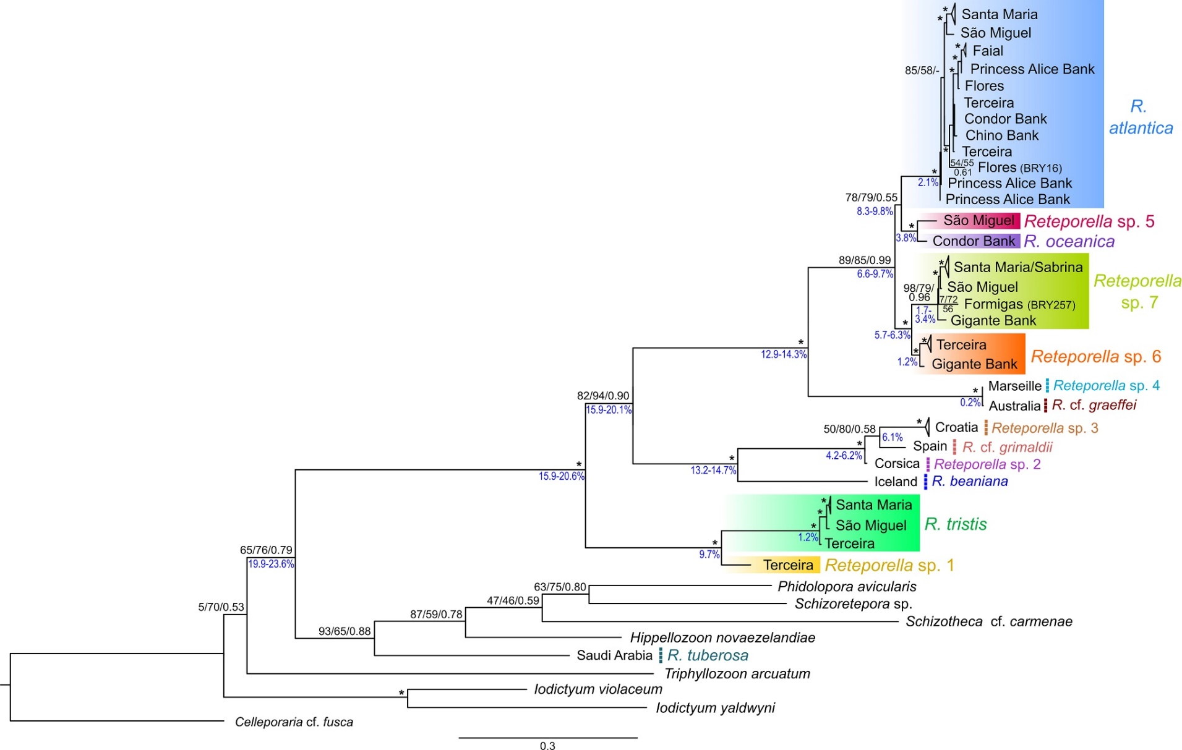
Figure S1 – Maximum likelihood analysis of the COI data. Constructed using the W-IQ-Tree web server [3] under the GTR+I (1st codon position), F81+I (2nd codon position) and GTR+G (3rd codon position) models of nucleotide evolution. Values at the nodes correspond to branch test (SH-aLTR) values, ultrafast bootstrap support (UFboot) values, and posterior probabilities (PP), inferred with W-IQ-Tree and MrBayes v3.2.7 software [4], respectively. Hyphen (-) indicates nodes absent in one of the phylogenetic reconstructions; asterisk (*) indicates nodes supported by both ML and BI analyses (SH-aLTR>= 80%, UFboot >= 95%, PP >= 95%). Mean divergence levels among Reteporella terminals, as estimated with MEGA11 [2], are depicted at the nodes in blue. Known and putative new Azorean Reteporella species are indicated with different coloured shading. Non-Azorean species are indicated by dashed coloured lines. Other phidoloporids included in the analyses are given in normal black font. Geographic origins of Reteporella samples are given as terminal labels. The scale bar represents substitutions per site.
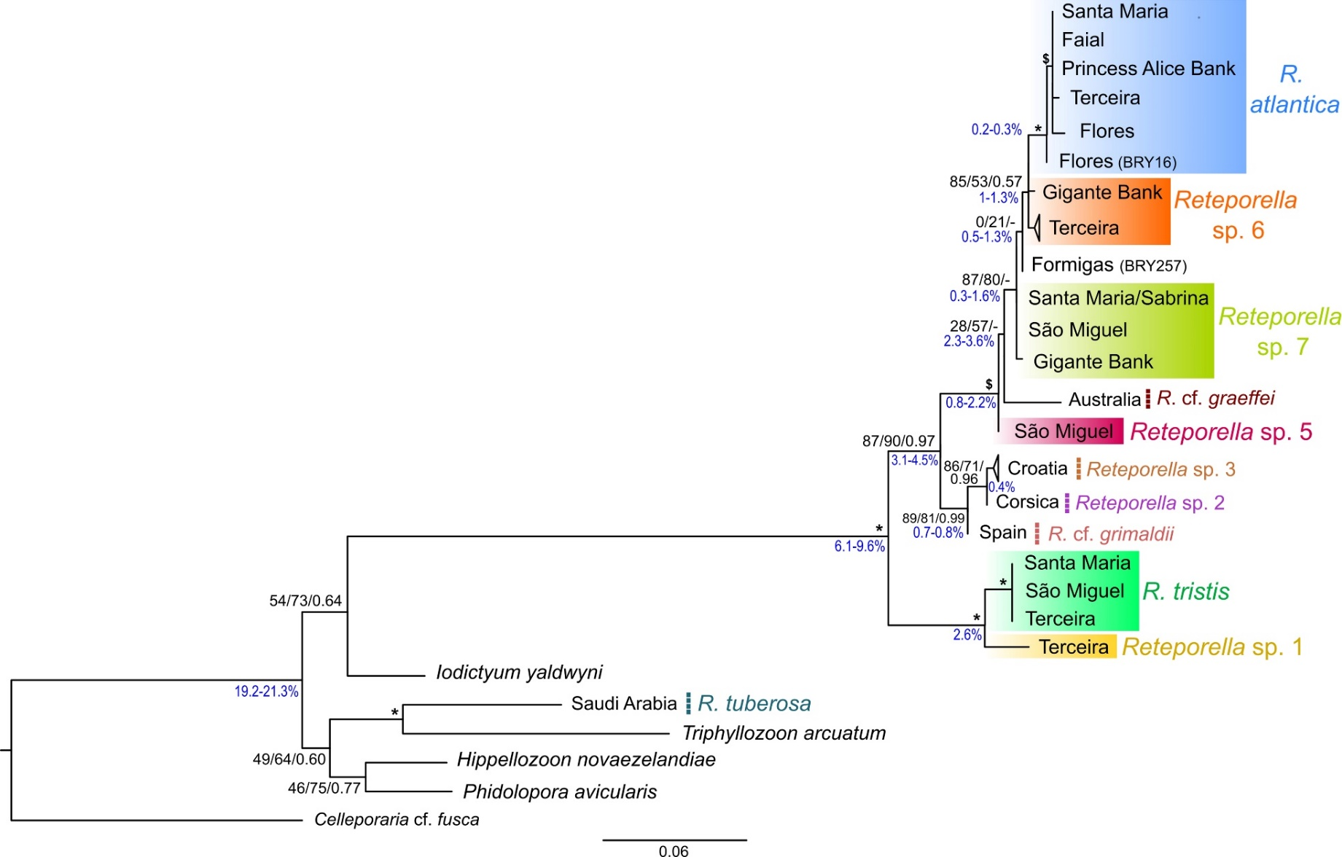
Figure S2 – Maximum likelihood analysis of the 16S rRNA data. Constructed using the W-IQ-Tree web server [3] under the GTR+I+G model of nucleotide evolution. Values at the nodes correspond to branch test (SH-aLTR) values, ultrafast bootstrap support (UFboot) values, and posterior probabilities (PP), inferred with W-IQ-Tree and MrBayes v3.2.7 software [4], respectively. Hyphen (-) indicates nodes absent in one of the phylogenetic reconstructions; asterisk (*) indicates nodes supported by both ML and BI analyses (SH-aLTR>= 80%, UFboot >= 95%, PP >= 95%); dollar sign ($) indicates nodes supported only by ML analyses (SH-aLTR>= 80%, UFboot >= 95%). Mean divergence levels among Reteporella terminals, as estimated with MEGA11 [2], are depicted at the nodes in blue. Known and putative new Azorean Reteporella species are indicated with different coloured shading. Non-Azorean Reteporella species are indicated by dashed coloured lines. Geographical origins of the Reteporella samples are given as terminal labels. Other phidoloporids included in the analyses are given in normal black font. Geographic origins of Reteporella samples are given as terminal labels. The scale bar represents substitutions per site.

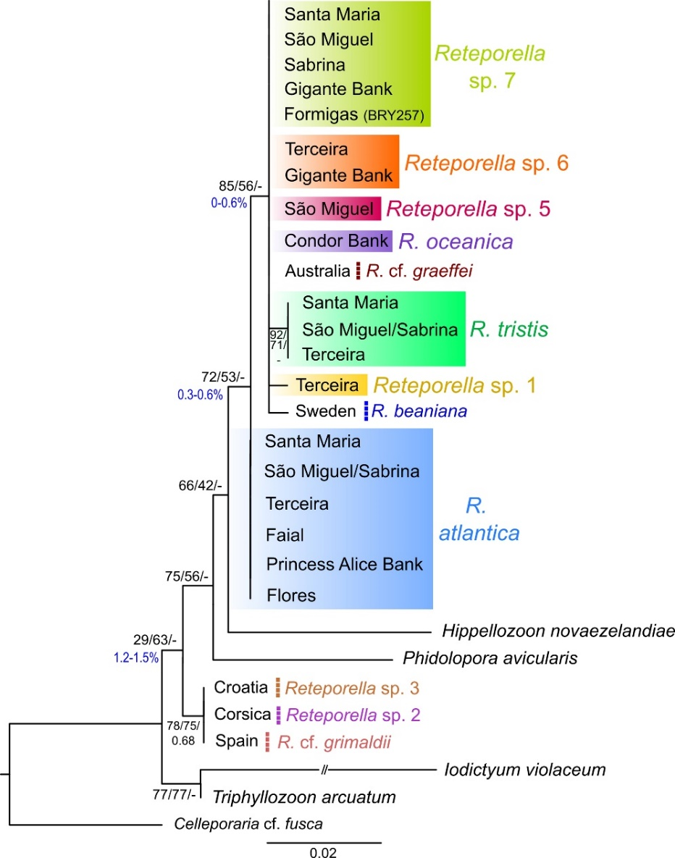
Figure S3 – Maximum likelihood analysis of the 28S rRNA data. Constructed using the W-IQ-Tree web server [3] under the GTR+I+G model of nucleotide evolution. Values at the nodes correspond to branch test (SH-aLTR) values, ultrafast bootstrap support (UFboot) values, and posterior probabilities (PP), inferred with W-IQ-Tree and MrBayes v3.2.7 software [4], respectively. Hyphen (-) indicates nodes absent in one of the phylogenetic reconstructions; asterisk (*) indicates nodes supported by both ML and BI analyses (SH-aLTR>= 80%, UFboot >= 95%, PP >= 95%). Mean divergence levels among Reteporella terminals, as estimated with MEGA11 [2], are depicted at the nodes in blue. Known and putative new Azorean Reteporella species are indicated with different coloured shading. Non-Azorean Reteporella species are indicated by dashed coloured lines. Geographical origins of the Reteporella samples are given as terminal labels. Other phidoloporids included in the analyses are given in normal black font. Geographic origins of Reteporella samples are given as terminal labels. The scale bar represents substitutions per site.
References
1. Wisshak M, Berning B, Jakobsen J, Freiwald A. Temperate carbonate production: biodiversity of calcareous epiliths from intertidal to bathyal depths (Azores). Mar Biodivers. 2015;45:87–112. https://doi.org/10.1007/s12526-014-0231-6.
2. Tamura K, Stecher G, Kumar S. MEGA11: Molecular Evolutionary Genetics Analysis Version 11. Mol Biol Evol. 2021;38:3022–7. https://doi.org/10.1093/molbev/msab120.
3. Trifinopoulos J, Nguyen LT, von Haeseler A, Minh BQ. W-IQ-TREE: a fast online phylogenetic tool for maximum likelihood analysis. Nucleic Acids Res. 2016;44:W232-5. https://doi.org/10.1093/nar/gkw256.
4. Ronquist F, Teslenko M, Van Der Mark P, Ayres DL, Darling A, Höhna S, et al. MBayes 3.2: Efficient Bayesian phylogenetic inference and model choice across a large model space. Syst Biol. 2012;61:539–42. https://doi.org/10.1093/sysbio/sys029.

