ADDITIONAL FILES

Figure S1. Species rank-abundance curves of arboreal Collembola in the four land-use systems studied (rainforest, jungle rubber, rubber plantation, oil palm plantation).
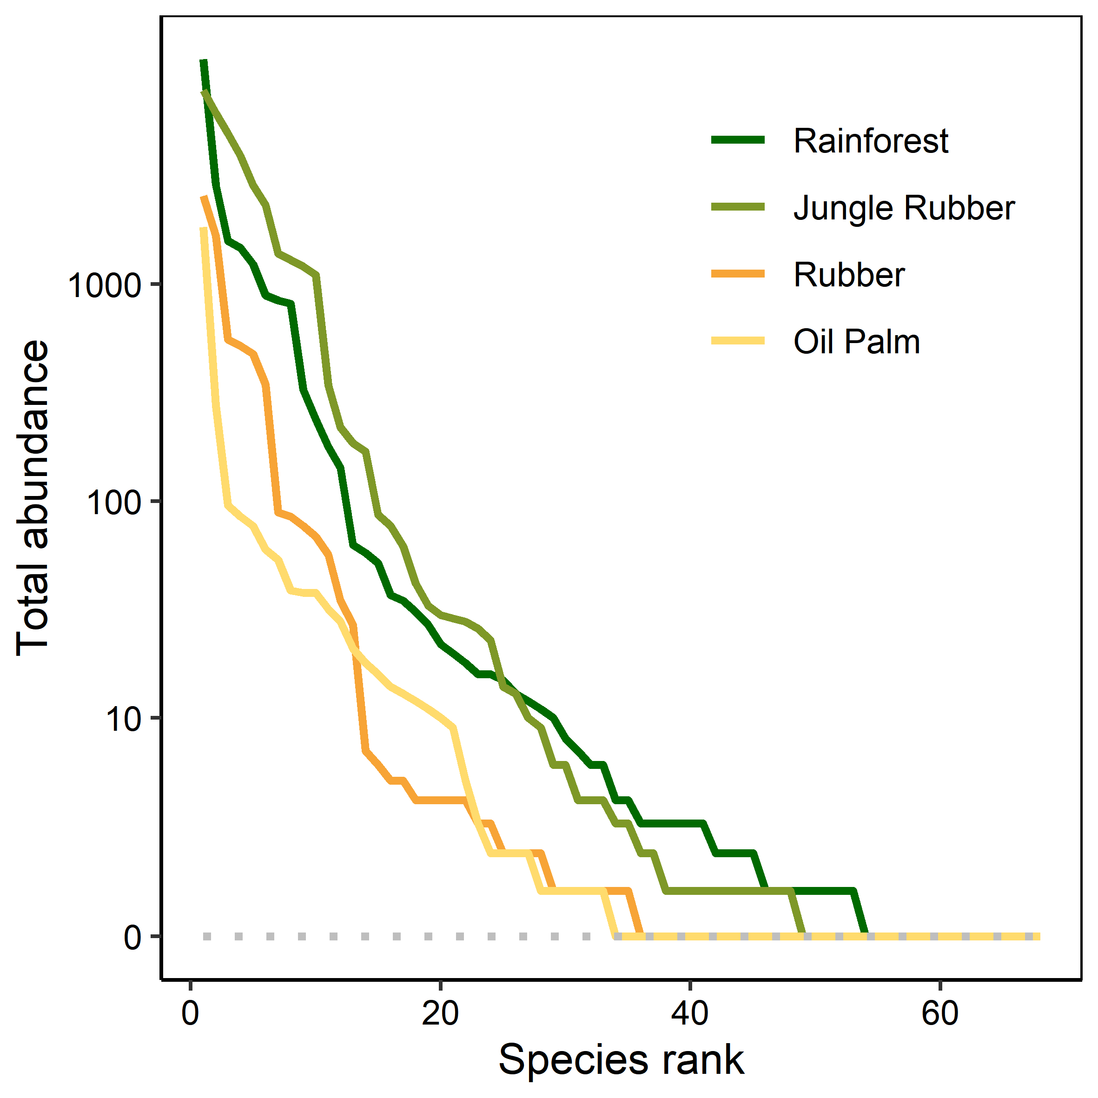

Table S1. Relative abundance and rank of Collembola species in the four land-use systems (rainforest, jungle rubber, rubber plantation, oil palm plantation) in Jambi Province, Sumatra, Indonesia.
Nr. | Morpho(species) | Rainforest |  | Jungle rubber |  | Rubber |  | Oil palm
Nr. | Morpho(species) | Mean ± SD | Rank | Mean ± SD | Rank | Mean ± SD | Rank | Mean ± SD | Rank
1 | Ascocyrtus cinctus | 0.001 ± 0.001 | 25 | 0.002 ± 0.005 | 18 | 0.001 ± 0.002 | 17 | 0.007 ± 0.016 | 13
2 | Callyntrura kudatensis | 0 | 55 | 0 | 67 | 0.003 ± 0.009 | 19 | 0.005 ± 0.014 | 17
3 | Callyntrura sp.01 | 0.002 ± 0.007 | 30 | 0.001 ± 0.001 | 24 | 0.003 ± 0.010 | 23 | 0 | 58
4 | Callyntrura sp.02 | < 0.001 | 51 | < 0.001 | 34 | 0 | 45 | 0 | 42
5 | Callyntrura sp.03 | 0 | 63 | 0 | 50 | 0.007 ± 0.016 | 14 | 0.003 ± 0.008 | 19
6 | Callyntrura sp.04 | < 0.001 | 47 | < 0.001 | 35 | 0 | 62 | 0.001 ± 0.005 | 33
7 | Callyntrura sp.05 | 0.002 ± 0.004 | 23 | < 0.001 | 45 | 0 | 49 | 0 | 47
8 | Callyntrura sp.06 | 0.000 ± 0.001 | 36 | 0 | 57 | 0 | 60 | 0 | 48
9 | Callyntrura sp.07 | 0 | 68 | 0 | 61 | 0.002 ± 0.007 | 21 | 0 | 45
10 | Callyntrura sp.08 | < 0.001 | 39 | < 0.001 | 40 | 0 | 53 | 0 | 60
11 | Callyntrura sp.09 | 0 | 67 | < 0.001 | 46 | 0 | 59 | 0 | 40
12 | Callyntrura sp.10 | 0 | 60 | < 0.001 | 39 | 0 | 43 | 0 | 56
13 | Callyntrura sp.11 | < 0.001 | 46 | 0 | 51 | < 0.001 | 30 | 0 | 38
14 | Calvatomina sp.01 | 0.002 ± 0.004 | 16 | 0 | 64 | 0 | 66 | 0 | 35
15 | Calvatomina sp.02 | 0.001 ± 0.003 | 26 | 0 | 55 | 0 | 61 | 0 | 44
16 | Calvatomina sp.03 | < 0.001 | 38 | 0 | 49 | 0 | 63 | 0 | 61
17 | Calvatomina sp.04 | 0 | 62 | < 0.001 | 41 | 0 | 44 | 0 | 46
18 | Calvatomina sp.05 | < 0.001 | 48 | 0 | 53 | 0 | 57 | 0 | 55
19 | Calvatomina sp.06 | 0 | 57 | 0 | 66 | 0.000 ± 0.001 | 34 | 0 | 50
20 | Dicranocentroides sp.01 | 0 | 66 | < 0.001 | 47 | 0 | 65 | 0 | 52
21 | Entomobrya cf. proxima | 0.003 ± 0.003 | 17 | < 0.001 | 44 | 0 | 56 | 0 | 54
22 | Entomobrya proxima | 0.003 ± 0.003 | 14 | 0.002 ± 0.003 | 15 | < 0.001 | 24 | 0.016 ± 0.044 | 21
23 | Hypogastrura sp.01 | < 0.001 | 44 | 0.017 ± 0.059 | 12 | 0 | 40 | 0.001 ± 0.003 | 30
24 | Hypogastrura sp.02 | 0 | 61 | 0.000 ± 0.001 | 29 | 0 | 50 | 0 | 41
25 | Hypogastrura sp.03 | 0 | 54 | 0.001 ± 0.003 | 26 | 0.000 ± 0.001 | 28 | 0 | 66
26 | Lepidocyrtinae sp.01 | 0.208 ± 0.240 | 2 | 0.161 ± 0.207 | 2 | 0.000 ± 0.001 | 18 | 0.013 ± 0.043 | 18
27 | Lepidocyrtinae sp.02 | 0.000 ± 0.002 | 29 | 0.038 ± 0.044 | 7 | 0.005 ± 0.014 | 9 | 0.017 ± 0.069 | 3
28 | Lepidocyrtinae sp.03 | 0.053 ± 0.073 | 4 | 0.158 ± 0.133 | 3 | 0.001 ± 0.003 | 15 | 0.007 ± 0.024 | 14
29 | Lepidocyrtinae sp.04 | 0.002 ± 0.005 | 13 | < 0.001 | 33 | 0.538 ± 0.308 | 1 | 0.164 ± 0.238 | 2
30 | Lepidocyrtinae sp.05 | 0.000 ± 0.001 | 40 | 0.000 ± 0.001 | 32 | 0.001 ± 0.002 | 16 | 0.116 ± 0.246 | 5
31 | Lepidocyrtoides sp.01 | 0.012 ± 0.011 | 10 | < 0.001 | 42 | 0 | 37 | 0 | 67
32 | Lepidonella sp.01 | 0.002 ± 0.004 | 21 | 0 | 62 | 0 | 52 | 0 | 51
33 | Lepidonella sp.02 | 0.000 ± 0.001 | 34 | < 0.001 | 38 | < 0.001 | 31 | 0.011 ± 0.038 | 20
34 | Lepidonella sp.03 | 0 | 59 | 0 | 60 | 0.000 ± 0.002 | 29 | 0.001 ± 0.005 | 31
35 | Lepidosira calolepis | 0.089 ± 0.064 | 3 | 0.057 ± 0.070 | 8 | 0.002 ± 0.007 | 22 | 0.001 ± 0.002 | 25
36 | Salina celebensis | < 0.001 | 52 | < 0.001 | 37 | 0.014 ± 0.055 | 8 | 00 | 65
37 | Salina cf. celebensis | 0.003 ± 0.008 | 19 | 0.056 ± 0.100 | 5 | 0.040 ± 0.081 | 6 | 0.018 ± 0.053 | 10
38 | Salina cf. saikehi | 0.014 ± 0.016 | 9 | 0.000 ± 0.001 | 25 | 0.005 ± 0.018 | 10 | 0.000 ± 0.001 | 24
39 | Salina cingulata | 0.027 ± 0.030 | 8 | 0.002 ± 0.004 | 21 | 0.004 ± 0.010 | 12 | 0.011 ± 0.041 | 9
40 | Salina saikehi | 0.001 ± 0.002 | 32 | 0.023 ± 0.035 | 10 | 0.008 ± 0.024 | 11 | 0.033 ± 0.062 | 4
41 | Salina sp.01 | 0.398 ± 0.257 | 1 | 0.092 ± 0.130 | 6 | 0.026 ± 0.086 | 4 | 0.022 ± 0.056 | 6
42 | Salina sp.02 | 0.077 ± 0.124 | 5 | 0.223 ± 0.202 | 1 | 0.159 ± 0.250 | 2 | 0.419 ± 0.401 | 1
43 | Salina sp.03 | 0 | 56 | 0.000 ± 0.001 | 28 | 0.024 ± 0.079 | 5 | 0.000 ± 0.001 | 26
44 | Salina sp.04 | 0.001 ± 0.003 | 18 | < 0.001 | 36 | 0 | 51 | 0 | 36
45 | Seira taeniata | 0.039 ± 0.031 | 6 | 0.053 ± 0.076 | 9 | 0.000 ± 0.001 | 20 | 0.002 ± 0.010 | 22
46 | Sminthurinus sp.01 | 0.000 ± 0.001 | 28 | 0 | 68 | 0 | 67 | 0 | 49
47 | Sminthurinus sp.02 | 0.001 ± 0.001 | 24 | 0 | 54 | 0 | 38 | 0 | 34
48 | Sminthurinus sp.03 | 0.001 ± 0.001 | 33 | 0.000 ± 0.001 | 20 | < 0.001 | 26 | 0.021 ± 0.035 | 7
49 | Sminthurinus sp.04 | < 0.001 | 49 | 0 | 59 | 0.002 ± 0.007 | 33 | 0.030 ± 0.115 | 8
50 | Sminthurinus sp.05 | < 0.001 | 50 | 0.000 ± 0.000 | 31 | 0.014 ± 0.023 | 7 | 0.014 ± 0.028 | 16
51 | Sminthurinus sp.06 | < 0.001 | 53 | 0.005 ± 0.009 | 14 | 0 | 39 | 0 | 57
52 | Sminthurinus sp.07 | 0.008 ± 0.011 | 12 | 0.012 ± 0.021 | 11 | 0 | 54 | 0.019 ± 0.062 | 15
53 | Sminthurinus sp.08 | < 0.001 | 41 | 0.002 ± 0.004 | 16 | < 0.001 | 32 | 0.027 ± 0.048 | 12
54 | Sminthurinus sp.09 | 0 | 58 | < 0.001 | 30 | 0 | 48 | 0.001 ± 0.005 | 29
55 | Sphaeridia sp.01 | 0.001 ± 0.001 | 22 | 0.001 ± 0.001 | 23 | 0 | 64 | 0.000 ± 0.001 | 28
56 | Sphyrotheca sp.01 | 0.002 ± 0.004 | 15 | 0.001 ± 0.003 | 27 | 0 | 46 | 0 | 68
57 | Sphyrotheca sp.02 | < 0.001 | 45 | 0.003 ± 0.009 | 17 | 0.000 ± 0.001 | 25 | 0 | 39
58 | Sphyrotheca sp.03 | 0.001 ± 0.002 | 31 | 0.001 ± 0.005 | 19 | 0 | 41 | 0 | 63
59 | Sphyrotheca sp.04 | 0.001 ± 0.002 | 20 | < 0.001 | 43 | 0.000 ± 0.002 | 35 | 0 | 59
60 | Sphyrotheca sp.05 | 0.000 ± 0.001 | 35 | 0 | 63 | 0 | 55 | 0 | 62
61 | Sphyrotheca sp.06 | < 0.001 | 42 | 0 | 52 | 0 | 68 | 0.000 ± 0.001 | 32
62 | Sphyrotheca sp.07 | 0 | 64 | < 0.001 | 48 | 0 | 47 | 0 | 37
63 | Superodontella sp.01 | < 0.001 | 43 | 0 | 65 | 0 | 36 | 0 | 64
64 | Willowsia cf. guangdongensis | 0.038 ± 0.031 | 7 | 0.079 ± 0.094 | 4 | 0.130 ± 0.190 | 3 | 0.002 ± 0.005 | 23
65 | Willowsia hyalina | 0 | 65 | 0.001 ± 0.004 | 22 | 0 | 58 | 0 | 53
66 | Willowsia jacobsoni | 0.001 ± 0.001 | 27 | 0 | 56 | 0.002 ± 0.006 | 27 | 0.014 ± 0.020 | 11
67 | Willowsia sp.01 | 0.007 ± 0.006 | 11 | 0.006 ± 0.007 | 13 | 0.009 ± 0.029 | 13 | 0.001 ± 0.005 | 27
68 | Willowsia sp.02 | 0.000 ± 0.000 | 37 | 0 | 58 | 0 | 42 | 0 | 43

Figure S2. Venn diagrams of shared and exclusive Collembola species in the four land-use systems (rainforest, jungle rubber, rubber plantation, oil palm plantation) (A), two landscapes (Bukit Duabelas, Harapan) (B) and two seasons (dry, rainy) (C).
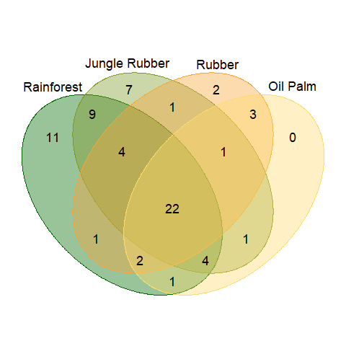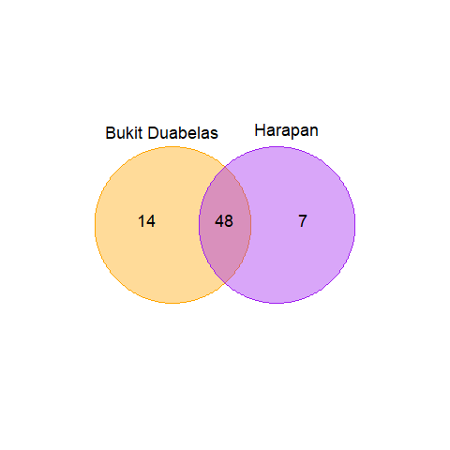
B
A
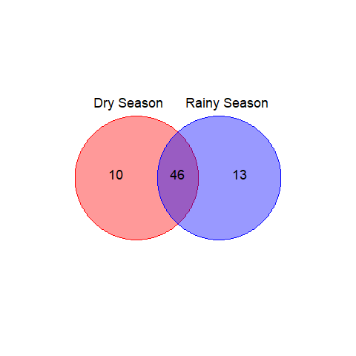
C

Figure S3. Species accumulation curves showing accumulation rates of new species in the studied four land-use systems (rainforest, jungle rubber, rubber plantation, oil palm plantation) in Jambi Province, Sumatra, Indonesia.
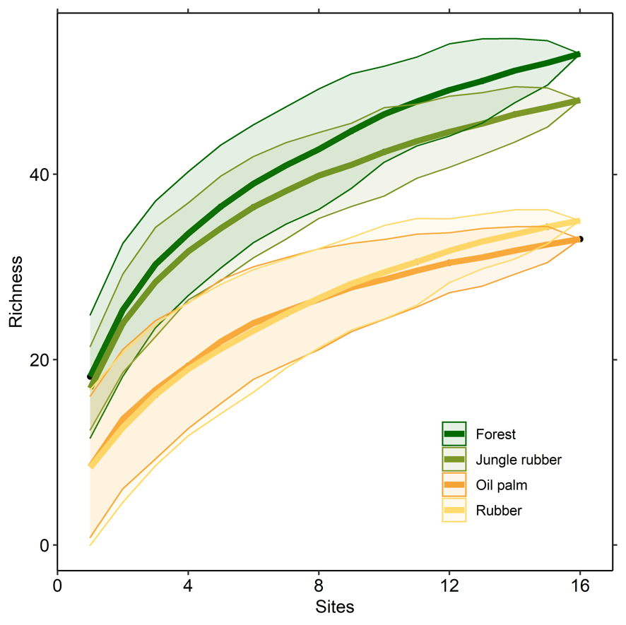

Figure S4. Location of the 32 study plots in two landscapes near Bukit Duabelas National Park and Harapan Rainforest in Jambi province, Sumatra, Indonesia (from [24]).
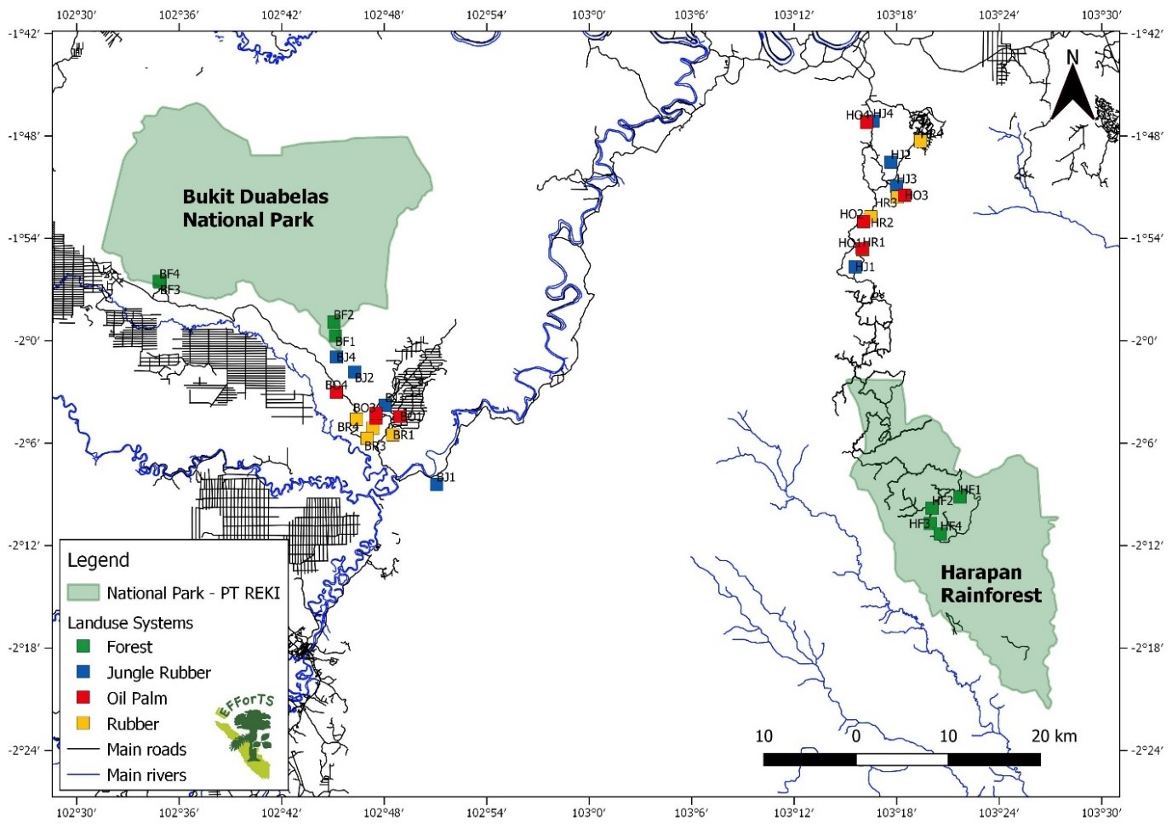

Figure S5. Overview of the investigated land-use systems: Lowland rainforest (A), jungle rubber (B), rubber plantation (C) and oil palm plantation (D). Photos by Jochen Drescher.

