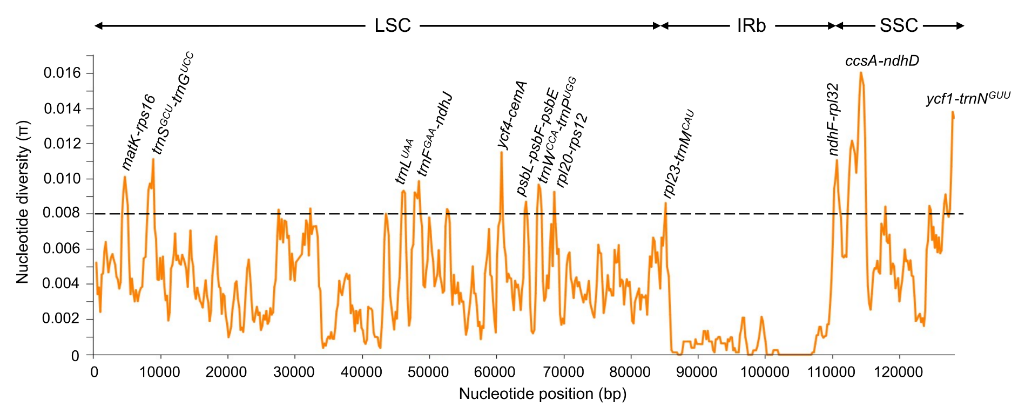
Figure S1. Sliding window analysis of nucleotide diversity among nineteen chloroplast genomes of Amaranthus species. Eleven Amaranthus cp genomes were assembled in this study while eight genomes were obtained from NCBI database. Window length: 800 bp; step size: 200 bp.

