Supplementary Information
for
“Genomic evidence indicates small island-resident populations and sex-biased behaviors of Hawaiian reef manta rays”

Jonathan L. Whitney^{1,2*}, Richard R. Coleman³, and Mark H. Deakos⁴

¹ National Oceanic and Atmospheric Administration, Pacific Islands Fisheries Science Center, Honolulu, Hawaiʻi
² Department of Oceanography, University of Hawaiʻi at Manoa, Honolulu, Hawaiʻi
³Rosenstiel School of Marine and Atmospheric Science (RSMAS), University of Miami, Miami, Florida
⁴ Hawaii Association for Marine Education and Research, Lahaina, Maui

*Corresponding author. Email: Jonathan.Whitney@noaa.gov; Jw2@hawaii.edu

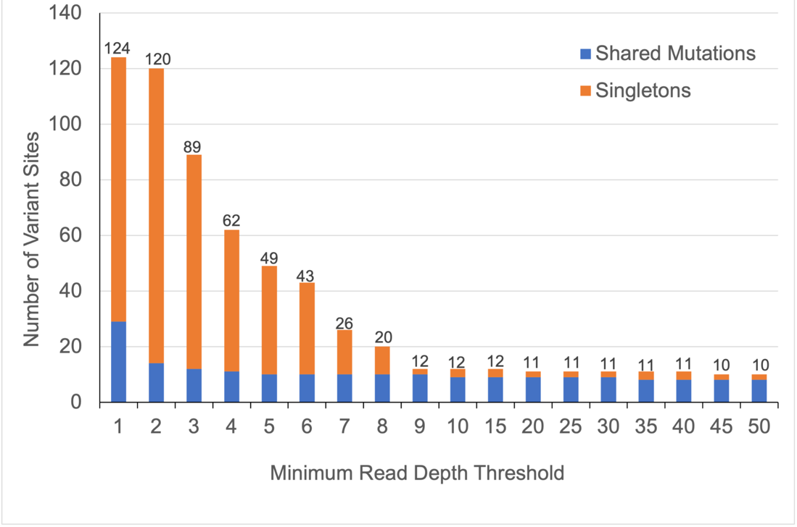
Figure S1. Number of variable sites across 34 Mobula alfredi mitogenomes with respect to minimum mean read depth threshold, grouped by singletons (orange) and shared mutations (blue).

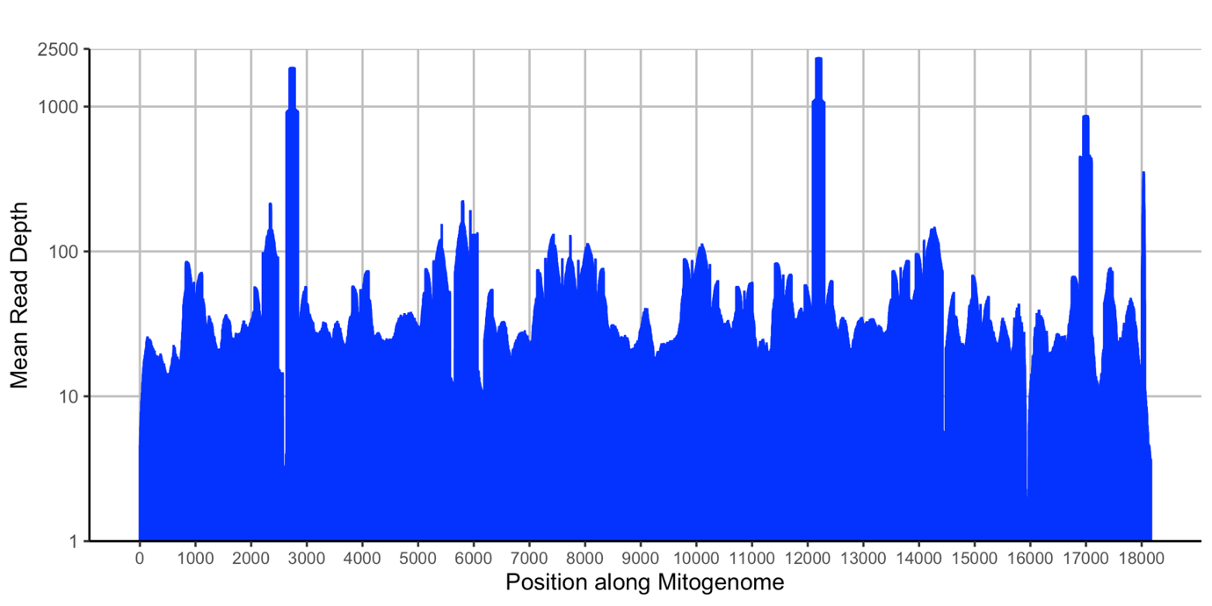
Figure S2. Mean read depth along mitogenome across 34 Mobula alfredi individuals mapped to assembled mitogenome (Genbank: OP562409).

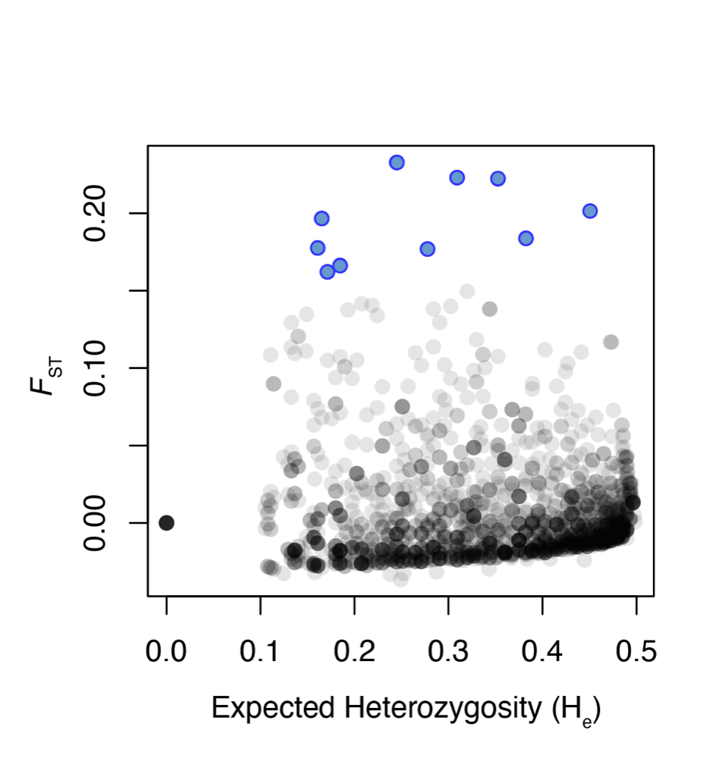

Figure S3. Genetic differentiation versus expected heterozygosity of 2048 nuclear SNPs genotyped. In the scatterplot, black and grey dots indicate neutral loci (n=2038), and blue dots indicate outlier loci (n=10).

A)

B)

C)

Figure S4. DeltaK graph generated from STRUCTURE HARVESTER (Earl & von Holdt 2012). A) all loci, 2048 snps, B) neutral loci, 2038 snps, C) outlier loci, 10 snps.

