Supplementary figures and table

Tables S1 through S4 can be found in a separate Excel document.

Table S5. Landmarks (L) and semi-landmarks (SL) of 2D geometric morphometric analysis and the biological variables they characterize

Figure S1. All significant outlier PCs based on outlier analyses of each of the datasets
- PC6, PC8 of dataset (a)
- PC4, PC9 of dataset (b)
- PC6 of dataset (c)
- PC6, PC7 of dataset (d)

Figure S2. Skull length to MWAM strain and Log skull length to MWAM strain regression graph

Figure S3. PCA figures showing trajectory observed
- PC1 and PC2 of dataset (c) and (d) (with outgroup)
- PC1 and PC2 of dataset (c) and (d) (without outgroup)

Figure S4. PCA graphs of each dataset after excluding landmarks on top of the cranium

Table S5. Landmarks (L) 2D geometric morphometric analysis and the biological variable they characterize

Landmarks and semi-landmarks | Biological variable characterized
L1. Anterior end of premaxilla | Total skull length
L2. Junction of premaxilla and maxilla | Length of premaxilla
L3. Ventral end of rostrum corresponding to anterior end of maxillary fenestra | Overall shape and curvature of the skull
L4. Ventral end of rostrum corresponding to anterior end of antorbital fenestra | Overall shape and curvature of the skull
L5. Junction of maxilla and jugal | Length of maxilla
L6. Anterior end of antorbital fenestra | Shape of antorbital fenestra
L7. Posterior dorsal end of antorbital fenestra | Shape of antorbital fenestra
L8. Posterior ventral end of antorbital fenestra | Shape of antorbital fenestra
L9. Anterior end of orbit | Shape of orbit
L10. Junction between postorbital and orbit | Shape of orbit
L11. Dorsal most point of orbit | Shape of orbit
L12. Junction between jugal and quadratojugal | Length of jugal
L13. Junction between quadratojugal and quadrate | Length of quadratojugal
L14. Posterior ventral end of quadrate | Length of ventral end of skull
L15. Posterior dorsal end of quadrate | Height of quadrate
L16. Posterior end of squamosal | Length of squamosal protrudes out posteriorly
L17. Posterior dorsal end of parietal | Height of posterior end of skull and length of dorsal end of skull
L18. Junction of frontal and parietal | Length of parietal
L19. Junction of nasal and frontal | Length of frontal
L20. Dorsal end of rostrum corresponding to anterior end of antorbital fenestra | Overall shape and curvature of the skull
L21. Dorsal end of rostrum corresponding to anterior end of maxillary fenestra | Overall shape and curvature of the skull

***Aim of the semi-landmarks assigned is to capture overall shape of the skull and shape of the fenestrae that are identifiable in the majority of the specimens

***There is no semi-landmarks between L13 to L14. This is because L13 and L14 overlap with each other in some of the specimens, which makes it impossible to assign semi-landmarks

***There is no semi-landmarks between L21 to L1 because some of the specimens have a portion of the nasal missing or displaced

Figure S1. All significant outlier PCs based on outlier analyses of each of the datasets

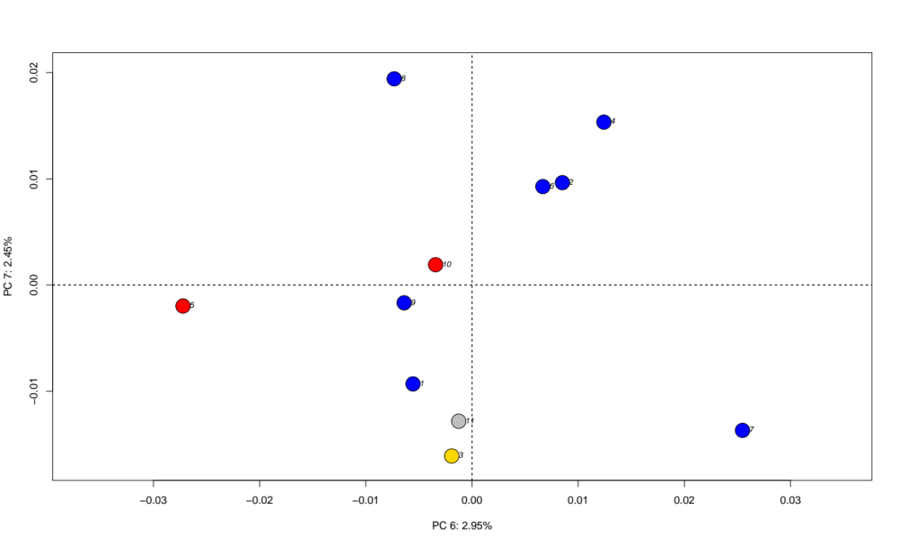

PC6 of dataset (a) with deformation grids of positive and negative PC6. 1: Deinonychus, 2: Dromaeosaurus, 3: Halszkaraptor, 4: Linheraptor, 5: Microraptor, 6: Saurornitholestes, 7: Tsaagan, 8: Velociraptor a, 9: Velociraptor b, 10: Sinornithosaurus, 11: Gobivenator

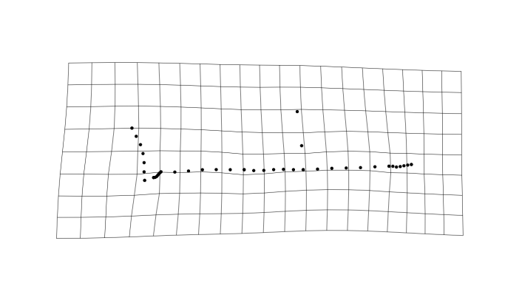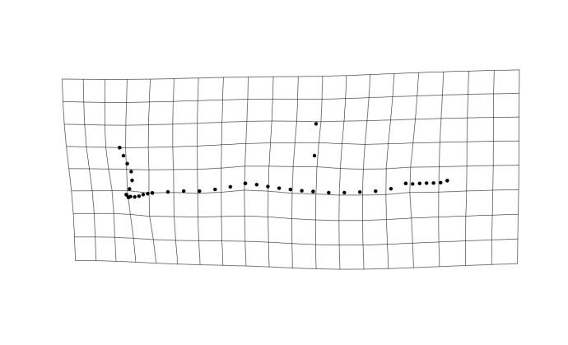
Negative PC6 Positive PC6
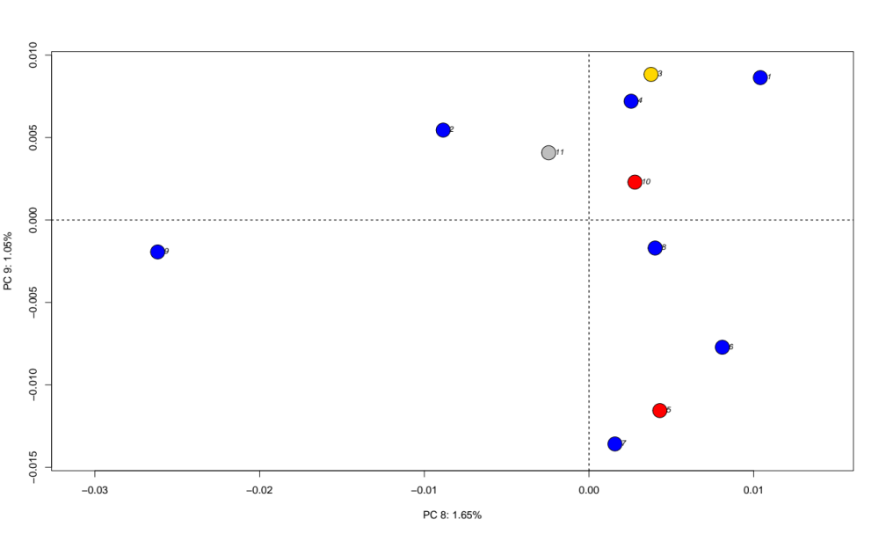
PC8 of dataset (a) with deformation grids of positive and negative PC8. 1: Deinonychus, 2: Dromaeosaurus, 3: Halszkaraptor, 4: Linheraptor, 5: Microraptor, 6: Saurornitholestes, 7: Tsaagan, 8: Velociraptor a, 9: Velociraptor b, 10: Sinornithosaurus, 11: Gobivenator

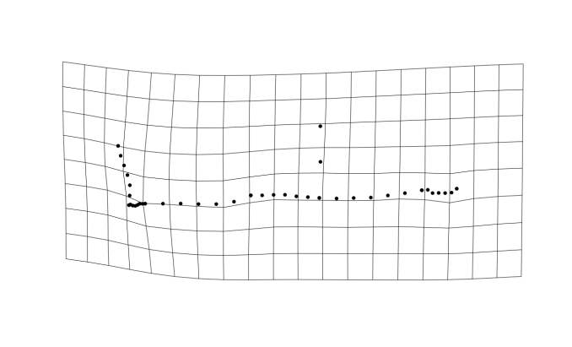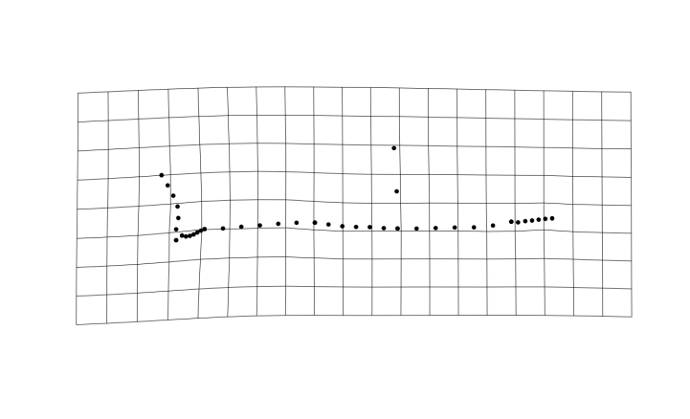

Negative PC8 Positive PC8

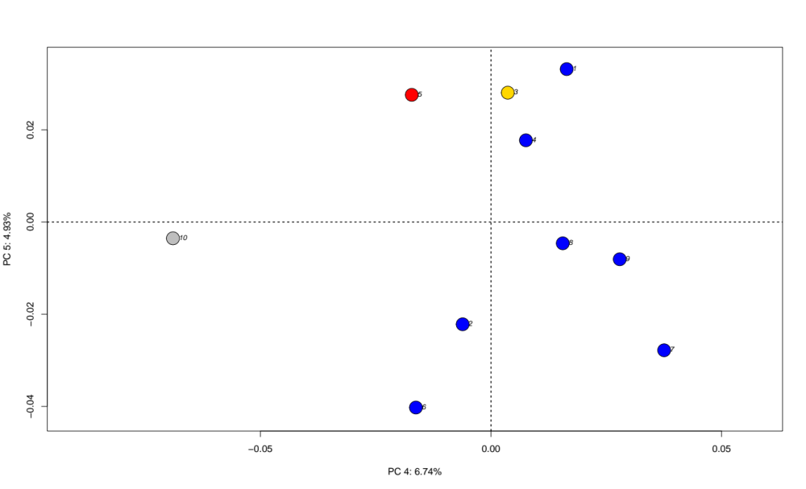
PC4 and PC5 of dataset (b) with deformation grids of positive and negative PC4. 1: Deinonychus, 2: Dromaeosaurus, 3: Halszkaraptor, 4: Linheraptor, 5: Microraptor, 6: Saurornitholestes, 7: Velociraptor a, 8: Velociraptor b, 9: Tsaagan, 10: Gobivenator

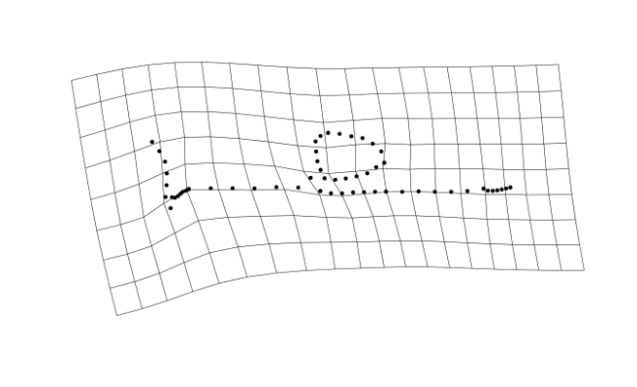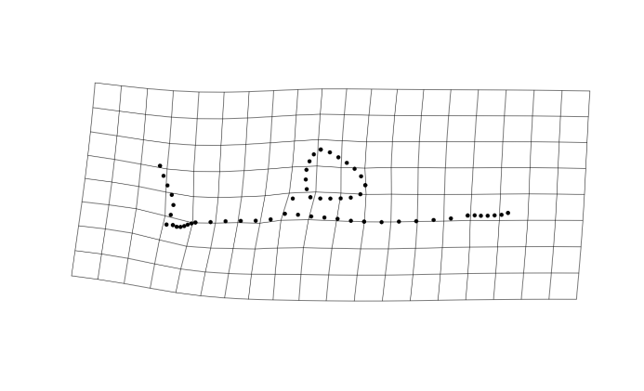
Negative PC4 Positive PC4
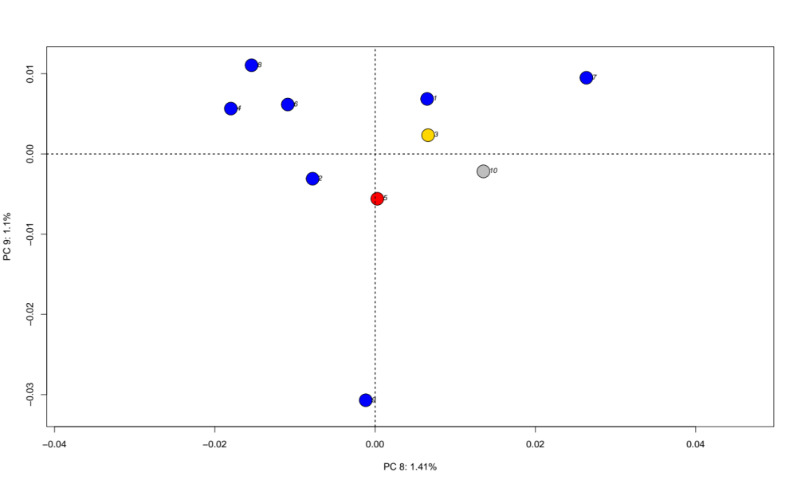
PC8 and PC9 of dataset (b) with deformation grids of positive and negative PC9. 1: Deinonychus, 2: Dromaeosaurus, 3: Halszkaraptor, 4: Linheraptor, 5: Microraptor, 6: Saurornitholestes, 7: Velociraptor a, 8: Velociraptor b, 9: Tsaagan, 10: Gobivenator

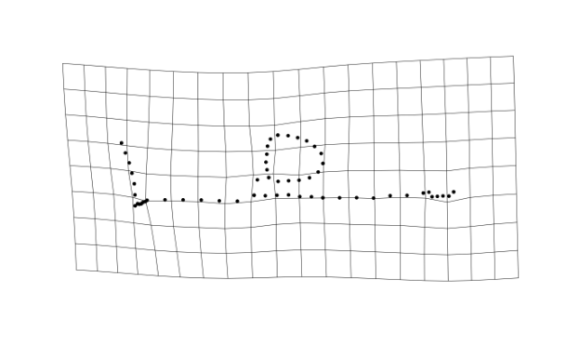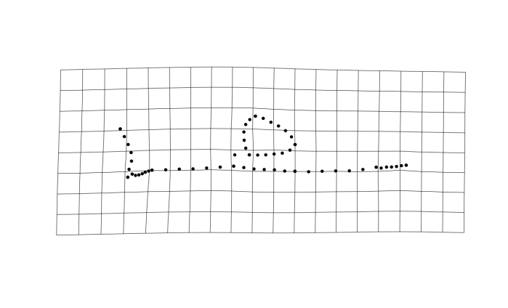
Positive PC9 Negative PC9
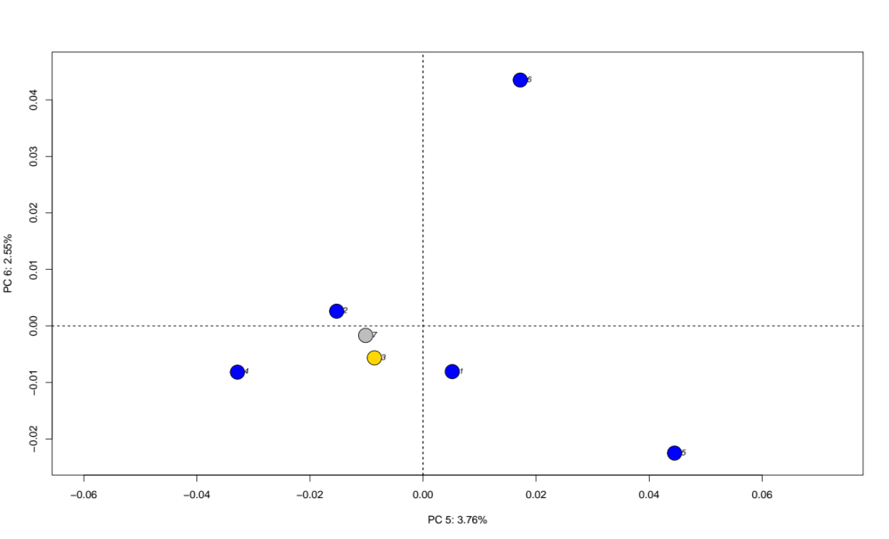
PC5 and PC6 of dataset (c) with deformation grids of positive and negative PC6. 1: Deinonychus, 2: Dromaeosaurus, 3: Halszkaraptor, 4: Linheraptor, 5: Tsaagan, 6: Velociraptor, 7: Gobivenator

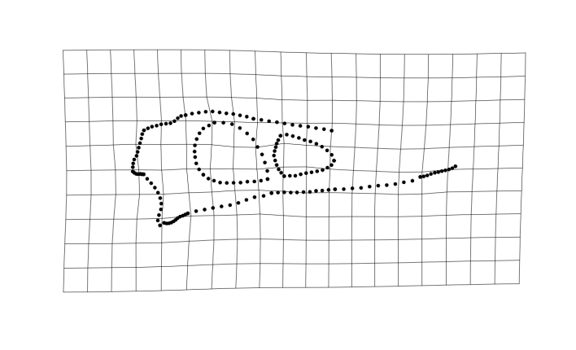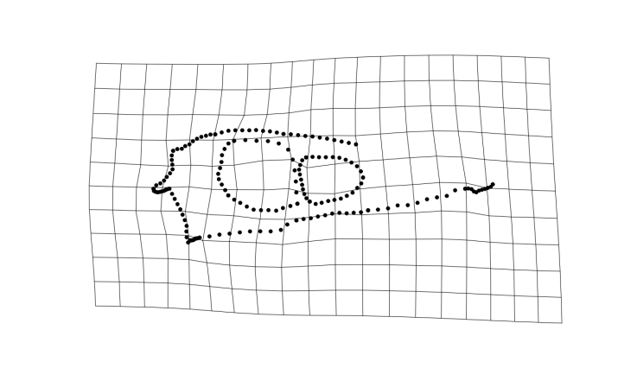
Negative PC6 Positive PC6
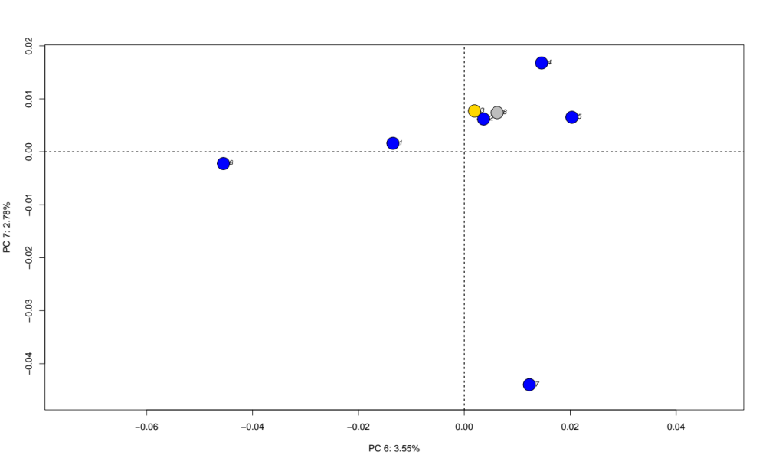
PC6 and PC7 of dataset (d) with deformation grids of positive and negative PC6 and PC7. 1: Deinonychus, 2: Dromaeosaurus, 3: Halszkaraptor, 4: Linheraptor, 4: Saurornitholestes, 6: Tsaagan, 7: Velociraptor, 8: Gobivenator

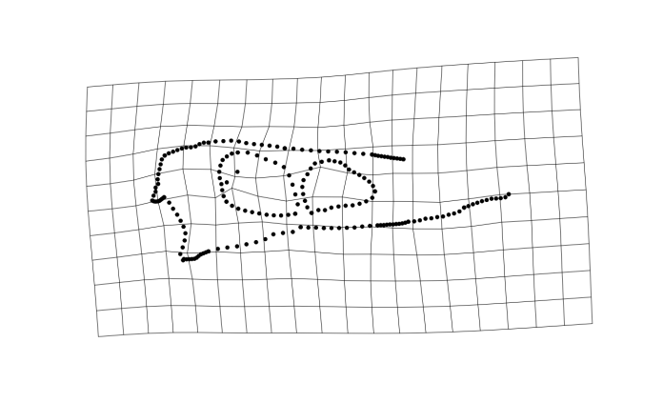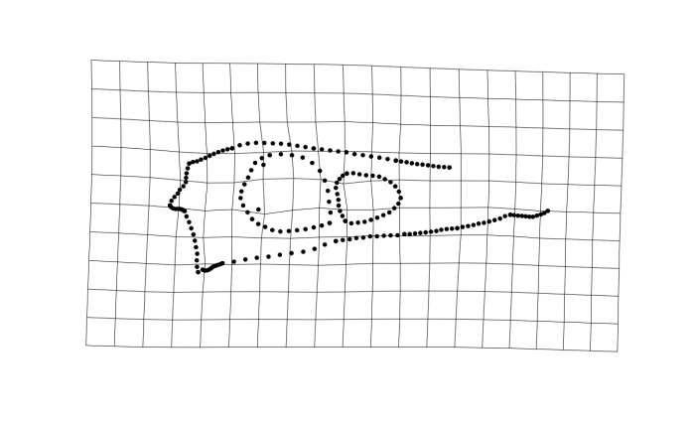
Negative PC6 Positive PC6

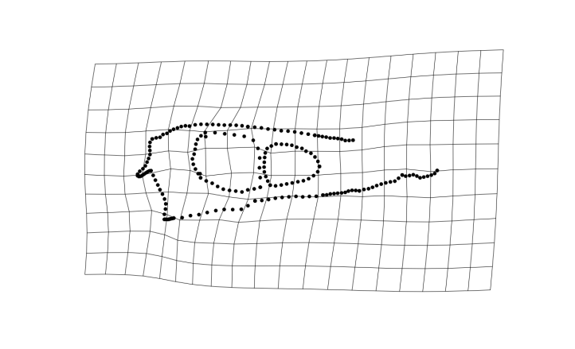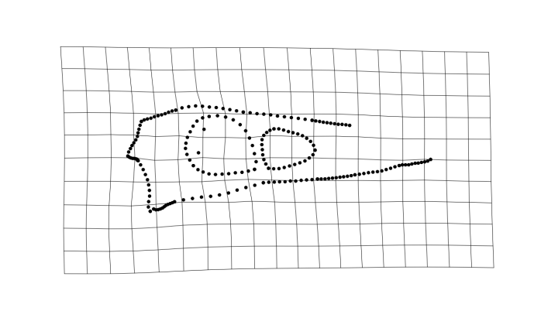
Negative PC7 Positive PC7

Figure S2. Skull length to MWAM strain and Log skull length to MWAM strain linear regression graph

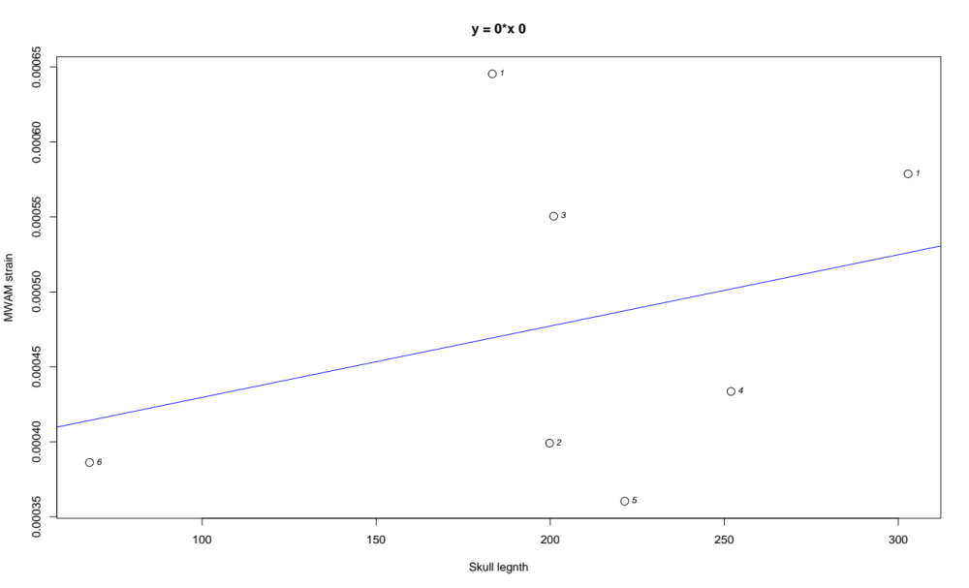

Linear regression between skull length (mm) and MWAM strain for specimens with MWAM strain values available. (R²_{adj} = -0.0844, p = 0.498)

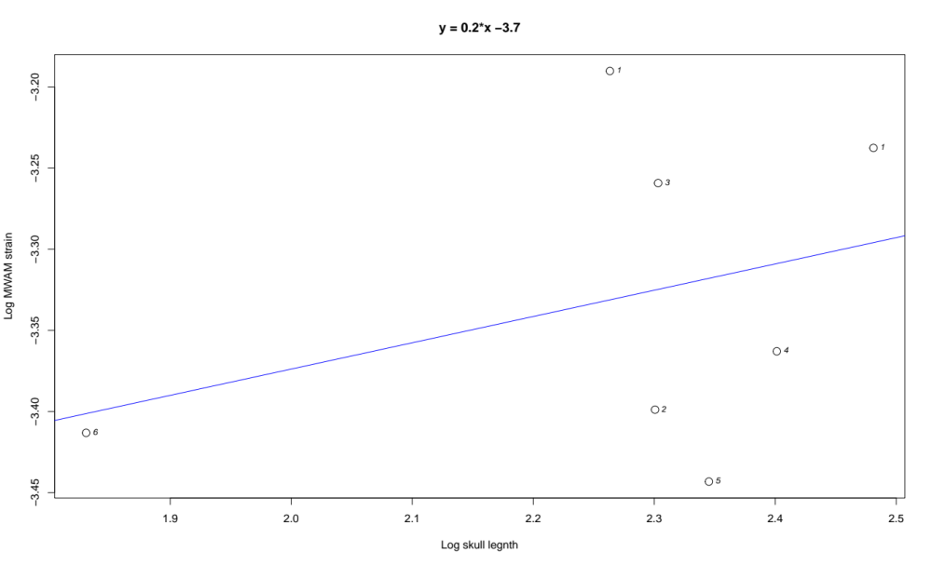
Linear regression between log skull length (mm) and log MWAM strain for specimens with MWAM strain values available. (R²_{adj} = -0.0591, p = 0.452)

Figure S3. PCA figures showing trajectory observed

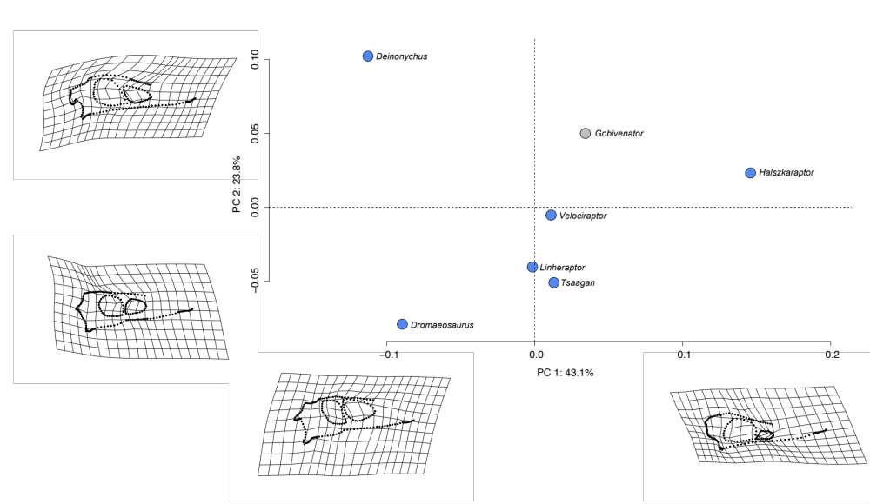
PC1 and PC2 of dataset (c) including outgroup Gobivenator

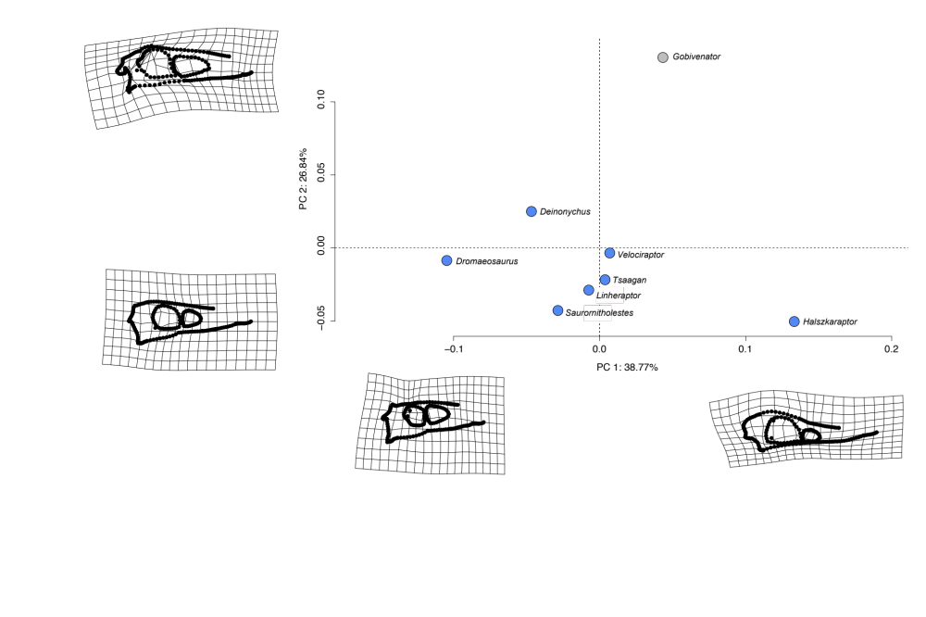
PC1 and PC2 of dataset (d) including outgroup Gobivenator

PC1 and PC2 of dataset (c) excluding outgroup Gobivenator

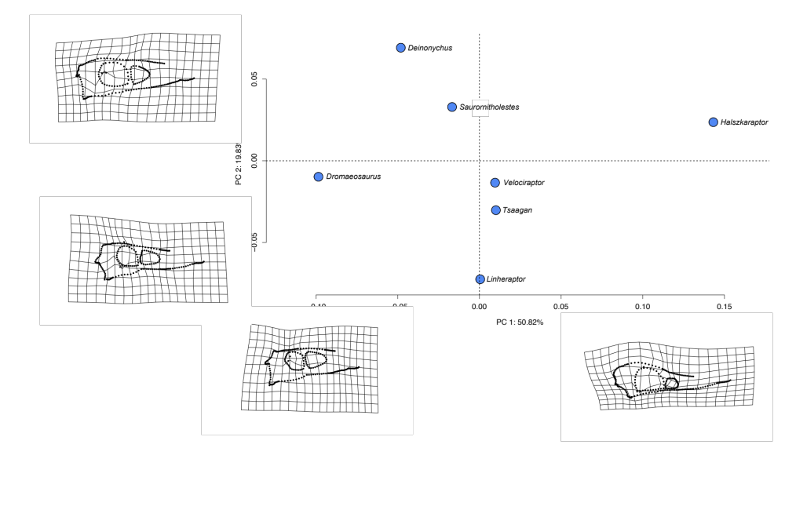
PC1 and PC2 of dataset (d) excluding outgroup Gobivenator
Figure S4. PCA graphs of each dataset after excluding landmarks on top of the cranium

Dataset (a)
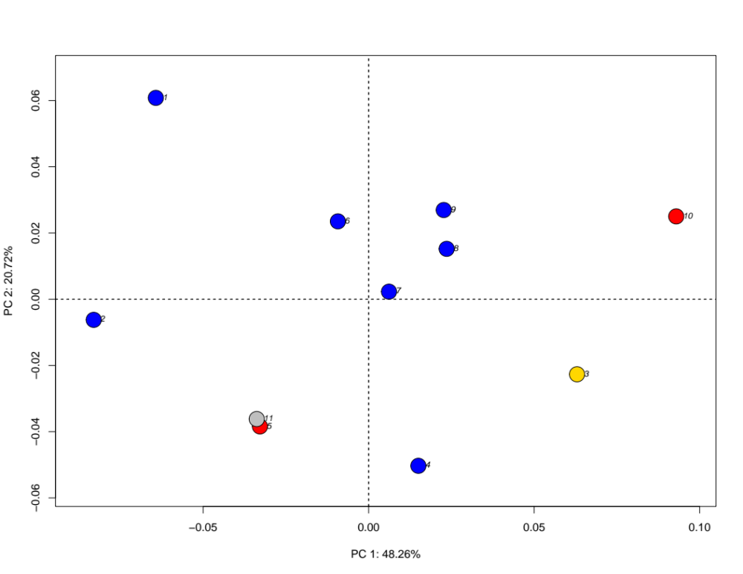
1: Deinonychus, 2: Dromaeosaurus, 3: Halszkaraptor, 4: Linheraptor, 5: Microraptor, 6: Saurornitholestes, 7: Tsaagan, 8: Velociraptor a, 9: Velociraptor b, 10: Sinornithosaurus, 11: Gobivenator

Dataset (b)
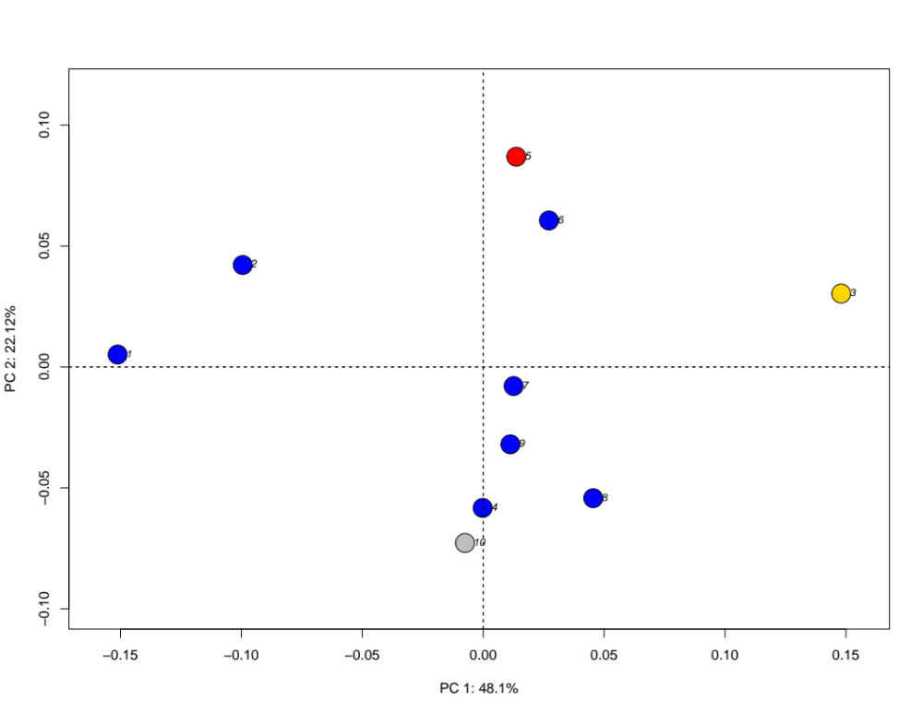
1: Deinonychus, 2: Dromaeosaurus, 3: Halszkaraptor, 4: Linheraptor, 5: Microraptor, 6: Saurornitholestes, 7: Velociraptor a, 8: Velociraptor b, 9: Tsaagan, 10: Gobivenator

Dataset (c)
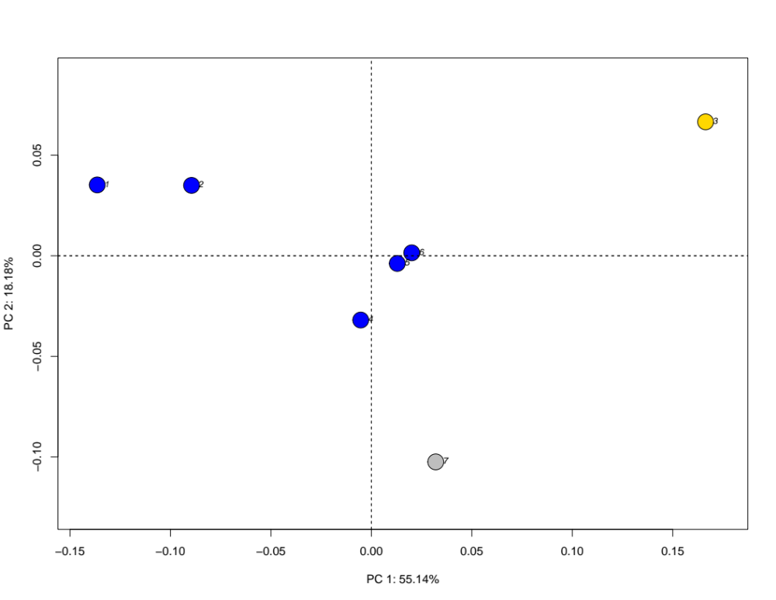
1: Deinonychus, 2: Dromaeosaurus, 3: Halszkaraptor, 4: Linheraptor, 5: Tsaagan, 6: Velociraptor, 7: Gobivenator

Dataset (d)
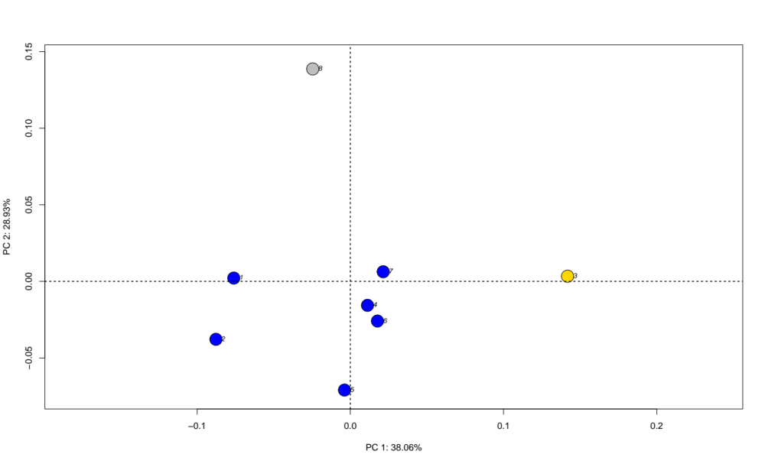
1: Deinonychus, 2: Dromaeosaurus, 3: Halszkaraptor, 4: Linheraptor, 4: Saurornitholestes, 6: Tsaagan, 7: Velociraptor, 8: Gobivenator

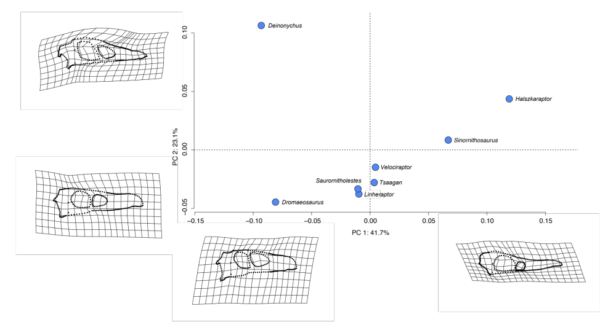
This dataset uses 255 landmarks examining 8 species. Together, PC1 and PC2 explain 64.81% of the cranial morphological variations observed among the eight specimens (PC1: 41.7%; PC2: 23.1%) (Fig. 9). Positive PC1 scores describe an anteroposteriorly elongate skull, snout, and jugal; a dorsoventrally shorter posterior end of skull; a rounded dorsal and posterior end of the skull; anteroposteriorly and dorsoventrally short antorbital fenestra; and a dorsoventrally less expanded infratemporal fenestra, and a slightly dorsoventrally compressed quadrate curving towards posterior end of the skull. Positive PC2 scores describe a dorsoventrally compressed snout, a flat ventral edge of the skull, an anteroposteriorly expanded and concave squamosal-parietal region, a dorsoventrally curved quadrate, a slightly triangular antorbital fenestrae, and a slightly rectangular orbit.
In outlier tests, PC4, PC6, and PC7 each have one outlier identified (Fig. 10). For PC4, Saurornitholestes langstoni represents the outlier with negative PC is lower outlier. Positive PC4 scores describe a curved jugal and nasal, a posteriorly-protruding squamosal, and a less posteriorly expanded orbit (Fig. S6). For PC6, T. mangas is an upper outlier (Fig. S7). Positive PC6 scores describe a dorsoventrally flat jugal and frontal, a dorsoventrally short and anteroposteriorly elongate orbit, and an enlarged antorbital fenestra. For PC7, V. mongoliensis is an upper outlier. Positive PC7 scores describe a rounded parietal, reduced lateral temporal fenestra, an anteriorly-expanded orbit, a dorsoventrally-compressed infratemporal fenestra, and a posteriorly-protruding squamosal (Fig. S8). Although no outliers have been identified for PC1 and PC2, the standard deviation for both are visibly larger than other PCs (Fig. 10).

