Unraveling the Mitogenomic Phylogeny of Eastern Asian Dorcus Stag Beetles (Coleoptera: Lucanidae): Implications for the Taxonomic Revision of the Genus
Muhammad Jafir: Department of Ecology, School of Resources and Environmental Engineering, Anhui University, Hefei 230601, Anhui, China. (m.jafir@ahu.edu.cn)
Liyang Zhou: Department of Ecology, School of Resources and Environmental Engineering, Anhui University, Hefei 230601, Anhui, China. (zhouly1102@163.com)
Yongjing Chen: Department of Ecology, School of Resources and Environmental Engineering, Anhui University, Hefei 230601, Anhui, China. (1452394259@qq.com)
Mengqiong Xu: Department of Ecology, School of Resources and Environmental Engineering, Anhui University, Hefei 230601, Anhui, China. (1549142548@qq.com)
Xia Wan: Department of Ecology, School of Resources and Environmental Engineering, Anhui University, Hefei 230601, Anhui, China. (wanxia@ahu.edu.cn)
*Corresponding author: wanxia@ahu.edu.cn (Xia Wan)

Links for the studied taxa genome data are available at NCBI database.
- Dorcus curvidens mitochondrion, complete genome - Nucleotide - NCBI (nih.gov)
- Dorcus davidis mitochondrion, complete genome - Nucleotide - NCBI (nih.gov)
- Dorcus linwenhsini mitochondrion, complete genome - Nucleotide - NCBI (nih.gov)
- Dorcus rectus mitochondrion, complete genome - Nucleotide - NCBI (nih.gov)
- Dorcus tityus mitochondrion, complete genome - Nucleotide - NCBI (nih.gov)
- Dorcus tanakai mitochondrion, complete genome - Nucleotide - NCBI (nih.gov)
- Dorcus hansi mitochondrion, complete genome - Nucleotide - NCBI (nih.gov)
- Dorcus hopei mitochondrion, complete genome - Nucleotide - NCBI (nih.gov)
- Falcicornis taibaishanensis mitochondrion, complete genome - Nucleotide - NCBI (nih.gov)
- Hemisodorcus arrowi mitochondrion, complete genome - Nucleotide - NCBI (nih.gov)
- Hemisodorcus donckieri mitochondrion, complete genome - Nucleotide - NCBI (nih.gov)
- Hemisodorcus derelictus mitochondrion, complete genome - Nucleotide - NCBI (nih.gov)
- Hemisodorcus macleayii mitochondrion, complete genome - Nucleotide - NCBI (nih.gov)
- Hemisodorcus rubrofemoratus mitochondrion, complete genome - Nucleotide - NCBI (nih.gov)
- Hemisodorcus sinensis mitochondrion, complete genome - Nucleotide - NCBI (nih.gov)
- Serrognathus castanicolor mitochondrion, complete genome - Nucleotide - NCBI (nih.gov)
- Dorcus cervulus mitochondrion, complete genome - Nucleotide - NCBI (nih.gov)
- Dorcus hirticornis mitochondrion, complete genome - Nucleotide - NCBI (nih.gov)

Table S1. Start codon usage of 13 protein-coding genes of 18 newly sequenced Dorcus s.l.
Species  Gene | ND2 | COI | COII | ATP8 | ATP6 | COIII | ND3 | ND5 | ND4 | ND4L | ND6 | Cytb | ND1
Dorcus curvidens | ATA | AAC | ATT | ATT | ATA | ATG | ATA | ATA | ATA | ATG | ATG | ATG | ATA
Dorcus davidis | ATT | AAT | ATT | ATT | ATG | ATG | ATA | ATA | ATG | ATG | ATA | ATG | ATA
Dorcus linwenhsini | ATA | AAC | ATT | ATT | ATA | ATG | ATA | ATA | ATA | ATG | ATG | ATG | ATA
Dorcus rectus | ATA | AAC | ATT | ATT | ATA | ATG | ATA | ATA | ATA | ATG | ATG | ATG | ATA
Dorcus tityus | ATA | AAT | ATT | ATT | ATA | ATG | ATA | ATA | ATA | ATG | ATG | ATG | ATA
Dorcus tanakai | ATT | AAT | ATT | ATT | ATG | ATG | ATA | ATA | ATG | ATG | ATA | ATG | ATA
Dorcus hansi | ATA | AAT | ATT | ATT | ATA | ATG | ATA | ATA | ATG | ATG | ATG | ATG | ATA
Dorcus hopei | ATA | AAC | ATT | ATT | ATA | ATG | ATA | ATA | ATA | ATG | ATG | ATG | ATA
Falcicornis taibaishanensis | ATA | AAC | ATT | ATC | ATA | ATG | ATA | ATA | ATA | ATG | ATG | ATG | ATA
Hemisodorcus arrowi | ATA | AAC | ATT | ATT | ATG | ATG | ATT | ATA | ATG | ATG | ATA | ATG | ATA
Hemisodorcus donckieri | ATA | AAT | ATT | ATT | ATA | ATG | ATA | ATA | ATA | ATG | ATG | ATG | ATA
Hemisodorcus derelictus | ATA | AAC | ATT | ATT | ATG | ATG | ATT | ATA | ATG | ATG | ATA | ATG | ATA
Hemisodorcus macleayii | ATA | AAT | ATT | ATT | ATA | ATG | ATA | ATA | ATA | ATG | ATA | ATG | ATA
Hemisodorcus rubrofemoratus | ATA | AAC | ATT | ATT | ATA | ATG | ATA | ATA | ATA | ATG | ATG | ATG | ATA
Hemisodorcus sinensis | ATA | AAT | ATT | ATA | ATA | ATG | ATA | ATG | ATA | ATG | ATG | ATG | ATA
Serrognathus castanicolor | ATT | AAC | ATT | ATT | ATG | ATG | ATT | ATA | ATG | ATG | ATA | ATG | ATA
Dorcus cervulus | ATT | AAC | ATT | ATT | ATG | ATG | ATT | ATA | ATG | ATG | ATA | ATG | ATA
Dorcus hirticornis | ATA | AAC | ATT | ATT | ATG | ATG | ATT | ATG | ATG | ATG | ATA | ATG | ATA

Table S2. Stop codon usage of 13 protein coding genes of 18 newly sequenced Dorcus s.l. species.
Species  Gene | ND2 | COI | COII | ATP8 | ATP6 | COIII | ND3 | ND5 | ND4 | ND4L | ND6 | Cytb | ND1
Dorcus curvidens | TAA | TAA | T | TAA | TAA | TA | TAG | TA | TA | TAA | TAA | TAG | TAG
Dorcus davidis | TAA | TAA | T | TAG | TAA | TA | TAG | TA | TA | TAA | TAA | TAG | TAG
Dorcus linwenhsini | TAA | TAA | T | TAG | TA | TA | TA | T | T | TAA | TAA | TAG | TAG
Dorcus rectus | TAA | T | T | TAG | TAA | TA | TAG | T | TA | TAA | TAA | TAG | TAG
Dorcus tityus | TAA | TAA | T | TAA | TAA | TA | TAG | T | TA | TA | TAA | TAG | TAG
Dorcus tanakai | TAA | TAA | T | TAG | TAA | TA | TAG | TA | TA | TAA | TAA | TAG | TAG
Dorcus hansi | TAA | TAA | T | TAA | T | TA | T | T | T | TAA | TAA | TAG | TAA
Dorcus hopei | TAA | TAA | T | TAA | TAA | TA | TAG | TA | TA | TAA | TAA | TAG | TAG
Falcicornis taibaishanensis | TAA | TAA | T | TAA | TAA | TA | TAG | T | TA | TAA | TAA | TAG | TAG
Hemisodorcus arrowi | TAA | TAA | T | TAG | TAA | TA | TAG | T | TA | TAA | TAA | TAG | TAG
Hemisodorcus donckieri | TAA | TAA | T | TAG | TAA | TA | TAG | T | TA | TAA | TAA | TAG | TAG
Hemisodorcus derelictus | TAA | TAA | T | TAG | TAA | TA | TAG | T | TA | TAA | TAA | TAG | TAG
Hemisodorcus macleayii | T | T | T | TAG | TAA | TA | TAG | T | TAG | TAA | TAA | TAG | TAG
Hemisodocus rubrofemoratus | TAA | TAA | T | TAG | TA | TA | TA | T | TA | TAA | TAA | TAG | TAG
Hemisodorcus sinensis | TAA | TAA | T | TAG | TA | TA | TA | T | TA | TAA | TAA | TAG | TAG
Serrognathus castanicolor | TAA | TAA | T | TAG | TAA | TA | TAG | T | TA | TAA | TAA | TAG | TAG
Dorcus cervulus | TAA | TAA | T | TAA | TAA | TA | TAG | T | T | TAA | TAA | TAG | TAG
Dorcus hirticornis | TAA | TAA | T | TAA | TAA | TA | TAG | TA | TA | TAA | TAA | TAG | TAG

Table S3. Mitochondrial genes primers used for the amplification of isolated DNA of Dorcus s.l. specimens.
Gene | Primer Name | Primer’s sequence (5´-3´) | References
Cytochrome c oxidase subunit I (COI) | COI-F | CAACATTTATTTTGATTTTTTGG | (1)
Cytochrome c oxidase subunit I (COI) | COI-R | TCCAATGCACTAATCTGCCATATTA | (1)
Cytochrome b | Cytb-F | GAGGAGCAACTGTAATTACTAA | (2)
Cytochrome b | Cytb-R | AAAAGAAARTATCATTCAGGTTGAAT | (2)
16SrDNA | 16S-F | CCGGTTTGAACTCAGATCATG | (3)
16SrDNA | 16S-R | TAATTTATTGTACCTTGTGTATCAG | (3)

Fig. S1. Completely sequenced mitochondrial genome of Dorcus specimens including all the genes and control region. A: Dorcus curvidens (Accession No. OL944342), B: Hemisodorcus derelictus (Accession No. OL944351), C: Hemisodorcus donkieri (Accession No. OL944352), D: Hemisodorcus arrowi (Accession No. OL944350).

Fig. S2. Completely sequenced mitochondrial genome of Dorcus specimens including all the genes and control region. A: Dorcus rectus (Accession No. OL944346), B: Dorcus linwenhsini (Accession No. OL944345), C: Dorcus hopei (Accession No. OL944344), D: Dorcus hansi (Accession No. MF621709).

Fig. S3. Completely sequenced mitochondrial genome of Dorcus specimens including all the genes and control region. A: Dorcus tanakai (Accession No. OL944347), B: Dorcus tityus (Accession No. OL944348), C: Dorcus cervulus (Accession No. OL944356), D: Dorcus rubrofemoratus (Accession No. OL944354).
Fig. S4. Partially complete sequenced mitochondrial genome of Dorcus specimens having all the genes but missing control region. A: Serrognathus castanicolor (Accession No. OL944357), B: Hemisodorcus sinensis (Accession No. OL944355), C: Hemisodorcus macleayii (Accession No. OL944353), D: Falcicornis taibaishanensis (Accession No. OL944349).
Fig. S5. Partially complete sequenced mitochondrial genome of Dorcus specimens having all the genes but missing control region. A: Dorcus davidis (Accession No. OL944343), B: Dorcus hirticornis (Accession No. OL944358).
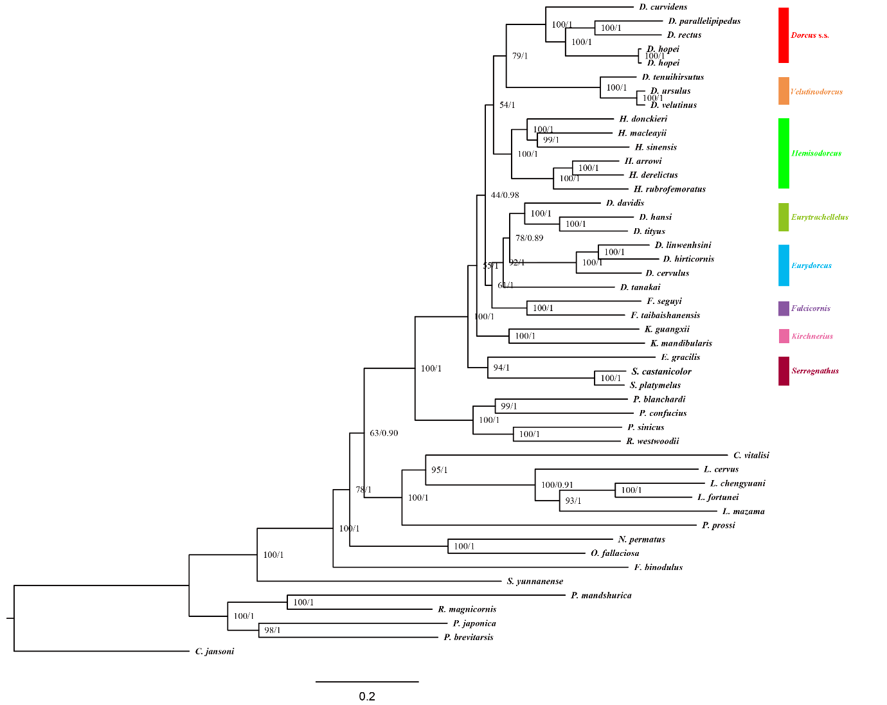
Fig.S6 Maximum likelihood (ML) method and Bayesian inferences (BI) based phylogenetic reconstruction of Eastern Asian Dorcus stag beetles using 13 protein-coding genes (PCGs).

Fig. S7 a-d: Habitus of Epidorcus gracilis. e-h: Habitus of Serrognathus castanicolor. Scale, 10mm.

Fig. S8. a: Habitus of Kirchnerius guangxii. b-d: Habitus of Kirchnerius mandibularis. Scale, 10mm.
Fig. S9 a-c: Habitus of Falcicornis seguyi. d-f: Habitus of Falcicornis taibaishanensis. Scale, 10mm.
Fig. S10 a: Habitus of Dorcus linwenhsini. b: Habitus of Serrognathus hirticornis. c-d: Habitus of Serrognathus cervulus. e-f: Habitus of Dorcus tanakai. Scale, 10mm.

Fig. S11 a-d: Habitus of Dorcus davidi. e-g: Habitus of Dorcus tityus. h: Habitus of Dorcus hansi.. Scale, 10mm.

Fig. S12 . a-c: Habitus of Hemisodorcus donckieri. d-e: Habitus of Hemisodorcus arrowi. f: Habitus of Hemisodorcus macleayii. g-h: Habitus of Hemisodorcus rubrofemoratus. i-k: Habitus of Hemisodorcus sinensis. l: Habitus of Hemisodorcus derelictus. Scale, 10mm.

Fig. S13 a-d: Habitus of Dorcus velutinus. e: Habitus of Dorcus ursulus. f: Habitus of Dorcus tenuihirsutus. Scale, 10mm.

Fig. S14 a: Habitus of Dorcus curvidens. b-c: Habitus of Dorcus parallelipedus. d-f: Habitus of Dorcus rectus. g-h: Habitus of Dorcus hopei. i-l: Habitus of Dorcus hopei. Scale, 10mm. (see figure b-c in after Bartolozzi et al (2014 , fig. 16-17)).
References
1. Simon C, Frati F, Beckenbach A, Crespi B, Liu H, Flook P. Evolution, weighting, and phylogenetic utility of mitochondrial gene sequences and a compilation of conserved polymerase chain reaction primers. Annals of the entomological Society of America. 1994;87(6):651-701.
2. Balke M, Watts CH, Cooper SJ, Humphreys WF, Vogler AP. A highly modified stygobiont diving beetle of the genus Copelatus (Coleoptera, Dytiscidae): taxonomy and cladistic analysis based on mitochondrial DNA sequences. Systematic entomology. 2004;29(1):59-67.
3. Hosoya T, Araya K. Phylogeny of Japanese stag beetles (Coleoptera: Lucanidae) inferred from 16S mtrRNA gene sequences, with reference to the evolution of sexual dimorphism of mandibles. Zoological Science. 2005;22(12):1305-18.

