Supplementary information

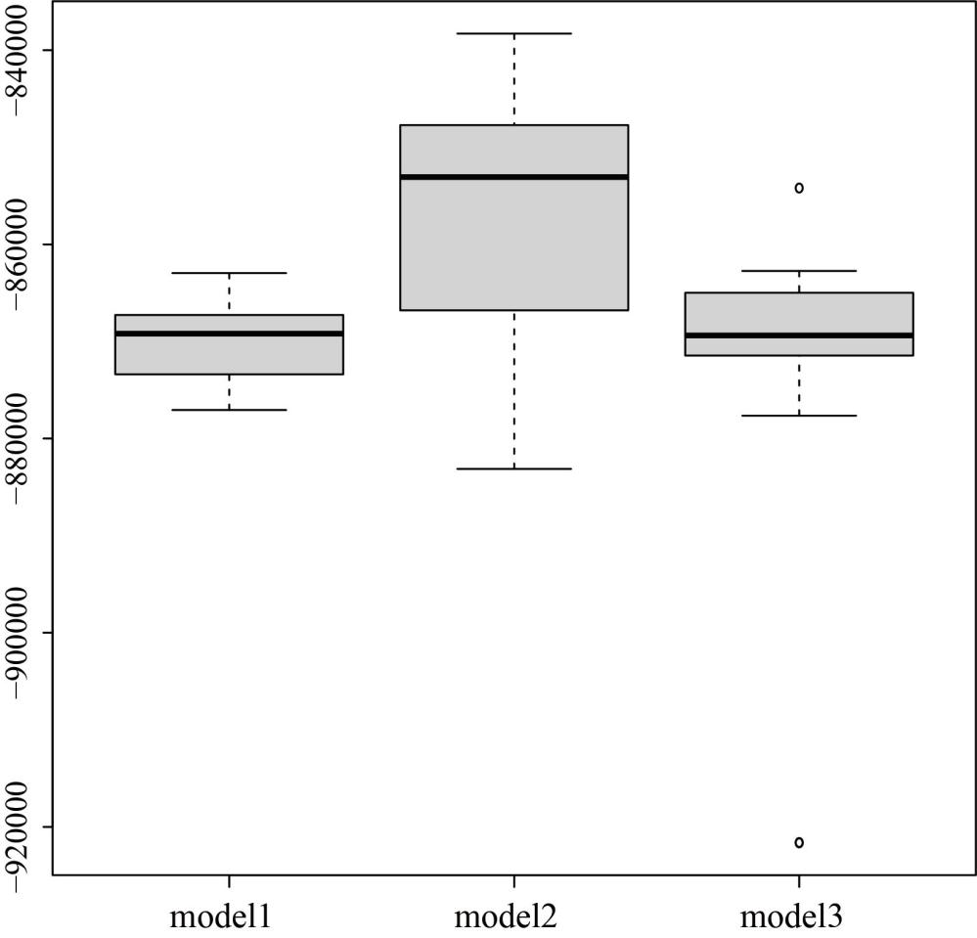
Figure S1 Comparison of demographic models of eastern species pairs. Boxplots showing the log₁₀ Likelihood distributions from 50 expected SFS each approximated using 100,000 coalescent simulations under the parameters that maximize the likelihood for each model.

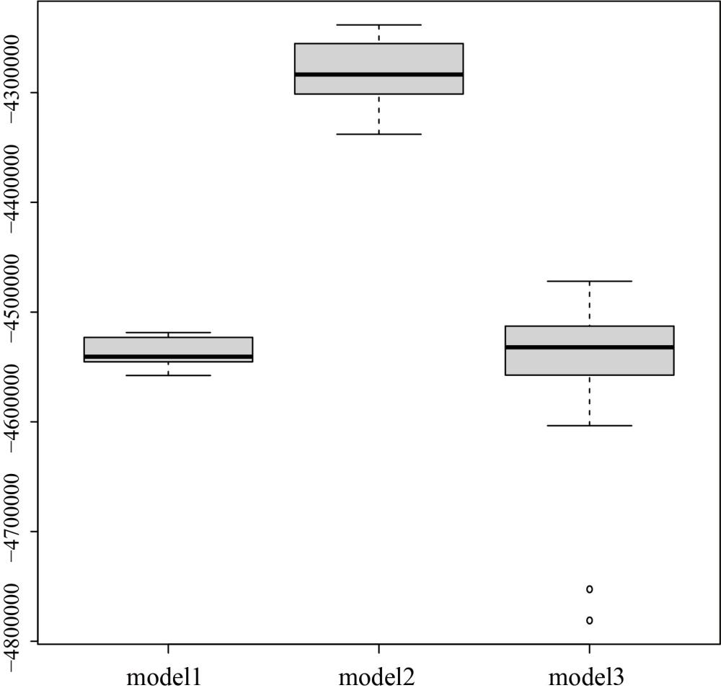
Figure S2 Comparison of demographic models of western species pairs. Boxplots showing the log₁₀ Likelihood distributions from 50 expected SFS each approximated using 100,000 coalescent simulations under the parameters that maximize the likelihood for each model.

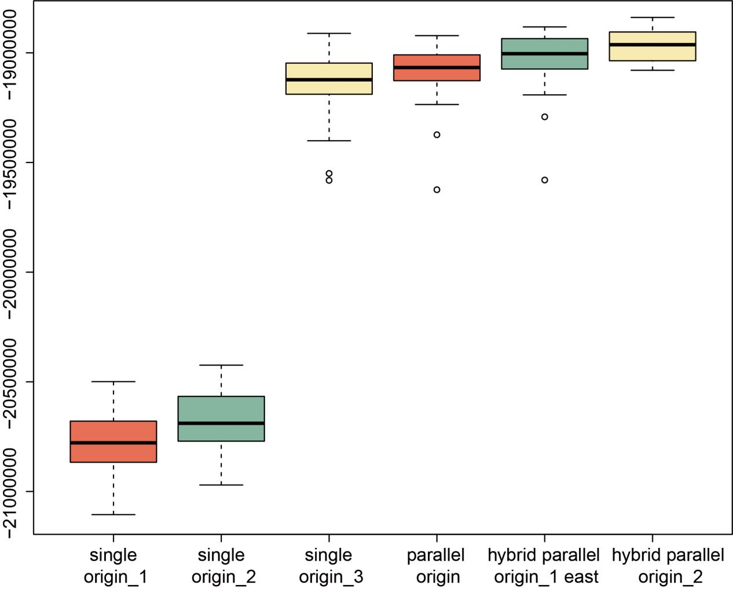
Figure S3 Comparison of demographic models of pecies pairs. Boxplots showing the log₁₀ Likelihood distributions from 50 expected SFS each approximated using 100,000 coalescent simulations under the parameters that maximize the likelihood for each model.
Figure S4 Treemix models determining the best m value. (a) The default “Evanno”-like method in R package OptM. (b) The various linear model in R package OptM.

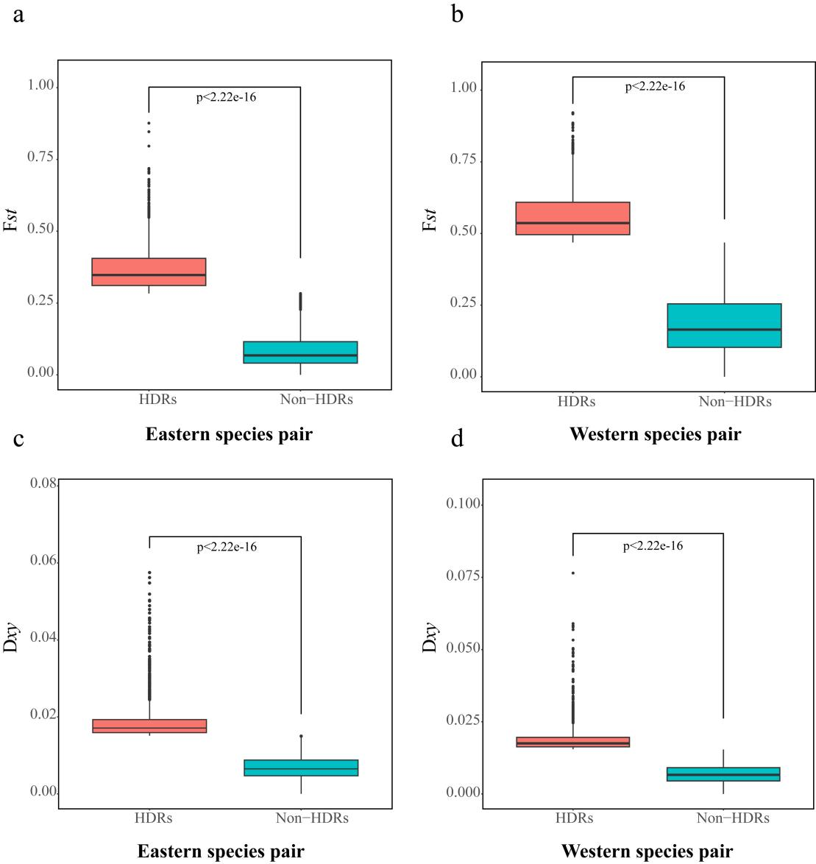
Figure S5 Comparison of HDRs and Non-HDRs between species pairs. (a) Boxplots showing the distributions of Fst for the HDRs and Non-HDRs in Eastern species pair. (b) Boxplots showing the distributions of Fst for the HDRs and Non-HDRs in Western species pair. (c) Boxplots showing the distributions of Dxy for the HDRs and Non-HDRs in Eastern species pair. (d) Boxplots showing the distributions of Dxy for the HDRs and Non-HDRs in Eastern species pair.

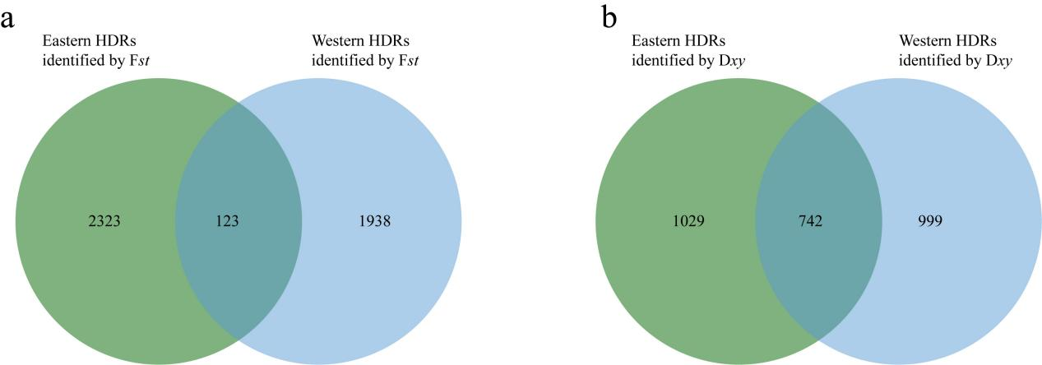
Figure S6 Venn diagram plots with overlapping windows among HDRs. (a) Overlapping HDRs identified by Fst between Eastern and Western species pairs. (b) Overlapping HDRs identified by Dxy between Eastern and Western species pairs.

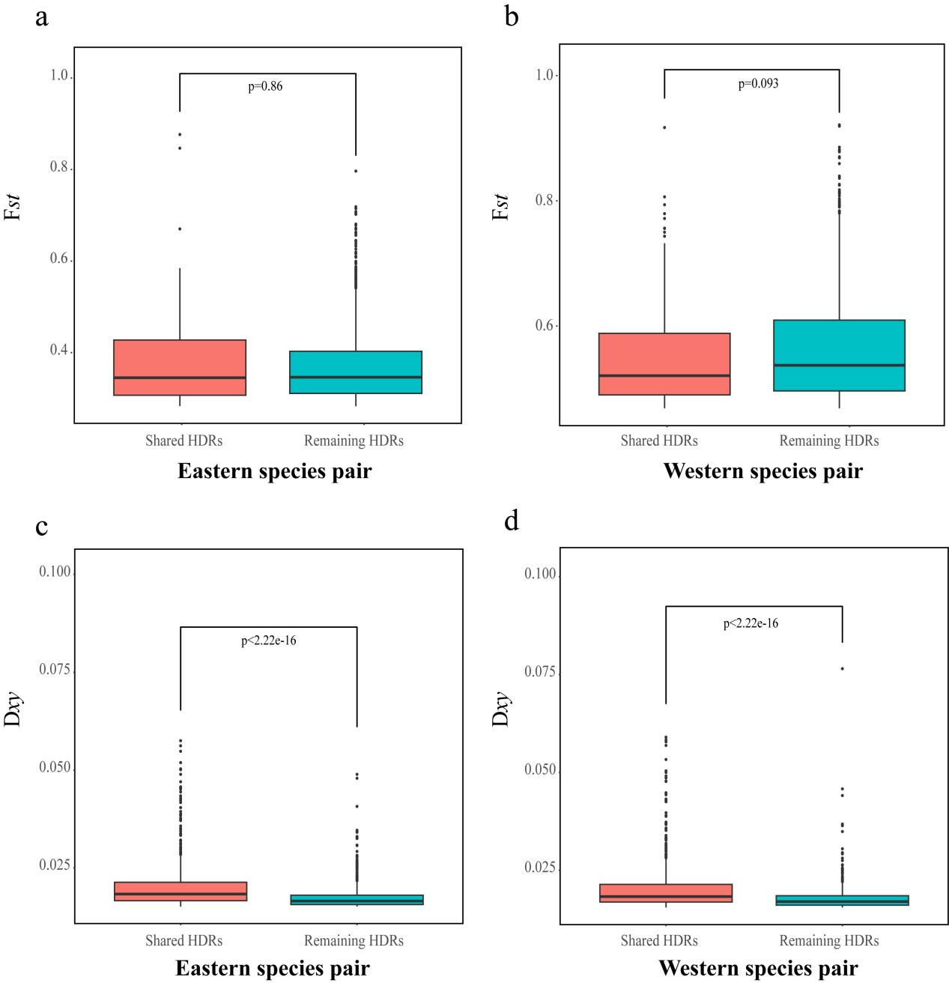
Figure S7 Comparisons of HDRs between the species. (a) Boxplots showing the distributions of Fst for the shared HDRs and remaining HDRs in Eastern species pair. (b) Boxplots showing the distributions of Fst for the shared HDRs and remaining HDRs in Western species pair. (c) Boxplots showing the distributions of Dxy for the shared HDRs and remaining HDRs in Eastern species pair. (d) Boxplots showing the distributions of Dxy for the shared HDRs and remaining HDRs in Western species pair.

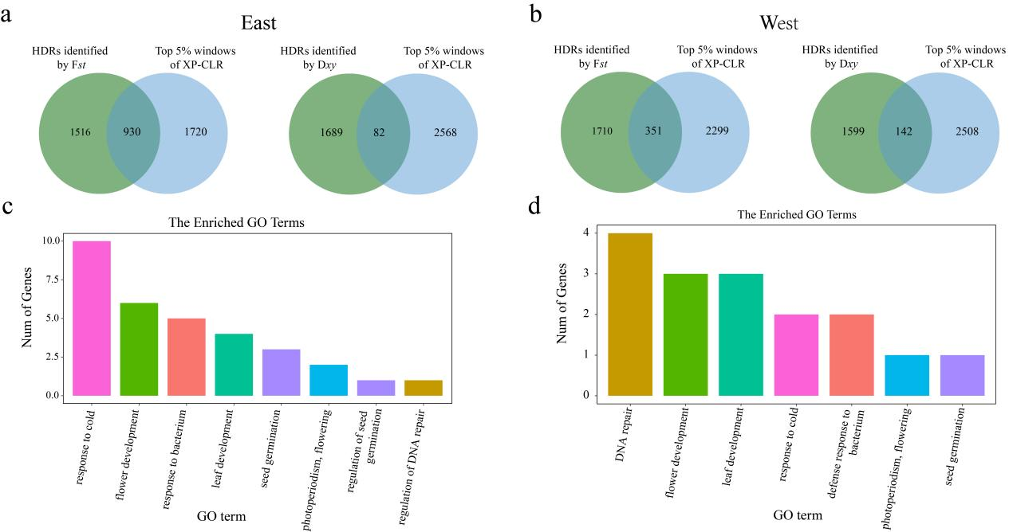
Figure S8 Identification and GO enrichment analysis of the positive selection HDRs. (a) and (b) Venn diagram plots with overlapping windows among HDRs and top 5% XP-CLR. (c) Enrichment categories of candidate positive selection region based on XP-CLR in Eastern species pair. (d) Enrichment categories of candidate positive selection region based on XP-CLR in Western species pair.

