Supplementary material
Genetic and phenotypic diversification in a widespread fish, the Sailfin molly (Poecilia latipinna)
Ralph Tiedemann, Rüdiger Riesch, Maxi Tomowski, Katja Havenstein, Jan Schlupp, Waldir M. Berbel-Filho & Ingo Schlupp

Supplementary Background Information

Sailfin mollies are members of the family Poeciliidae, are livebearing, show ovoviviparity, and have internal fertilization [1]. As is typical for the family, males possess a modified anal fin, the gonopodium. This is used to transfer sperm into the female gonoduct during a short copulation and males make no paternal contribution beyond the ejaculate. The gestation period is ca. 21−30 days and offspring are immediately independent from the mother. In addition, paternity within clutches is often mixed [2-4]. Sailfin molly males are highly ornamented and use two tactics to obtain matings. They may court a female or try to obtain sneak copulations [5, 6]. Males can switch between these tactics, although the largest males of any given population mostly court, while the smallest males almost always attempt forced copulations [7]. In livebearing fishes, such as the Sailfin molly, females are on average larger than males, reaching maturity around 30mm and growing indeterminately to more than 80mm [8]. Males effectively cease growth at maturity [9]. They can reach maturity as small as 18mm, but also reach a size of up to 80mm [10]. Small males are typically much more common than larger males [11].
Phylogenetically, the Sailfin molly forms a clade with other mollies showing a long dorsal fin. This clade is part of the genus Poecilia (formerly Mollienesia), which in turn is part of the family Poeciliidae [12-14].
Furthermore, between the Panuco basin in Tamaulipas, Mexico and the Nueces River, Texas, USA, Sailfin mollies are the sexual hosts to a unisexual, sperm-parasitic fish of hybrid origin, the Amazon molly, Poecilia formosa [15].
Supplementary Results (of preliminary life-history analyses)

The GLM on male SL revealed significant effects of both independent variables [Genetic Cluster: F_{5,181} = 6.973, P < 0.001; Population(Genetic Cluster): F_{8,181} = 5.405, P < 0.001], but based on our measure of effect size (partial eta squared, η_{p}²) variation between populations within genetic clusters was slightly more important (η_{p}² = 0.193) than variation due to genetic cluster (0.163). We uncovered a parallel pattern in the GLM of female SL [Genetic Cluster: F_{4,128} = 2.745, P = 0.031; Population(Genetic Cluster): F_{5,128} = 19.322, P < 0.001], albeit with a much stronger effect size for variation amongst populations within genetic clusters (η_{p}² = 0.430) than for variation amongst genetic clusters (η_{p}² = 0.079).
The multivariate GLM on the remaining male traits returned significant effects of the covariate SL (F_{3,178} = 3873.374, P < 0.001), but also of Genetic Cluster (F_{15,491} = 6.621, P < 0.001) and Population(Genetic Cluster) (F_{24,517} = 12.443, P < 0.001). Nonetheless, based on η_{p}², SL had by far the strongest effect (0.985), while the effect of Population(Genetic Cluster) was much weaker (0.357) but still more important than that of Genetic Cluster (0.156). Post-hoc univariate comparisons (Bonferroni-corrected significance at ⍺ = 0.017) demonstrated that SL significantly affected male lean mass (F_{1,180} = 11491.200, P < 0.001, η_{p}² = 0.985) and GSI (F_{1,180} = 45.709, P < 0.001, η_{p}² = 0.203), but not fat content (F_{1,180} = 2.201, P = 0.140, η_{p}² = 0.012). While male lean mass increased with increasing SL, GSI decreased with increasing SL so that larger males had smaller relative testis mass. Genetic Cluster and Population(Genetic Cluster), on the other hand, significantly affected all three traits (Genetic Cluster, lean mass: F_{5,180} = 5.350, P < 0.001, η_{p}² = 0.129; fat content: F_{5,180} = 8.213, P < 0.001, η_{p}² = 0.186; GSI: F_{5,180} = 5.169, P < 0.001, η_{p}² = 0.126; Population(Genetic Cluster), lean mass: F_{8,180} = 25.807, P = <0.001, η_{p}² = 0.534; fat content: F_{8,180} = 9.932, P < 0.001, η_{p}² = 0.306; GSI: F_{8,180} = 4.075, P < 0.001, η_{p}² = 0.153).
The multivariate GLM on the remaining female traits demonstrated significant effects of the covariates SL (F_{6,121} = 310.471, P < 0.001) and Embryonic Stage of Development (F_{6,121} = 8.679, P < 0.001), but also of Genetic Cluster (F_{24,423} = 7.566, P < 0.001) and Population(Genetic Cluster) (F_{30,486} = 18.258, P < 0.001). Again, SL had by far the strongest effect (η_{p}² = 0.939), while all other effects were much weaker [Embryonic Stage of Development: 0.301; Genetic Cluster: 0.268; Population(Genetic Cluster: 0.453)], even though the effect of variation between populations within a genetic cluster was again stronger than that of variation between Genetic Clusters. Post-hoc univariate comparisons (Bonferroni-corrected significance at ⍺ = 0.008) demonstrated that SL significantly affected female lean mass (F_{1,126} = 1757.468, P < 0.001, η_{p}² = 0.933), fecundity (F_{1,126} = 103.535, P < 0.001, η_{p}² = 0.451) and embryo lean mass (F_{1,126} = 7.606, P = 0.007, η_{p}² = 0.057), while the other traits were not significantly affected (P > 0.317 in all cases). SL had a positive relationship with all three variables, so that larger females had greater lean mass and fecundity and produced larger offspring. Embryonic Stage of Development had significant effects on female fat content (F_{1,126} = 9.533, P = 0.002, η_{p}² = 0.070), embryo fat content (F_{1,126} = 35.843, P < 0.001, η_{p}² = 0.221), embryo lean mass (F_{1,126} = 7.952, P = 0.006, η_{p}² = 0.059) and RA (F_{1,126} = 12.313, P < 0.001, η_{p}² = 0.089), but not on the other two traits (P > 0.386 in both cases). Genetic Cluster, on the other hand, significantly affected all traits (lean mass: F_{4,126} = 4.902, P = 0.001, η_{p}² = 0.135; fat content: F_{4,126} = 12.458, P < 0.001, η_{p}² = 0.283; fecundity: F_{4,126} = 13.398, P < 0.001, η_{p}² = 0.298; embryo fat content: F_{4,126} = 4.355, P = 0.002, η_{p}² = 0.121; embryo lean mass: F_{4,126} = 14.486, P < 0.001, η_{p}² = 0.315; RA: F_{4,126} = 4.193, P = 0.003, η_{p}² = 0.117) and the same was true for Population(Genetic Cluster) (lean mass: F_{5,126} = 32.441, P < 0.001, η_{p}² = 0.563; fat content: F_{5,126} = 33.091, P < 0.001, η_{p}² = 0.568; fecundity: F_{5,126} = 14.435, P < 0.001, η_{p}² = 0.364; embryo fat content: F_{5,126} = 5.817, P < 0.001, η_{p}² = 0.188; embryo lean mass: F_{5,126} = 29.450, P < 0.001, η_{p}² = 0.539; RA: F_{5,126} = 9.686, P < 0.001, η_{p}² = 0.278).
Supplementary Discussion (of analyses presented in the main manuscript)
It was no surprise that male and female lean mass, but also female fecundity, increased with fish SL (longer fish are heavier; larger females also ought to have more body cavity space to accommodate more developing offspring). However, GSI decreased with increasing male SL, likely due to the sailfin molly mating system. Smaller males usually invest less into male secondary characteristics (i.e., bold body and fin coloration and elaborate dorsal fins) and follow a sneaker tactic that relies on approaching females from behind and attempting to force copulations via gonopodial thrusting [7, 16, 17]. Large males, on the other hand, are usually very colorful, have elaborate dorsal fins, and rely on male courtship displays to attract female attention [16, 18], with females generally preferring large over small males [17, 19]. Smaller males investing more into relative testis size than larger males to facilitate their mating behavior of forced copulations makes intuitively sense. We found RA and embryo fat content to decrease with increasing developmental stage. Both of these patterns have been well documented in poeciliid fishes [20, 21]. Sailfin mollies are predominantly lecithotrophic species (i.e., almost all resources needed for embryo development are usually stored in the yolk prior to fertilization), although they can supplement embryos with additional nutrients under some environmental conditions [20, 22]. This means that embryos will lose roughly 40% of their mass during embryo development, which will result in a lower RA towards the end of pregnancy compared to RA closer to fertilization [20]. Similarly, embryonic fat content usually also declines with increasing embryonic stage [23] [21], probably because fat reserves in the yolk get metabolized by the embryo during development.

Supplementary Table 1: Specifications for the Hydrolab probe (Datasonde 4a) used.

Parameter | Range | Accuracy | Resolution
Temperature | -5−50 Celsius | ±.10 | 0.01
Specific Conductivity | 0−100 mS/cm | ± 1% of reading  ± 0.001 mS/cm | 4 digits
pH | 0−14 units | ± 0.2 units | 0.01 units
Dissolved Oxygen (DO) | 0−50 mg/L | ± 0.2 mg/L | 0.01 mg/L
Turbidity (Shuttered) | 0−100 or 100−1000 NTU | ± 2.6% of range 0.1 or 1 NTU
Chlorophyll a | 0.02 microgr/L | 0.01 microgr/L

Supplementary Table 2: Sampling locations
Field Number | ID | Geographic Location
IS 08063 | LPB | Lincoln Park, Brownsville (South-Texas); N 25° 53.976 W 097° 28.763
IS 08011 | NET | TX 124787; N 29° 33.101 W 094° 23.343
IS 08012 | CAM | Cameron, LA, HWY 82 (Louisiana); N 29° 45.631 W 093° 51.016
IS 08015 | LA1 | HWY 14 + HWY 331; N 29° 57.517 W 092° 01.278
IS 08021 | LA2 | HW 90, LA; N 30° 14.281 W 89° 37.228
IS 08024 | MIS | HWY 613 (Mississippi); N 30° 30.720 W 088° 33.073
IS 08030 | WF1 | HWY 98, Florida near Royal Bluff; N 29° 47.872 W 84° 44.678
IS 08031 | WF2 | Panacea Mineral Spring Pool, Panacea, FL; N 30° 02.069 W 84° 23.389
IS 08047 | CF1 | Florida Inland; N 29° 38.069 W 82° 20.330
IS 08038 | WF4 | Roadside Ditch, HWY 595 (Florida W); N 28° 29.925 W 082° 38.865
IS 08039 | WF5 | Graveyard Ditch, (Florida W); N 27° 50.945 W 082° 40.076
IS 08041 | CF2 | Roadside Ditch Haines City, FL (Florida Inland); N 28° 06.845 W 081° 36.239
IS 08042 | CF3 | Roadside Ditch Kissimmee, FL; N 28° 08.745 W 081° 27.968
IS 08043 | EF1 | Roadside Ditch Satellite Beach (Florida East); N 28° 10.341 W 80° 35.780
IS 08046 | CF4 | Boatramp near Lake Enstins, FL (Florida Inland); N 28° 51.045 W 081° 41.423
IS 08048 | EF2 | Boatramp Bulow Creek, Volusia County, FL (Florida East); N 29° 24.437 W 81° 07.322
IS 08049 | EF3 | Six Mile Landing (Florida East); N 30° 06.00 W 081° 20.695
IS 08055 | SC1 | James Island County Park near Charleston, SC; N 32° 44.047 W 79° 59.755

Supplementary Table 3: Microsatellite data per locus and population. P <0.05 indicates deviation of allele frequencies from Hardy-Weinberg-equilibrium (i.e., HO = HE).

Locus | Population |  | N | No. alleles | Allele size | H₀ | H_{E} | P | A_{R}
GT-I41 | PlatIS08062 | LPB | 10 | 3 | 155-159 | 0.400 | 0.358 | 1.000 | 2.526
 | PlatIS08011 | NET | 10 | 2 | 155-157 | 0.200 | 0.189 | 1.000 | 1.763
 | PlatIS08012 | CAM | 10 | 2 | 155-157 | 0.600 | 0.505 | 1.000 | 2.000
 | PlatIS08015 | LA1 | 10 | 2 | 155-157 | 0.700 | 0.479 | 0.220 | 1.998
 | PlatIS08021 | LA2 | 10 | 2 | 155-157 | 0.500 | 0.395 | 1.000 | 1.984
 | PlatIS08024 | MIS | 10 | 2 | 155-157 | 0.100 | 0.100 | 1.000 | 1.500
 | PlatIS08030 | WF1 | 10 | 3 | 157-167 | 0.700 | 0.511 | 0.631 | 2.495
 | PlatIS08031 | WF2 | 8 | 3 | 157-163 | 0.750 | 0.675 | 0.158 | 2.964
 | PlatIS08038 | WF4 | 10 | 3 | 157-163 | 0.300 | 0.279 | 1.000 | 2.263
 | PlatIS08039 | WF5 | 10 | 4 | 151-167 | 0.700 | 0.605 | 1.000 | 3.351
 | PlatIS08043 | EF1 | 10 | 3 | 157-161 | 0.500 | 0.584 | 0.102 | 2.878
 | PlatIS08048 | EF2 | 9 | 4 | 153-161 | 0.444 | 0.399 | 1.000 | 2.928
 | PlatIS08049 | EF3 | 10 | 1 | 157 | - | - | - | 1.000
 | PlatIS08041 | CF2 | 6 | 2 | 157-159 | 0.167 | 0.167 | 1.000 | 1.833
 | PlatIS08042 | CF3 | 5 | 2 | 157-159 | 0.200 | 0.467 | 0.333 | 2.000
 | PlatIS08046 | CF4 | 10 | 2 | 157-159 | 0.300 | 0.395 | 0.480 | 1.984
 | PlatIS08047 | CF1 | 10 | 1 | 157 | - | - | - | 1.000
 | PlatIS08055 | SC1 | 10 | 1 | 157 | - | - | - | 1.000
GA-IV42 | PlatIS08062 | LPB | 10 | 6 | 174-202 | 0.900 | 0.853 | 0.996 | 5.187
 | PlatIS08011 | NET | 10 | 2 | 174-198 | 0.300 | 0.268 | 1.000 | 1.895
 | PlatIS08012 | CAM | 10 | 2 | 174-198 | 0.400 | 0.337 | 1.000 | 1.957
 | PlatIS08015 | LA1 | 10 | 3 | 174-198 | 0.400 | 0.468 | 1.000 | 2.484
 | PlatIS08021 | LA2 | 10 | 2 | 174-198 | 0.500 | 0.479 | 1.000 | 1.998
 | PlatIS08024 | MIS | 10 | 2 | 174-198 | 0.200 | 0.337 | 0.306 | 1.957
 | PlatIS08030 | WF1 | 10 | 2 | 196-198 | 0.200 | 0.189 | 1.000 | 1.763
 | PlatIS08031 | WF2 | 8 | 7 | 176-200 | 1.000 | 0.842 | 0.840 | 5.455
 | PlatIS08038 | WF4 | 10 | 8 | 182-202 | 0.800 | 0.884 | 0.122 | 6.028
 | PlatIS08039 | WF5 | 10 | 8 | 174-202 | 0.900 | 0.863 | 0.502 | 5.872
 | PlatIS08043 | EF1 | 10 | 11 | 180-266 | 1.000 | 0.916 | 1.000 | 7.168
 | PlatIS08048 | EF2 | 9 | 12 | 186-260 | 0.889 | 0.941 | 0.562 | 7.873
 | PlatIS08049 | EF3 | 10 | 9 | 180-242 | 0.900 | 0.826 | 0.913 | 5.921
 | PlatIS08041 | CF2 | 6 | 5 | 186-242 | 0.500 | 0.727 | 0.252 | 4.500
 | PlatIS08042 | CF3 | 5 | 6 | 186-242 | 0.600 | 0.889 | 0.147 | 6.000
 | PlatIS08046 | CF4 | 10 | 8 | 182-226 | 1.000 | 0.884 | 0.958 | 6.063
 | PlatIS08047 | CF1 | 10 | 8 | 190-228 | 1.000 | 0.795 | 0.464 | 5.247
 | PlatIS08055 | SC1 | 10 | 2 | 220-242 | 0.100 | 0.100 | 1.000 | 1.500
GA-I29B | PlatIS08062 | LPB | 10 | 8 | 215-243 | 0.800 | 0.805 | 0.594 | 5.351
 | PlatIS08011 | NET | 10 | 4 | 225-231 | 0.600 | 0.574 | 1.000 | 2.995
 | PlatIS08012 | CAM | 10 | 4 | 225-231 | 0.200 | 0.284 | 0.159 | 2.500
 | PlatIS08015 | LA1 | 10 | 3 | 227-231 | 0.700 | 0.542 | 0.280 | 2.498
 | PlatIS08021 | LA2 | 10 | 2 | 227-229 | 0.700 | 0.521 | 0.520 | 2.000
 | PlatIS08024 | MIS | 10 | 3 | 225-229 | 0.500 | 0.637 | 0.635 | 2.893
 | PlatIS08030 | WF1 | 10 | 6 | 225-247 | 0.500 | 0.826 | 0.032 | 4.961
 | PlatIS08031 | WF2 | 8 | 6 | 221-255 | 0.625 | 0.767 | 0.193 | 4.742
 | PlatIS08038 | WF4 | 10 | 9 | 227-257 | 0.900 | 0.868 | 0.822 | 6.109
 | PlatIS08039 | WF5 | 10 | 11 | 219-257 | 0.900 | 0.932 | 0.285 | 7.404
 | PlatIS08043 | EF1 | 10 | 5 | 229-263 | 0.700 | 0.621 | 0.771 | 3.789
 | PlatIS08048 | EF2 | 9 | 12 | 221-263 | 0.889 | 0.941 | 0.574 | 7.873
 | PlatIS08049 | EF3 | 10 | 11 | 227-265 | 1.000 | 0.937 | 0.667 | 7.474
 | PlatIS08041 | CF2 | 6 | 3 | 227-247 | 0.833 | 0.727 | 0.668 | 3.000
 | PlatIS08042 | CF3 | 5 | 4 | 229-255 | 0.400 | 0.733 | 0.114 | 4.000
 | PlatIS08046 | CF4 | 10 | 4 | 225-243 | 0.300 | 0.489 | 0.168 | 2.957
 | PlatIS08047 | CF1 | 10 | 7 | 225-253 | 0.600 | 0.805 | 0.031 | 4.939
 | PlatIS08055 | SC1 | 10 | 9 | 231-267 | 0.900 | 0.900 | 0.915 | 6.466
GA-III29B | PlatIS08062 | LPB | 10 | 11 | 214-254 | 0.900 | 0.916 | 0.828 | 7.168
 | PlatIS08011 | NET | 10 | 6 | 236-264 | 0.800 | 0.811 | 0.718 | 4.807
 | PlatIS08012 | CAM | 10 | 9 | 230-252 | 0.800 | 0.826 | 0.689 | 5.921
 | PlatIS08015 | LA1 | 10 | 7 | 236-250 | 0.700 | 0.774 | 0.334 | 5.053
 | PlatIS08021 | LA2 | 10 | 7 | 216-248 | 1.000 | 0.879 | 0.970 | 5.791
 | PlatIS08024 | MIS | 10 | 8 | 228-244 | 0.900 | 0.868 | 0.986 | 5.942
 | PlatIS08030 | WF1 | 10 | 5 | 202-228 | 0.500 | 0.505 | 0.649 | 3.395
 | PlatIS08031 | WF2 | 8 | 9 | 212-240 | 0.875 | 0.917 | 0.700 | 6.992
 | PlatIS08038 | WF4 | 10 | 7 | 212-242 | 1.000 | 0.858 | 0.997 | 5.635
 | PlatIS08039 | WF5 | 10 | 10 | 214-236 | 0.900 | 0.889 | 0.568 | 6.679
 | PlatIS08043 | EF1 | 10 | 7 | 212-256 | 0.800 | 0.832 | 0.852 | 5.198
 | PlatIS08048 | EF2 | 9 | 8 | 214-236 | 0.778 | 0.889 | 0.588 | 6.186
 | PlatIS08049 | EF3 | 10 | 8 | 216-248 | 0.700 | 0.837 | 0.710 | 5.613
 | PlatIS08041 | CF2 | 6 | 6 | 214-240 | 1.000 | 0.879 | 0.764 | 5.636
 | PlatIS08042 | CF3 | 5 | 5 | 214-230 | 0.800 | 0.822 | 0.901 | 5.000
 | PlatIS08046 | CF4 | 10 | 8 | 218-242 | 0.600 | 0.742 | 0.031 | 5.158
 | PlatIS08047 | CF1 | 10 | 6 | 214-236 | 0.700 | 0.721 | 0.305 | 4.483
 | PlatIS08055 | SC1 | 10 | 7 | 214-238 | 1.000 | 0.863 | 0.893 | 5.555
GA-V18 | PlatIS08062 | LPB | 10 | 4 | 115-145 | 0.600 | 0.679 | 0.723 | 3.440
 | PlatIS08011 | NET | 10 | 4 | 123-129 | 0.200 | 0.363 | 0.106 | 2.763
 | PlatIS08012 | CAM | 10 | 5 | 117-129 | 0.400 | 0.442 | 0.220 | 3.263
 | PlatIS08015 | LA1 | 10 | 4 | 121-133 | 0.600 | 0.500 | 1.000 | 3.158
 | PlatIS08021 | LA2 | 10 | 5 | 121-129 | 0.900 | 0.774 | 0.947 | 4.404
 | PlatIS08024 | MIS | 10 | 5 | 119-129 | 0.900 | 0.800 | 1.000 | 4.535
 | PlatIS08030 | WF1 | 10 | 4 | 115-129 | 0.600 | 0.668 | 0.576 | 3.389
 | PlatIS08031 | WF2 | 8 | 4 | 115-131 | 0.500 | 0.442 | 1.000 | 3.125
 | PlatIS08038 | WF4 | 10 | 6 | 115-137 | 0.700 | 0.705 | 1.000 | 3.999
 | PlatIS08039 | WF5 | 10 | 7 | 115-133 | 0.700 | 0.811 | 0.332 | 4.946
 | PlatIS08043 | EF1 | 10 | 5 | 109-129 | 0.800 | 0.800 | 0.810 | 4.535
 | PlatIS08048 | EF2 | 9 | 7 | 109-143 | 0.889 | 0.843 | 0.296 | 5.402
 | PlatIS08049 | EF3 | 10 | 7 | 115-137 | 0.600 | 0.689 | 0.135 | 4.658
 | PlatIS08041 | CF2 | 6 | 1 | 115 | - | - | - | 1.000
 | PlatIS08042 | CF3 | 5 | 4 | 109-139 | 0.400 | 0.644 | 0.237 | 4.000
 | PlatIS08046 | CF4 | 10 | 3 | 109-121 | 0.700 | 0.568 | 0.541 | 2.758
 | PlatIS08047 | CF1 | 10 | 4 | 121-167 | 0.300 | 0.284 | 1.000 | 2.500
 | PlatIS08055 | SC1 | 10 | 4 | 115-123 | 0.600 | 0.647 | 0.252 | 3.413
GA-III49A | PlatIS08062 | LPB | 10 | 5 | 404-418 | 0.600 | 0.568 | 0.275 | 3.658
 | PlatIS08011 | NET | 10 | 7 | 404-426 | 0.900 | 0.858 | 0.575 | 5.635
 | PlatIS08012 | CAM | 10 | 8 | 400-422 | 0.800 | 0.889 | 0.676 | 6.194
 | PlatIS08015 | LA1 | 10 | 10 | 394-422 | 0.900 | 0.868 | 0.964 | 6.551
 | PlatIS08021 | LA2 | 10 | 7 | 402-420 | 0.900 | 0.811 | 0.868 | 5.315
 | PlatIS08024 | MIS | 10 | 4 | 402-418 | 0.300 | 0.284 | 1.000 | 2.500
 | PlatIS08030 | WF1 | 10 | 5 | 402-426 | 0.400 | 0.368 | 1.000 | 3.000
 | PlatIS08031 | WF2 | 8 | 7 | 398-422 | 0.875 | 0.900 | 0.421 | 6.143
 | PlatIS08038 | WF4 | 10 | 10 | 402-434 | 1.000 | 0.884 | 0.679 | 6.494
 | PlatIS08039 | WF5 | 10 | 7 | 402-422 | 0.900 | 0.842 | 1.000 | 5.399
 | PlatIS08043 | EF1 | 10 | 7 | 404-416 | 0.900 | 0.874 | 0.479 | 5.756
 | PlatIS08048 | EF2 | 9 | 8 | 400-436 | 1.000 | 0.850 | 0.992 | 5.832
 | PlatIS08049 | EF3 | 10 | 11 | 402-430 | 1.000 | 0.916 | 0.842 | 7.071
 | PlatIS08041 | CF2 | 6 | 7 | 402-436 | 1.000 | 0.909 | 0.598 | 6.455
 | PlatIS08042 | CF3 | 5 | 7 | 404-436 | 1.000 | 0.933 | 1.000 | 7.000
 | PlatIS08046 | CF4 | 10 | 5 | 410-424 | 0.600 | 0.511 | 1.000 | 3.526
 | PlatIS08047 | CF1 | 10 | 5 | 404-420 | 0.400 | 0.679 | 0.099 | 3.758
 | PlatIS08055 | SC1 | 10 | 5 | 410-426 | 0.800 | 0.737 | 0.704 | 4.142
GA-II41 | PlatIS08062 | LPB | 10 | 4 | 118-126 | 0.500 | 0.553 | 0.100 | 3.220
 | PlatIS08011 | NET | 10 | 1 | 118 | - | - | - | 1.000
 | PlatIS08012 | CAM | 10 | 1 | 118 | - | - | - | 1.000
 | PlatIS08015 | LA1 | 10 | 1 | 118 | - | - | - | 1.000
 | PlatIS08021 | LA2 | 10 | 2 | 118-120 | 0.100 | 0.100 | 1.000 | 1.500
 | PlatIS08024 | MIS | 10 | 1 | 118 | - | - | - | 1.000
 | PlatIS08030 | WF1 | 10 | 2 | 118-122 | 0.500 | 0.521 | 1.000 | 2.000
 | PlatIS08031 | WF2 | 8 | 2 | 118-122 | 0.250 | 0.400 | 0.385 | 1.992
 | PlatIS08038 | WF4 | 10 | 4 | 118-124 | 0.400 | 0.437 | 0.301 | 3.026
 | PlatIS08039 | WF5 | 10 | 5 | 118-126 | 0.700 | 0.621 | 0.767 | 3.789
 | PlatIS08043 | EF1 | 10 | 1 | 122 | - | - | - | 1.000
 | PlatIS08048 | EF2 | 9 | 2 | 122-124 | 0.111 | 0.111 | 1.000 | 1.556
 | PlatIS08049 | EF3 | 10 | 2 | 122-130 | 0.100 | 0.100 | 1.000 | 1.500
 | PlatIS08041 | CF2 | 6 | 1 | 122 | - | - | - | 1.000
 | PlatIS08042 | CF3 | 5 | 2 | 122-130 | 0.200 | 0.200 | 1.000 | 2.000
 | PlatIS08046 | CF4 | 10 | 2 | 122-124 | 0.200 | 0.189 | 1.000 | 1.763
 | PlatIS08047 | CF1 | 10 | 2 | 120-122 | 0.200 | 0.189 | 1.000 | 1.763
 | PlatIS08055 | SC1 | 10 | 1 | 122 | - | - | - | 1.000
GA-I47A | PlatIS08062 | LPB | 10 | 7 | 129-183 | 0.800 | 0.816 | 0.904 | 5.140
 | PlatIS08011 | NET | 10 | 7 | 131-187 | 0.800 | 0.768 | 0.985 | 4.983
 | PlatIS08012 | CAM | 8 | 5 | 135-173 | 0.625 | 0.608 | 0.631 | 4.000
 | PlatIS08015 | LA1 | 10 | 8 | 133-179 | 0.700 | 0.779 | 0.425 | 5.289
 | PlatIS08021 | LA2 | 9 | 11 | 135-189 | 0.778 | 0.856 | 0.362 | 6.817
 | PlatIS08024 | MIS | 10 | 5 | 131-171 | 0.500 | 0.600 | 0.212 | 3.484
 | PlatIS08030 | WF1 | 10 | 4 | 123-137 | 0.500 | 0.611 | 0.422 | 3.483
 | PlatIS08031 | WF2 | 8 | 6 | 123-139 | 0.875 | 0.783 | 1.000 | 4.749
 | PlatIS08038 | WF4 | 10 | 7 | 123-153 | 0.800 | 0.768 | 0.846 | 4.983
 | PlatIS08039 | WF5 | 10 | 6 | 131-187 | 0.600 | 0.579 | 0.700 | 4.026
 | PlatIS08043 | EF1 | 10 | 8 | 131-171 | 0.800 | 0.789 | 0.861 | 5.553
 | PlatIS08048 | EF2 | 9 | 7 | 129-165 | 0.889 | 0.745 | 0.934 | 5.118
 | PlatIS08049 | EF3 | 10 | 7 | 131-167 | 0.600 | 0.763 | 0.294 | 4.851
 | PlatIS08041 | CF2 | 6 | 3 | 133-143 | 0.167 | 0.682 | 0.022 | 3.000
 | PlatIS08042 | CF3 | 5 | 5 | 131-159 | 0.800 | 0.822 | 0.337 | 5.000
 | PlatIS08046 | CF4 | 10 | 6 | 131-181 | 0.600 | 0.632 | 0.413 | 4.158
 | PlatIS08047 | CF1 | 10 | 4 | 129-137 | 0.300 | 0.437 | 0.135 | 3.026
 | PlatIS08055 | SC1 | 10 | 6 | 129-169 | 0.900 | 0.795 | 1.000 | 4.877
GT-II33 | PlatIS08062 | LPB | 10 | 2 | 177-179 | 0.200 | 0.442 | 0.132 | 1.995
 | PlatIS08011 | NET | 10 | 2 | 177-179 | 0.100 | 0.100 | 1.000 | 1.500
 | PlatIS08012 | CAM | 10 | 2 | 177-179 | 0.300 | 0.395 | 0.479 | 1.984
 | PlatIS08015 | LA1 | 10 | 2 | 177-179 | 0.300 | 0.268 | 1.000 | 1.895
 | PlatIS08021 | LA2 | 10 | 3 | 165-179 | 0.200 | 0.195 | 1.000 | 2.000
 | PlatIS08024 | MIS | 10 | 4 | 177-195 | 0.600 | 0.658 | 1.000 | 3.263
 | PlatIS08030 | WF1 | 10 | 5 | 177-191 | 0.600 | 0.700 | 0.290 | 3.913
 | PlatIS08031 | WF2 | 8 | 7 | 175-189 | 0.750 | 0.850 | 0.291 | 5.615
 | PlatIS08038 | WF4 | 10 | 6 | 175-189 | 1.000 | 0.842 | 0.763 | 5.197
 | PlatIS08039 | WF5 | 10 | 4 | 175-189 | 0.400 | 0.605 | 0.230 | 3.351
 | PlatIS08043 | EF1 | 10 | 4 | 175-181 | 0.400 | 0.489 | 0.657 | 2.957
 | PlatIS08048 | EF2 | 9 | 3 | 175-179 | 0.556 | 0.647 | 0.763 | 2.930
 | PlatIS08049 | EF3 | 10 | 3 | 175-179 | 0.400 | 0.563 | 0.305 | 2.500
 | PlatIS08041 | CF2 | 6 | 3 | 175-179 | 0.500 | 0.667 | 0.724 | 2.985
 | PlatIS08042 | CF3 | 5 | 2 | 177-179 | 0.200 | 0.467 | 0.332 | 2.000
 | PlatIS08046 | CF4 | 10 | 2 | 177-179 | 0.600 | 0.505 | 1.000 | 2.000
 | PlatIS08047 | CF1 | 10 | 3 | 177-181 | 0.400 | 0.637 | 0.135 | 2.893
 | PlatIS08055 | SC1 | 10 | 3 | 175-179 | 0.800 | 0.616 | 0.738 | 2.763
GT-I13B | PlatIS08062 | LPB | 10 | 2 | 248-250 | 0.300 | 0.268 | 1.000 | 1.895
 | PlatIS08011 | NET | 10 | 2 | 248-250 | 0.800 | 0.505 | 0.173 | 2.000
 | PlatIS08012 | CAM | 10 | 2 | 248-250 | 0.400 | 0.526 | 0.564 | 2.000
 | PlatIS08015 | LA1 | 10 | 2 | 248-250 | 0.300 | 0.479 | 0.480 | 1.998
 | PlatIS08021 | LA2 | 10 | 3 | 248-252 | 0.700 | 0.563 | 0.733 | 2.500
 | PlatIS08024 | MIS | 10 | 1 | 248 | - | - | - | 1.000
 | PlatIS08030 | WF1 | 10 | 1 | 248 | - | - | - | 1.000
 | PlatIS08031 | WF2 | 8 | 1 | 248 | - | - | - | 1.000
 | PlatIS08038 | WF4 | 10 | 1 | 248 | - | - | - | 1.000
 | PlatIS08039 | WF5 | 10 | 1 | 248 | - | - | - | 1.000
 | PlatIS08043 | EF1 | 10 | 1 | 248 | - | - | - | 1.000
 | PlatIS08048 | EF2 | 9 | 1 | 248 | - | - | - | 1.000
 | PlatIS08049 | EF3 | 10 | 1 | 248 | - | - | - | 1.000
 | PlatIS08041 | CF2 | 6 | 1 | 248 | - | - | - | 1.000
 | PlatIS08042 | CF3 | 5 | 2 | 248-252 | 0.200 | 0.200 | 1.000 | 2.000
 | PlatIS08046 | CF4 | 10 | 3 | 246-250 | 0.800 | 0.679 | 0.751 | 2.978
 | PlatIS08047 | CF1 | 10 | 3 | 246-250 | 0.300 | 0.595 | 0.056 | 2.762
 | PlatIS08055 | SC1 | 10 | 2 | 248-250 | 0.200 | 0.189 | 1.000 | 1.763
GA-I5B | PlatIS08062 | LPB | 10 | 1 | 146 | - | - | - | 1.000
 | PlatIS08011 | NET | 10 | 1 | 146 | - | - | - | 1.000
 | PlatIS08012 | CAM | 10 | 1 | 146 | - | - | - | 1.000
 | PlatIS08015 | LA1 | 10 | 1 | 146 | - | - | - | 1.000
 | PlatIS08021 | LA2 | 10 | 1 | 146 | - | - | - | 1.000
 | PlatIS08024 | MIS | 10 | 1 | 146 | - | - | - | 1.000
 | PlatIS08030 | WF1 | 10 | 2 | 146-148 | 0.400 | 0.337 | 1.000 | 1.957
 | PlatIS08031 | WF2 | 8 | 4 | 142-148 | 0.750 | 0.642 | 0.689 | 3.492
 | PlatIS08038 | WF4 | 10 | 3 | 142-146 | 0.600 | 0.468 | 1.000 | 2.484
 | PlatIS08039 | WF5 | 10 | 3 | 142-146 | 0.400 | 0.353 | 1.000 | 2.395
 | PlatIS08043 | EF1 | 10 | 2 | 144-146 | 0.300 | 0.268 | 1.000 | 1.895
 | PlatIS08048 | EF2 | 9 | 2 | 142-146 | 0.111 | 0.111 | 1.000 | 1.556
 | PlatIS08049 | EF3 | 10 | 1 | 146 | - | - | - | 1.000
 | PlatIS08041 | CF2 | 6 | 1 | 146 | - | - | - | 1.000
 | PlatIS08042 | CF3 | 5 | 1 | 146 | - | - | - | 1.000
 | PlatIS08046 | CF4 | 10 | 2 | 142-146 | 0.500 | 0.521 | 1.000 | 2.000
 | PlatIS08047 | CF1 | 10 | 1 | 146 | - | - | - | 1.000
 | PlatIS08055 | SC1 | 10 | 2 | 146-148 | 0.200 | 0.442 | 0.133 | 1.995
GT-I34 | PlatIS08062 | LPB | 10 | 7 | 210-254 | 0.900 | 0.847 | 0.956 | 5.434
 | PlatIS08011 | NET | 10 | 13 | 220-254 | 1.000 | 0.953 | 0.543 | 8.079
 | PlatIS08012 | CAM | 10 | 15 | 214-282 | 1.000 | 0.974 | 1.000 | 8.816
 | PlatIS08015 | LA1 | 10 | 12 | 224-258 | 1.000 | 0.937 | 0.656 | 7.641
 | PlatIS08021 | LA2 | 10 | 14 | 208-272 | 1.000 | 0.963 | 1.000 | 8.447
 | PlatIS08024 | MIS | 10 | 12 | 228-278 | 1.000 | 0.932 | 0.714 | 7.509
 | PlatIS08030 | WF1 | 10 | 10 | 232-278 | 0.900 | 0.895 | 0.943 | 6.598
 | PlatIS08031 | WF2 | 8 | 12 | 230-282 | 1.000 | 0.967 | 1.000 | 8.500
 | PlatIS08038 | WF4 | 10 | 11 | 218-274 | 0.900 | 0.916 | 0.827 | 7.168
 | PlatIS08039 | WF5 | 10 | 13 | 238-280 | 0.900 | 0.953 | 0.495 | 8.079
 | PlatIS08043 | EF1 | 10 | 11 | 230-288 | 0.900 | 0.916 | 0.833 | 7.071
 | PlatIS08048 | EF2 | 9 | 16 | 218-286 | 1.000 | 0.987 | 1.000 | 9.412
 | PlatIS08049 | EF3 | 10 | 15 | 206-274 | 1.000 | 0.958 | 1.000 | 8.483
 | PlatIS08041 | CF2 | 6 | 8 | 216-272 | 0.833 | 0.924 | 0.494 | 7.136
 | PlatIS08042 | CF3 | 5 | 9 | 226-272 | 1.000 | 0.978 | 1.000 | 9.000
 | PlatIS08046 | CF4 | 10 | 15 | 252-288 | 0.800 | 0.968 | 0.066 | 8.684
 | PlatIS08047 | CF1 | 10 | 9 | 240-286 | 0.700 | 0.889 | 0.277 | 6.361
 | PlatIS08055 | SC1 | 10 | 9 | 226-264 | 0.700 | 0.889 | 0.287 | 6.361
GT-I49 | PlatIS08062 | LPB | 10 | 4 | 138-156 | 0.500 | 0.553 | 0.604 | 3.220
 | PlatIS08011 | NET | 10 | 3 | 138-146 | 0.500 | 0.489 | 0.652 | 2.789
 | PlatIS08012 | CAM | 10 | 3 | 138-146 | 0.600 | 0.484 | 1.000 | 2.720
 | PlatIS08015 | LA1 | 10 | 2 | 138-144 | 0.500 | 0.479 | 1.000 | 1.998
 | PlatIS08021 | LA2 | 10 | 2 | 138-144 | 0.500 | 0.521 | 1.000 | 2.000
 | PlatIS08024 | MIS | 10 | 2 | 144-150 | 0.200 | 0.189 | 1.000 | 1.763
 | PlatIS08030 | WF1 | 10 | 3 | 142-150 | 0.600 | 0.668 | 0.709 | 2.955
 | PlatIS08031 | WF2 | 8 | 5 | 138-150 | 0.750 | 0.725 | 0.429 | 4.339
 | PlatIS08038 | WF4 | 10 | 4 | 138-146 | 0.800 | 0.689 | 1.000 | 3.394
 | PlatIS08039 | WF5 | 10 | 5 | 138-154 | 0.800 | 0.695 | 1.000 | 3.762
 | PlatIS08043 | EF1 | 10 | 7 | 138-150 | 0.800 | 0.847 | 0.362 | 5.319
 | PlatIS08048 | EF2 | 9 | 3 | 138-144 | 0.333 | 0.464 | 0.247 | 2.748
 | PlatIS08049 | EF3 | 10 | 5 | 138-158 | 0.500 | 0.568 | 0.270 | 3.658
 | PlatIS08041 | CF2 | 6 | 2 | 144-152 | 0.333 | 0.545 | 0.479 | 2.000
 | PlatIS08042 | CF3 | 5 | 5 | 138-150 | 0.800 | 0.844 | 0.847 | 5.000
 | PlatIS08046 | CF4 | 10 | 1 | 138 | - | - | - | 1.000
 | PlatIS08047 | CF1 | 10 | 3 | 138-148 | 0.300 | 0.416 | 0.477 | 2.457
 | PlatIS08055 | SC1 | 10 | 1 | 144 | - | - | - | 1.000

Supplementary Table 4: Summary statistics of sample size and microsatellite diversity for the analyzed populations (mean values across 13 microsatellite loci; see supplement for locus-specific information).
Population | N | No. of alleles | Allelic richness | H₀ | H_{E}
LPB | 10 | 4.923 | 3.787 | 0.569 | 0.589
NET | 10 | 4.154 | 3.170 | 0.477 | 0.452
CAM | 10 | 4.538 | 3.335 | 0.471 | 0.482
LA1 | 10 | 4.385 | 3.274 | 0.523 | 0.506
LA2 | 10 | 4.692 | 3.520 | 0.598 | 0.543
MIS | 10 | 3.846 | 2.950 | 0.400 | 0.416
WF1 | 10 | 4.000 | 3.147 | 0.492 | 0.523
WF2 | 8 | 5.615 | 4.547 | 0.692 | 0.685
WF4 | 10 | 6.077 | 4.445 | 0.708 | 0.662
WF5 | 10 | 6.462 | 4.619 | 0.677 | 0.673
EF1 | 10 | 5.538 | 4.163 | 0.608 | 0.611
EF2 | 9 | 6.538 | 4.647 | 0.607 | 0.610
EF3 | 10 | 6.231 | 4.210 | 0.523 | 0.551
CF2 | 6 | 3.308 | 3.119 | 0.410 | 0.479
CF3 | 5 | 4.154 | 4.154 | 0.508 | 0.615
CF4 | 10 | 4.692 | 3.464 | 0.538 | 0.545
CF1 | 10 | 4.308 | 3.245 | 0.400 | 0.496
SC1 | 10 | 4.000 | 3.218 | 0.477 | 0.475

Supplementary Table 5: Summary statistics of sample size and life-history traits for male sailfin
mollies (Poecilia latipinna) from 14 populations across their geographical distribution. GSI: gonadosomatic index.
Genetic Cluster | Population | N | SL [mm] | Lean Mass* [mg] | Fat Content [%] | GSI* [%]
1 | NET | 18 | 33.50 ± 4.95 | 181.87 ± 33.35 | 4.77 ± 3.85 | 1.07 ± 0.30
 | CAM | 15 | 31.33 ± 6.62 | 199.36 ± 33.42 | 5.82 ± 4.76 | 1.20 ± 0.31
 | LA1 | 9 | 27.56 ± 4.00 | 209.71 ± 34.05 | 2.22 ± 3.98 | 1.42 ± 0.30
 | LA2 | 11 | 29.73 ± 4.17 | 180.49 ± 34.53 | 3.27 ± 2.31 | 0.95 ± 0.30
 | MIS | 10 | 37.10 ± 9.05 | 203.12 ± 33.87 | 2.16 ± 2.51 | 1.40 ± 0.28
 | LPB | 10 | 29.90 ± 2.42 | 180.91 ± 33.58 | 7.77 ± 4.44 | 1.20 ± 0.28
 | Mean |  | 31.75 ± 6.13 | 190.96 ± 35.81 | 4.00 ± 4.02 | 1.19 ± 0.31
2 | WF1 | 14 | 33.07 ± 4.05 | 167.39 ± 35.61 | 9.77 ± 5.47 | 1.07 ± 0.31
3 | WF5 | 10 | 28.00 ± 5.54 | 200.44 ± 36.18 | 6.41 ± 5.99 | 1.32 ± 0.32
4 | CF1 | 16 | 39.75 ± 6.61 | 144.98 ± 35.52 | 8.35 ± 5.22 | 1.26 ± 0.32
 | CF3 | 12 | 34.17 ± 7.27 | 167.17 ± 33.39 | 0.70 ± 1.54 | 0.93 ± 0.28
 | EF2 | 20 | 37.85 ± 3.41 | 188.39 ± 34.79 | 4.18 ± 3.92 | 0.98 ± 0.31
 | EF3 | 15 | 30.60 ± 5.44 | 203.35 ± 33.54 | 6.65 ± 3.17 | 1.14 ± 0.31
 | Mean |  | 35.90 ± 6.53 | 178.38 ± 37.11 | 5.25 ± 4.84 | 1.08 ± 0.33
5 | CF4 | 20 | 31.60 ± 6.65 | 194.71 ± 35.67 | 2.63 ± 1.58 | 1.07 ± 0.31
6 | SC1 | 15 | 29.47 ± 5.04 | 199.56 ± 36.02 | 7.77 ± 4.44 | 1.50 ± 0.32
* estimated marginal means from general linear models with SL as a covariate (at SL = 32.81 mm).

Supplementary Table 6: Summary statistics of sample size and life-history traits for female sailfin mollies (Poecilia latipinna) from 11 populations across their geographical distribution. RA: reproductive allocation.
Genetic Cluster | Population | N | SL [mm] | Lean Mass* [mg] | Fat Content+ [%] | Fecundity* | Embryo Lean Mass+ [mg] | Embryo Fat Content+ [%] | RA+ [%]
1 | CAM | 17 | 35.12 ± 3.14 | 343.76 ± 34.63 | 10.09 ± 3.25 | 23.62 ± 8.19 | 3.11 ± 0.61 | 14.41 ± 3.53 | 18.49 ± 5.01
 | LA1 | 16 | 39.13 ± 3.03 | 316.40 ± 30.72 | 1.34 ± 2.88 | 32.01 ± 7.27 | 2.72 ± 0.54 | 12.57 ± 3.12 | 23.27 ± 4.43
 | MIS | 16 | 40.94 ± 2.08 | 316.24 ± 30.48 | 1.79 ± 2.83 | 16.98 ± 7.21 | 3.70 ± 0.53 | 15.66 ± 3.07 | 18.72 ± 4.36
 | LPB | 7 | 47.43 ± 5.88 | 341.27 ± 33.39 | 7.14 ± 3.14 | 28.16 ± 7.90 | 3.51 ± 0.59 | 17.25 ± 3.40 | 23.14 ± 4.83
 | Mean |  | 39.46 ± 4.99 | 329.42 ± 32.57 | 5.09 ± 3.05 | 25.19 ± 7.71 | 3.26 ± 0.57 | 14.97 ± 3.31 | 20.90 ± 4.70
2 | WF1 | 16 | 41.31 ± 1.66 | 291.89 ± 30.55 | 9.33 ± 2.96 | 19.27 ± 7.23 | 3.89 ± 0.56 | 16.56 ± 3.21 | 22.04 ± 4.55
3 | WF5 | 14 | 38.50 ± 3.06 | 295.91 ± 30.95 | 6.39 ± 2.87 | 20.60 ± 7.32 | 3.60 ± 0.54 | 17.84 ± 3.11 | 21.84 ± 4.42
4 | CF1 | 15 | 45.80 ± 3.14 | 246.24 ± 34.10 | 10.40 ± 3.16 | 26.00 ± 8.07 | 3.77 ± 0.60 | 18.05 ± 3.43 | 28.03 ± 4.88
 | CF3 | 11 | 37.82 ± 3.31 | 299.19 ± 31.16 | 3.02 ± 2.91 | 14.28 ± 7.37 | 4.94 ± 0.55 | 12.73 ± 3.15 | 19.23 ± 4.47
 | EF3 | 12 | 39.25 ± 4.83 | 379.12 ± 30.62 | 7.60 ± 2.85 | 27.94 ± 7.24 | 2.60 ± 0.54 | 17.04 ± 3.10 | 16.70 ± 4.39
 | Mean |  | 41.42 ± 5.18 | 308.18 ± 30.79 | 7.01 ± 2.85 | 22.74 ± 7.29 | 3.77 ± 0.54 | 15.94 ± 3.09 | 21.32 ± 4.39
5 | CF4 | 14 | 43.07 ± 5.77 | 321.99 ± 31.29 | 3.08 ± 2.90 | 10.45 ± 7.40 | 4.47 ± 0.55 | 17.81 ± 3.14 | 16.37 ± 4.46
* estimated marginal means from general linear models with SL as a covariate (at SL = 40.49 mm).
⁺ estimated marginal means from general linear models with SL and embryonic stage of development as covariates (at SL = 40.49 mm, Stage = 26.76).

 | Component (males) |  | Component (females)
 | 1 | 2 | 1 | 2
Water Temperature [ºC] | 0.879 | 0.147 | 0.894 | 0.145
pH | 0.313 | 0.764 | 0.518 | 0.520
Turbidity | -0.172 | 0.844 | 0.128 | 0.894
DO [%] | 0.820 | -0.404 | 0.768 | -0.499
Salinity [ppt] | 0.726 | 0.149 | 0.826 | -0.158
Supplementary Table 7: Axis loadings for sex-specific Principal Component Analysis of environmental variables for each sample site. Variables with axis loadings >|600| are in bold.

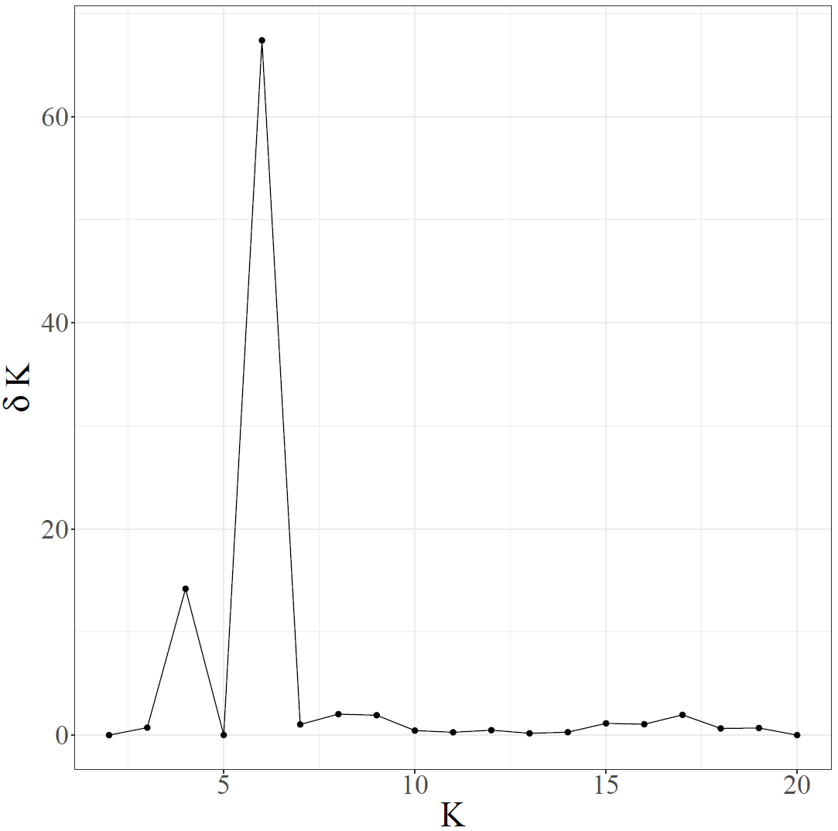
Supplementary Figure 1: Evanno-plot illustrating the relationship between the number of clusters (K) and the rate of change in the log-likelihood of the STRUCTURE output data as indicated by ΔK. The optimal number of genetic clusters is determined by identifying the peak value of δK.

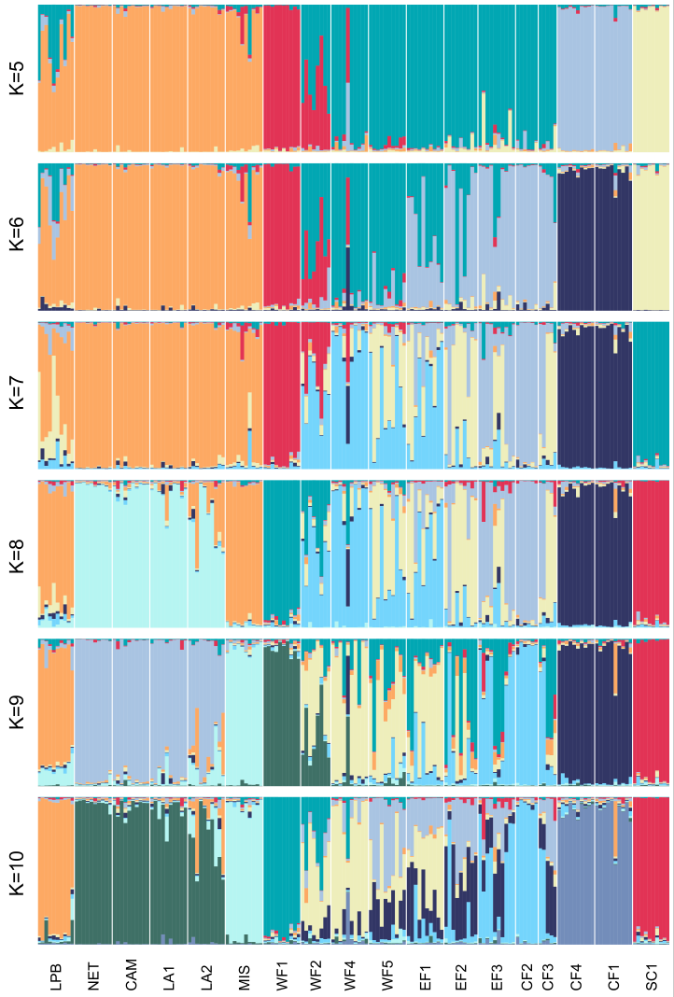
Supplementary Figure 2: Results of complementary STRUCTURE analyses (K=5−10). Each bar represents an individual genotype with single relative membership probability illustrated by distinct colors. Individual genotypes are ordered by their respective sampling location.
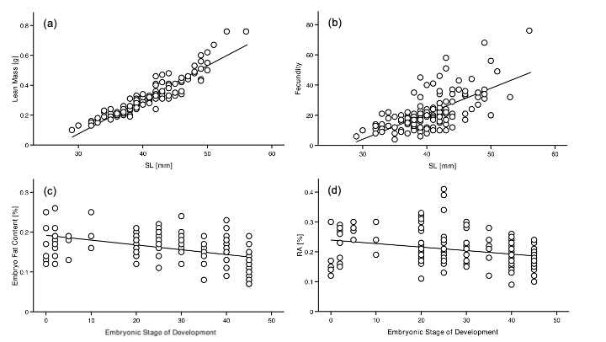
Supplementary Figure 3: Visualization of the significant effects of the covariates SL and Embryonic Stage of Development on female life-history traits. (a) Lean mass, (b) fecundity, (c) embryo fat content and (d) reproductive allocation (RA).

References
1. Greven H: Gonads, genitals, and reproductive biology. In: Ecology and Evolution of Poeciliid Fishes. Edited by Evans JP, Pilastro A, Schlupp I. Chicago: University of Chicago Press; 2011.
2. Girndt A, Riesch R, Schroeder C, Sehlupp I, Plath M, Tiedemann R: Multiple paternity in different populations of the sailfin molly, Poecilia latipinna. Animal Biology 2012, 62(3):245-262.
3. Travis J, Trexler JC, Mulvey M: Multiple Paternity and Its Correlates In Female Poecilia latipinna (Poeciliidae). Copeia 1990(3):722-729.
4. Trexler JC, Travis J, Dinep A: Variation among populations of the sailfin molly in the rate of concurrent multiple paternity and its implications for mating-system evolution. Behavioral Ecology and Sociobiology 1997, 40(5):297-305.
5. Trexler JC, Travis J: Phenotypic Plasticity in the Sailfin Molly, Poecilia latipinna (Pisces: Poeciliidae). I. Field Experiments. Evolution 1990, 44(1):143-156.
6. Schlupp I, McKnab R, Ryan MJ: Sexual harassment as a cost for molly females: Bigger males cost less. Behaviour 2001, 138:277-286.
7. Travis J, Woodward BD: Social Context and Courtship Flexibility in Male Sailfin Mollies Poecilia latipinna Pisces Poeciliidae. Animal Behaviour 1989, 38(6):1001-1011.
8. Page LM, Burr BM: Peterson field guide to freshwater fishes of North America north of Mexico: Houghton Mifflin Harcourt; 2011.
9. Snelson FF, Jr.: Indeterminate growth in males of the sailfin molly, Poecilia latipinna. SO - Copeia 1982(2) 1982 296-304 1982.
10. Hubbs C, Edwards RJ, Garrett GP: An Annotated Checklist of the Freshwater Fishes of Texas with Keys to Identification of Species. Texas Journal of Science 1991, 43(4 SUPPL):1-56.
11. Snelson FF, Jr.: Size and Morphological Variation in Males of the Sailfin Molly Poecilia latipinna. Environmental Biology of Fishes 1985, 13(1):35-48.
12. Palacios M, Voelker G, Rodriguez LA, Mateos M, Tobler M: Phylogenetic analyses of the subgenus Mollienesia (Poecilia, Poeciliidae, Teleostei) reveal taxonomic inconsistencies, cryptic biodiversity, and spatio-temporal aspects of diversification in Middle America. Molecular Phylogenetics and Evolution 2016, 103:230-244.
13. Meredith RW, Pires MN, Reznick DN, Springer MS: Molecular phylogenetic relationships and the evolution of the placenta in Poecilia (Micropoecilia)(Poeciliidae: Cyprinodontiformes). Molecular Phylogenetics and Evolution 2010, 55(2):631-639.
14. Schartl M, Wilde B, Schlupp I, Parzefall J: Evolutionary origin of a parthenoform, the Amazon molly Poecilia formosa, on the basis of a molecular genealogy. Evolution 1995, 49(5):827-835.
15. Schlupp I: The evolutionary ecology of gynogenesis. Annual Review of Ecology Evolution and Systematics 2005, 36:399-417.
16. Farr JATJ: Fertility Advertisement by Female Sailfin Mollies Poecilia latipinna Pisces Poeciliidae. Copeia 1986, 1986(2):467-472.
17. Fraser BA, Janowitz I, Thairu M, Travis J, Hughes KA: Phenotypic and genomic plasticity of alternative male reproductive tactics in sailfin mollies. Proceedings of the Royal Society B-Biological Sciences 2014, 281(1781).
18. Parzefall J: Zur vergleichenden Ethologie verschiedener Mollienesia Arten einschliesslich einer Höhlenform von M. sphenops. Behaviour 1969, 33:1-37.
19. Ptacek MB, Travis J: Mate choice in the sailfin molly, Poecilia latipinna. Evolution 1997, 51(4):1217-1231.
20. Trexler JC: Resource availability and plasticity in offspring provisioning: Embryo nourishment in sailfin mollies. Ecology 1997, 78(5):1370-1381.
21. Pirroni S, Meka J, Jourdan J, Santi F, Plath M, Langerhans RB, Riesch R: Variability in maternal provisioning and offspring quality in eastern mosquitofish (Gambusia holbrooki). Aqua, International Journal of Ichthyology 2022, 28(2):79 - 95.
22. Trexler JC: Variation in the Degree of Viviparity in the Sailfin Molly, Poecilia latipinna. Copeia 1985, 1985(4):999-1004.
23. Riesch R, Schlupp I, Langerhans RB, Plath M: Shared and Unique Patterns of Embryo Development in Extremophile Poeciliids. PLoS ONE 2011, 6(11):1-11.

