Records identified from web of science:
Databases (n >5000)

Identification

Records excluded because they did not fit with the criteria used in the study.
(n=3113)
Records screened based on article title and abstract.
(n = 3246)
Reports sought for retrieval.
(n = 133)

Full-text articles excluded because they did not fit with the criteria used in the study.
(n=26)

Screening

Full-text articles excluded because the number of studies less than three have been deleted.
(n=31)
Reports assessed for eligibility.
(n =107)

Studies included in quantitative synthesis(meta-analysis) review.
(n = 76)

Included

From: Page MJ, McKenzie JE, Bossuyt PM, Boutron I, Hoffmann TC, Mulrow CD, et al. The PRISMA 2020 statement: an updated guideline for reporting systematic reviews. BMJ 2021;372: n71. doi: 10.1136/bmj. n71

Fig S1. Flowchart diagram of the process of obtaining literature data to build a database for this study.

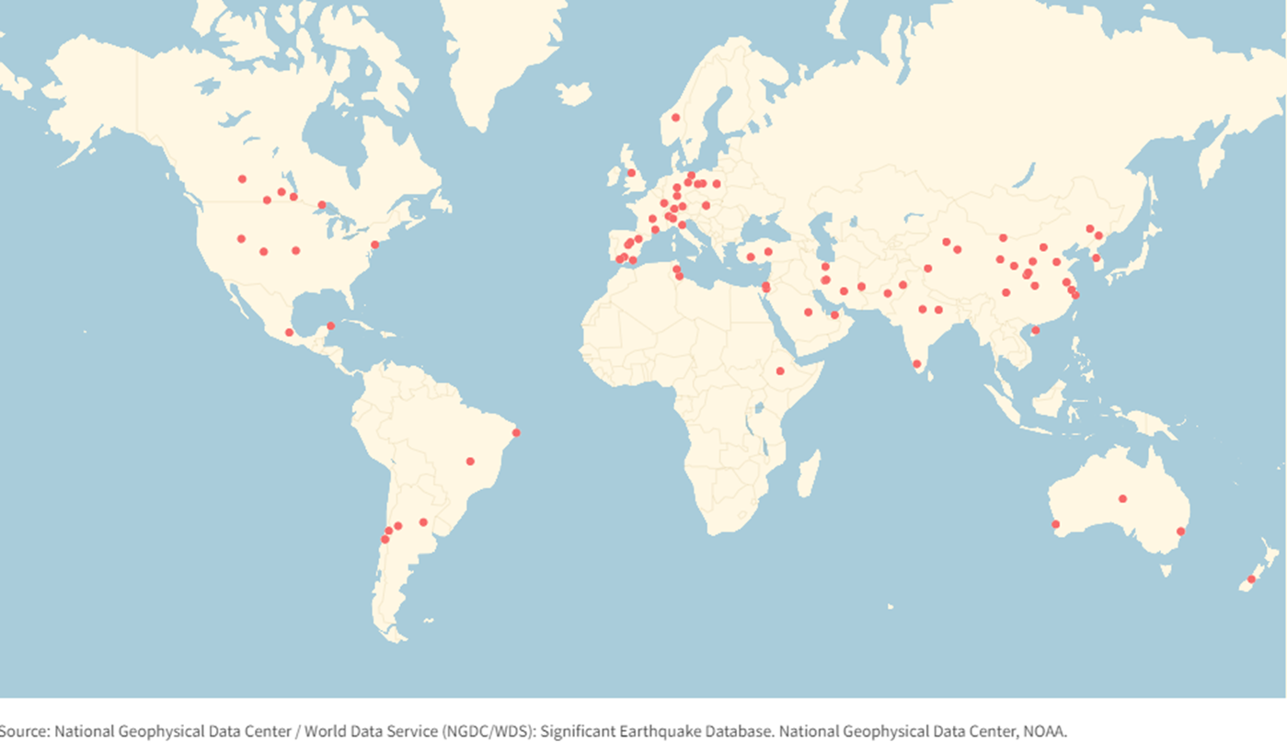

Fig S2. Locations of all studies used in our meta-analysis.

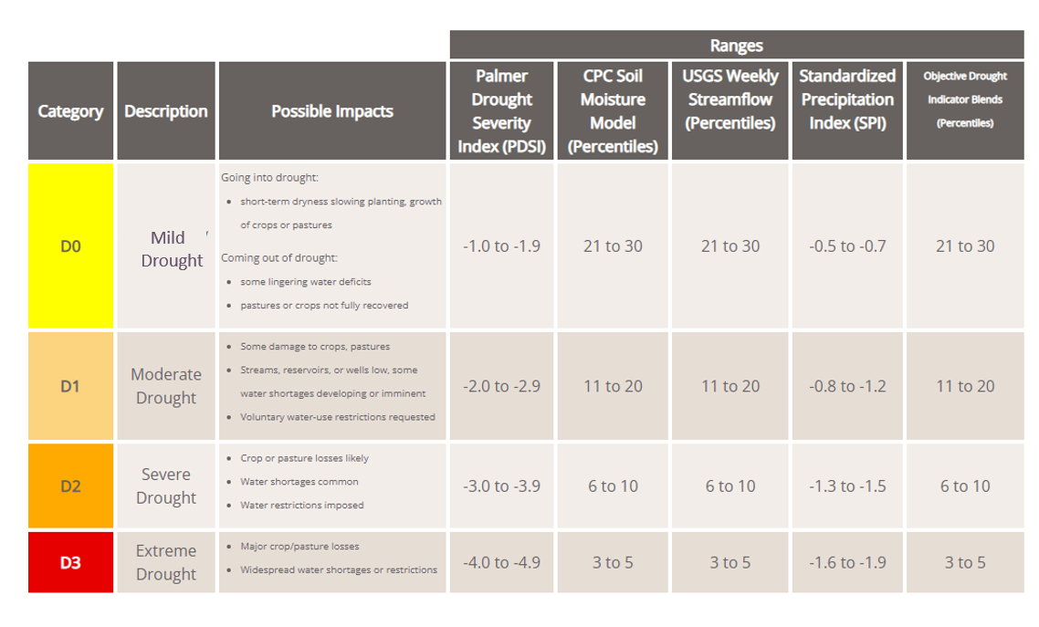
Fig S3. Drought Classification (National Drought Mitigation Center (NDMC), the U.S. Department of Agriculture (USDA) and the National Oceanic and Atmospheric Administration (NOAA).)

