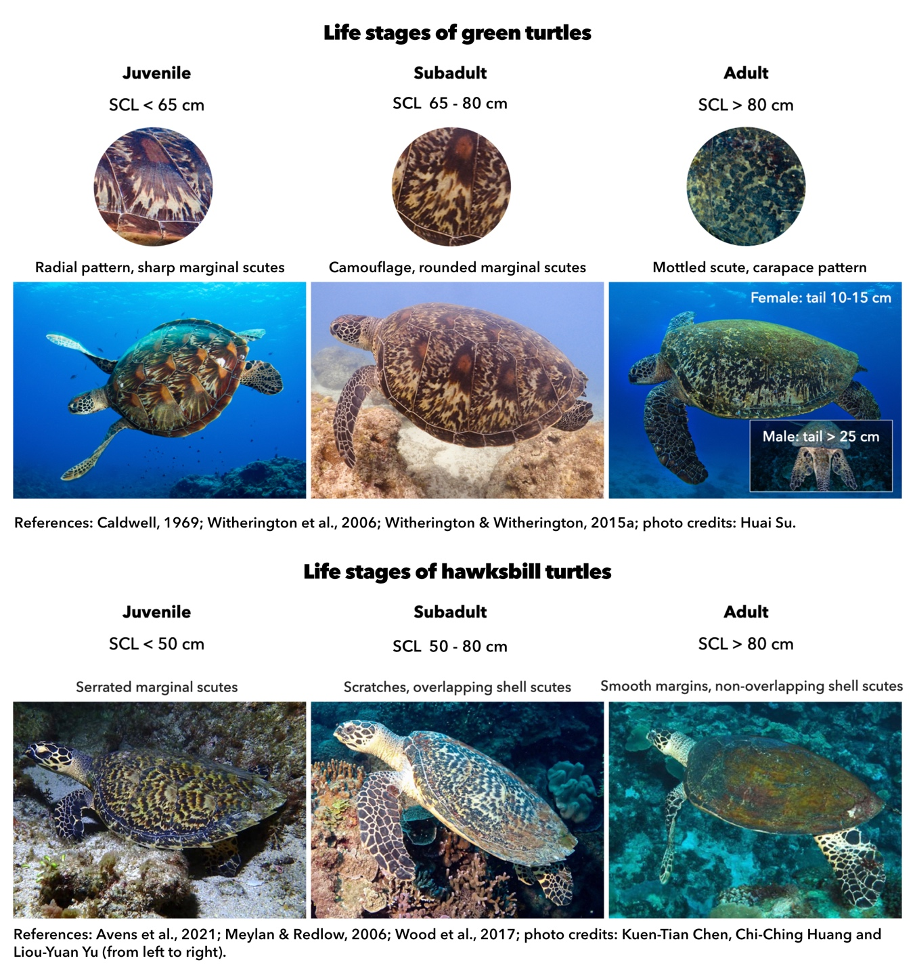
Supplementary materials:
Fig. S1. Carapace patterns and estimated straight carapace length (SCL) of green and hawksbill turtles at different life stages. Photo credits: Huai Su, Kuen-Tian Chen, Chi-Ching Huang and Liou-Yuan Yu.
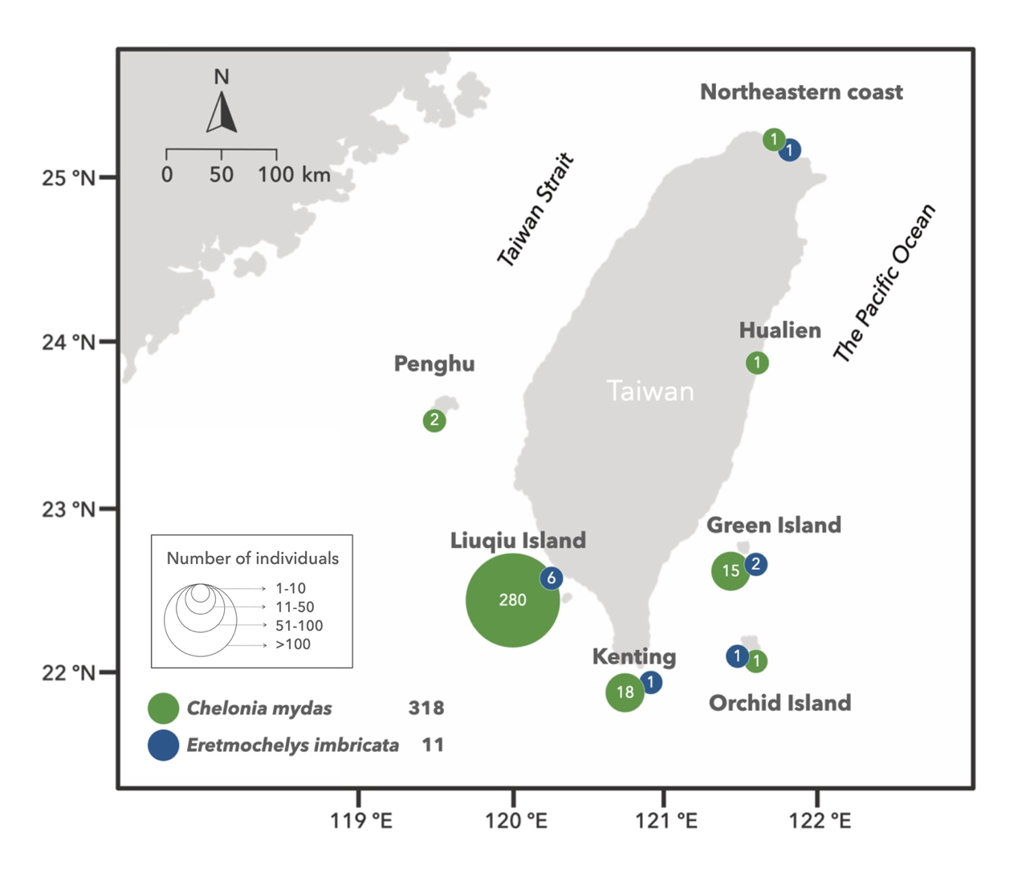
Fig. S2. Distribution of resident sea turtles around Taiwan. The color and size of the circles indicate the species and the number of individuals at each site.

