Supplementary figures
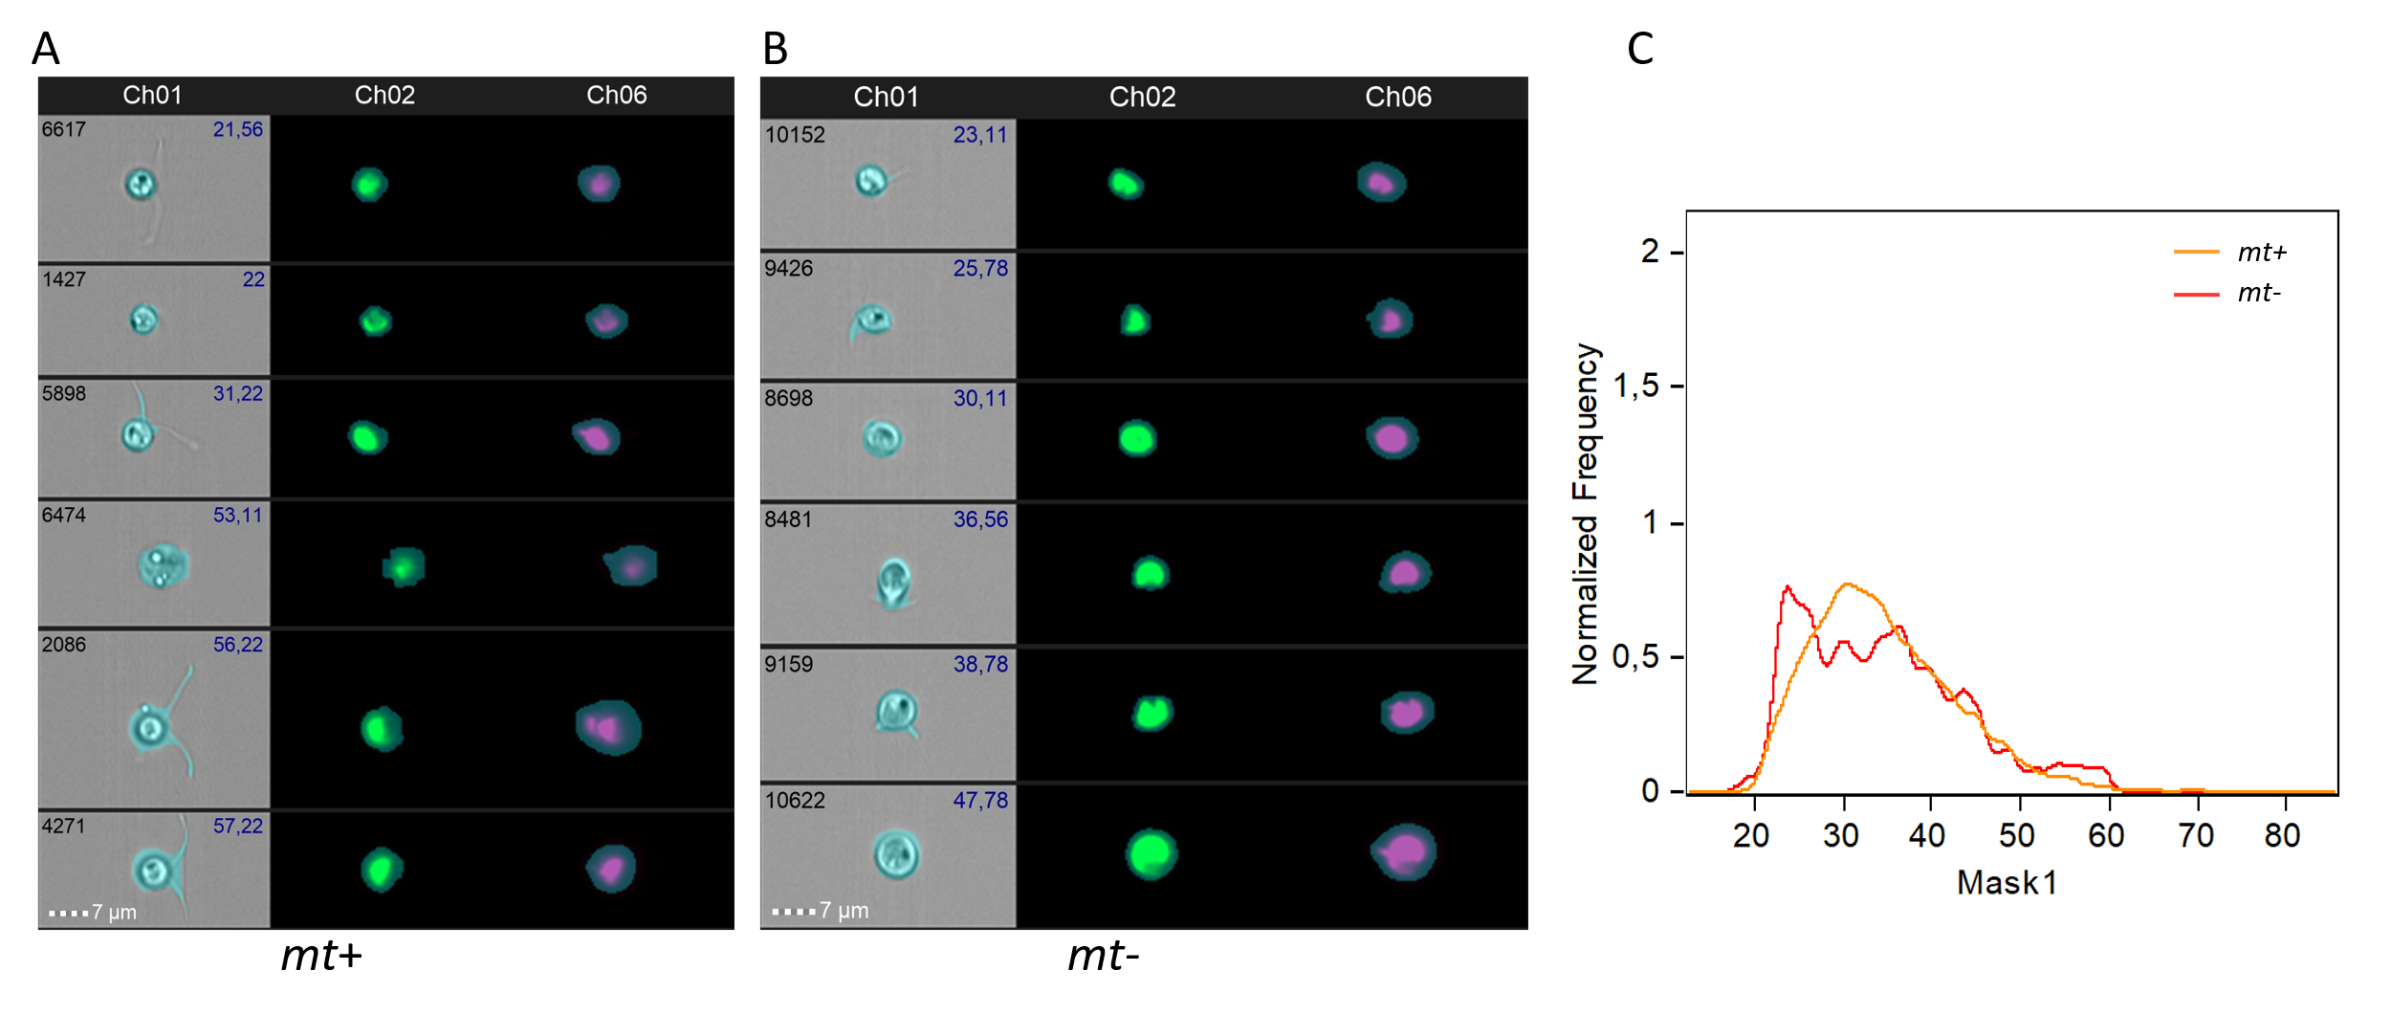
Figure S1: Comparison of gamete size distribution between mt+ and mt- of U. mutabilis. Representative images of individual gametes from the mt+ (A) and mt- (B) populations captured under brightfield (Ch01), GFP fluorescence (Ch02), and merged GFP/RFP (Ch06) channels at 60 × magnification. Scale bar = 7 μm; C: Normalized frequency distribution of gamete sizes for mt+ (orange line) and mt- (red line) populations.

