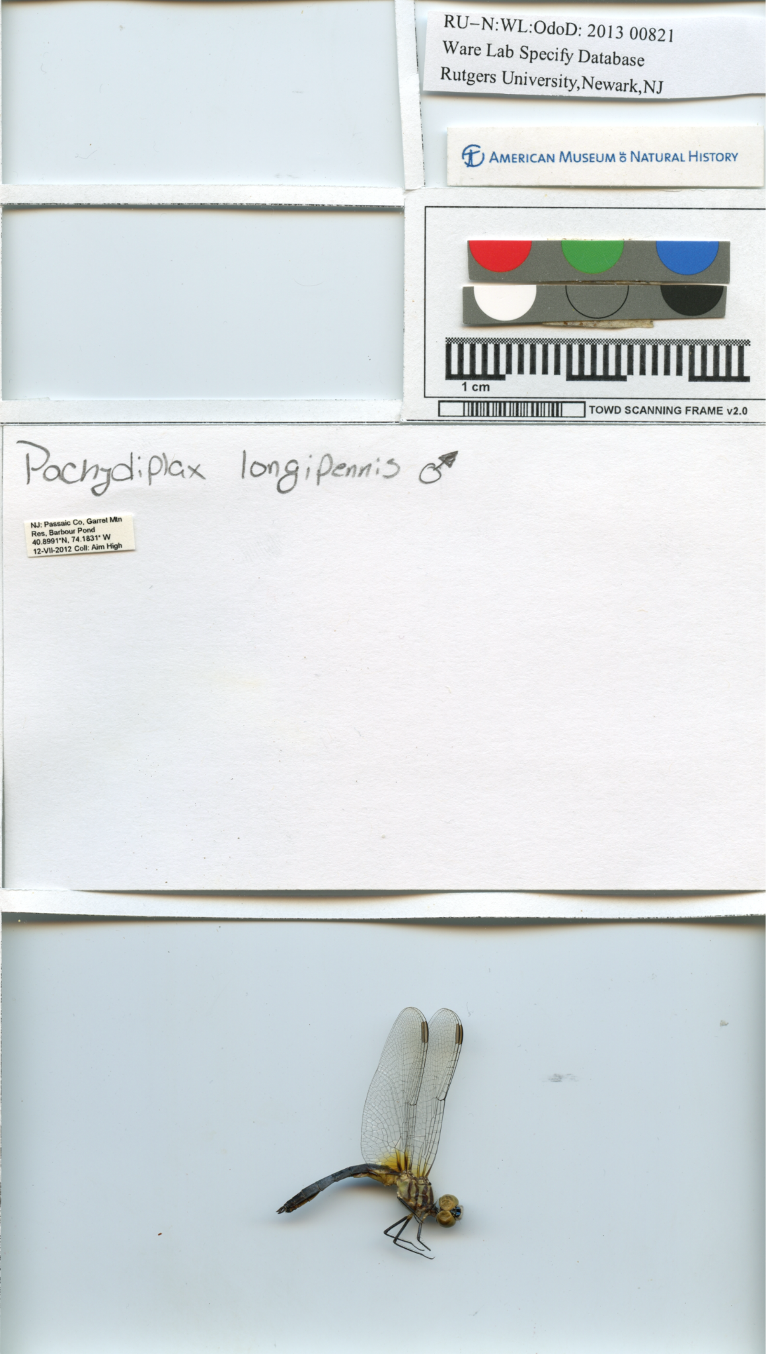
Supplementary figure 1: Scanned specimen using TOWD template

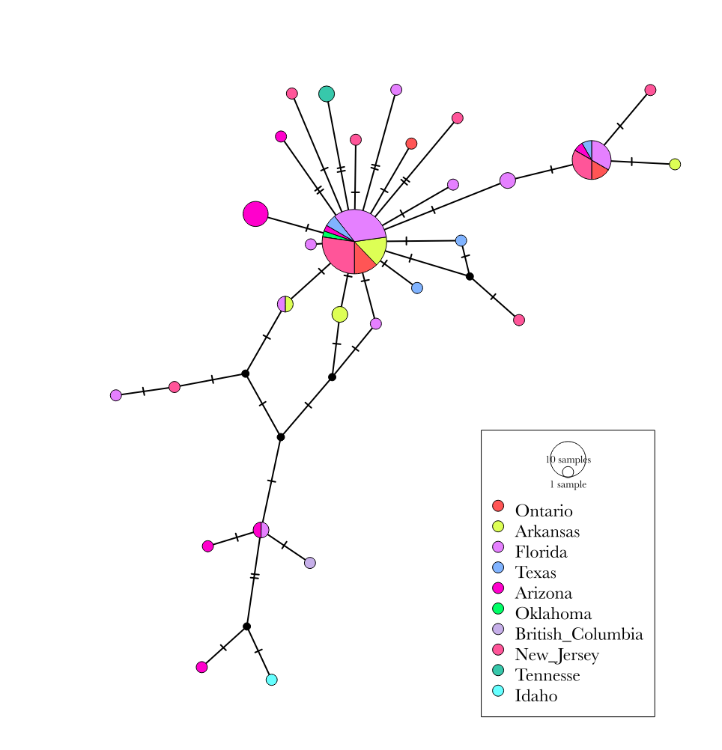Supplementary Figure 2: COI haplotype network of P. longipennis, including sequences from Tennessee

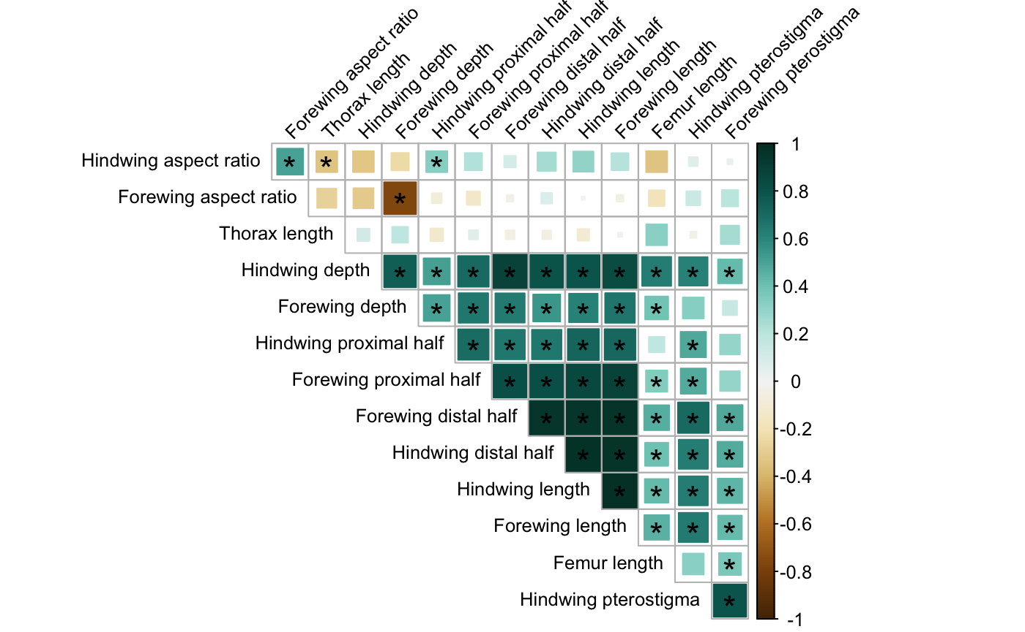
Supplementary Figure 3: Pairwise Pearson Correlation Coefficients between morphological measurements.
*Denotes statistical significance

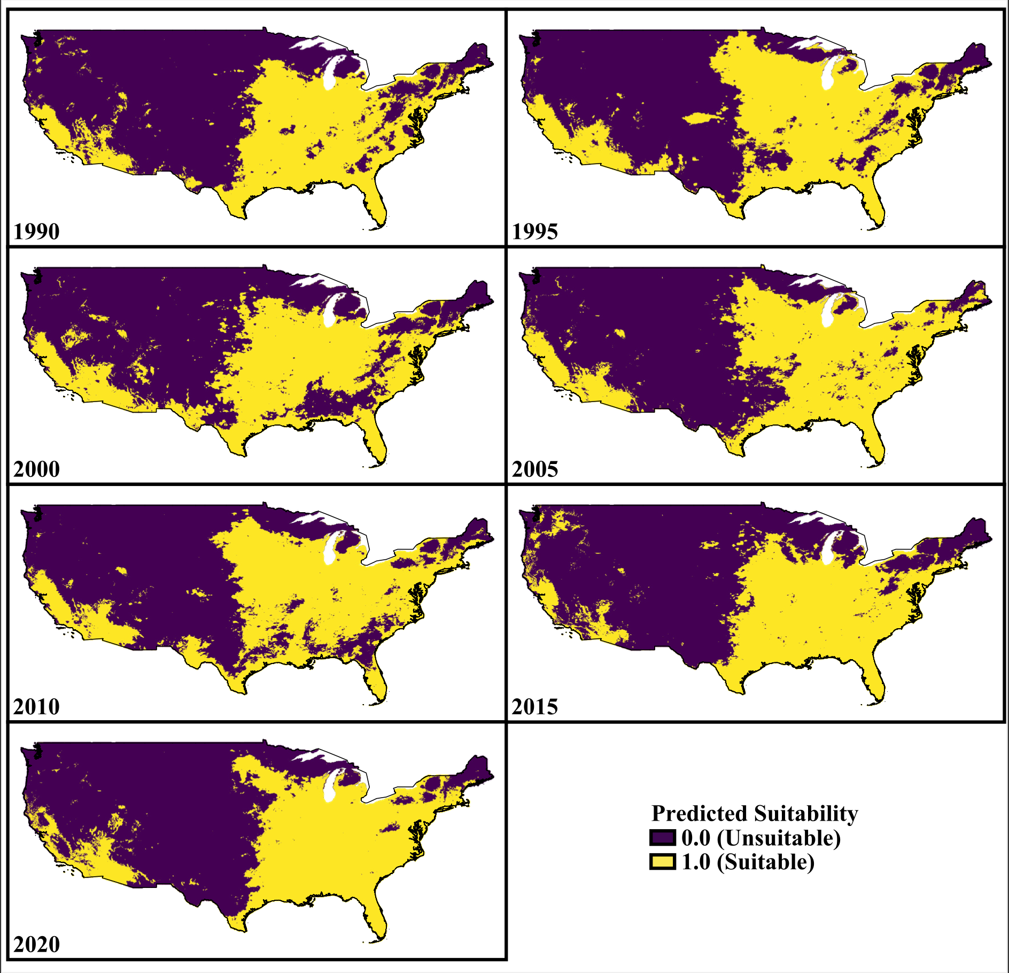

Supplementary Figure 4: Habitat suitability of P. longipennis.

Supplementary table one: Read coverage and duplication
Individual | Read pairs | Percent duplication | Average coverage
Idaho_1 | 11,583,023 | 12.51% | 2.93
Idaho_2 | 12,783,475 | 12.21% | 3.23
Idaho_3 | 12,448,985 | 12.38% | 3.15
Idaho_4 | 9,201,853 | 10.24% | 2.37
Idaho_5 | 8,506,595 | 10.73% | 2.19
Tennesse_1 | 9,675,905 | 11.11% | 2.39
Tennesse_2 | 9,036,103 | 10.89% | 2.27
Tennesse_3 | 9,270,442 | 13.82% | 2.21
Tennesse_4 | 5,248,999 | 16.49% | 0.47
Tennesse_5 | 9,383,957 | 12.80% | 2.27
New Jersey_1 | 8,023,065 | 10.57% | 2.02
New Jersey_2 | 11,476,680 | 12.39% | 2.81
New Jersey_3 | 11,153,491 | 12.12% | 2.73
New Jersey_4 | 12,081,928 | 11.56% | 2.98
New Jersey_5 | 13,520,629 | 12.323% | 3.31

Supplementary Table 2: Wing area measurements of P. longipennis
image_name | Individual | Population | hindwing_area_cm2 | forewing_area_cm2
0AC1C123-FA41-4C15-8E0F-B2551A24B2C7_1_105_c.jpeg | 1 | Idaho | 1.754010642 | 1.215001684
5061AF63-4C1C-42CB-8AEB-04EC3785B20F_1_105_c.jpeg | 1 | Idaho | 1.966922516 | 1.368680454
8BC3CEF6-CA23-431F-8BB9-6E61636EEA01_1_105_c.jpeg | 2 | Idaho | 1.953961845 | 1.244922116
7CC6F43E-0F82-488B-93A5-626AF1BFB980_1_105_c.jpeg | 2 | Idaho | 1.567989906 | 1.284168587
B97D7ED4-6E26-450E-8F0D-542A481EA108_1_105_c.jpeg | 3 | Idaho | 2.14006918 | 1.678566184
6B388BE7-A825-4775-8756-B38E432C0156_1_105_c.jpeg | 3 | Idaho | 1.556571816 | 1.139464192
7FE42C93-C07A-4EA9-8780-0741FF8996DE_1_105_c.jpeg | 3 | Idaho | 2.133115092 | 1.730003736
BAAD116A-6FF0-4D79-8232-559A77EEA9E5_1_105_c.jpeg | 4 | Idaho | 2.116299741 | 1.483539078
BB779614-0E51-4E2B-AA67-A43A93ADC69E_1_105_c.jpeg | 4 | Idaho | 2.399309145 | 2.001636824
D8FF208C-0365-4618-B578-3572371DA4AB_1_105_c.jpeg | 4 | Idaho | 1.667347863 | 1.479162816
3B2CB93D-4E11-4A03-9C16-D9FF88B407A6_1_105_c.jpeg | 4 | Idaho | 2.180012313 | 1.804404222
BD19F957-3660-43E8-98CA-74E772288A60_1_105_c.jpeg | 5 | Idaho | 1.746145446 | 1.234471241
D4426030-E40A-44EF-8A8F-A741754177C2_1_105_c.jpeg | 5 | Idaho | 2.358871531 | 1.841295545
1EA076EE-4586-4EF7-B5EF-6DAF1350577D_1_105_c.jpeg | 5 | Idaho | 1.674049811 | 1.124865905
3D32BD18-C953-4617-B9DC-818A63B5E5F9_1_105_c.jpeg | 5 | Idaho | 2.42782722 | 1.807239168
19A38A95-507E-475F-BCBA-66E82C6764FB_1_105_c.jpeg | 7 | Idaho | 1.711127201 | 1.366134228
9829F61C-2ABB-4353-8B90-A80101DD4AC4_1_105_c.jpeg | 7 | Idaho | 2.320771169 | 2.106510907
AA2F0C2C-5663-4782-BADB-836E810E823C_1_105_c.jpeg | 7 | Idaho | 2.130046232 | 1.90327386
EC3EA0B0-CFA6-4B00-8400-A283B89EA194_1_105_c.jpeg | 7 | Idaho | 1.837846853 | 1.429473376
0C80DC54-D1F3-47F1-AD96-E3770E2AE16A_1_105_c.jpeg | 8 | Idaho | 1.94690297 | 1.684486524
2E32D4C8-26F3-4E3B-B34B-30E71C5DEB70_1_105_c.jpeg | 8 | Idaho | 2.260652108 | 1.613303678
56971028-5072-4F25-90EB-35C29B9A2555_1_105_c.jpeg | 8 | Idaho | 2.224287251 | 1.824733196
66AFE522-00FD-4056-A0F0-1D3CD183EA07_1_105_c.jpeg | 8 | Idaho | 1.709042612 | 1.517612493
FDF6D498-3D7E-491E-8FD4-1E720AEA5C6F_1_105_c.jpeg | 9 | Idaho | 2.006333759 | 1.498956226
74D083DD-DBBA-4C0D-A5CB-8D7A5C173012_1_105_c.jpeg | 9 | Idaho | 1.750775418 | 1.343492501
0A1987D1-2600-4347-A10C-9F9FA85F5D63_1_105_c.jpeg | 10 | Idaho | 2.015173026 | 1.766097748
EFECC631-169C-4800-8E54-8C0E830D789F_1_105_c.jpeg | 10 | Idaho | 1.720869035 | 1.763848084
33D50523-81BF-46E3-B752-C62461E5C688_1_105_c.jpeg | 10 | Idaho | 2.081679408 | 1.679848158
58468D2D-2D36-4309-BAAE-E77C729E9B65_1_105_c.jpeg | 10 | Idaho | 1.890845963 | 1.657943176
1A47599B-7973-4EA4-B4FA-667EB6C96698_1_105_c.jpeg | 11 | Idaho | 2.746025475 | 2.090574495
304F7944-CFC4-45CE-8D6C-30E8E2162DAE_1_105_c.jpeg | 11 | Idaho | 2.928655514 | 2.252968002
6E85415E-8B66-4A87-BC53-63E4A5AEC689_1_105_c.jpeg | 11 | Idaho | 1.547240604 | 1.355312991
FA6B34C5-A299-4A66-9F97-2AD3DEFB0AA2_1_105_c.jpeg | 12 | Idaho | 2.222982509 | 1.960033239
4E7C1556-77C7-49C1-BE47-F6CA1A11387C_1_105_c.jpeg | 12 | I^{1,2}daho | 1.8945173 | 1.362662799
D2C43FFB-CFA5-40B8-B651-4979B5ADEC25_1_105_c.jpeg | 13 | Idaho | 2.623589943 | 1.889414194
F29B2C4E-2F36-4081-98D3-C381E2DE755B_1_105_c.jpeg | 13 | Idaho | 2.494784608 | 1.996910001
6A75EF05-30CB-4D08-99DA-514C632B7BDE_1_105_c.jpeg | 4 | Virginia | 2.078925542 | 1.671171532
80AC17E7-1C9D-4E09-84A7-293408A2520A_1_105_c.jpeg | 4 | Virginia | 2.07696546 | 1.687046731
6F3C5436-929C-471A-921B-E0540119D799_1_105_c.jpeg | 5 | Virginia | 2.269248304 | 1.820902299
F5E9D40C-30E7-45E2-8DFC-84A137F56D08_1_105_c.jpeg | 5 | Virginia | 2.400300903 | 1.926064912
laurel hill park 01.png | 1 | New Jersey | 2.238375248 | 1.854500881
laurel hill park 02.png | 2 | New Jersey | 2.356453768 | 1.861667365
laurel hill park 03.png | 3 | New Jersey | 2.493593166 | 2.002625392
laurel hill park 04.png | 4 | New Jersey | 2.198613761 | 1.725524581
laurel hill park 05.png | 5 | New Jersey | 2.681156515 | 1.898661242
laurel hill park 06.pngs | 6 | New Jersey | 2.734575542 | 2.333961259
laurel hill park 07.png | 7 | New Jersey | 2.78313158 | 2.257278979
laurel hill park 08.png | 8 | New Jersey | 2.228998282 | 1.736964336
laurel hill park 09.png | 9 | New Jersey | 2.21522554 | 1.88949767
laurel hill park 10.png | 10 | New Jersey | 2.249978591 | 1.805333235

