Supplemental Figures:
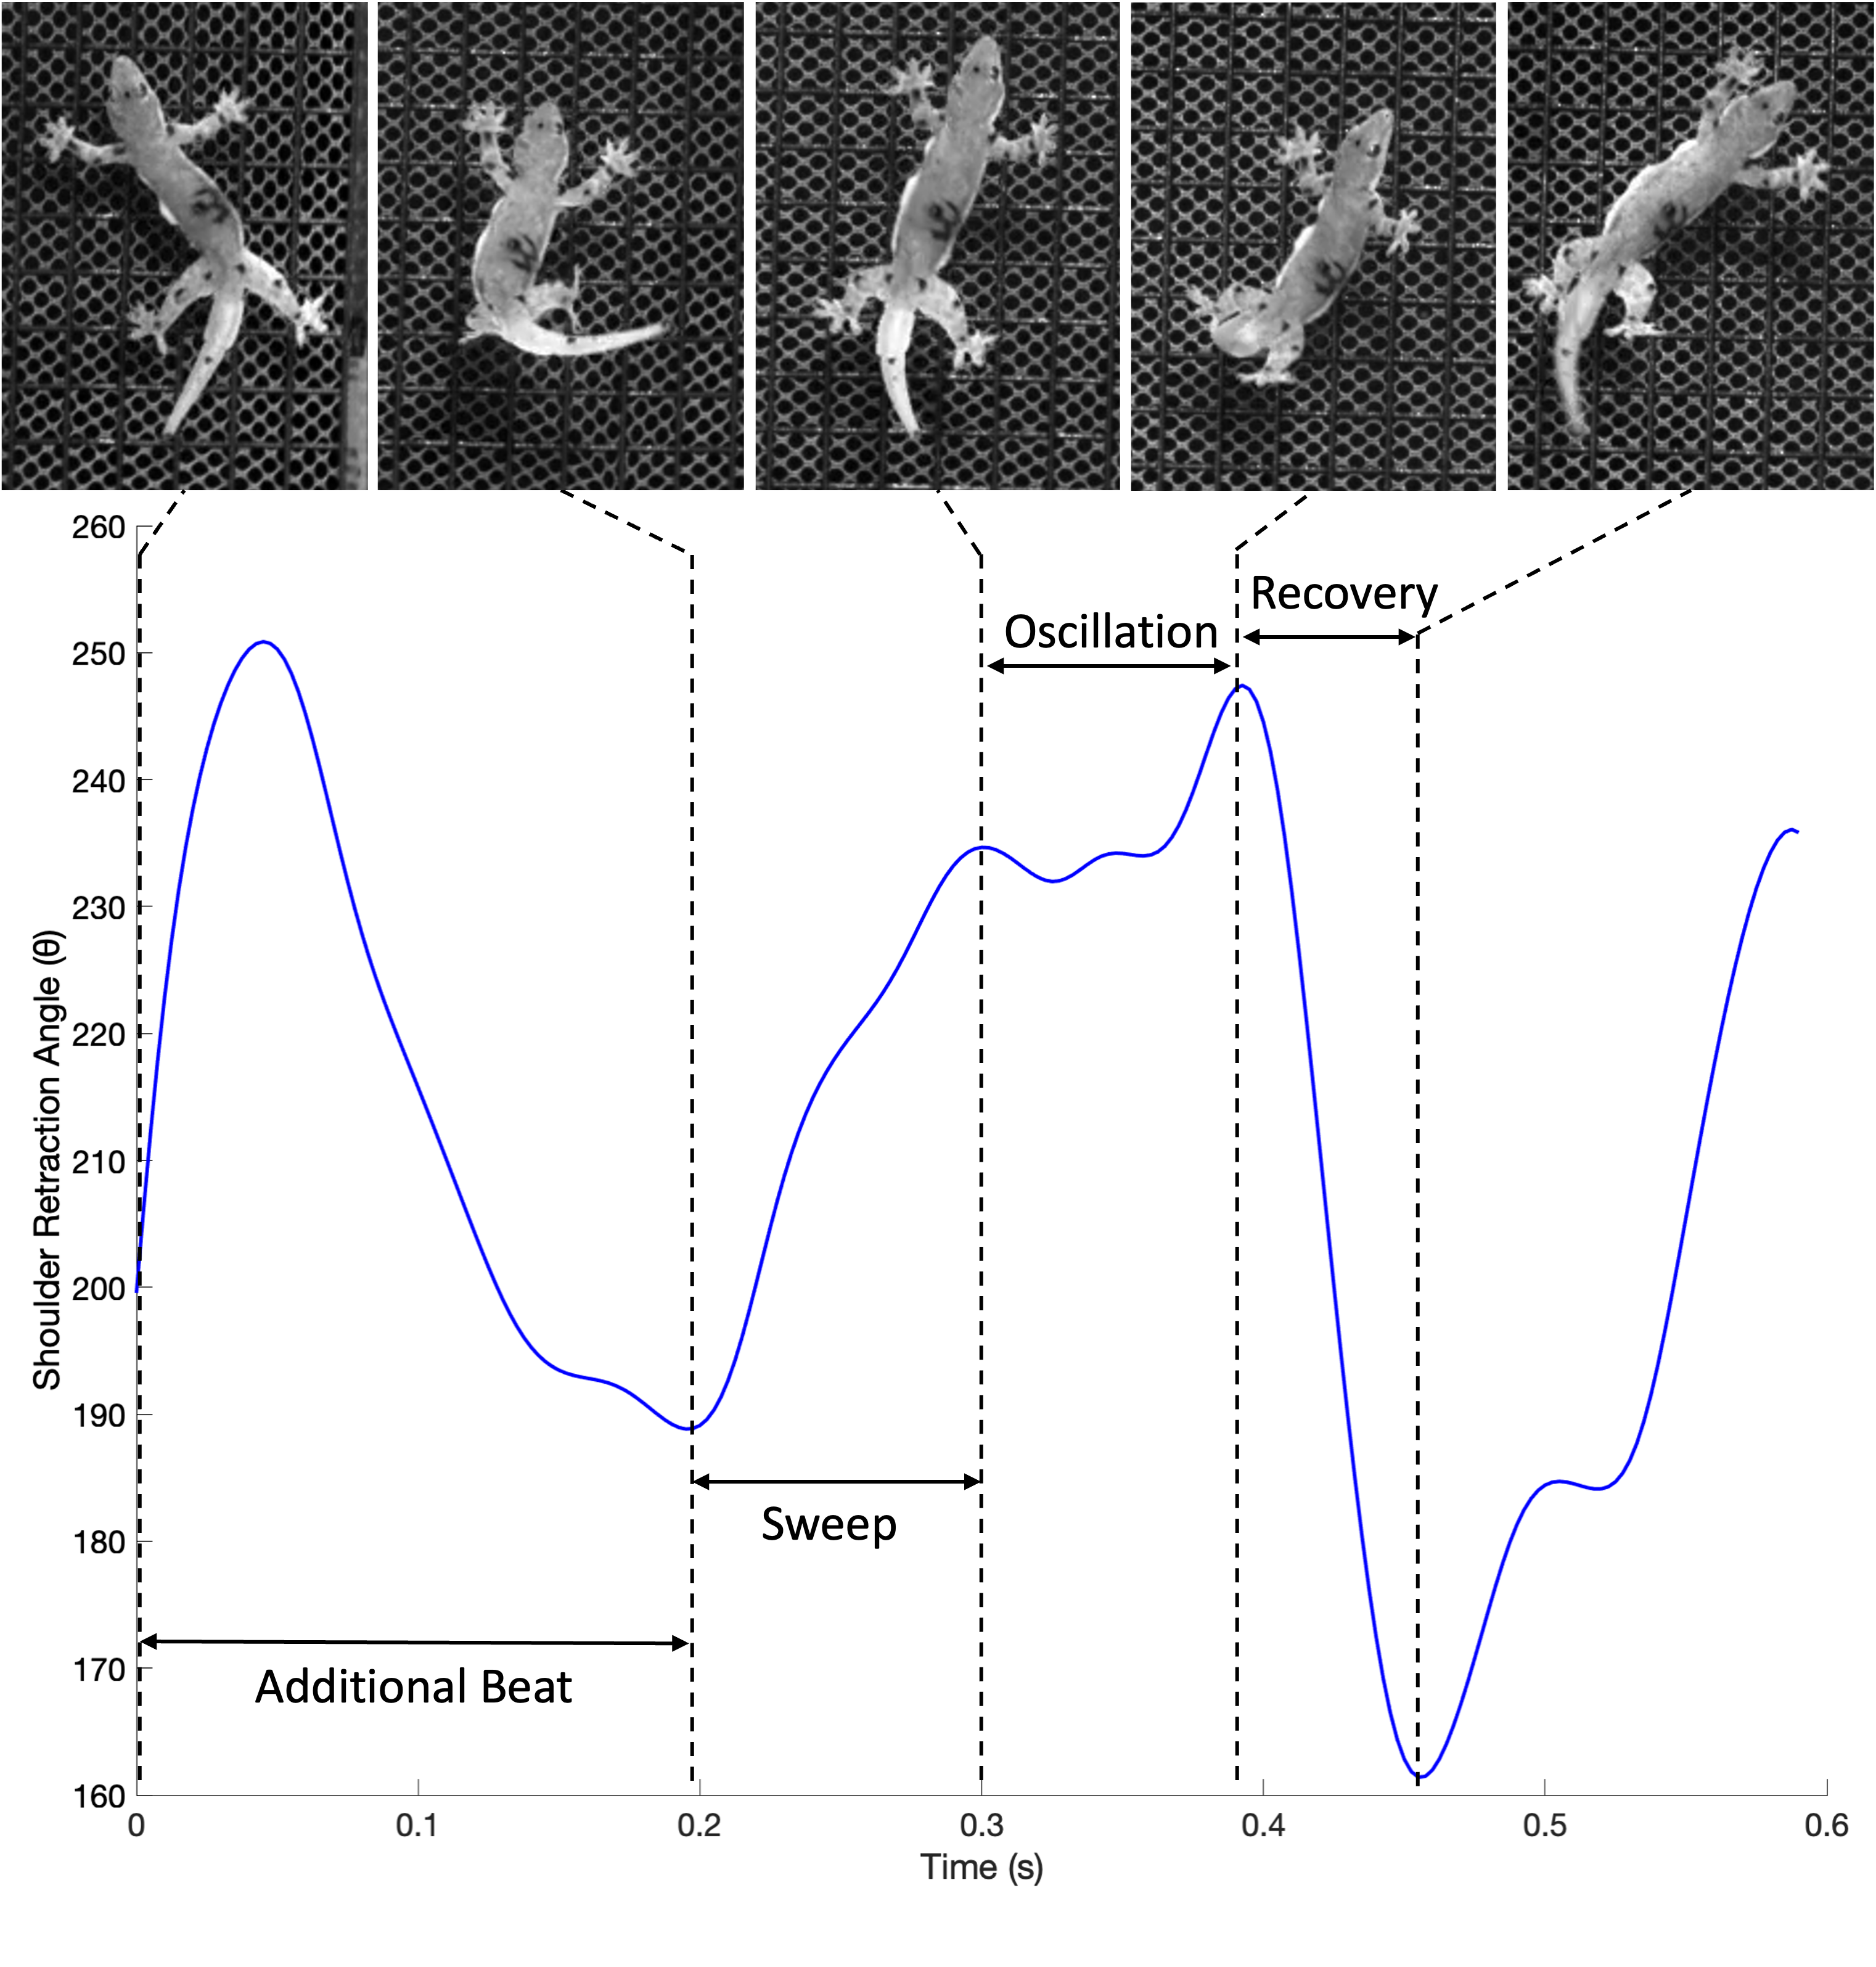Figure S1. Representative trace of shoulder retraction behavior variation. An additional beat, a sweep, oscillations in the swept configuration posture, and a recovery stroke are present. The data derive from trial 09 from gecko #3.

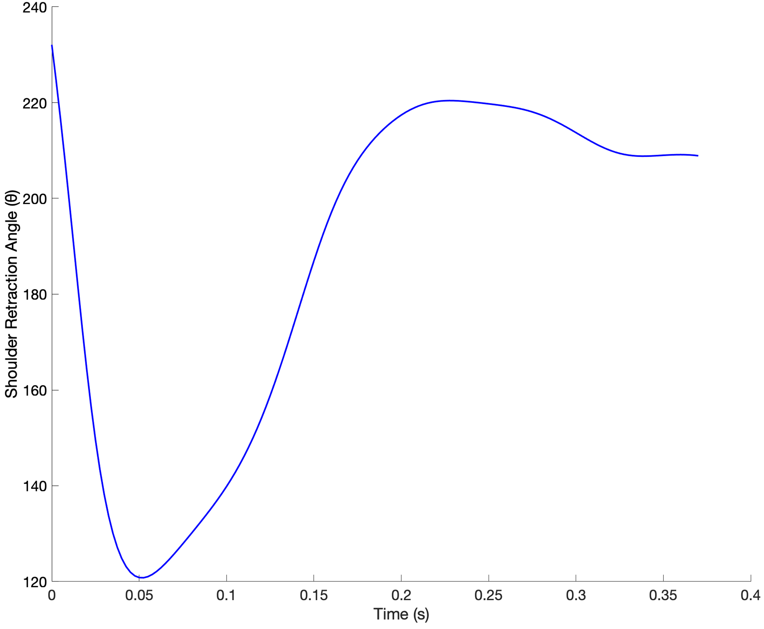Figure S2. Trace of shoulder retraction wherein the local maximum occurred prior to the onset of data collection. The data represents gecko 5’s trial 08.
Figure S3. Representative cross-correlation between shoulder retraction angle and forward velocity. The x-axis shows the lag of variable 2 (forward velocity) relative to variable 1 (shoulder retraction angle). The y-axis shows correlation coefficient from the cross-correlation test. The maximum correlation coefficient for this example occurred at a lag of 12 frames (i.e., 0.03 s). A Pearson Correlation test on the lagged data showed a significant positive correlation (p > 0.001, R² = 0.86).
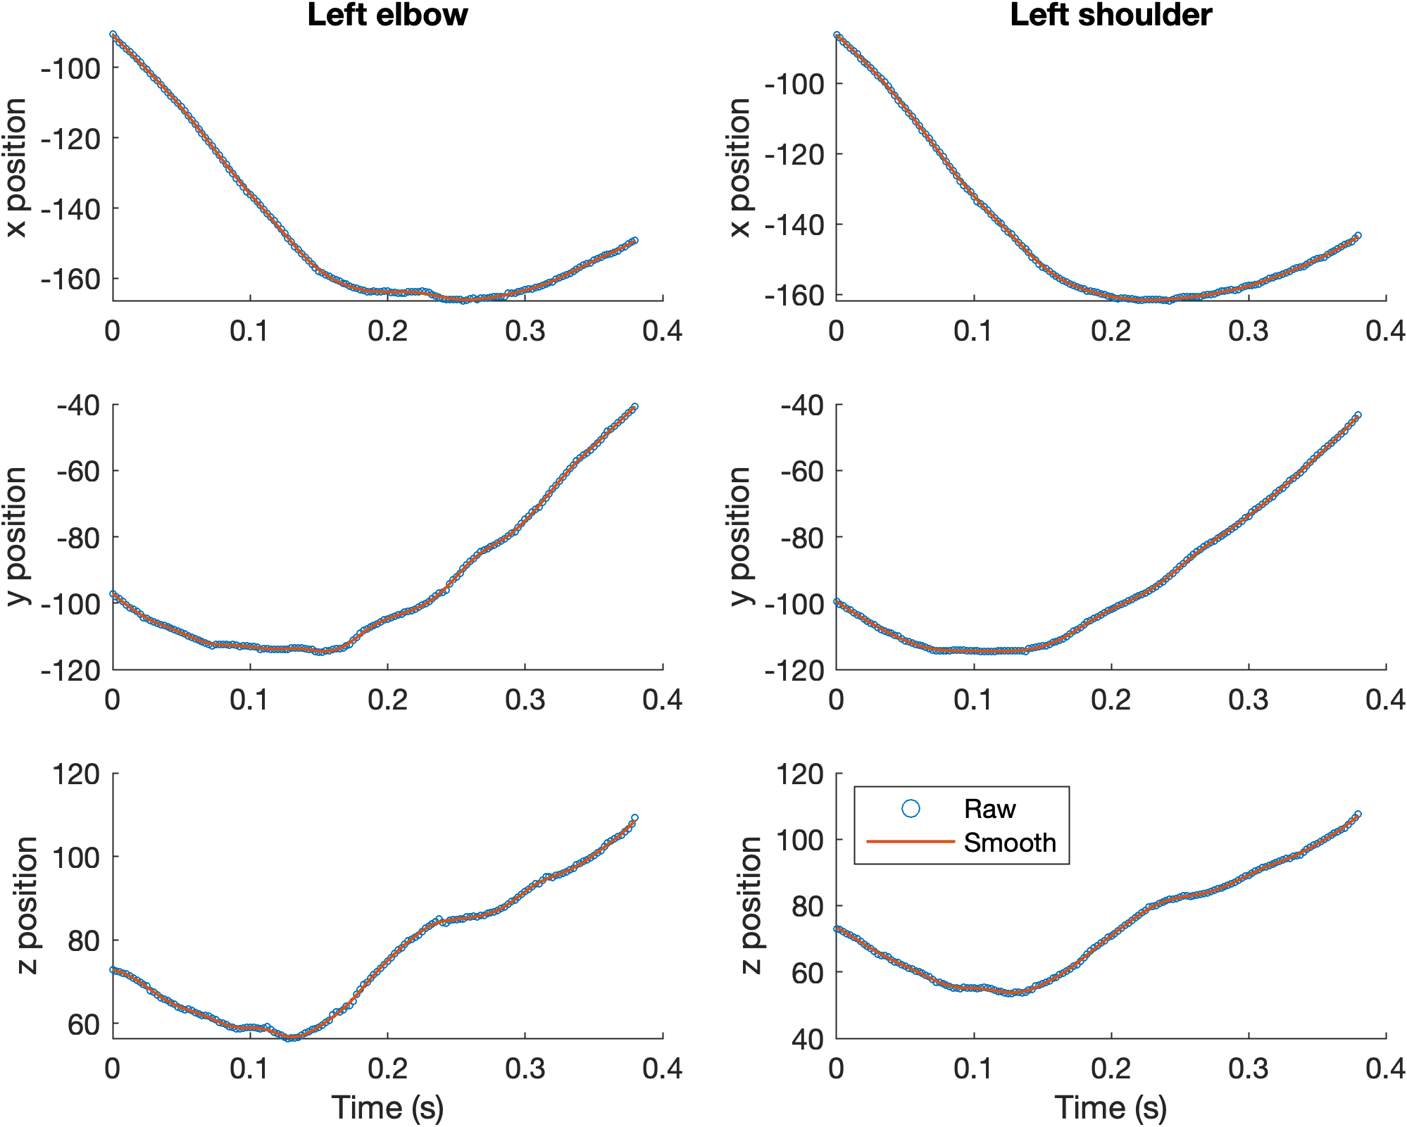Figure S4. Representative smoothing splines for each axial direction in the global coordinate system for two landmarks. The smoothed data closely follows the raw data while eliminating noise. The data represents gecko 1’s trial 03.

