Supplementary Information for the Manuscript titled:

“Citizen science data reveals widespread sexual dichromatism in the European fire salamander (Salamandra salamandra)”

Max Mühlenhaupt¹*, Rosalie Hey¹, Michelle Starp¹, Nils Anthes², Paul Bachhausen³, Thomas Bamann⁴, Sabrina Bleidißel⁵, Eike Bovensmann⁶, Jürgen Braunsdorf^{3, 7}, J. Maximilian Dehling⁸, Saskia Ebert¹, Hannes Egle^{9, 10}, Karolin Egle^{9, 10}, Simeon Egle^{9, 10}, Heidi Enderlein¹¹, Maximilian Fischer⁵, Lara Gemeinhardt¹², Sean G. Grond¹, Ricarda D. Gundert⁵, Oliver Krüger^{13, 14}, Lorenz Laux¹¹, Pia Oswald¹, Xenia Schlindwein², Manuela Schmidt¹, Laura Schulte¹, Ronny Schwalbe¹⁵, Theresa Stipp^{1, 7}, Michael Veith¹⁶, Frederik Wietbrok¹⁷ and Barbara A. Caspers^{1, 14}

¹ Department of Behavioural Ecology, Bielefeld University, Konsequenz 45, 33615 Bielefeld, Germany
² Institute of Evolution and Ecology, University of Tübingen, Auf der Morgenstelle 28E, 72076 Tübingen, Germany
³ Arbeitskreis Salamanderwanderung, AG Urodela, Deutsche Gesellschaft für Herpetologie und Terrarienkunde (DGHT), Am Püttkamp 20, 40629 Düsseldorf, Germany
⁴ Regierungspräsidium Tübingen, Konrad-Adenauer-Str. 20, 72072 Tübingen, Germany
⁵ Institute for Zoology and Didactic of Biology, University of Wuppertal, Gaußstraße 20, 42119 Wuppertal, Germany
⁶ Bund für Umwelt und Naturschutz Deutschland (BUND), Kreisgruppe Wolfsburg, Lönsstraße 5a, 38440 Wolfsburg, Germany
⁷ Untere Naturschutzbehörde, Kreis Lippe, Felix-Fechenbach-Straße 5, 32756 Detmold, Germany
⁸ Department of Biology, University of Koblenz, Universitätsstraße 1, 56070 Koblenz, Germany
⁹ Robert-Koch-Straße 18, 78532 Tuttlingen, Germany
¹⁰ NABU Tuttlingen, Robert-Koch-Straße 18, 78532 Tuttlingen, Germany
¹¹ Bund für Umwelt und Naturschutz Deutschland (BUND), Landesverband Sachsen e.V., Straße der Nationen 122, 09111 Chemnitz, Germany
¹² Molecular Evolution and Systematics of Animals, University of Leipzig, Talstraße 33, 04103 Leipzig, Germany
¹³ Department of Animal Behaviour, Bielefeld University, Konsequenz 45, 33615 Bielefeld, Germany
¹⁴ Joint Institute for Individualisation in a Changing Environment (JICE), Bielefeld University and University of Münster, Konsequenz 45, 33615 Bielefeld, Germany
¹⁵ NABU Heidelberg e.V., AK Amphibienwanderung, Karl-Ludwig Straße 1, 69117 Heidelberg, Germany
¹⁶ Department of Biogeography, Trier University, Universitätsring 15, 54296 Trier, Germany
¹⁷ Wietbrok Rechtsanwälte, Eißendorfer Pferdeweg 36, 21075 Hamburg, Germany
* Corresponding author, E-mail address: max.muehlenhaupt@uni-bielefeld.de

Supplementary Figures
A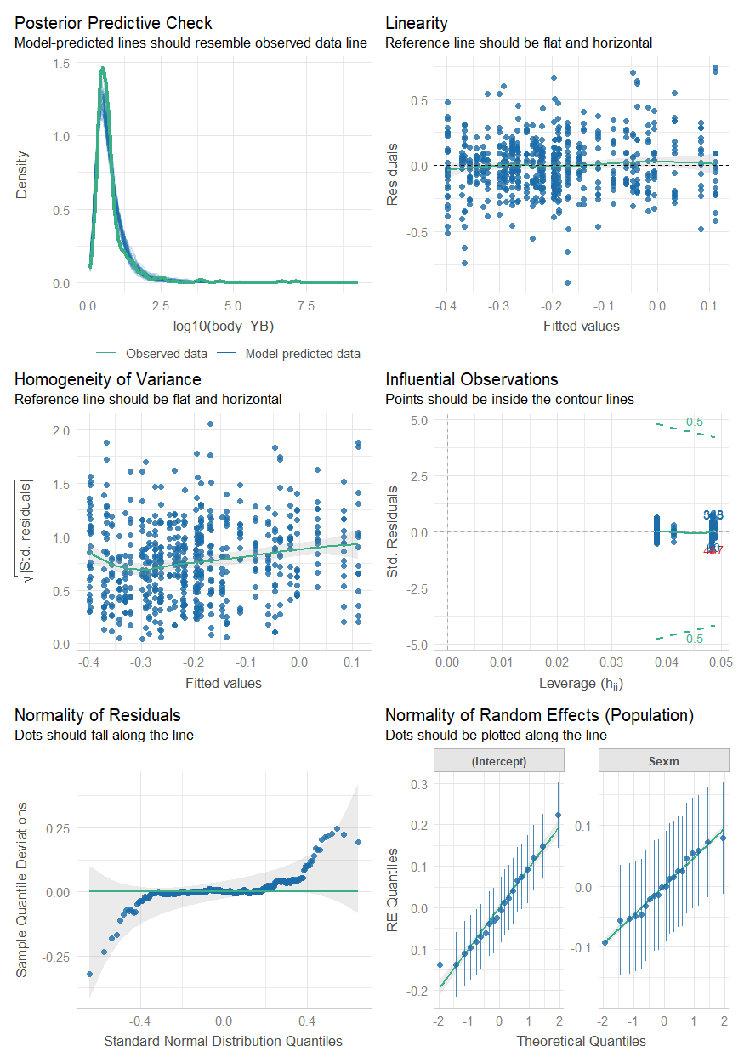

B
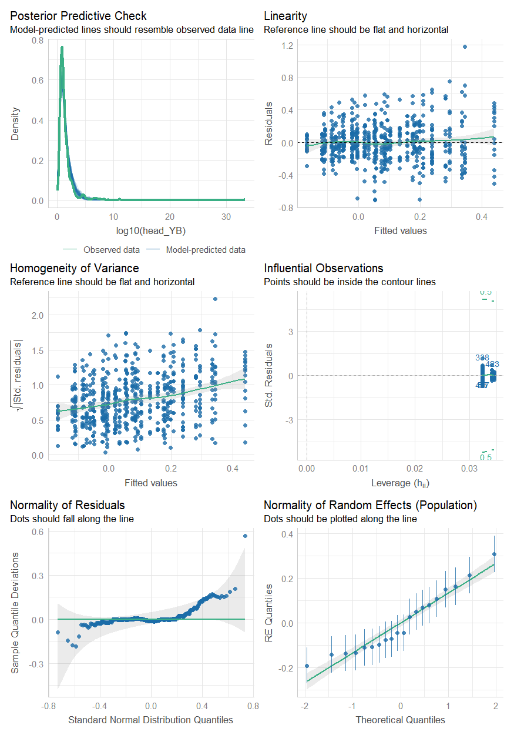

C
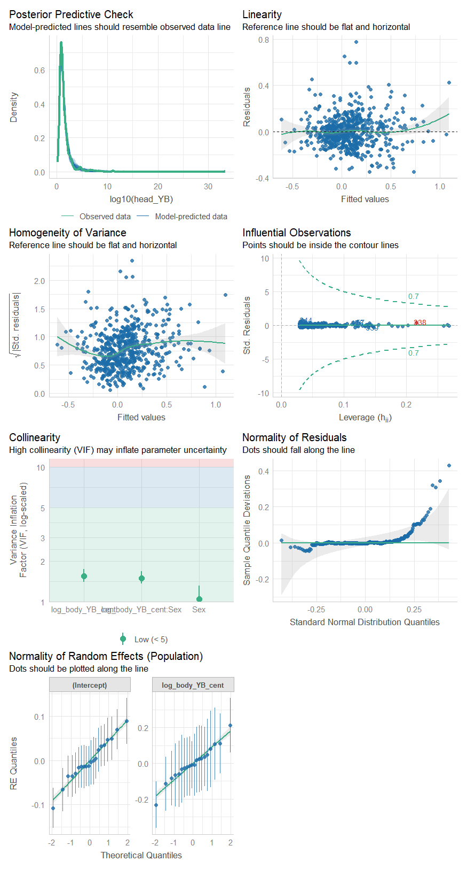

D
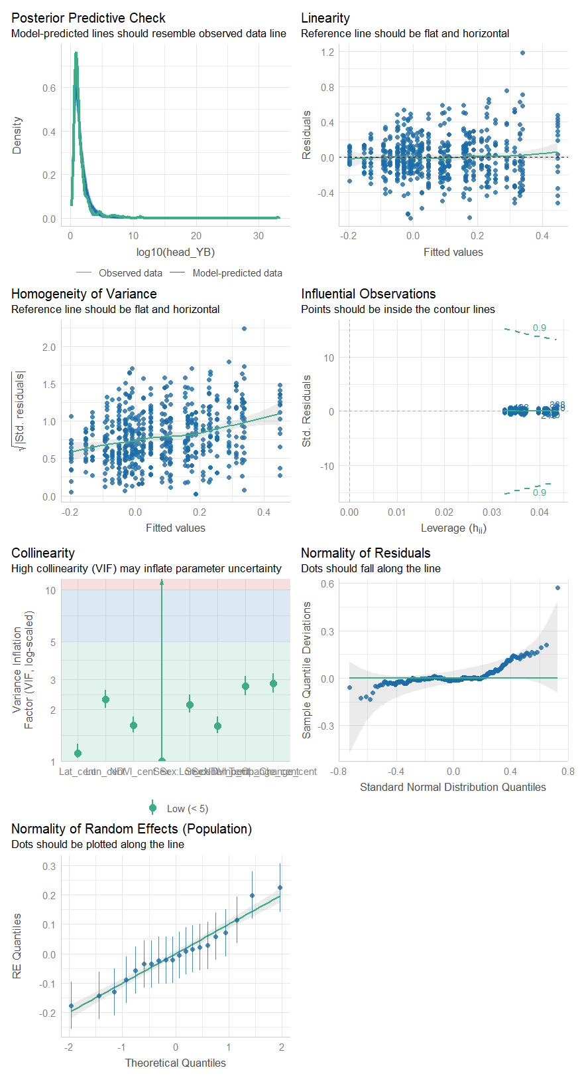

Supplementary Fig. 1 Model diagnostic plots provided by check_model in the performance package [1]. Panel A shows the diagnostic plots for the linear mixed effects model (LMM) investigating a sexual dichromatism in the yellow-to-black ratio of the body (body YB ratio). Panel B shows the diagnostic plots for the final LMM investigating a sexual dichromatism in the yellow-to-black ratio of the head (head YB ratio). Panel C shows the diagnostic plots of the final LMM investigating the relationship of head YB ratio with body YB ratio. Panel D shows the diagnostic plots of the final model investigating associations of the environmental variables with head YB ratio.

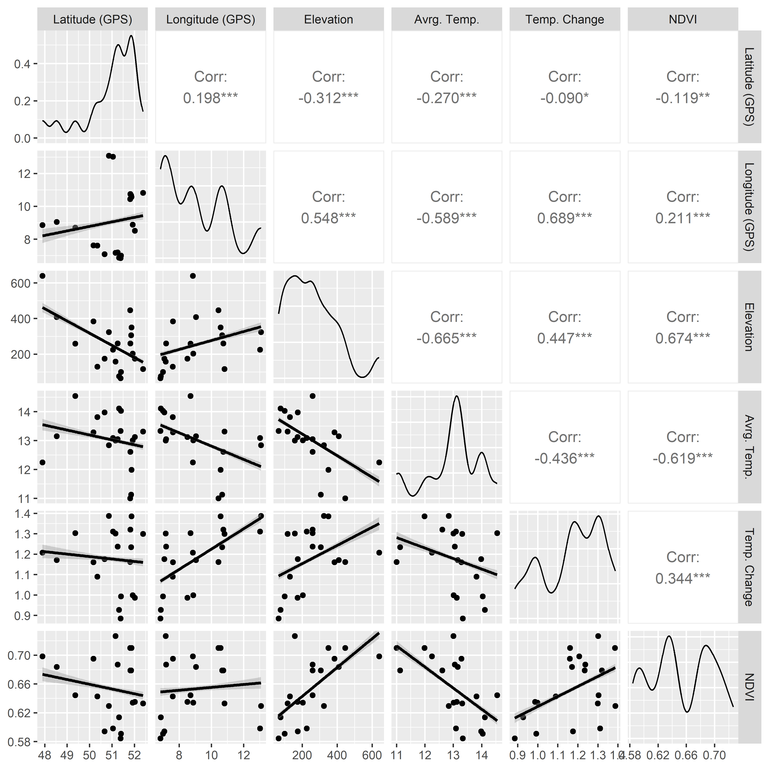
Supplementary Fig. 2 The correlation of the environmental variables. In the top right-hand plots, the Spearman’s correlation test statistics for each combination of environmental variables are shown. “Corr” denotes the correlation coefficient ρ. Asterisks represent the P-value (* = < 0.05; ** = < 0.01; *** = < 0.001). The diagonal plots show the distribution of the data using density plots. In the bottom left-hand plots, you can see the relationship of each combination of the environmental variables as depicted using a regression line. Each dot represents one study location.

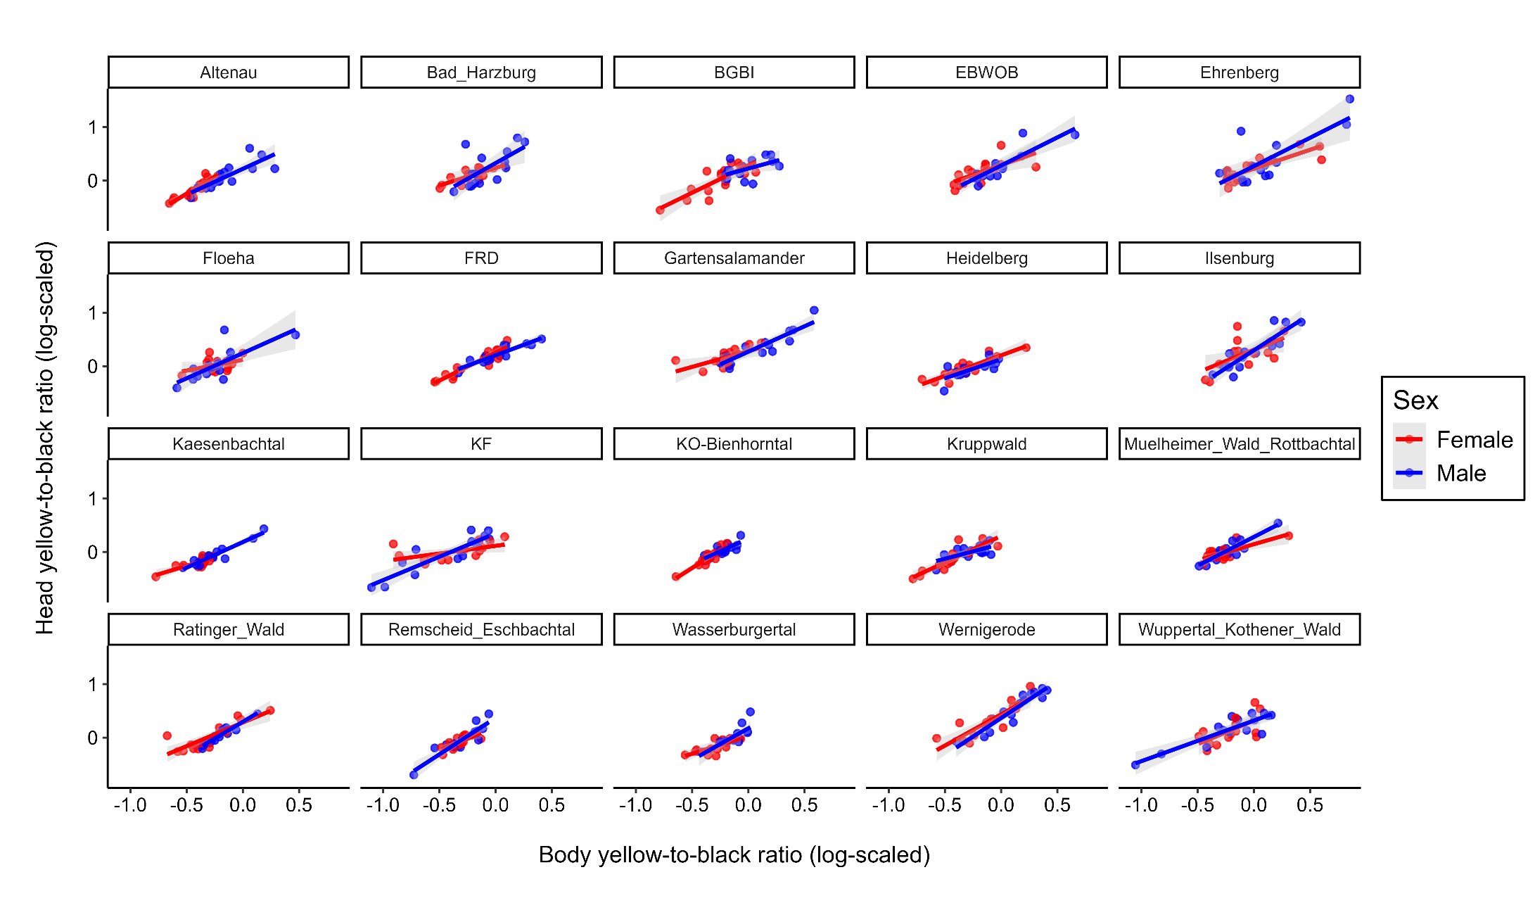

Supplementary Fig. 3 The correlation of the head black-to-yellow-ratio with the body black-to-yellow ratio within each population. The regression lines as well as the dots were colored by sex (red – females, blue – males).

Supplementary Tables

Supplementary Table 1 Conditional and marginal coefficients of determination (R²) for each final model of the statistical analysis. For each model, the model structure is provided.
Model Structure | Conditional R² | Marginal R²
log₁₀(body YB ratio) ~ Sex + (1 + Sex | Population) | 0.30 | 0.06
log₁₀(head YB ratio) ~ Sex + (1 | Population) | 0.29 | 0.04
log₁₀(head YB ratio) ~ log₁₀(body YB ratio) * Sex + (1 + log₁₀(body YB ratio) | Population) | 0.74 | 0.69
log₁₀(head YB ratio) ~ Sex + Temperature Change + NDVI + Latitude + Longitude + Sex:Temperature Change + Sex:NDVI + Sex:Longitude + (1 | Population) | 0.33 | 0.15

Supplementary Table 2 Comparison of each final model with the respective null model (intercept and random effects only model). For each model, the Akaike Information Criterion (AIC) and log-likelihood is provided. For each model comparison, χ2, degrees of freedom (Df) and the P-value are provided.
 |  | AIC | logLik | χ2 | Df | P
Sexual dichromatism in body YB ratio | Null Model | -87.53 | 48.77 | 18.89 | 1 | < 0.01
Sexual dichromatism in body YB ratio | Final Model | -104.42 | 58.21 | 18.89 | 1 | < 0.01
Sexual Dichromatism in head YB ratio | Null Model | 58.27 | -26.13 | 28.78 | 1 | < 0.01
Sexual Dichromatism in head YB ratio | Final Model | 31.48 | -11.74 | 28.78 | 1 | < 0.01
Relationship head YB ratio and body YB ratio | Null Model | -518.63 | 264.32 | 79.57 | 3 | < 0.01
Relationship head YB ratio and body YB ratio | Final Model | -592.20 | 304.10 | 79.57 | 3 | < 0.01
Environmental variables associated with head YB ratio | Null Model | 58.27 | -26.13 | 47.71 | 8 | < 0.01
Environmental variables associated with head YB ratio | Final Model | 26.56 | -2.28 | 47.71 | 8 | < 0.01

References
1. Lüdecke D, Ben-Shachar M, Patil I, Waggoner P, Makowski D. performance: An R Package for Assessment, Comparison and Testing of Statistical Models. JOSS. 2021;6:3139.

