Additional file 10

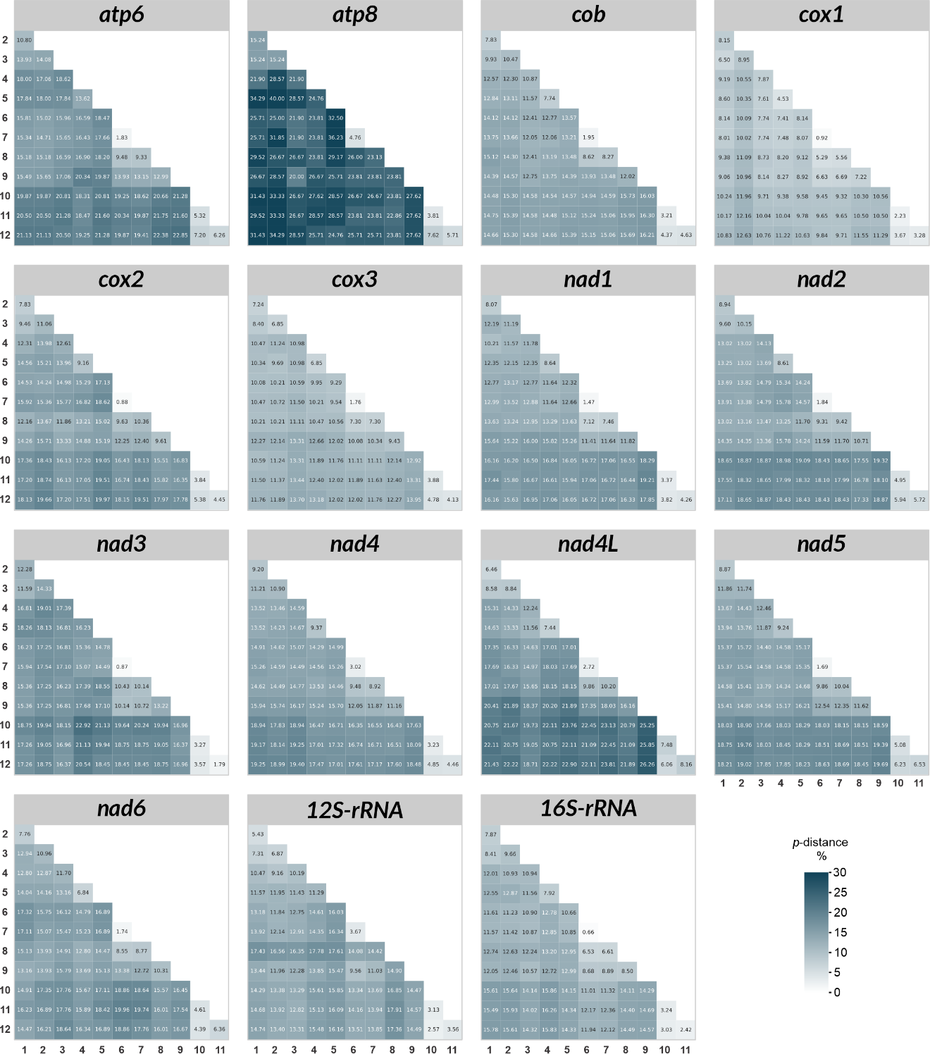
Fig. S8. Heatmap of pairwise genetic distances among Biomphalaria species with complete mitochondrial genomes, based on nucleotide sequences of the 13 PCGs (analysed individually) and the two rRNA genes. Lighter shades indicate lower genetic distances, whereas darker shades denote higher values. Numerical entries in the matrix represent uncorrected p-distance percentages. Labels 1–12 correspond to the species listed in Figure 11.

