Additional file 8

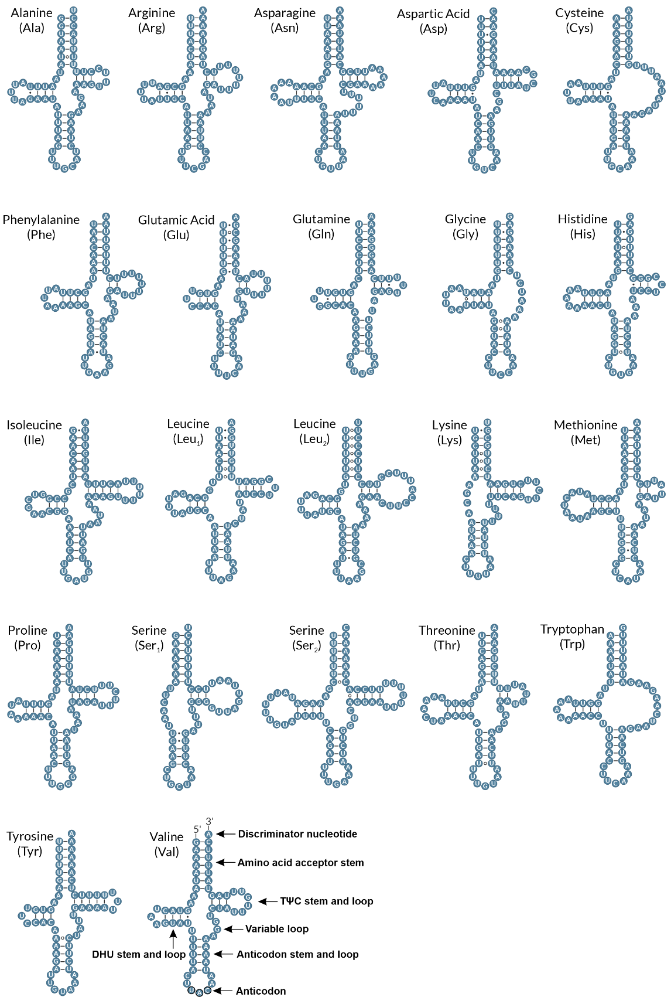
Fig. S2. Predicted secondary structures of the 22 tRNA genes from the mitochondrial genome of Biomphalaria peregrina from Misiones Province, Argentina. Canonical Watson–Crick base pairings are shown with solid lines, wobble G–U pairings with filled circles (•), and mismatches with open circles (⸰).

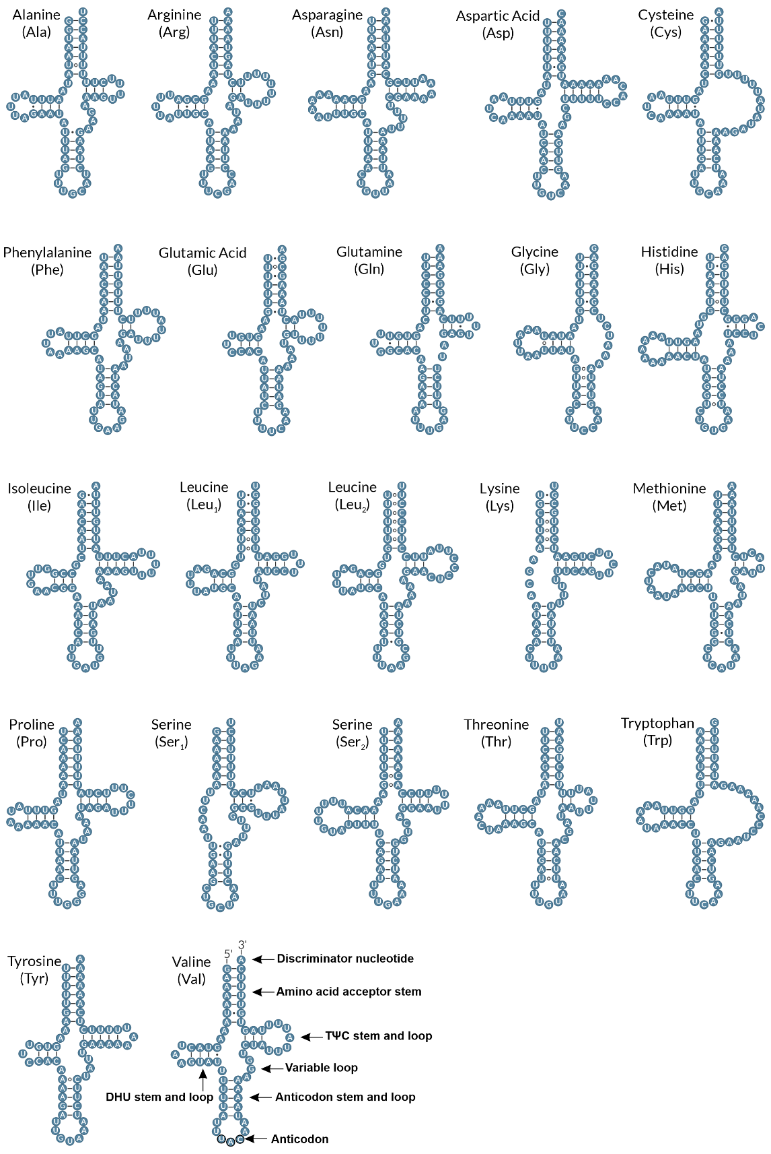
Fig. S3. Predicted secondary structures of the 22 tRNA genes from the mitochondrial genome of Biomphalaria peregrina from Río Negro Province, Argentina. Canonical Watson–Crick base pairings are shown with solid lines, wobble G–U pairings with filled circles (•), and mismatches with open circles (⸰).

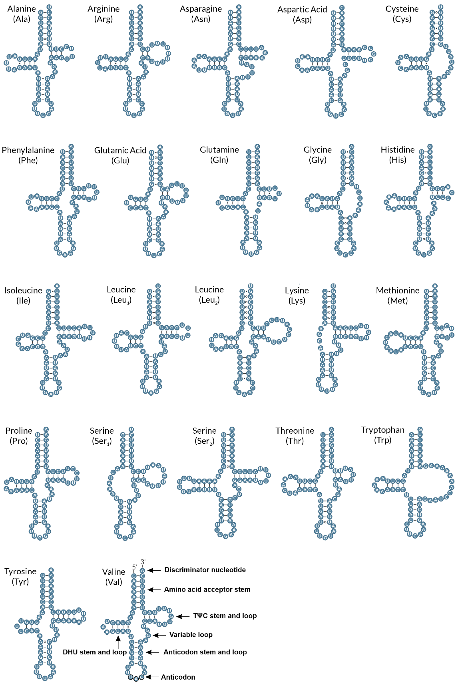
Fig. S4. Predicted secondary structures of the 22 tRNA genes from the mitochondrial genome of Biomphalaria peregrina from Buenos Aires Province, Argentina. Canonical Watson–Crick base pairings are shown with solid lines, wobble G–U pairings with filled circles (•), and mismatches with open circles (⸰).

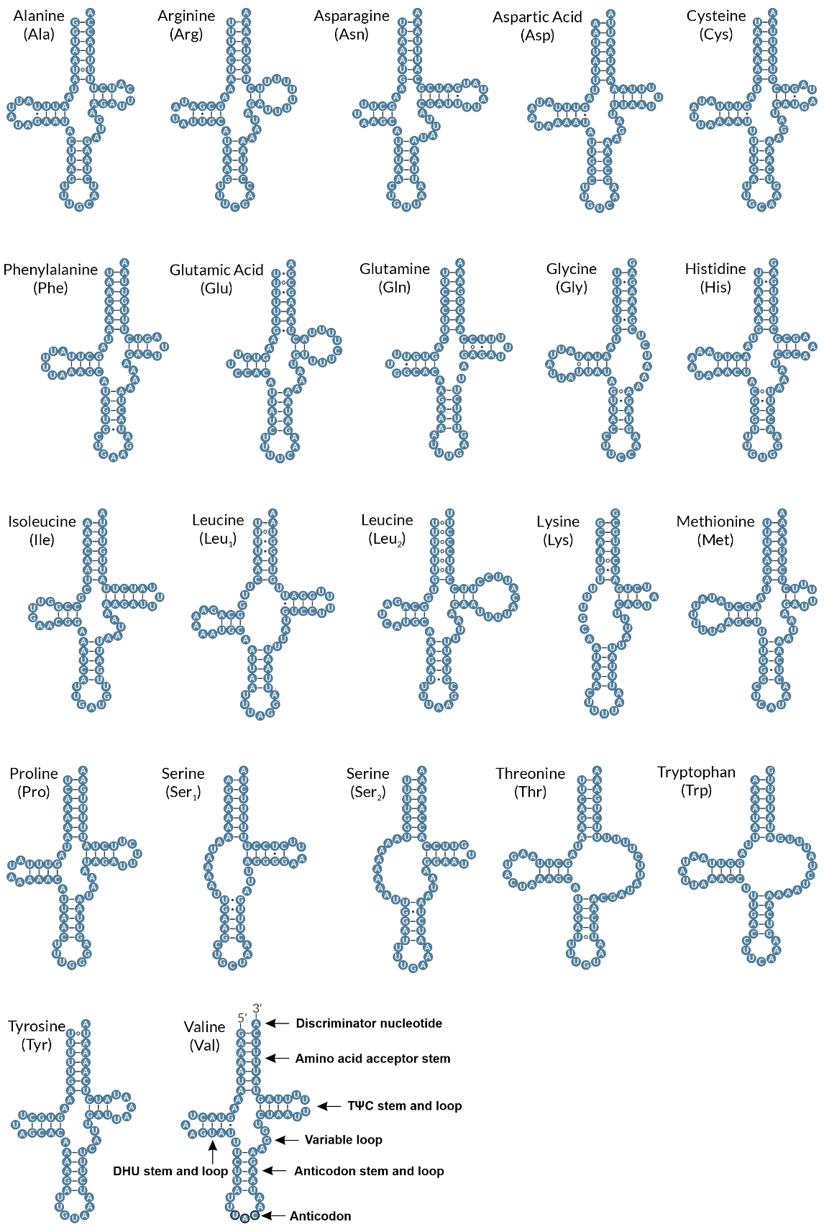
Fig. S5. Predicted secondary structures of the 22 tRNA genes from the mitochondrial genome of Biomphalaria orbignyi from Córdoba Province, Argentina. Canonical Watson–Crick base pairings are shown with solid lines, wobble G–U pairings with filled circles (•), and mismatches with open circles (⸰).

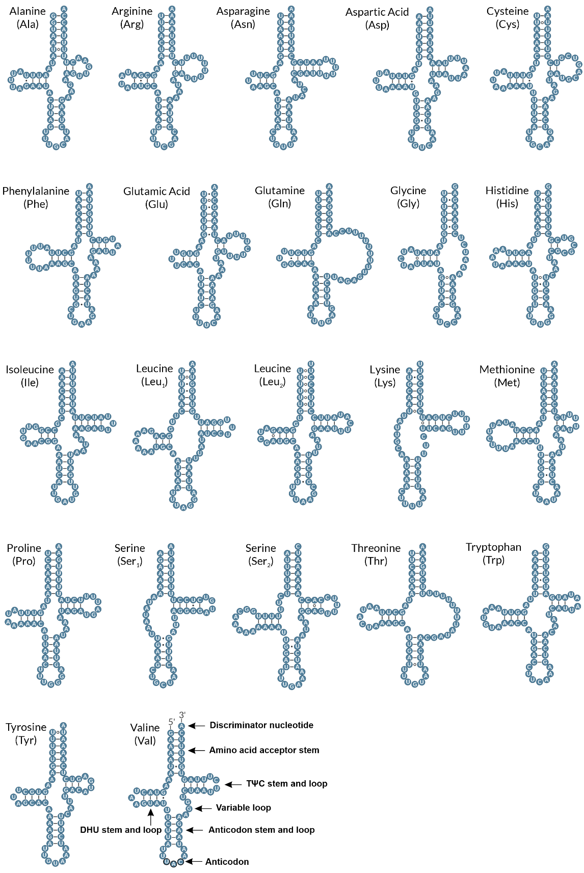
Fig. S6. Predicted secondary structures of the 22 tRNA genes from the mitochondrial genome of Biomphalaria aff. straminea from Corrientes Province, Argentina. Canonical Watson–Crick base pairings are shown with solid lines, wobble G–U pairings with filled circles (•), and mismatches with open circles (⸰).

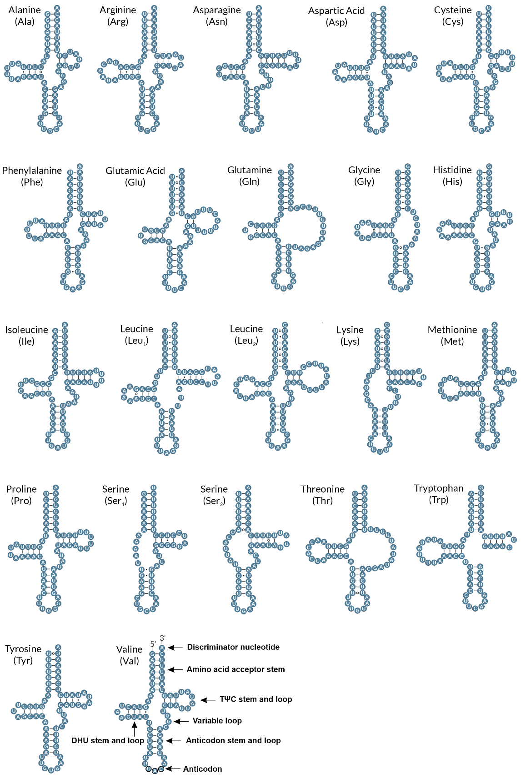
Fig. S7. Predicted secondary structures of the 22 tRNA genes from the mitochondrial genome of Biomphalaria tenagophila from Córdoba Province, Argentina. Canonical Watson–Crick base pairings are shown with solid lines, wobble G–U pairings with filled circles (•), and mismatches with open circles (⸰).

