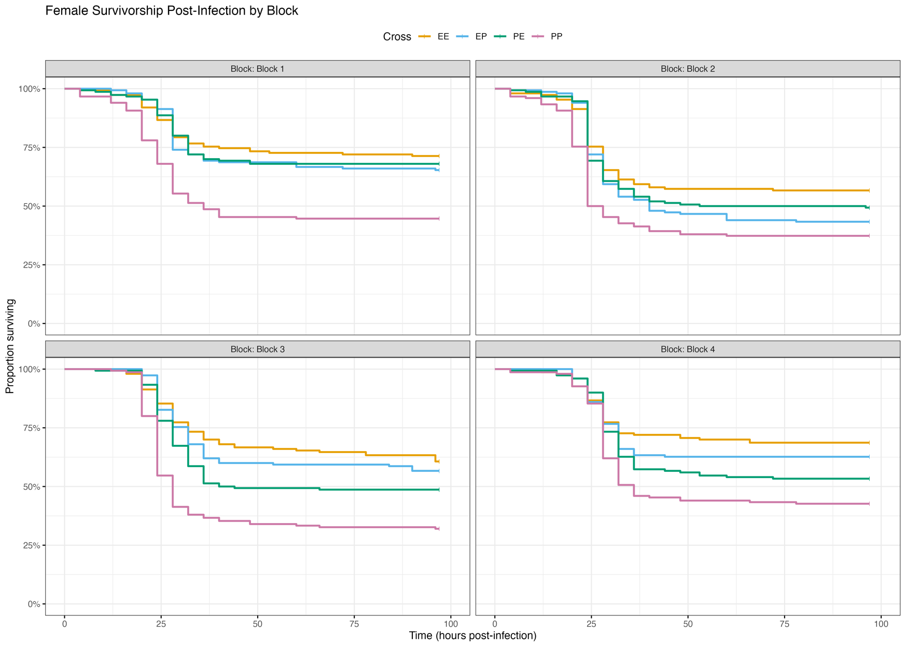

Supplementary Figure 1: Survival proportions of Drosophila genetic crosses (EE, PP, EP, PE) across four experimental blocks (1-4) in females. Kaplan-Meier survival curves show temporal survival patterns following infection, with separate panels for each block. Crosses are color-coded as indicated in the legend .

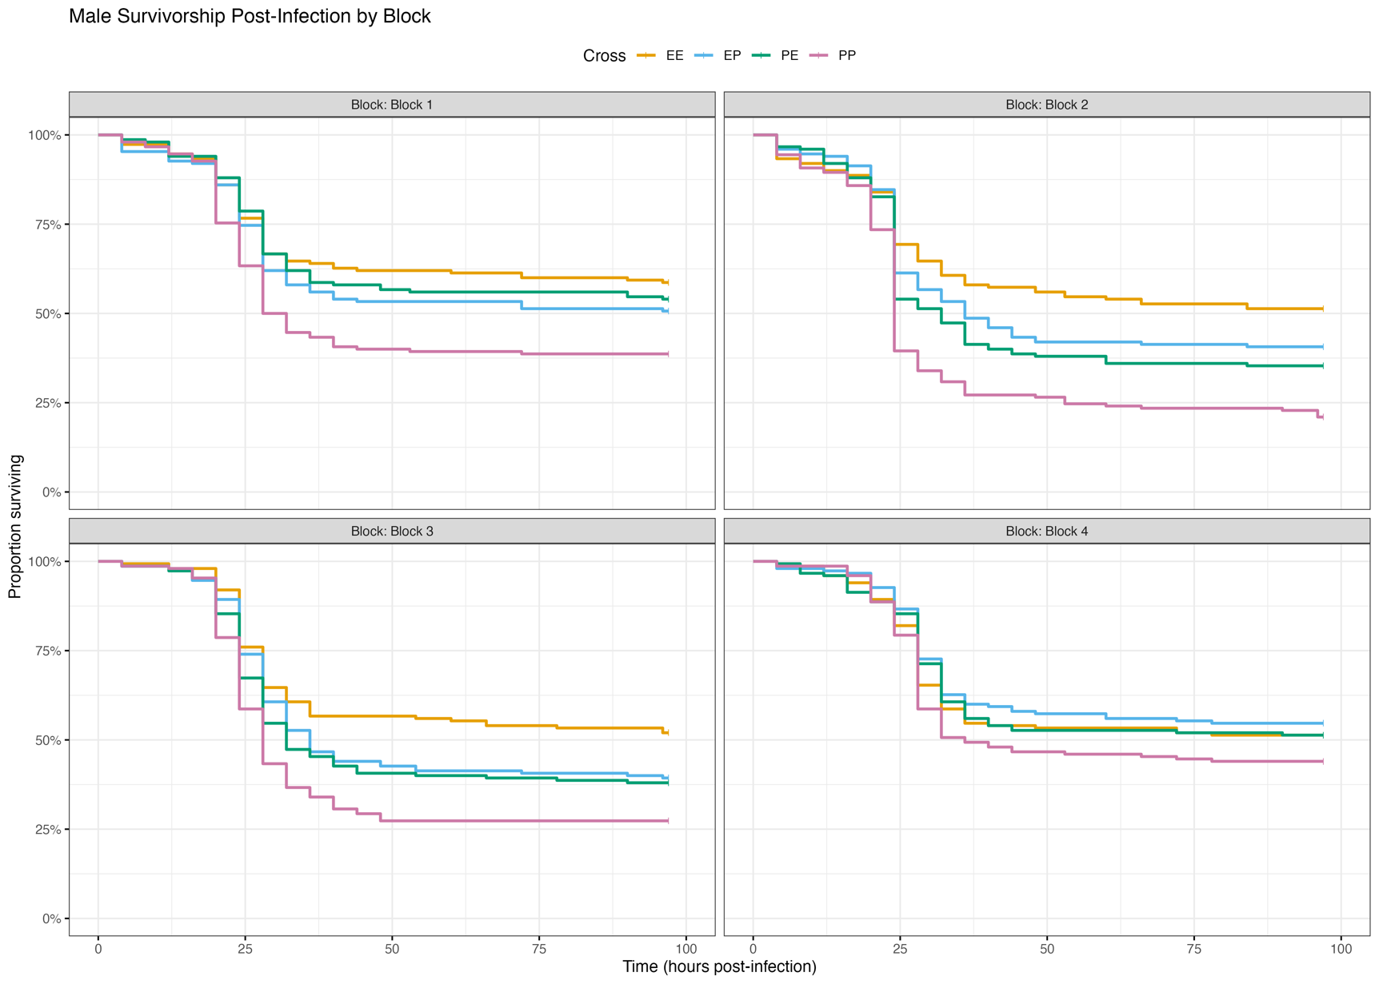

Supplementary Figure 2: Survival proportions of Drosophila genetic crosses (EE, PP, EP, PE) across four experimental blocks (1-4) in males. Kaplan-Meier survival curves show temporal survival patterns following infection, with separate panels for each block. Crosses are color-coded as indicated in the legend .

Supplementary Table 1: Sex-specific differences in immune gene expression across genetic backgrounds and infection time points. Statistical analysis of fold change differences between females and males for four immune genes (duox, dpt, drs, PPO1) across four crosses (PP, EE, EP, PE) at three time points (BI: before infection; 48 HPI: 48 hours post-infection; 96 HPI: 96 hours post-infection). Values represent fold change (FC) differences (Female FC - Male FC) with positive values indicating female-biased expression and negative values indicating male-biased expression. Statistical significance was determined by two-tailed t-test: *p < 0.05, **p < 0.01, ***p < 0.001. Effect sizes were calculated using Cohen's d and categorized as: negligible (|d| < 0.2), small (0.2 ≤ |d| < 0.5), medium (0.5 ≤ |d| < 0.8), or large (|d| ≥ 0.8).

Gene | Cross | Time | Significance | Female FC | Male FC | Difference | Direction | Cohen's d | Effect Size | P-value
dpt | PE | 48 HPI | ** | 22.12 | 83.32 | -61.20 | Male > Female | -7.02 | large | 0.003
dpt | PP | 48 HPI | ** | 3.94 | 130.37 | -126.42 | Male > Female | -13.36 | large | 0.003
dpt | EP | BI | * | 0.55 | 1.27 | -0.72 | Male > Female | -2.75 | large | 0.029
dpt | PE | BI | * | 0.13 | 30.41 | -30.28 | Male > Female | -4.47 | large | 0.031
drs | EE | 48 HPI | ** | 1.07 | 84.02 | -82.96 | Male > Female | -9.27 | large | 0.007
drs | EP | 48 HPI | ** | 2.02 | 107.32 | -105.30 | Male > Female | -8.51 | large | 0.009
drs | PE | 48 HPI | * | 13.98 | 31.36 | -17.38 | Male > Female | -3.60 | large | 0.039
drs | PP | 48 HPI | *** | 7.14 | 111.90 | -104.76 | Male > Female | -18.90 | large | < 0.001
drs | EE | 96 HPI | * | 1.50 | 7.76 | -6.26 | Male > Female | -6.14 | large | 0.015
drs | PE | 96 HPI | * | 1.70 | 21.10 | -19.39 | Male > Female | -6.62 | large | 0.014
drs | PP | 96 HPI | * | 4.40 | 9.77 | -5.37 | Male > Female | -3.34 | large | 0.016
duox | EP | 48 HPI | ** | 3.20 | 0.58 | 2.62 | Female > Male | 7.23 | large | 0.005
duox | PP | 48 HPI | * | 1.79 | 0.83 | 0.96 | Female > Male | 4.18 | large | 0.012
duox | PE | 96 HPI | * | 7.52 | 0.23 | 7.29 | Female > Male | 5.01 | large | 0.025
duox | PP | 96 HPI | * | 2.59 | 1.47 | 1.11 | Female > Male | 3.60 | large | 0.039
duox | PP | BI | * | 4.69 | 1.01 | 3.69 | Female > Male | 4.94 | large | 0.024
PPO1 | EE | 48 HPI | ** | 0.47 | 4.83 | -4.36 | Male > Female | -16.97 | large | 0.001
PPO1 | EP | 48 HPI | ** | 0.29 | 1.56 | -1.27 | Male > Female | -6.23 | large | 0.005
PPO1 | PP | 48 HPI | * | 0.20 | 2.01 | -1.82 | Male > Female | -4.75 | large | 0.024
PPO1 | EE | 96 HPI | * | 0.47 | 2.48 | -2.01 | Male > Female | -7.22 | large | 0.011
PPO1 | PE | 96 HPI | * | 0.61 | 1.14 | -0.53 | Male > Female | -3.41 | large | 0.040
PPO1 | PP | 96 HPI | * | 0.31 | 2.94 | -2.63 | Male > Female | -7.03 | large | 0.012
PPO1 | EE | BI | * | 0.10 | 0.47 | -0.37 | Male > Female | -4.21 | large | 0.026
PPO1 | PE | BI | ** | 0.16 | 1.17 | -1.01 | Male > Female | -6.71 | large | 0.002
PPO1 | PP | BI | ** | 0.14 | 1.01 | -0.87 | Male > Female | -5.72 | large | 0.009

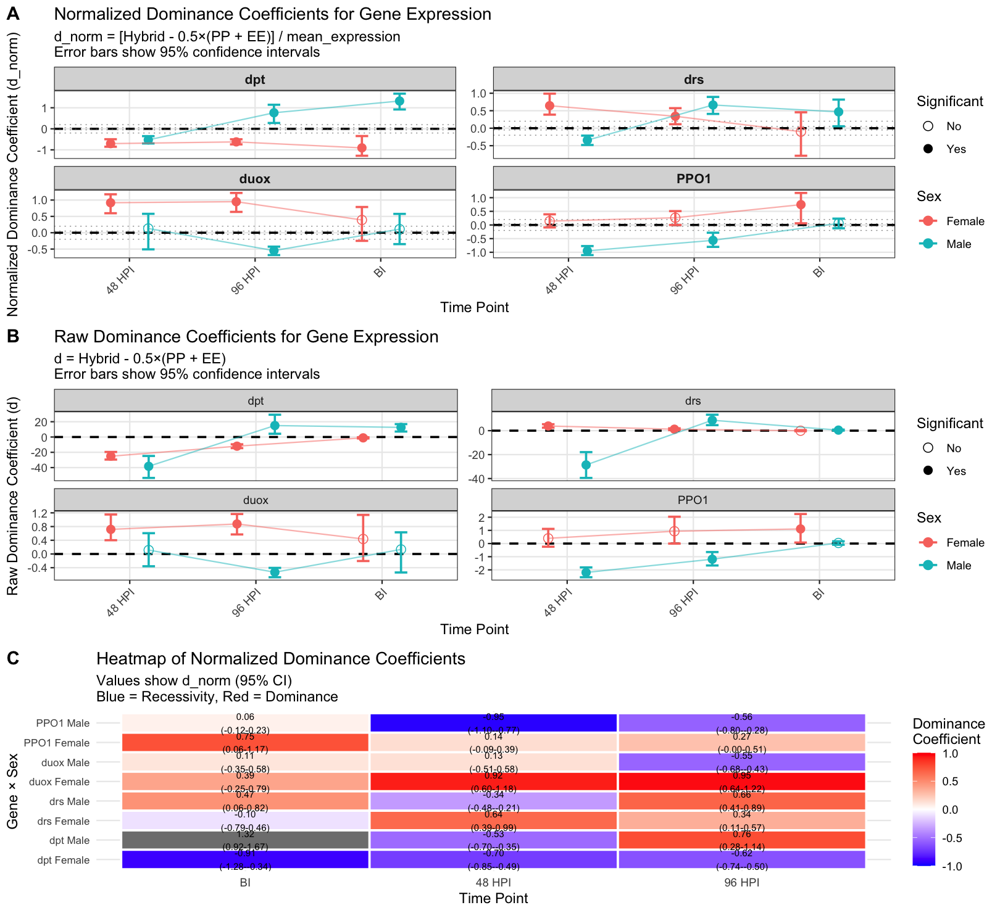

Supplementary Figure 3: Gene expression dominance in hybrids relative to evolved (EE) and control (PP) populations. (A) Normalized Coefficients (d_norm): $[Hybrid-0.5×(PP+EE)]/mean_expression$. Values near 0 are additive; >0 indicates E allele dominance; <0 indicates E allele recessivity. (B) Raw Coefficients (d): $Hybrid-0.5×(PP+EE)$, showing absolute expression difference. In A & B, points are jittered; error bars are 95% CI. Filled points are statistically significant. (C) Heatmap of d_norm: Visual summary of coefficients from panel A. Red indicates dominance; blue indicates recessivity. Values and 95% CIs are shown.

Supplementary Table S2: Summary of dominance coefficients for immune gene expression.
The table presents raw (d) and normalized (d_norm) dominance coefficients for four immune genes across sexes and time points (BI, 48 HPI, 96 HPI)

Gene | Sex | Time | d_point | d_ci_lower | d_ci_upper | d | mean_expression | d_norm | interpretation | significant
duox | Male | BI | 0.133 | -0.539 | 0.631 | 0.133 | 1.205 | 0.110 | Moderate Dominance | No
duox | Male | 48 HPI | 0.114 | -0.358 | 0.607 | 0.114 | 0.874 | 0.130 | Moderate Dominance | No
duox | Male | 96 HPI | -0.532 | -0.679 | -0.406 | -0.532 | 0.972 | -0.548 | Strong Recessivity | Yes
dpt | Male | BI | 12.606 | 7.156 | 16.897 | 12.606 | 9.539 | 1.322 | Strong Dominance | Yes
dpt | Male | 48 HPI | -38.291 | -53.543 | -24.757 | -38.291 | 72.755 | -0.526 | Strong Recessivity | Yes
dpt | Male | 96 HPI | 15.013 | 4.267 | 29.186 | 15.013 | 19.695 | 0.762 | Strong Dominance | Yes
drs | Male | BI | 0.456 | 0.050 | 0.882 | 0.456 | 0.977 | 0.467 | Strong Dominance | Yes
drs | Male | 48 HPI | -28.622 | -39.492 | -17.940 | -28.622 | 83.651 | -0.342 | Strong Recessivity | Yes
drs | Male | 96 HPI | 8.717 | 4.590 | 13.314 | 8.717 | 13.127 | 0.664 | Strong Dominance | Yes
PPO1 | Male | BI | 0.045 | -0.093 | 0.172 | 0.045 | 0.761 | 0.059 | Moderate Dominance | No
PPO1 | Male | 48 HPI | -2.199 | -2.561 | -1.816 | -2.199 | 2.322 | -0.947 | Strong Recessivity | Yes
PPO1 | Male | 96 HPI | -1.189 | -1.666 | -0.647 | -1.189 | 2.114 | -0.563 | Strong Recessivity | Yes
duox | Female | BI | 0.438 | -0.205 | 1.139 | 0.438 | 1.121 | 0.390 | Strong Dominance | No
duox | Female | 48 HPI | 0.718 | 0.402 | 1.152 | 0.718 | 0.782 | 0.918 | Strong Dominance | Yes
duox | Female | 96 HPI | 0.876 | 0.570 | 1.166 | 0.876 | 0.921 | 0.951 | Strong Dominance | Yes
dpt | Female | BI | -1.089 | -1.879 | -0.318 | -1.089 | 1.203 | -0.906 | Strong Recessivity | Yes
dpt | Female | 48 HPI | -25.097 | -29.501 | -19.537 | -25.097 | 35.653 | -0.704 | Strong Recessivity | Yes
dpt | Female | 96 HPI | -11.982 | -14.516 | -9.504 | -11.982 | 19.285 | -0.621 | Strong Recessivity | Yes
drs | Female | BI | -0.068 | -0.425 | 0.431 | -0.068 | 0.689 | -0.099 | Moderate Recessivity | No
drs | Female | 48 HPI | 3.897 | 2.486 | 5.371 | s | 6.053 | 0.644 | Strong Dominance | Yes
drs | Female | 96 HPI | 1.216 | 0.437 | 1.965 | 1.216 | 3.561 | 0.341 | Strong Dominance | Yes
PPO1 | Female | BI | 1.110 | 0.075 | 2.244 | 1.110 | 1.489 | 0.746 | Strong Dominance | Yes
PPO1 | Female | 48 HPI | 0.396 | -0.241 | 1.113 | 0.396 | 2.795 | 0.142 | Moderate Dominance | No
PPO1 | Female | 96 HPI | 0.936 | -0.003 | 2.037 | 0.936 | 3.527 | 0.265 | Strong Dominance | No

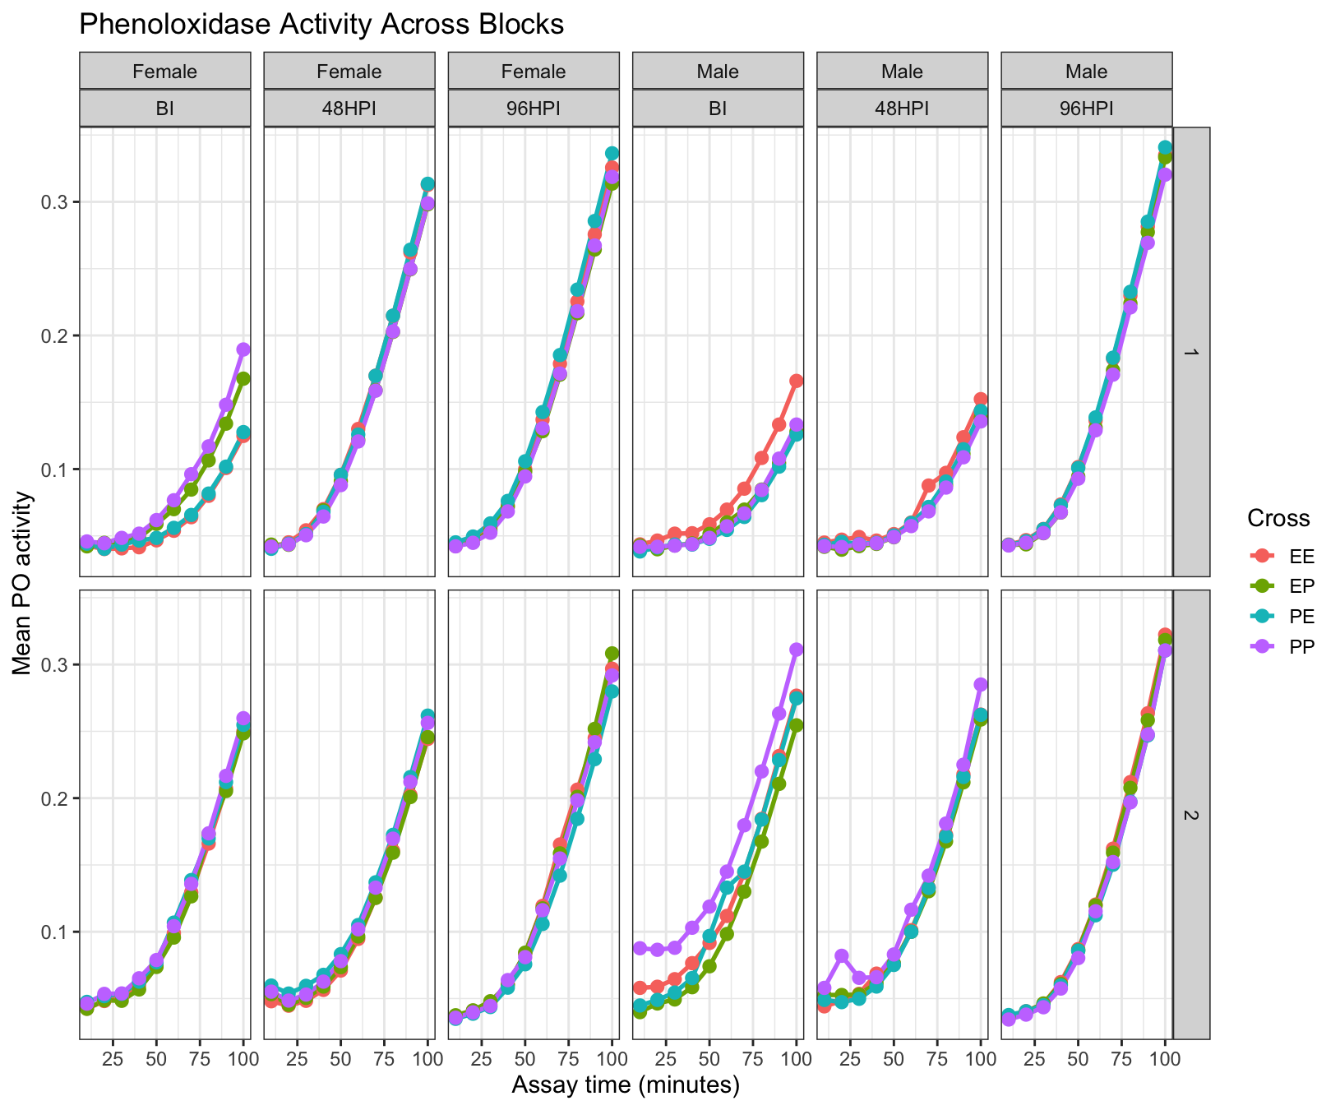

Supplementary Figure S4: Phenoloxidase (PO) activity dynamics across genetic crosses, sexes, infection time points, and experimental blocks.
Mean PO activity is shown as a function of assay time (minutes) for the four genetic crosses (EE, EP, PE, PP), plotted separately for females and males and for each infection time point (BI, 48 HPI, 96 HPI). Panels are faceted by sex and HPI, with experimental blocks displayed as separate rows (Block 1 on top, Block 2 on bottom). Points represent mean absorbance values at each assay time within a block, and lines depict the temporal progression of PO activity. This representation allows direct visual comparison of PO kinetics across blocks while preserving sex- and time-point–specific patterns.

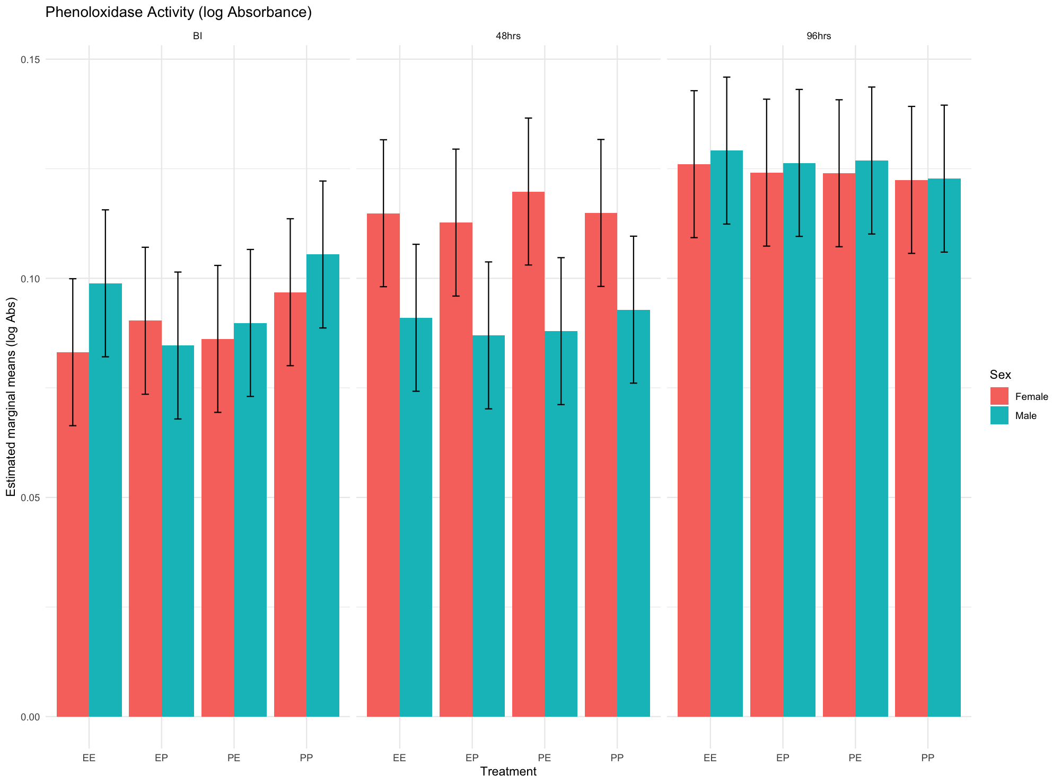

Supplementary Figure S5: Phenoloxidase activity (log absorbance) across crosses, sexes, and time points.
Estimated marginal means (± SE) of phenoloxidase (PO) activity are shown for four genetic crosses (EE, EP, PE, PP) at three time points: before infection (BI), 48 hours post-infection, and 96 hours post-infection. Bars represent females (red) and males (teal). Across all crosses, PO activity increases with time since infection, with the highest activity observed at 96 hours.

