Escarpment refugia under threat: climate-driven redistribution modeling of endemic flora in Saudi Arabia

Supplementary material
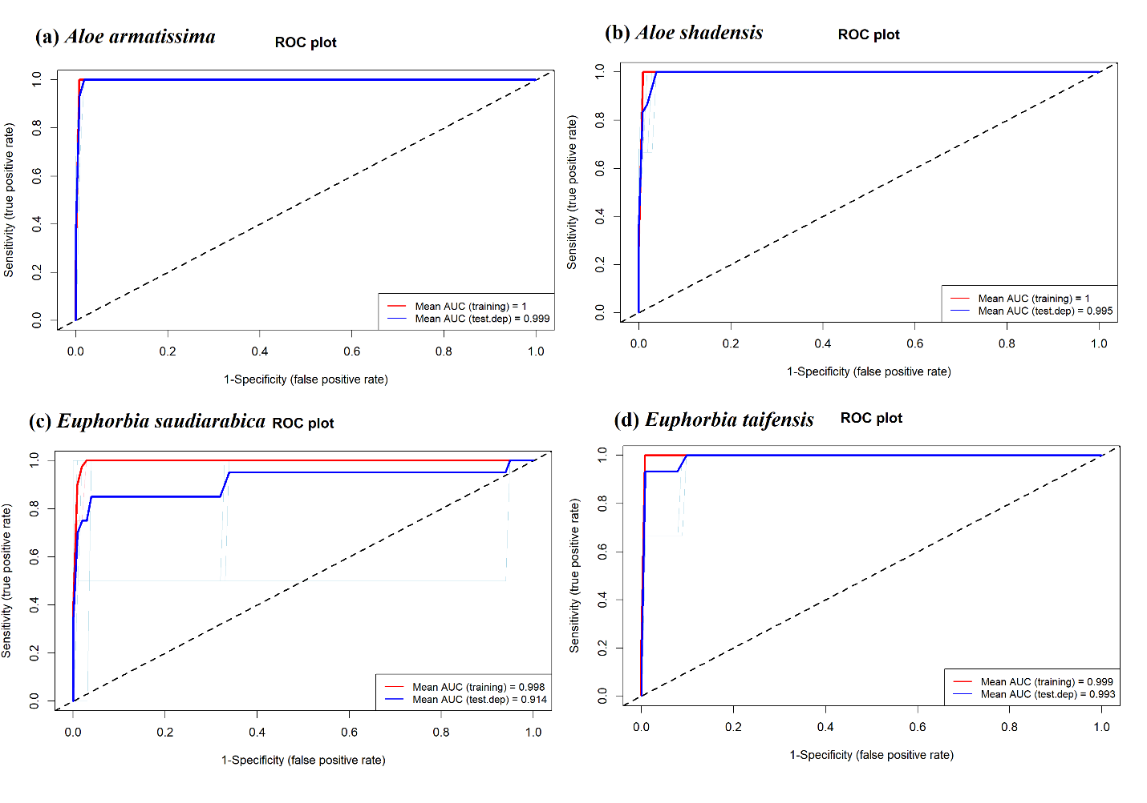
Figure S1. Receiver operating characteristic (ROC) curves for MaxEnt models developed for four endemic plant species in Saudi Arabia: (a) A. armatissima, (b) A. shadensis, (c) E. saudiarabica, and (d) E. taifensis.
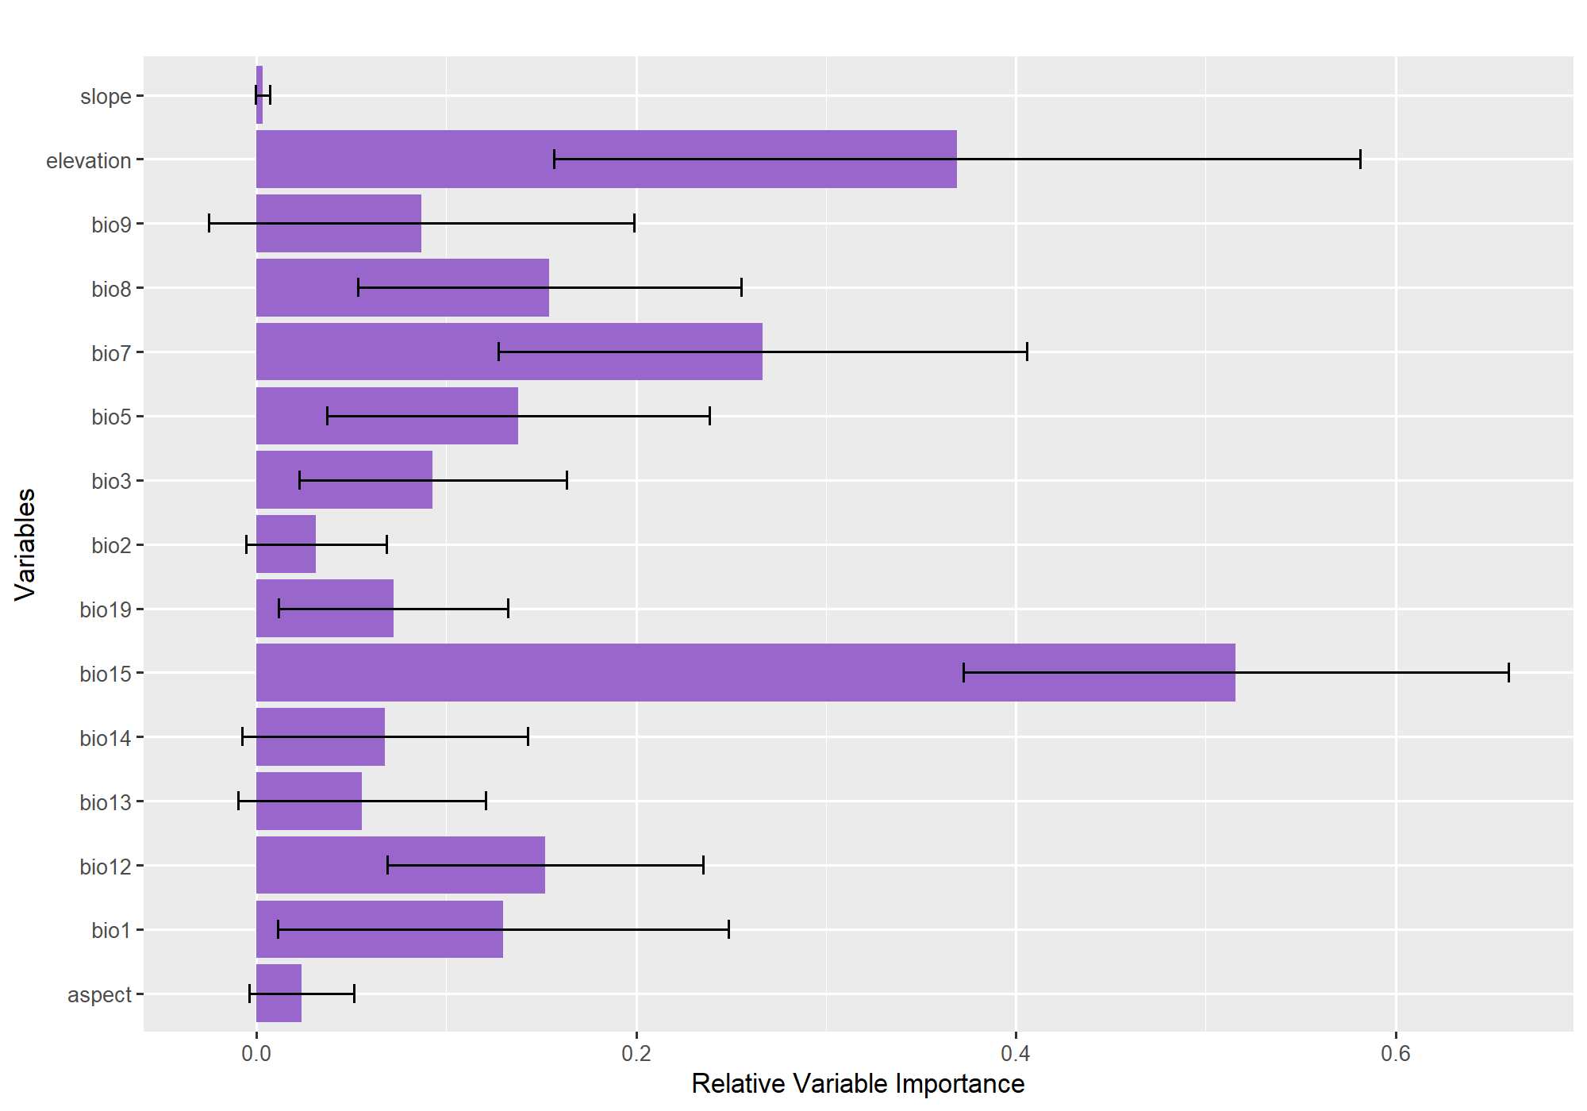
Figure S2. Relative importance of environmental predictors in the MaxEnt models for endemic plant species in Saudi Arabia. Bars represent mean relative contribution values across replicated runs, and horizontal error bars indicate variability among replicates.
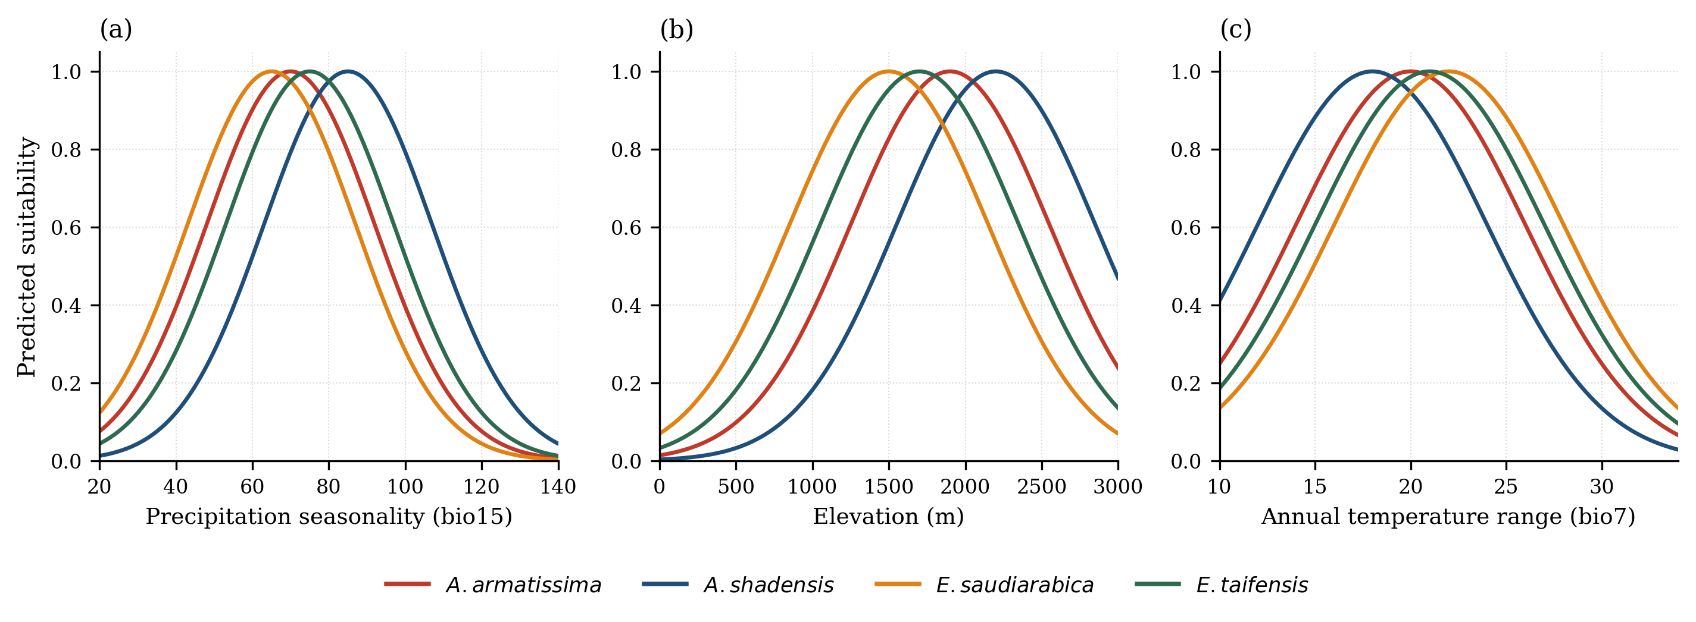
Figure S3. Marginal MaxEnt response curves showing how predicted habitat suitability varies along the three most influential predictors (a) precipitation seasonality (bio15), (b) elevation, and (c) annual temperature range (bio7) for each of the four endemic species. Each curve shows the modelled suitability for a predictor when the remaining predictors are held at their mean values.

