Appendix 1 – Supplemental Tables
Table S1 Final acoustic parameters used in cluster model and associated reasoning, including minimum frequency (min freq), maximum frequency (max freq), the maximum intersyllable gap (max intersyllable gap), the minimum duration (min duration), the maximum duration (max duration), the fast Fourier transform window (FFT window), and maximum distance to the cluster centre (max dist to cluster). Parameters were chosen based on previous literature on turtle vocalizations, and subsequently modified to fit the dataset.
Parameter | Value | Reasoning
Min freq | 1500 Hz | There were numerous non-target sounds at sound frequencies below 1500Hz (e.g., anthropogenic noise), and the average dominant frequency of vocalizations generally ranges above this minimum frequency.
Max freq | 10000 Hz | Non-target sounds are found above 10000 Hz (e.g., distorted noise, birds) and the average dominant frequency of a turtle calls range below this maximum frequency.
Max intersyllable gap | 0.15s | This value is conservative as it limits the number of non-target movement sounds from being included, and syllable gaps between turtle vocalisations generally do not extend this range.
Min duration | 0s | The minimum duration of a single pulse (syllable) of a turtle vocalization can range below 0.001 seconds.
Max duration | 0.3s | On average, the maximum duration of a single turtle vocalization pulse/syllable can range to a maximum of 0.3 seconds.
FFT window | 1042ms | The FFT window optimizes the temporal and frequency resolutions of each vocalization. For vocalization types 3-6, higher temporal resolution (low FFT) is necessary to discriminate each broadband pulse. For vocalization types 1-2, higher frequency resolution (high FFT) is necessary to discriminate each harmonic band. A 1042 ms FFT window was optimal to discriminate pulses and harmonic bands of each vocalization detected, as higher FFT settings resulted in poor discrimination between vocalizations with broadband pulses and broadband movement sounds.
Max dist to cluster | 2 | Max distance to cluster ensures that all audio detections are included in the output, irrespective of their similarity to the cluster centre.

Table S2 Criteria used to manually label and extract painted turtle vocalizations
 | Criteria | Reason
1 | Length of vocalization | Past publications have found that most turtle vocalizations are not prolonged and last anywhere from 0.001s to 3 seconds. We conservatively investigated sounds up to 3 seconds, as turtles sounds are generally a fraction of a second.
2 | Symmetry of spectrogram | Many vocalizations exhibit a symmetrical structure when visualised on a spectrogram, indicating a noise of biological origin.
3 | Comparison to mechanical test extractions | We compared the simulations of non-vocal sounds with a model turtle to audio extractions. Sounds that matched the spectral characteristics of the simulated non-vocal sounds were removed from analysis.
4 | Comparison to above water sounds | We compared underwater sounds to sounds produced above water to ensure the sound was not reflected into the basin (e.g., bird calls, human noises).
5 | Frequency range | While the full hearing range of C. picta is unknown, non-target anthropogenic noise is often under 1500Hz, while non-target biological noise (humans, birds, insects) can range above 10,000Hz. We investigated sounds between 1500Hz and 10000Hz.
6 | Similarity to other papers | We compared sounds to other papers that described turtle vocalisations.
7 | Presence of “harmonic”-like structures | Harmonics in vocalizations are often produced by a vibration of the vocal apparatus ¹, which relies on the vibration of either a hyoid apparatus or an apparatus with a function analogous to “vocal chords” ². While we cannot confirm the noise production mechanism, we identified low frequency harmonic-like sounds and attributed it to the turtles. We removed any sounds that were an artefact of aliasing or non-linear distortion, indicated by clipping or distortion in the waveform and spectrogram.
¹ Jorgewich-Cohen et al. 2024. Integrative Organismal Biology. https://doi.org/10.1093/iob/obae014
² Russell & Bauer. 2020. The Anatomical Record. https://doi.org/10.1002/ar.24553

Table S3 PERMANOVA model specifications investigating dissimilarity in acoustic functional traits with respect to treatment (a), social context and sex treatment (b). Linear model specification investigating variance-covariance of acoustic traits (value) between treatments and individual vocalisations (units) (c). Poisson hurdle model specifications investigating whether vocalisation abundance and sex treatment predict the probability of interacting or the number of interactions observed (d, e). Variable names are described in Table S5.
model | response | predictor | random effects* | family
a) | dissimilarity | treatment | trial_id | PERMANOVA
b) | dissimilarity | social + sex | trial_id | PERMANOVA
c) | value | trait:(treatment) - 1 | (trait-1|trial_id) + (trait-1|units) | Gaussian
d) | interactions | sex * vocal_abundance | - | poisson (log link)
e) | interactions | sex + vocal_abundance | - | poisson (log link)
* random effects for PERMANOVAs represent stratified blocks.

Table S4 Levels of all categorical variables (treatment, social, sex) used in statistical models and associated descriptions.
Treatment | Social | Sex | Description
M | Solo | Male | 1 male
MM | Together | Male | 2 males
F | Solo | Female | 1 female
FF | Together | Female | 2 females
MF | Together | Mix | 1 male and 1 female

Table S5 description of variables used in statistical models.
Variable Name | Variable Type | Description
value | continuous | Centered and scaled values of each acoustic trait.
trait | categorical | Name for each acoustic trait that was measured including dominant frequency (kHz), maximum frequency (kHz), minimum frequency (kHz), the number of harmonic bands, pulse number, mean pulse length (s), mean pulse length interval (s) and total duration (s).
units | discrete | Unique identifier for each vocalization.
treatment | categorical | Experimental treatments with 5 levels (M = 1 male, MM = 2 males, MF = 1 male and 1 female, FF = 2 females, F = female)
trial_ID | discrete | A unique identifier for each combination of trial (7 total) and treatment (5 total).
dissimilarity | matrix | Euclidean dissimilarity index from centered and scaled vocalization traits (dominant frequency, maximum frequency, minimum frequency, the presence of harmonic bands, pulse number, mean pulse length, mean pulse length interval and total duration).
social | categorical | Experimental treatments grouped into 2 levels based on the number of turtles in a treatment (solo = F and M, together = FF, MM and MF)
sex | categorical | Experimental treatments grouped into 3 levels based on the turtle’s sex (female = F and FF, male = M and MM, mix = MF )
vocal abundance | integer/continuous | The total number of vocalizations recorded for each 1-hour trial of each treatment.
interactions | integer/continuous | number of times turtles were in the same subsection of the experimental tank as their conspecific. Number of interactions were modelled for the presence of sociality (0,1) and the magnitude of social interactions (>1).

Table S6 PERMANOVA results. Model specification and variable names are described in Tables S3,S5.
 | Df | Sums of squares | R2 | F statistic | P-Value*
a) dissimilarity ~ treatment
treatment | 4 | 16.221 | 0.0567 | 2.178 | <0.001***
residual | 145 | 269.925 | 0.943 | - | -
Total | 149 | 289.147 | 1 | - | -
b) dissimilarity ~ social + sex
social | 1 | 2.229 | 0.00779 | 1.198 | 0.401
sex | 2 | 10.927 | 0.0382 | 2.935 | <0.001***
residual | 146 | 271.771 | 0.950 | - | -
Total | 149 | 286.147 | 1 | - | -
* Significance codes: ‘***’ <0.001; ‘**’ = 0.01; ‘*’= 0.05; ‘ ’ = 1

Table S7 PERMANOVA pairwise comparison results, comparing vocalisation functional trait dissimilarity across treatments. Model specification and variable names are described in Tables S3,S5.
 | df | SS | R2 | F | P |  | df | SS | R2 | F | P
a) MF_vs_F |  |  |  |  |  | b) MF_vs_MM
treatment | 1 | 3.802 | 0.033 | 2.152 | 0.010 | treatment | 1 | 4.198 | 0.025 | 2.043 | 0.026
residual | 64 | 113.1 | 0.967 | - | - | residual | 81 | 166.4 | 0.975 | - | -
total | 65 | 116.9 | 1 | - | - | total | 82 | 170.6 | 1 | - | -
c) MF_vs_M |  |  |  |  |  | d) MF_vs_FF
treatment | 1 | 3.581 | 0.033 | 1.801 | 0.037 | treatment | 1 | 2.664 | 0.026 | 1.543 | 0.088
residual | 53 | 105.4 | 0.967 | - | - | residual | 58 | 100.1 | 0.974 | - | -
total | 54 | 109.0 | 1 | - | - | total | 59 | 102.8 | 1 | - | -
e) F_vs_MM |  |  |  |  |  | f) F_vs_M
treatment | 1 | 7.907 | 0.055 | 4.124 | <0.001 | treatment | 1 | 4.79 | 0.060 | 2.746 | <0.001
residual | 71 | 136.1 | 0.945 | - | - | residual | 43 | 75.07 | 0.940 | - | -
total | 72 | 144.0 | 1 | - | - | total | 44 | 79.86 | 1 | - | -
g) F_vs_FF |  |  |  |  |  | h) MM_vs_M
treatment | 1 | 2.703 | 0.037 | 1.858 | 0.021 | treatment | 1 | 1.372 | 0.011 | 0.641 | 0.824
residual | 48 | 69.82 | 0.963 | - | - | residual | 60 | 128.4 | 0.989 | - | -
total | 49 | 72.53 | 1 | - | - | total | 61 | 129.8 | 1 | - | -
i) MM_vs_FF |  |  |  |  |  | j) M_vs_FF
treatment | 1 | 4.917 | 0.038 | 2.595 | 0.007 | treatment | 1 | 3.444 | 0.053 | 2.052 | 0.017
residual | 65 | 123.2 | 0.962 | - | - | residual | 37 | 62.10 | 0.947 | - | -
total | 66 | 128.1 | 1 | - | - | total | 38 | 65.55 | 1 | - | -

Table S8 Analysis of Variance Table showing results from an analysis of multivariate homogeneity of group dispersions. We tested whether distances from group centres (variances) were different among (a) sex treatments (male, female, mix), (b) social treatments (together or solo) and (c) treatments (M, MM, MF, F, FF).

 | DF | Sums of Square | Mean Square | F value | P value
a) sex
Groups | 2 | 22.503 | 11.252 | 5.797 | 0.00377
Residuals | 147 | 285.307 | 1.941
b) social
Groups | 1 | 1.741 | 1.741 | 0.796 | 0.374
Residuals | 148 | 323.600 | 2.186
c) treatment
Groups | 4 | 25.669 | 6.417 | 3.280 | 0.0132
Residuals | 145 | 283.728 | 1.957

Table S9 Table showing results from a tukey test inspecting which treatment groups differing group dispersions. We tested differences among (a) sex treatments (male, female, mix), (b) social treatments (together or solo) and (c) treatments (M, MM, MF, F, FF).

Comparisons | difference | Lower 95% CI | Upper 95% CI | Adjusted  P value
a) sex
male-female | 0.225 | 0.0854 | 0.366 | 0.00313
mix-female | 0.166 | 0.00715 | 0.324 | 0.0813
mix-male | -0.0598 | -0.212 | 0.092 | 0.695
b) social
together-solo | 0.0596 | -0.0524 | 0.172 | 0.380
c) treatment
FF-F | -0.0776 | -0.333 | 0.178 | 0.943
M-F | 0.176 | -0.100 | 0.451 | 0.512
MF-F | 0.145 | -0.0784 | 0.368 | 0.492
MM-F | 0.212 | -0.0042 | 0.428 | 0.112
M-FF | 0.253 | -0.0365 | 0.543 | 0.197
MF-FF | 0.223 | -0.0177 | 0.463 | 0.151
MM-FF | 0.289 | 0.0559 | 0.523 | 0.0206
MF-M | -0.0305 | -0.292 | 0.231 | 0.998
MM-M | 0.0361 | -0.219 | 0.291 | 0.997
MM-MF | 0.0667 | -0.131 | 0.264 | 0.918

Table S10 PERMANOVA pairwise comparison results, comparing vocalisation trait dissimilarity across sex treatments. Model specification and variable names are described in Tables S3,S5.

 | df | SS | R2 | F | P |  | df | SS | R2 | F | P
a) mix_vs_female |  |  |  |  |  | b) mix_vs_male
sex | 1 | 2.664 | 0.018 | 1.600 | 0.0671 | sex | 1 | 4.198 | 0.020 | 2.035 | 0.021
social | 1 | 2.703 | 0.018 | 1.623 | 0.0622 | social | 1 | 1.372 | 0.007 | 0.665 | 0.817
residual | 85 | 141.5 | 0.958 | - | - | residual | 97 | 200.1 | 0.969 | - | -
total | 87 | 147.7 | 1 | - | - | total | 99 | 206.4 | 1 | - | -
c) female_vs_male
sex | 1 | 7.87 | 0.037 | 4.285 | <0.001
social | 1 | 2.229 | 0.011 | 1.214 | 0.235
residual | 109 | 200.1 | 0.946 | - | -
total | 111 | 211.4 | 1 | - | -

Table S11 Poisson model results investigating whether vocalisation abundance and sex treatment predict the number of interactions observed. Variable names are described in Table S5.
 | estimate | SE | Z | P*
intercept | 2.259 | 0.135 | 16.688 | <0.001***
sex (male) | 0.347 | 0.172 | 2.171 | 0.0437*
sex (mix) | 0.257 | 0.171 | 1.504 | 0.1327
vocal abundance | -0.0304 | 0.0145 | -2.095 | 0.0361*
* Significance codes: ‘***’ <0.001; ‘**’ = 0.01; ‘*’= 0.05; ‘ ’ = 1

Table S12 Poisson model pairwise comparisons investigating differences in social interactions among sex treatments. Variable names are described in Table S5.
Contrast | estimate | SE | Z | P*
female - male | -3.47 | 1.72 | -2.018 | 0.108
female - mix | -2.45 | 1.63 | -1.507 | 0.288
male - mix | 1.02 | 1.82 | 0.559 | 0.842
* Significance codes: ‘***’ <0.001; ‘**’ = 0.01; ‘*’= 0.05; ‘ ’ = 1

Appendix 2 – Supplemental Figures
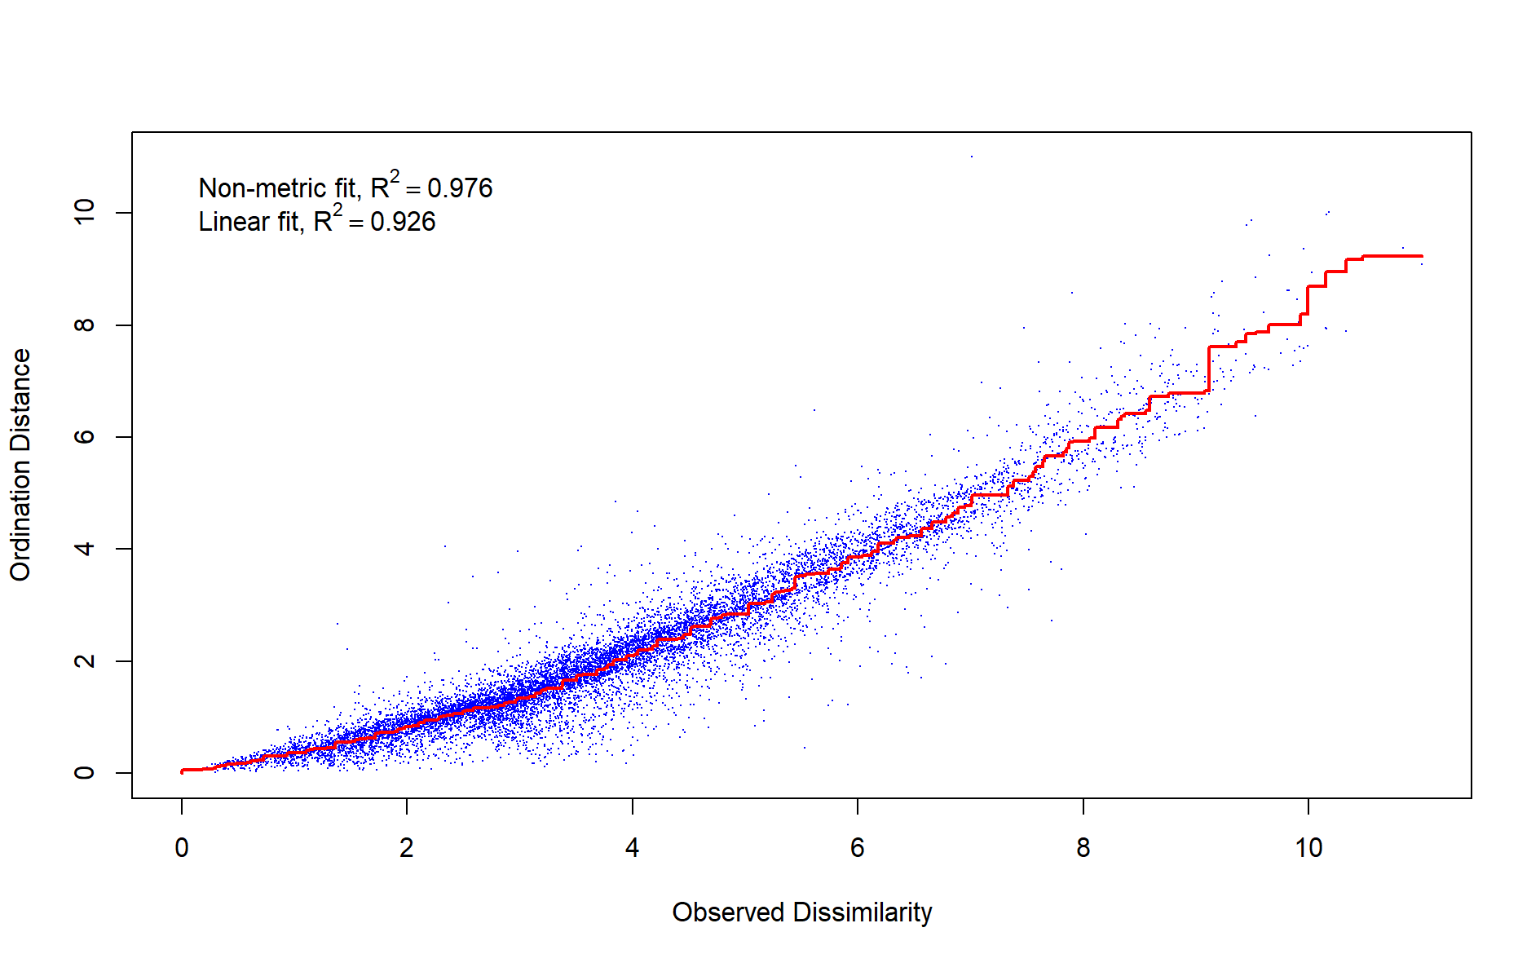
Figure S1 Regression curve showing ordination distance with respect to observed dissimilarity among acoustic functional traits.

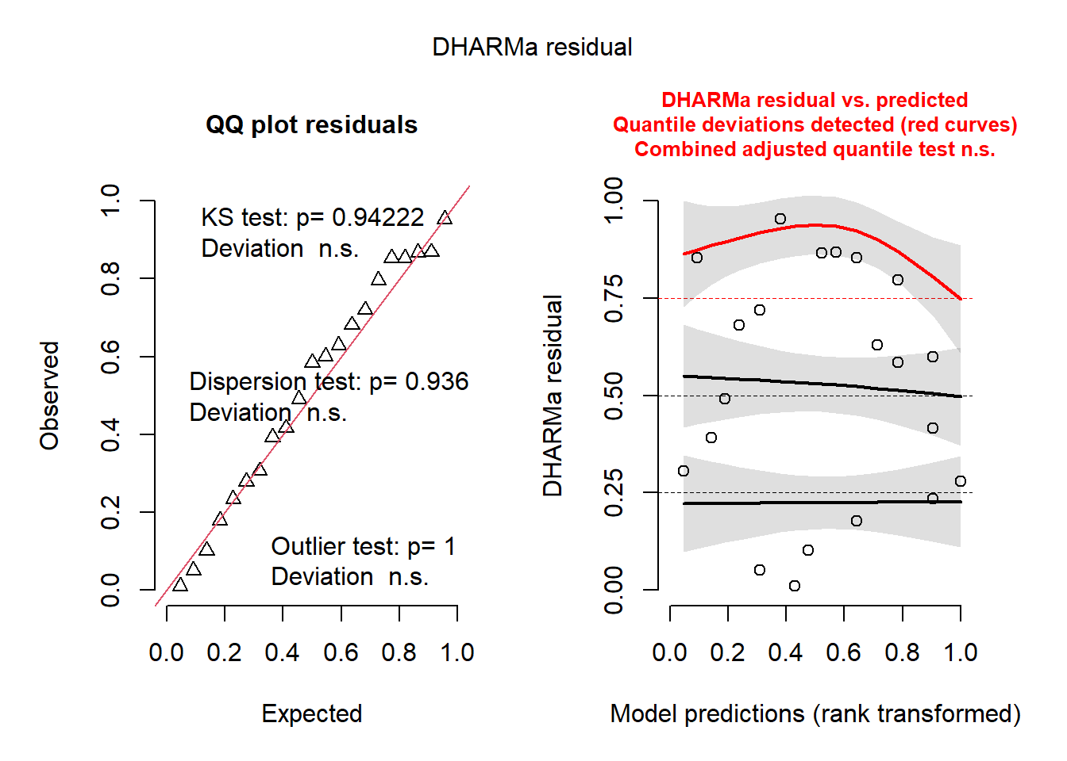
Figure S2 DHARMa residual plot showing model diagnostics for the Poisson model investigating whether vocalization abundance and sex treatment predict the number of interactions observed.

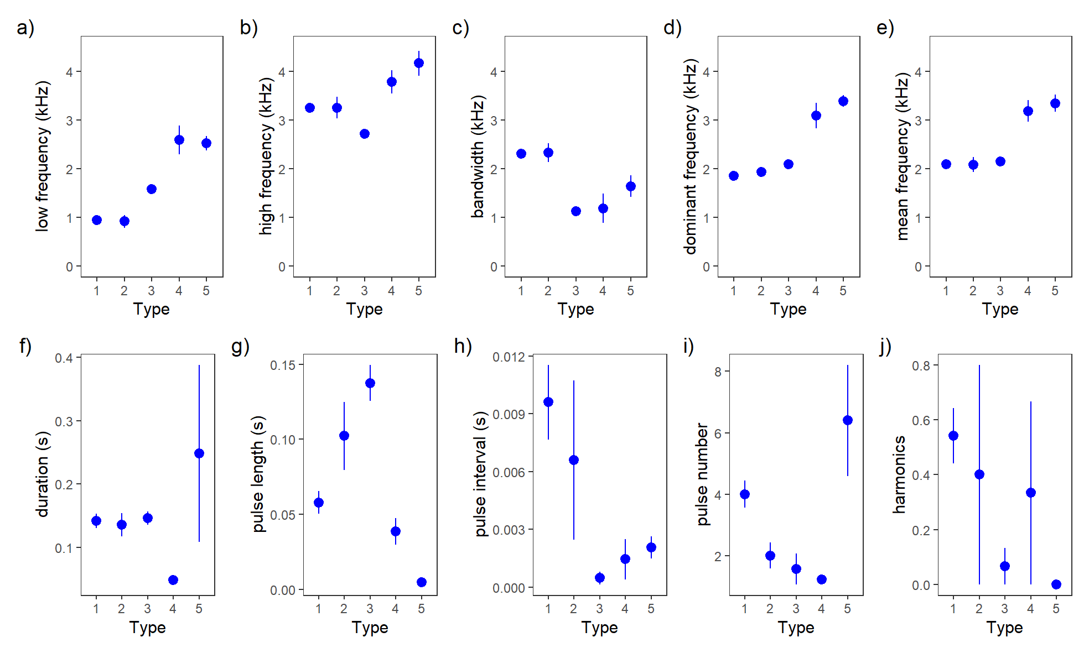

Figure S3 Mean a) minimum frequency, b) maximum frequency, c) bandwidth, d) dominant frequency, e) mean frequency, f) duration, g) pulse length, h) pulse interval length, i) number of pulses, and j) harmonics, with respect to each vocalization type. Error bars show standard errors.

