Identification of genomic regions associated with feed efficiency in Nelore cattle

Additional file 10 - Manhattan plots of QTL regions associated with relative growth rate in Nelore cattle
Figure of Manhattan plots of QTL regions associated with relative growth rate in Nelore cattle. The X-axis represents the chromosomes, and the Y-axis shows the proportion of genetic variance explained by SNP window from Bayes B analysis.

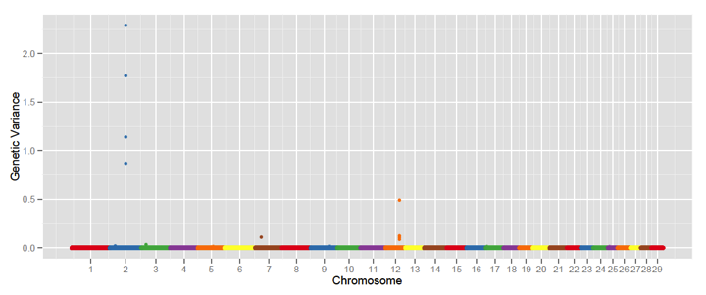
Additional File 10. Manhattan plots of QTL regions associated with relative growth rate in Nelore cattle. The X-axis represents the chromosomes, and the Y-axis shows the proportion of genetic variance explained by SNP window from Bayes B analysis.

