Identification of genomic regions associated with feed efficiency in Nelore cattle

Additional file 2 - Manhattan plots of QTL regions associated with dry matter intake in Nelore cattle
Figure of Manhattan plots of QTL regions associated with dry matter intake in Nelore cattle. The X-axis represents the chromosomes, and the Y-axis shows the proportion of genetic variance explained by SNP window from Bayes B analysis.

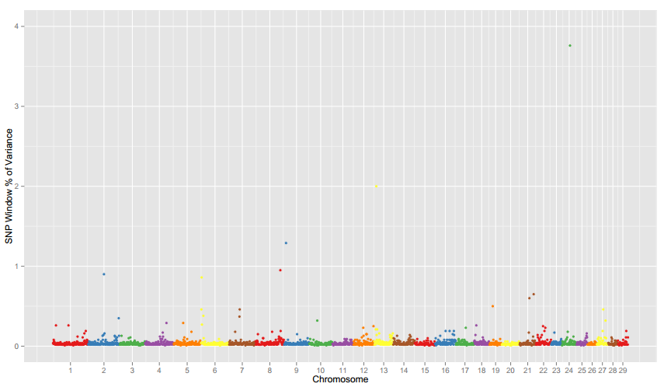

Additional File 2. Manhattan plots of QTL regions associated with dry matter intake in Nelore cattle. The X-axis represents the chromosomes, and the Y-axis shows the proportion of genetic variance explained by SNP window from Bayes B analysis.

