Exploring evidence of positive selection reveals genetic basis of meat quality traits in Berkshire pigs through whole genome sequencing
Authors: Hyeon Soo Jeong, Ki-Duk Song, Minseok Seo, Kelsey Caetano-Anollés, Jaemin Kim, Woori Kwak, Jae-don Oh, EuiSoo Kim, Dong Kee Jeong, Seoae Cho, Heebal Kim, Hak-Kyo Lee

ADDITIONAL FILE 1

Figure 2-12
Figure S1 2
Figure S2 3-6
Figure S3 7-11
Figure S4 12

Figure S1. The distributions of novel SNV and known SNP in each chromosome.
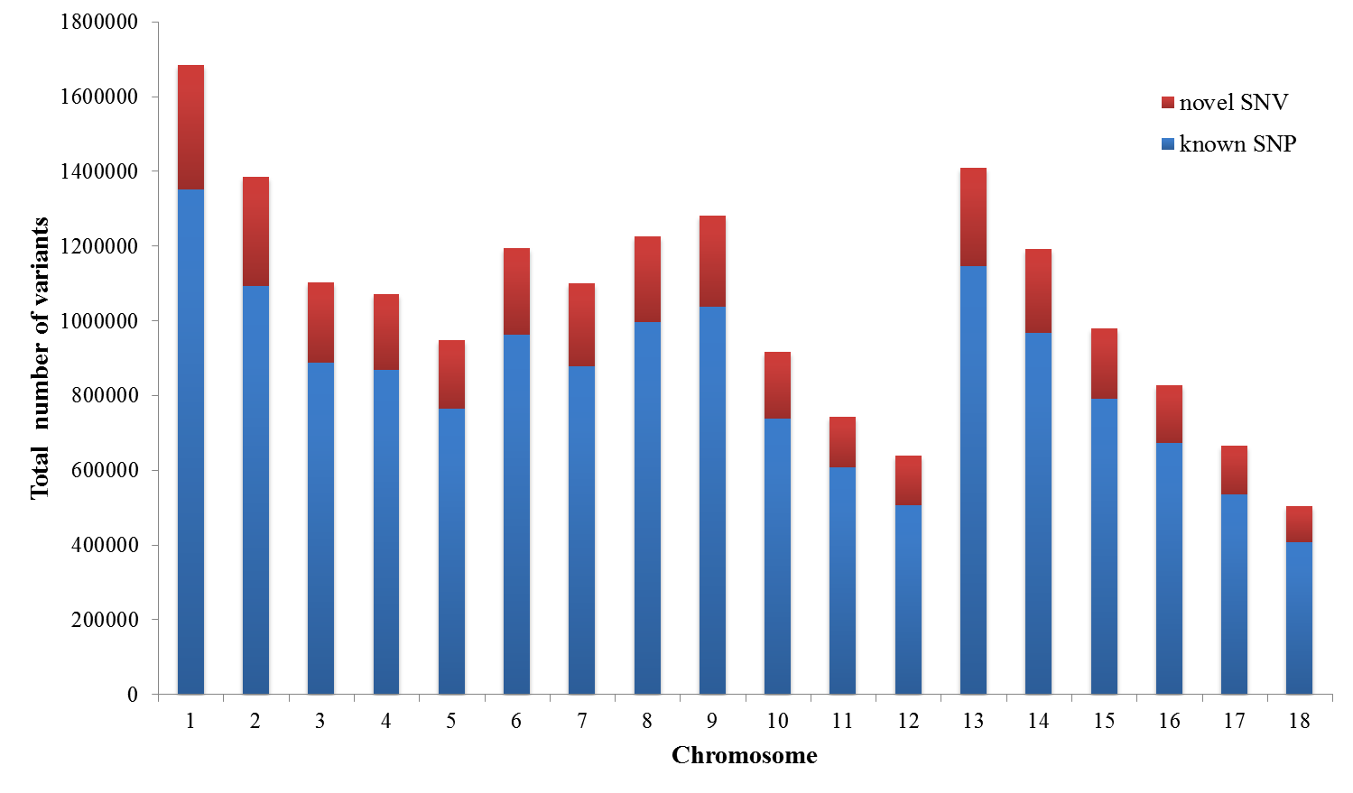

Figure S2. A statistical enrichment test (Fisher’s exact test) for detecting enriched non-synonymous SNP site on targeted genes.
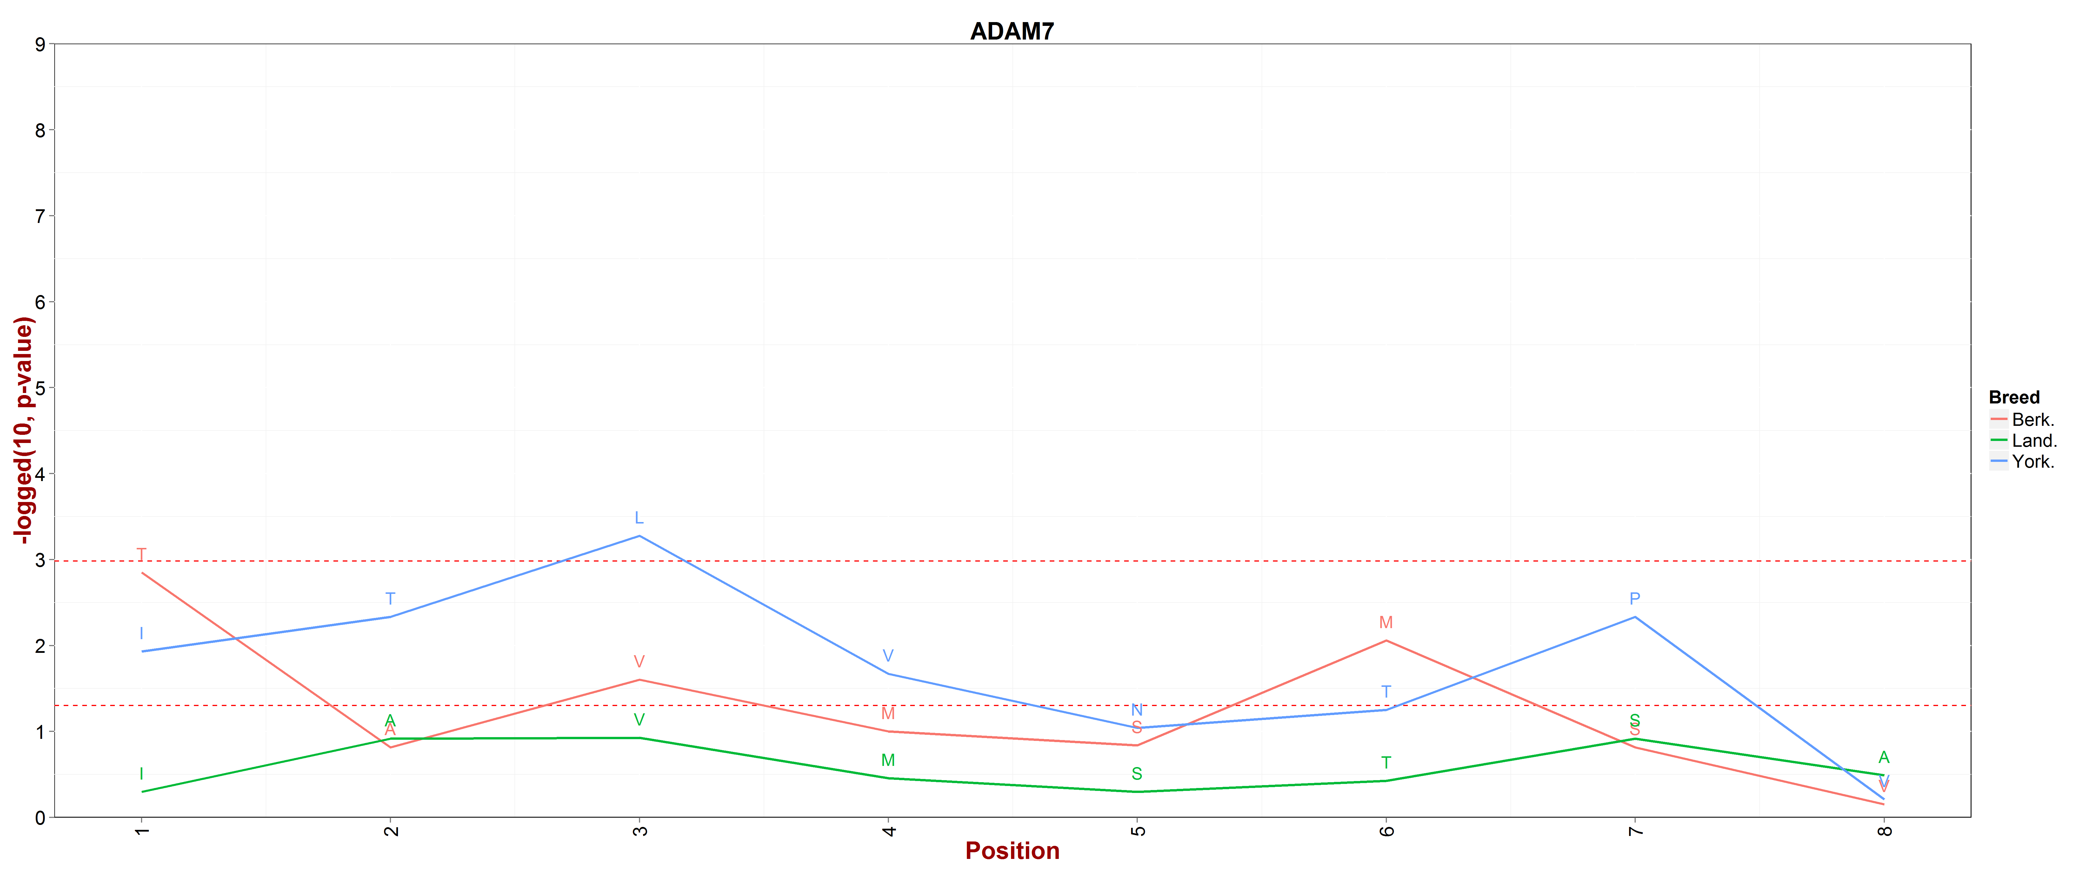
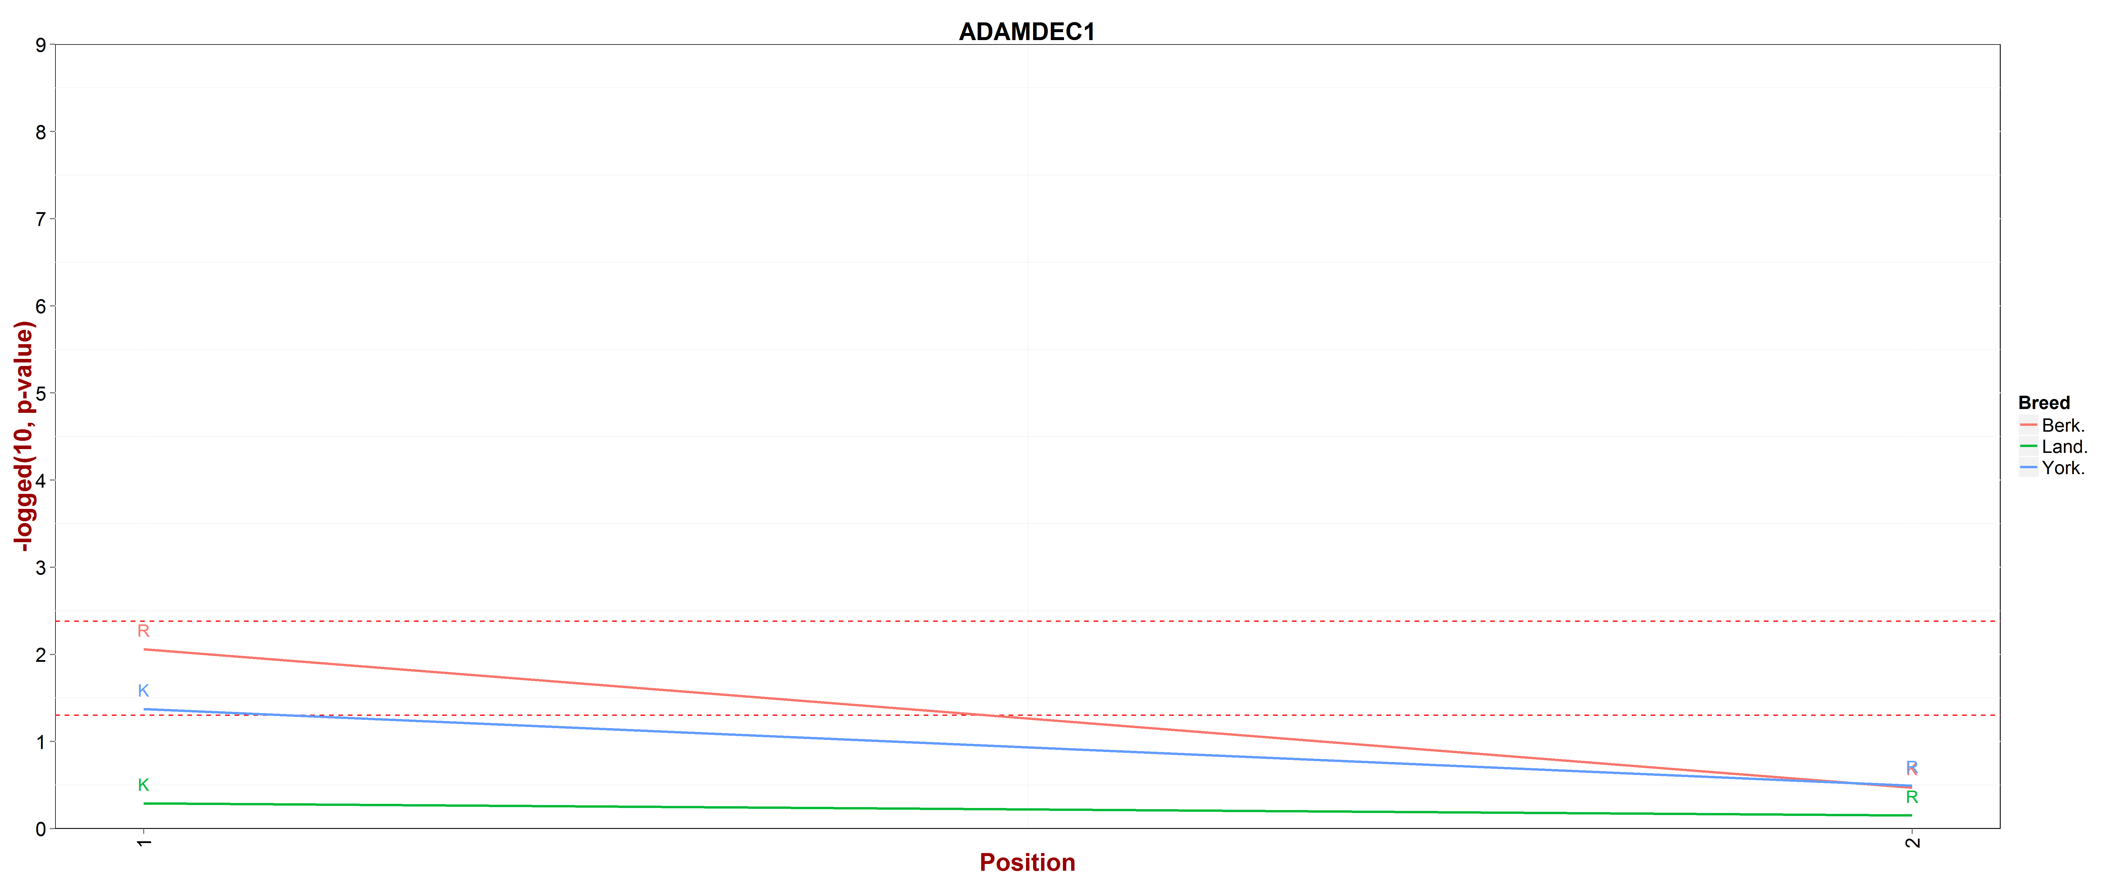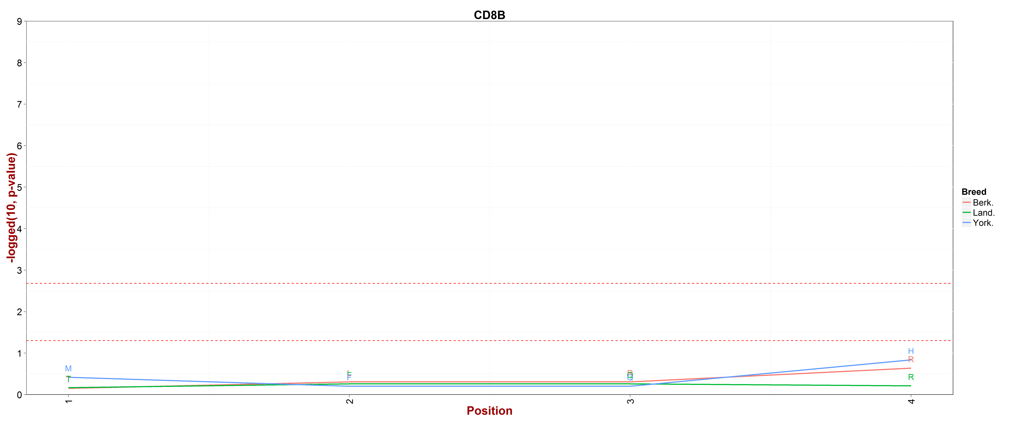
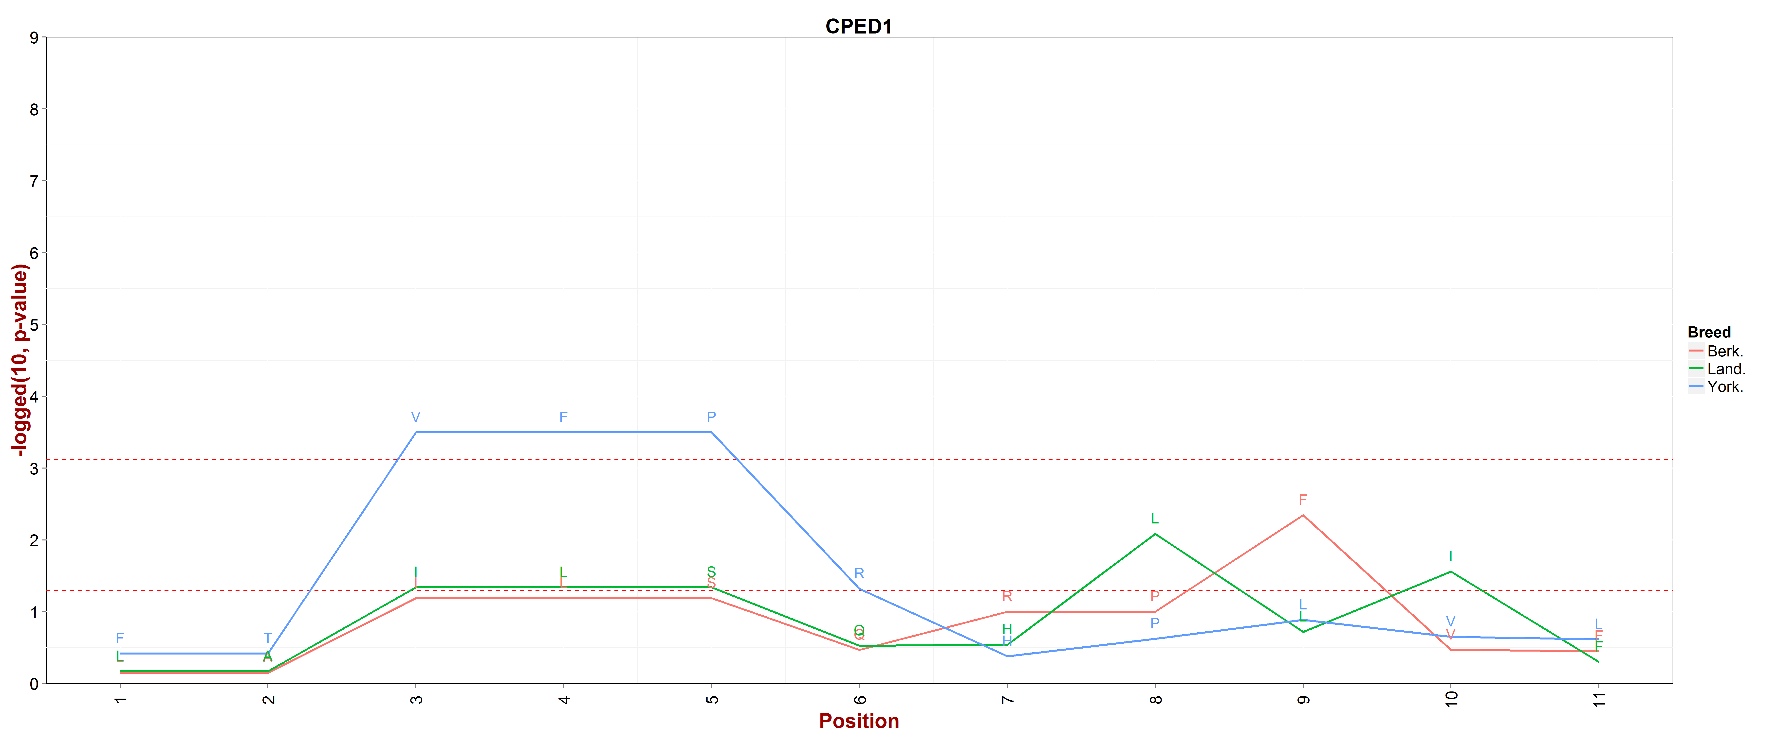
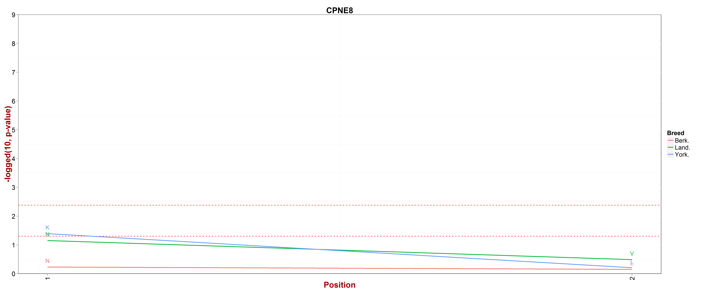
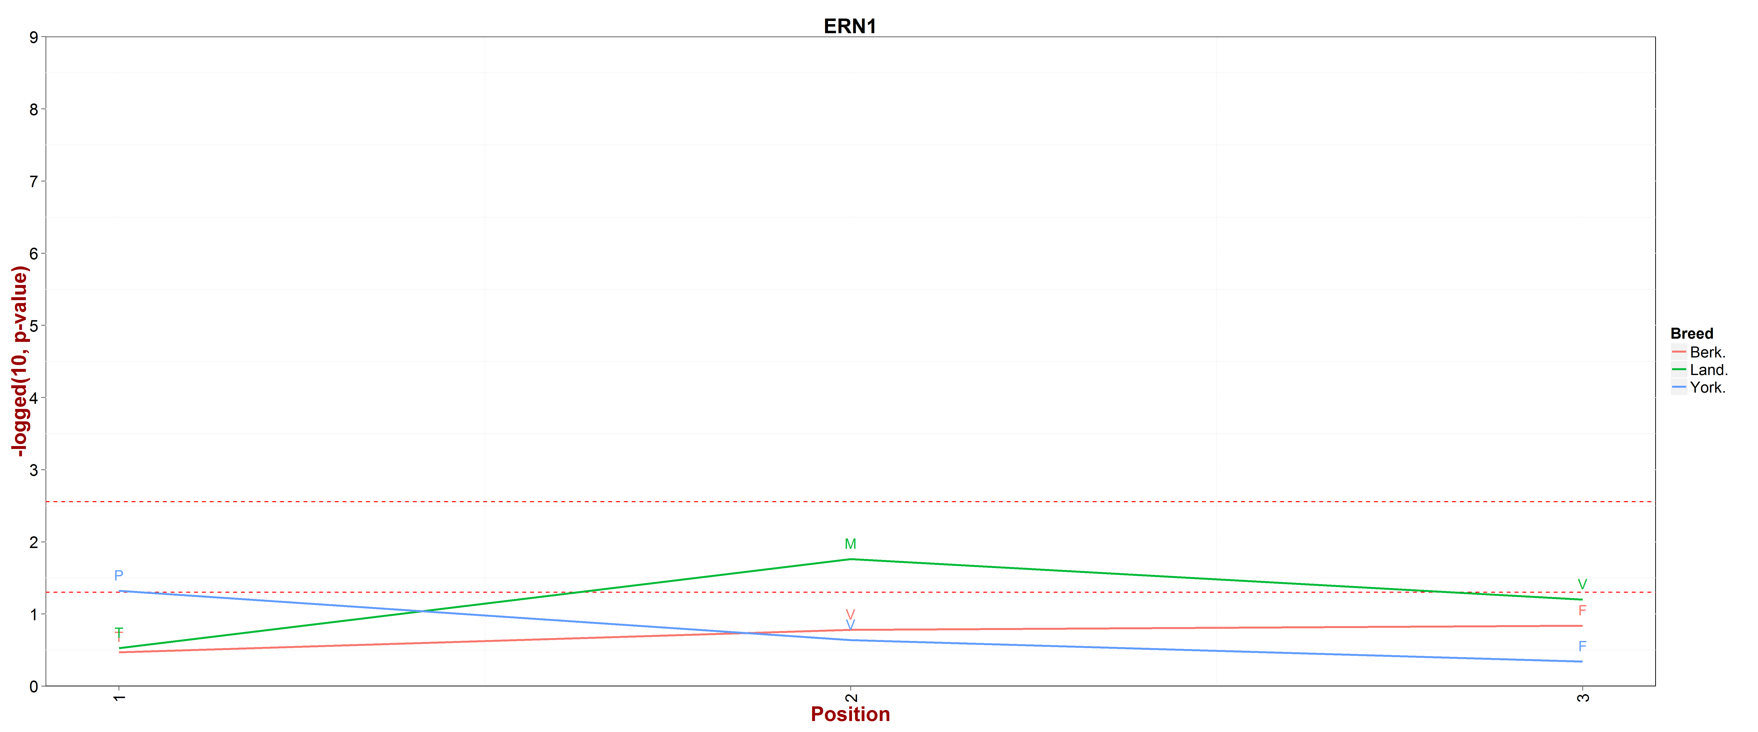

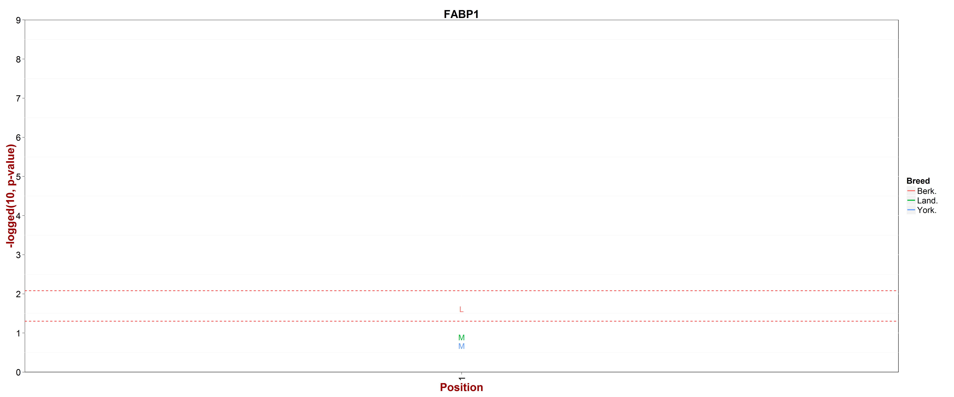
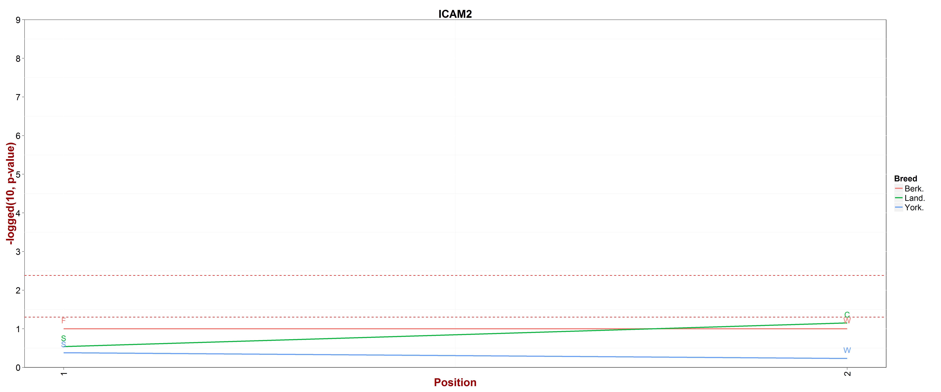
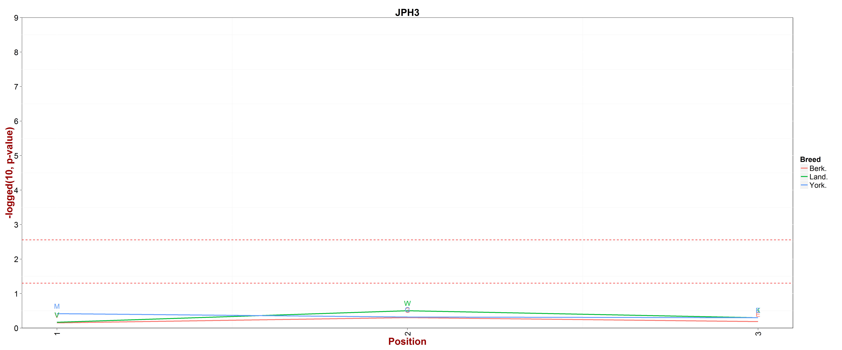

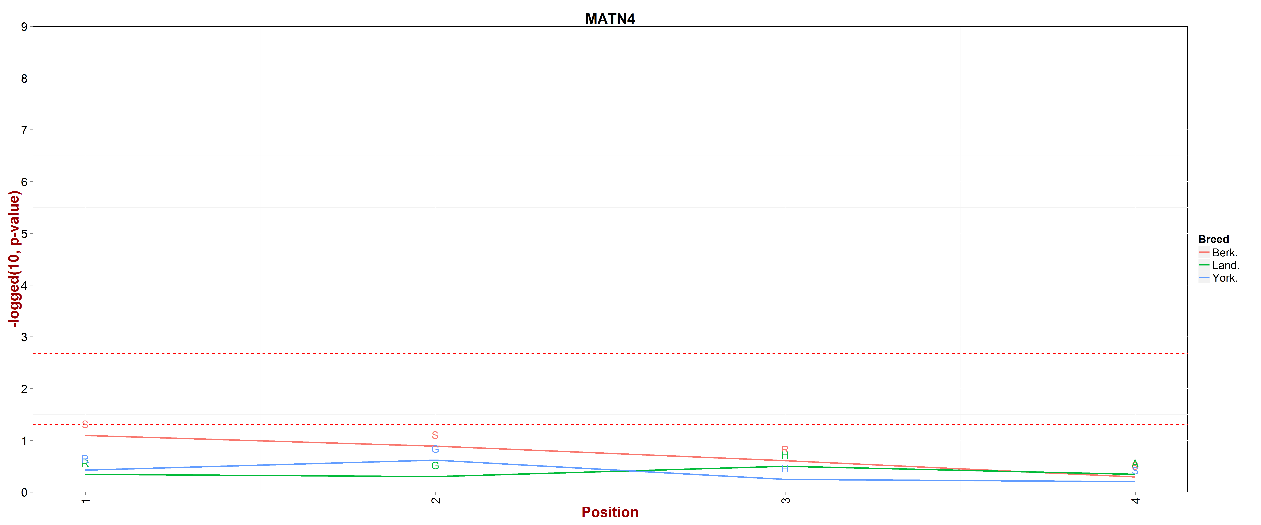
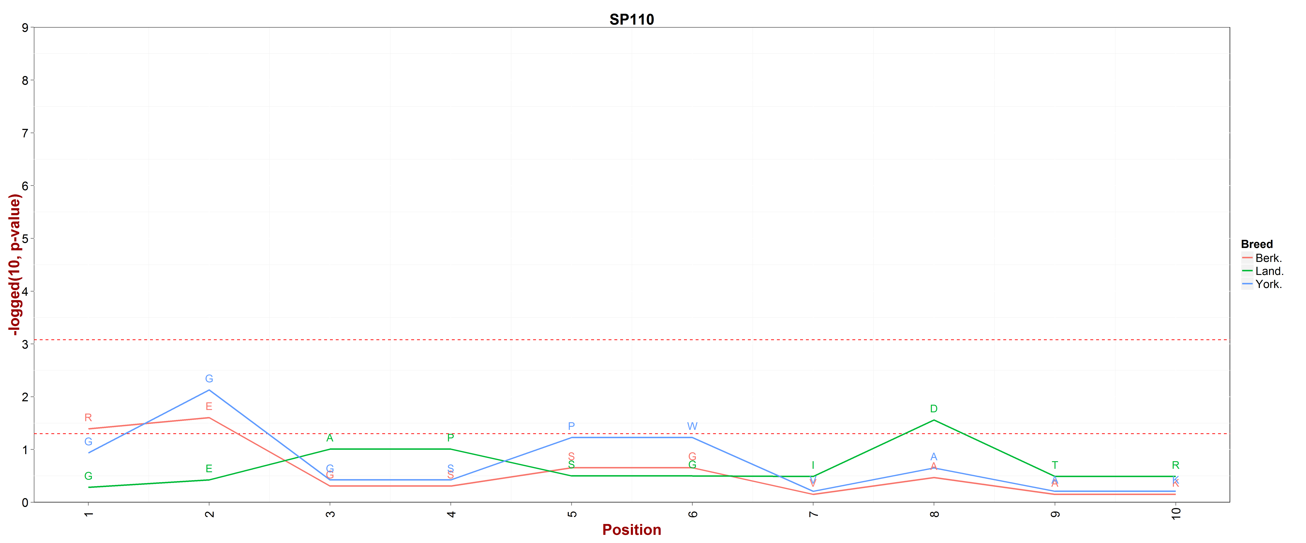
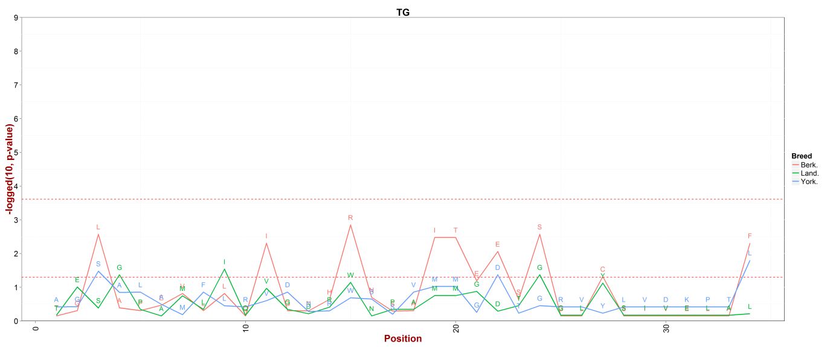

Figure S3. A statistical enrichment test (Fisher’s exact test) for detecting enriched Indel site on targeted genes.
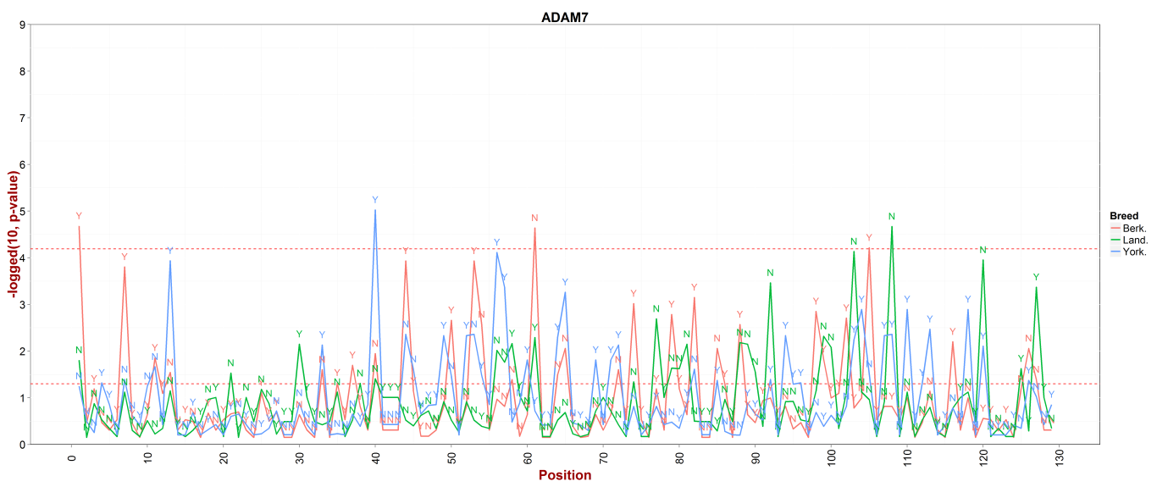
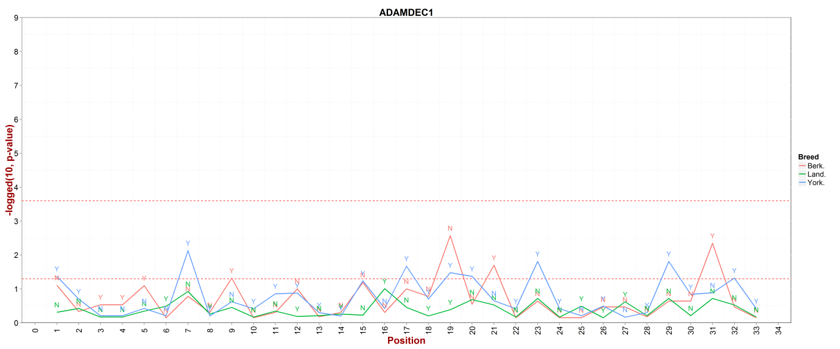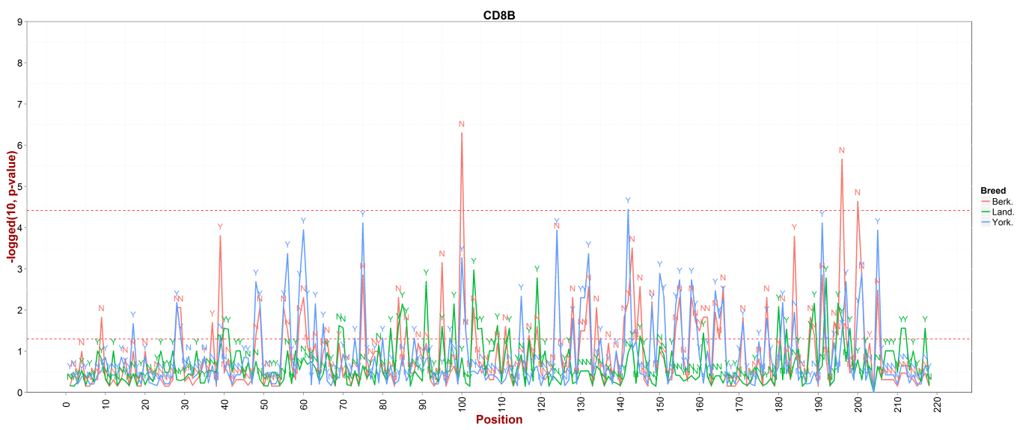
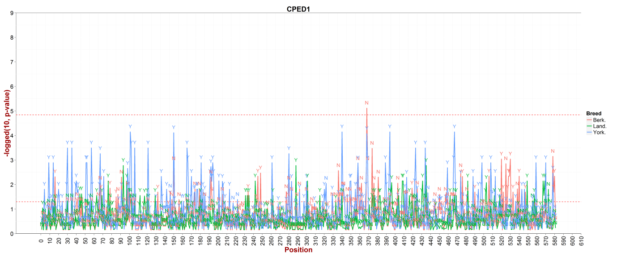
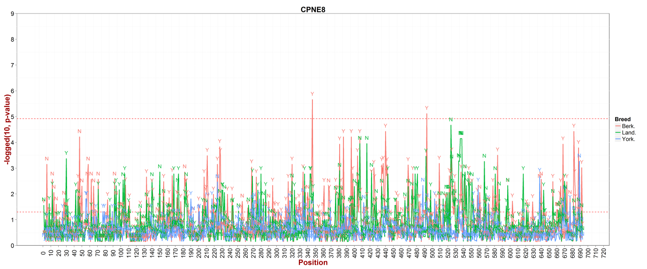
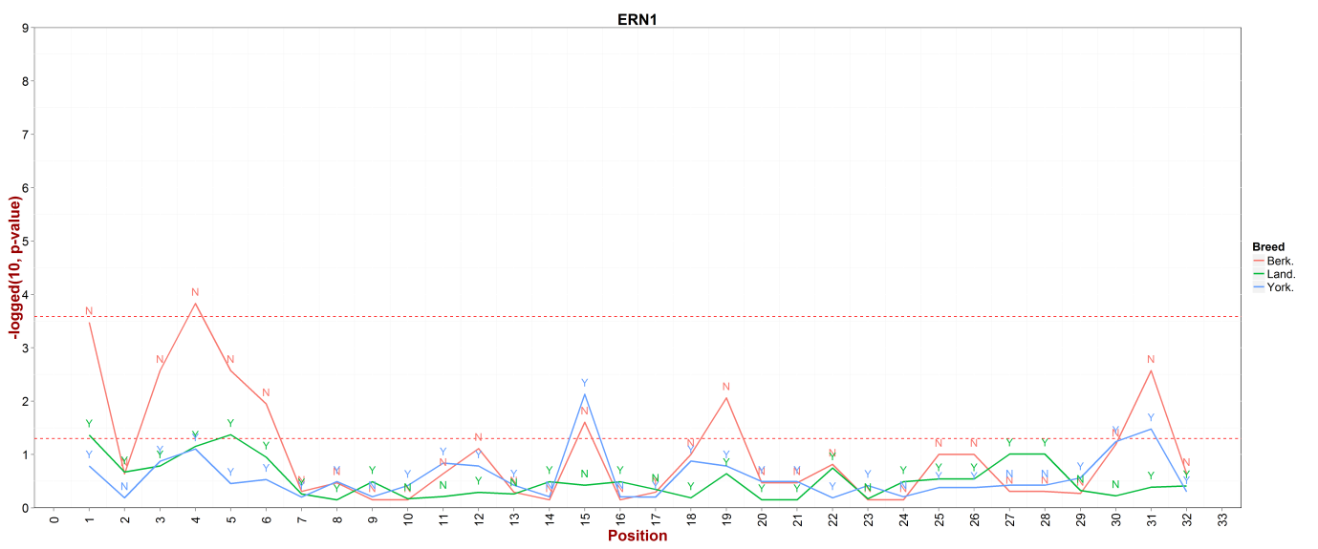

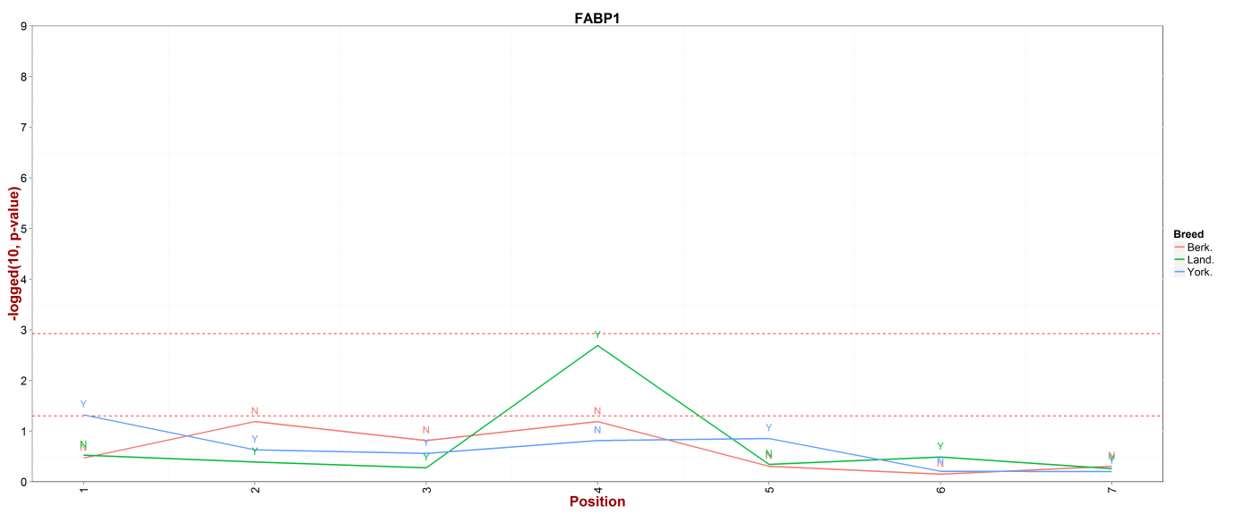
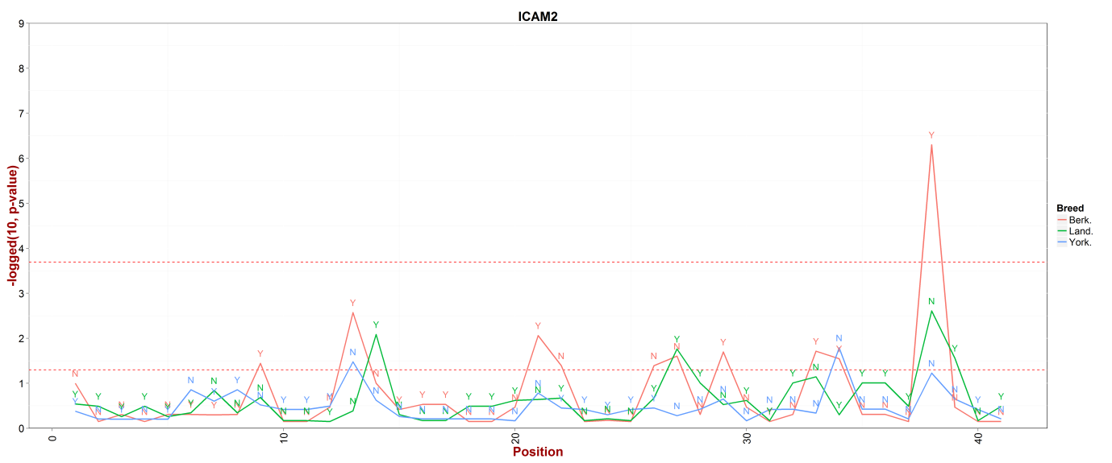
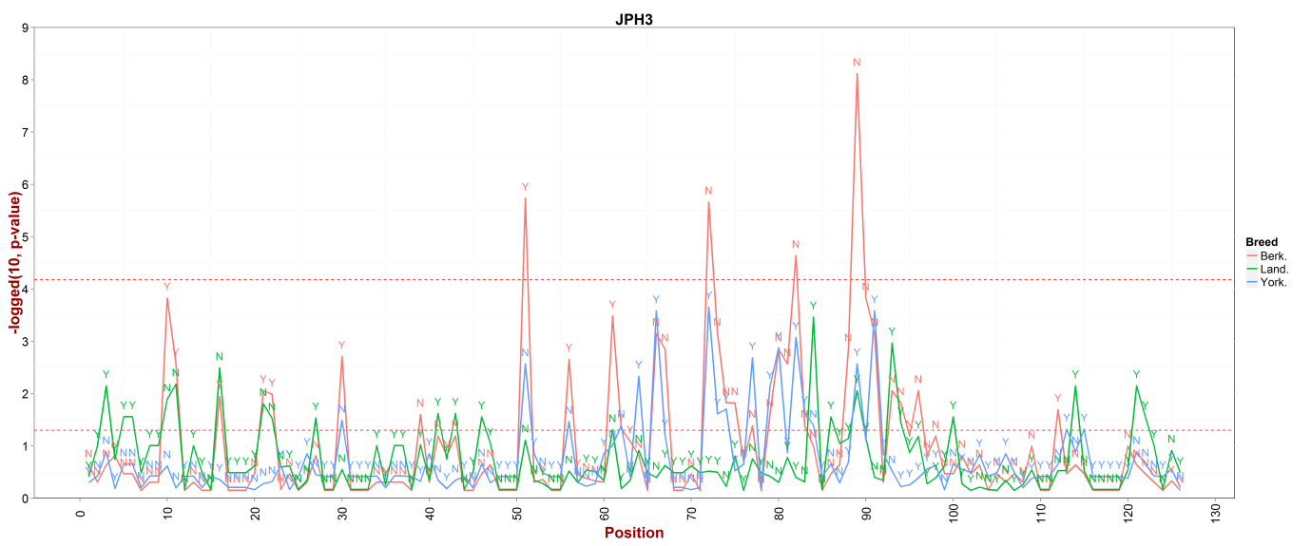

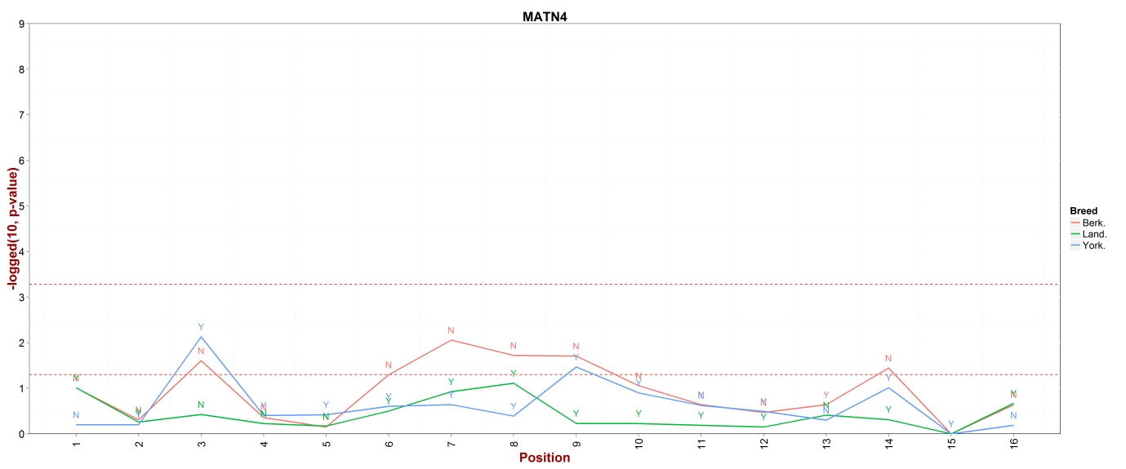
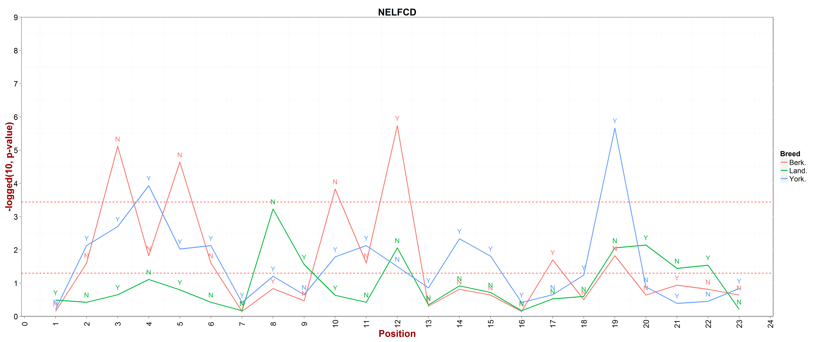
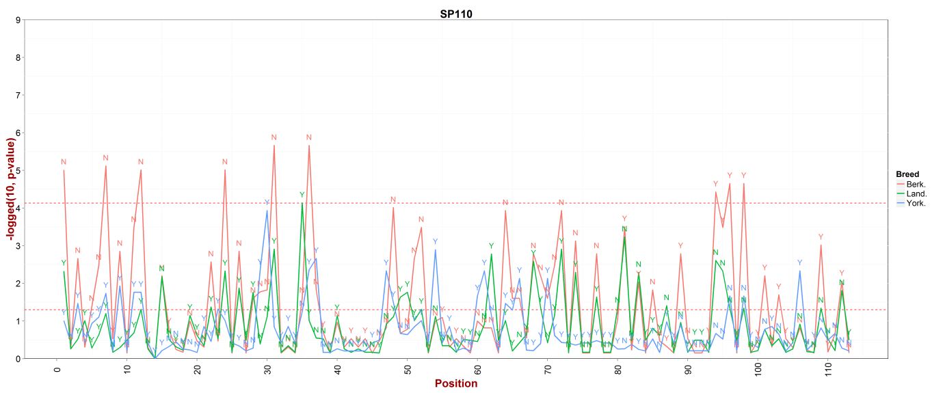

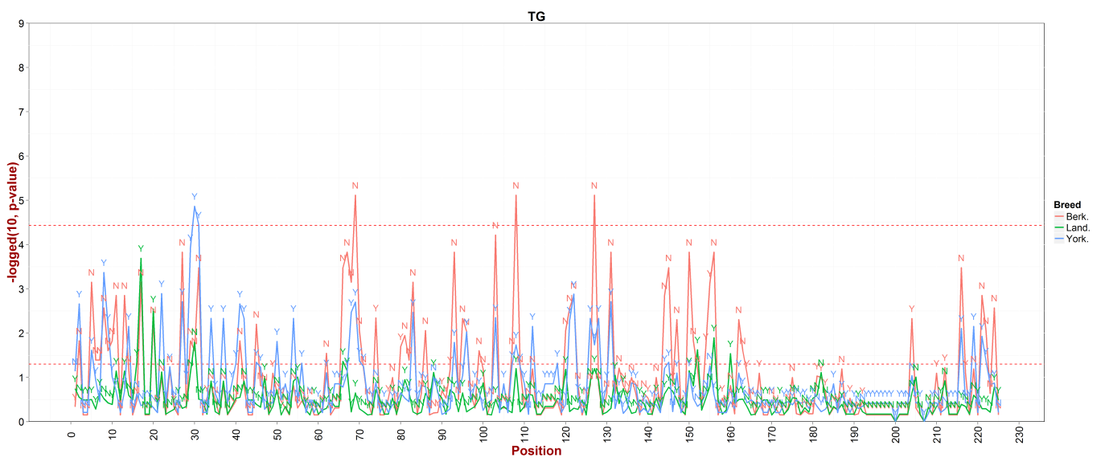

Figure S4. The overall reads mapping rate of assembled contigs for each breed and reference genome by aligning the total sequence reads of each Berkshire sample.
