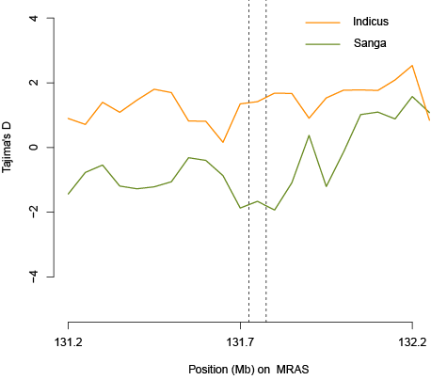
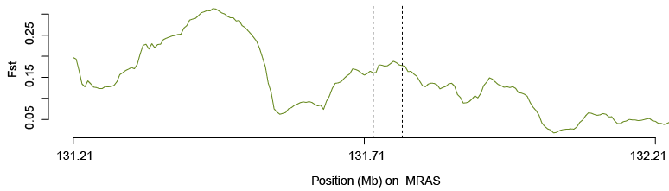

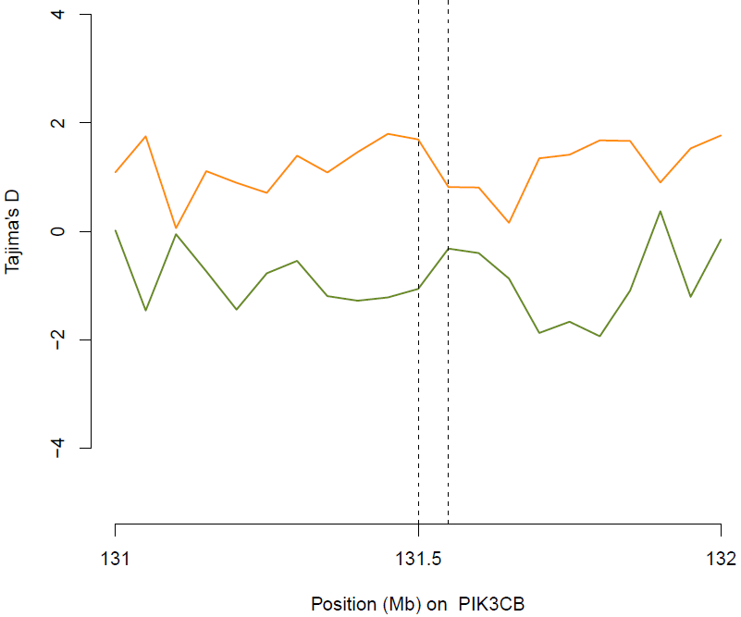
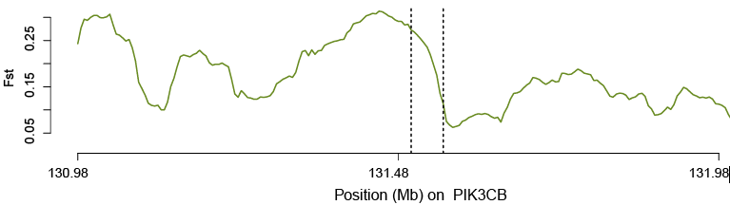

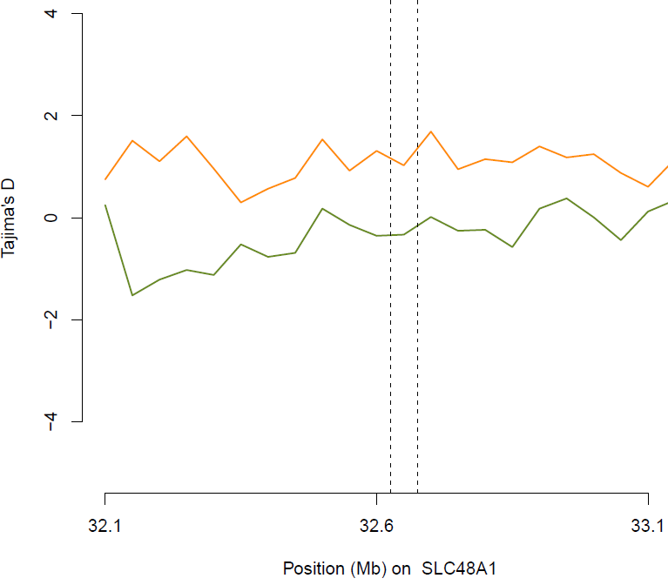
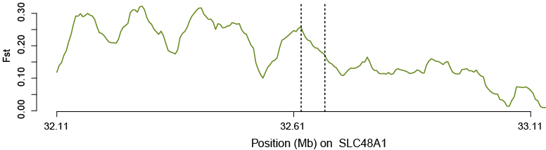
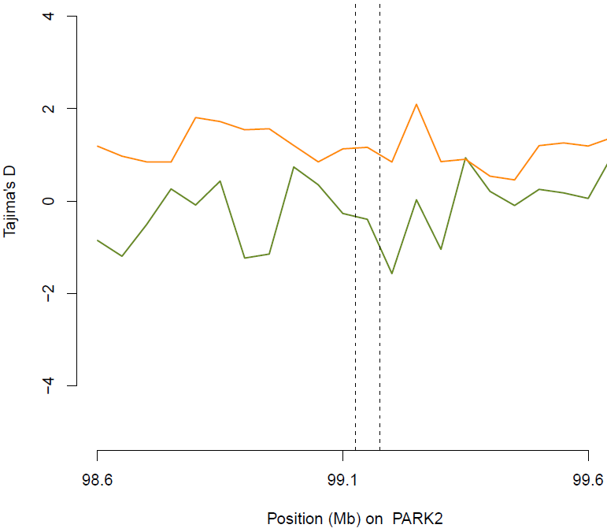
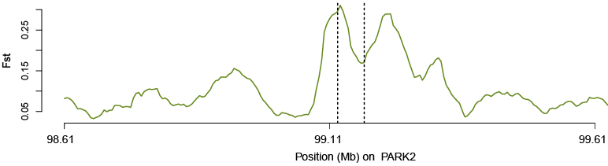
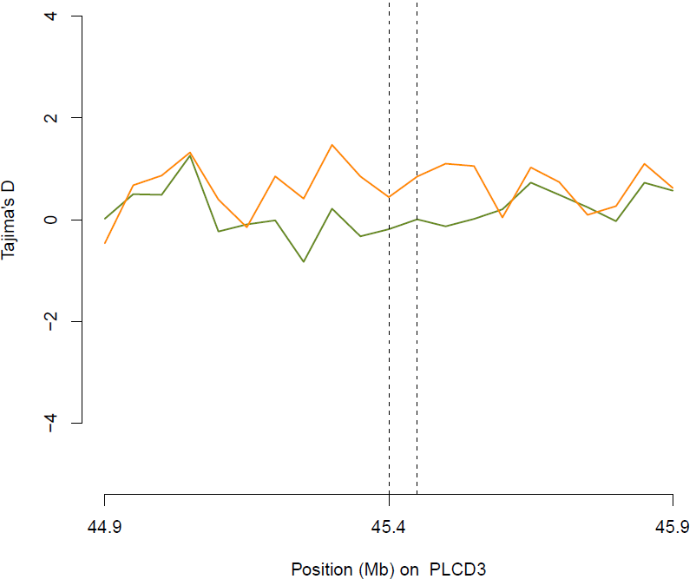
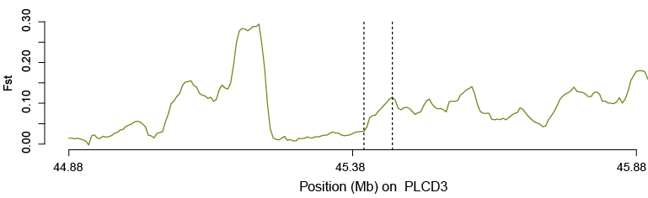
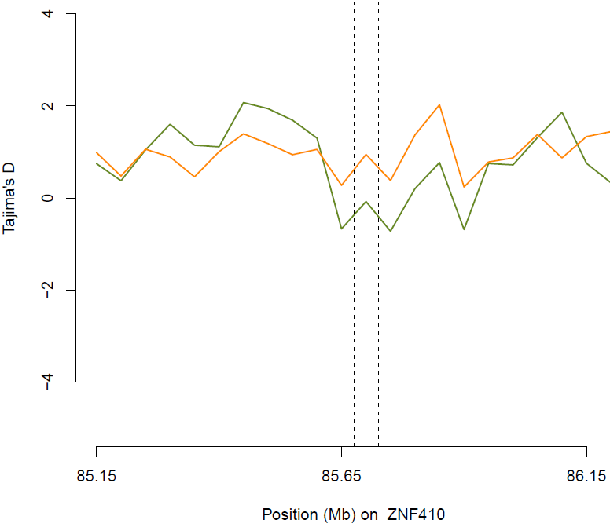
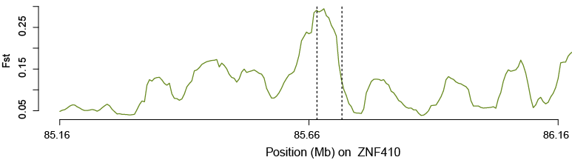
Additional file 5: Figure S1. Fst and Tajima’s D plot of positively selected gene regions in Ankole and Indicus cattle populations. The Tajima’s D plot for each gene region (upper plot for each gene) is the Tajima’s D value with in 50kb window plotted for both populations. The smaller (negative) Tajima’s D value in Ankole population shows that the gene region considered is positively selected. The Fst plot (under for each gene) is the Fst values within 50 kb windows separated by 5000 steps.

