Duroc
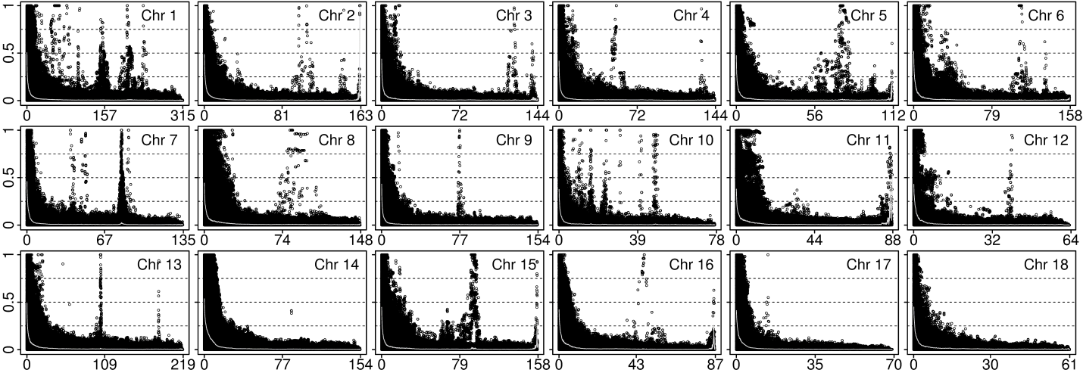
Landrace
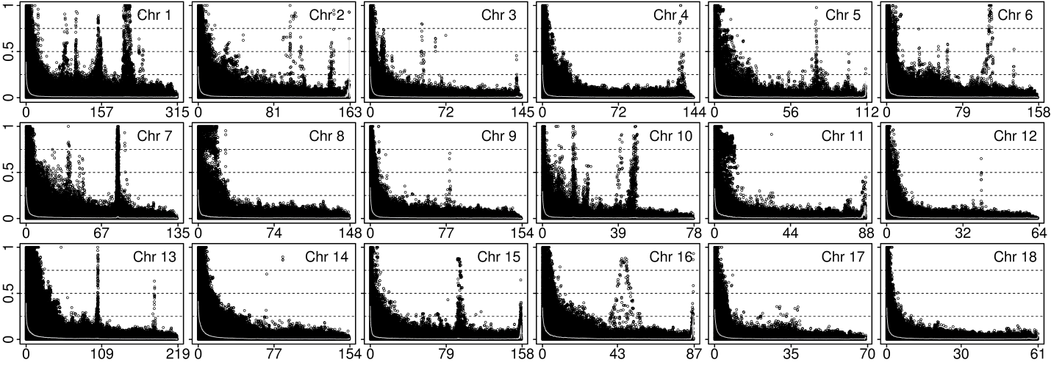
Linkage Disequilibrium (r²)
Yorkshire
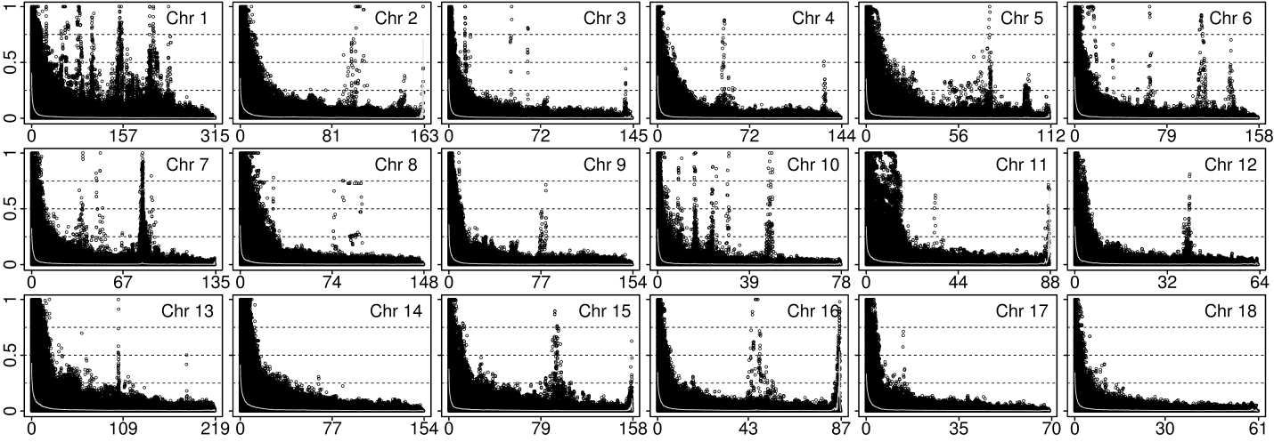
Distance between SNPs (Mb)

