Additional File 2: Information on distribution of sibs in families, GWAS based results for $P_{D2D}$ trait along with description of underlying genes at QTL region.

Figure S2.1: Distribution of dead and alive sibs out of total sib count per full-sib family

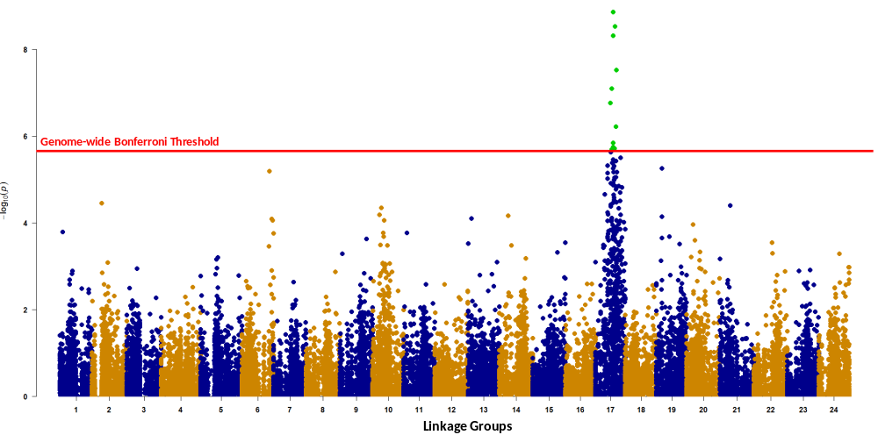
Figure S2.2: Manhattan plot of –log₁₀ P-values for $P_{D2D}$ trait distributed across different LGs.

Figure S2.3(A-B): Manhattan plot of –log₁₀ P-values for $P_{D2D}$ trait distributed along the length (cM) of SA17.
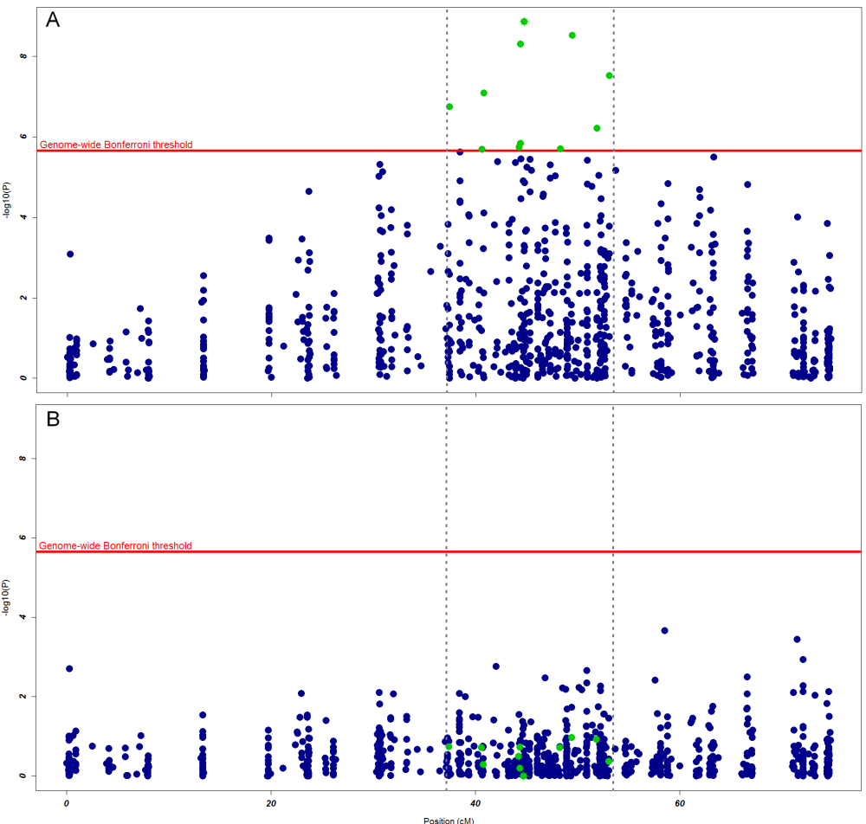
Highlighted green dots represent genome-wide significant SNPs and horizontal solid line represents the Bonferroni significance threshold (–log₁₀ P-values = 5.654). A) Plot with all the markers on SA17 and the top most significant SNP is highlighted green with asterisk (*) symbol; B) plot after correcting for the top most significant SNP and using it as a fixed effect in the model.

Figure S2.4: Q Q-Plot of –log₁₀ P-values – days to death phenotype $(P_{D2D})$

λ= 1.132356

Table S2.5: Variances explained by genome-wide significantly associated SNPs of $P_{D2D}$ trait.
SA | Locus ID | Pos | Allele1 | Allele2 | MAF | $$α$$ | SE | P-value | $$\%varG$$ | $$\%varP$$
17 | 248936_32 | 44.729 | G | T | 0.278 | 2.051 | 0.339 | 1.39E-09 | 13.411 | 4.257
17 | 24643_19 | 49.430 | A | G | 0.467 | 1.771 | 0.299 | 3.00E-09 | 12.385 | 3.931
17 | 283885_36 | 44.372 | G | C | 0.343 | 1.767 | 0.302 | 4.98E-09 | 11.169 | 3.545
17 | 211563_28 | 53.066 | A | G | 0.353 | 1.848 | 0.334 | 3.06E-08 | 12.384 | 3.931
17 | 81173_9 | 40.766 | A | G | 0.362 | 1.640 | 0.306 | 8.14E-08 | 9.859 | 3.130
17 | 265801_18 | 37.385 | T | C | 0.321 | 1.694 | 0.324 | 1.77E-07 | 9.929 | 3.152
17 | 95842_16 | 51.835 | G | C | 0.425 | -1.476 | 0.296 | 6.12E-07 | 8.448 | 2.682
17 | 53157_6 | 44.333 | T | C | 0.179 | 1.959 | 0.407 | 1.46E-06 | 8.930 | 2.835
17 | 80727_35 | 44.216 | A | C | 0.211 | 1.768 | 0.370 | 1.80E-06 | 8.263 | 2.623
17 | 3001_36 | 48.242 | A | G | 0.238 | 1.712 | 0.360 | 1.98E-06 | 8.449 | 2.682
17 | 225775_29 | 40.582 | T | C | 0.367 | -1.515 | 0.319 | 2.04E-06 | 8.461 | 2.686
SA = linkage group number for gilthead seabream (Sparus aurata, SA); Pos(cM) = genetic map position of SNP; A1 & A2 = minor & major alleles, respectively; MAF = minor allele frequency; α = Allele substitution effect; SE = standard error; P = significance value; $varG$= proportion of genotypic variance explained; $varP$ = proportion of phenotypic variance explained.

Table S2.6: Summary for the functions of important candidate genes at QTL region.
Genes (around ± 50Kb) | Description | Ref
transcription factor Sox-17-alpha-like | Sox-17 and Sox-17 alpha-like (Sox-32) are SRY-box (Sox) transcription factors that are important during development of different tissues and organs. Sox-17 has been recently reported to control also adult hematopoiesis which is s a formation of blood cellular components including immune cell components of blood. | [1, 2]
39S ribosomal mitochondrial protein | mitochondrial protein that is part of the large (39S) ribosomal subunit. | [3]
Acyl- thioesterase 1 | Acyl- thioesterase 1 (ACT1) is a key enzyme regulating an important post-translational protein modification, S-palmitoylation. Protein palmitoylation is crucial for functioning of key immune-related proteins (e.g. T cell receptor, Fcε receptor I, Fcγ receptor II, toll-like receptor 4) | [4]
regulator of G- signaling 20 | RGS proteins expressed in immune effector cell such as mast cells and lymphocytes as well as in their end-organ targets (i.e., bronchial smooth muscle) represent an important regulatory component of the intracellular signaling pathways induced by GPCRs in allergic inflammation. | [5, 6]

REFERENCES
1. Maha A, Ikuo N, Mitsujiro O, Atsushi I, Kaho H, Kiyoka S, Tetsuya T: Sox17 as a candidate regulator of myeloid restricted differentiation potential. Development, Growth & Differentiation 2014, 56(6):469-479.
2. Cuvertino S, Lacaud G, Kouskoff V: SOX7-enforced expression promotes the expansion of adult blood progenitors and blocks B-cell development. Open Biology 2016, 6(7).
3. Koc EC, Burkhart W, Blackburn K, Moyer MB, Schlatzer DM, Moseley A, Spremulli LL: The Large Subunit of the Mammalian Mitochondrial Ribosome: ANALYSIS OF THE COMPLEMENT OF RIBOSOMAL PROTEINS PRESENT. Journal of Biological Chemistry 2001, 276(47):43958-43969.
4. Sobocińska J, Roszczenko-Jasińska P, Ciesielska A, Kwiatkowska K: Protein Palmitoylation and Its Role in Bacterial and Viral Infections. Frontiers in Immunology 2017, 8:2003.
5. Druey KM: Regulation of G-protein-coupled signaling pathways in allergic inflammation. Immunologic research 2009, 43(1-3):62-76.
6. Druey KM: Chapter Nine - Emerging Roles of Regulators of G Protein Signaling (RGS) Proteins in the Immune System. In: Advances in Immunology. Edited by Shukla AK, vol. 136: Academic Press; 2017: 315-351.

