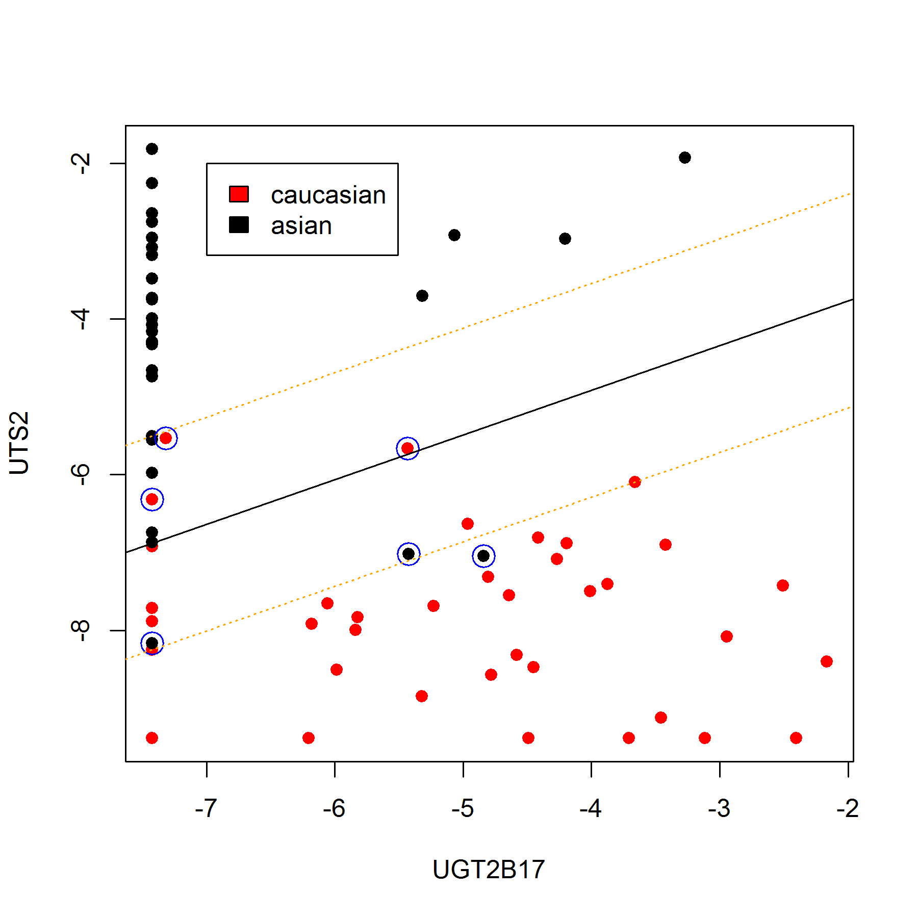
Additional file 2: Figure S1. The location of optimal hyperplane (black line) and supporting vectors (yellow lines) determined based on SVM method. Caucasian samples are marked with red, Chinese with black dots. Samples incorrectly assigned to population are marked with blue circles.

