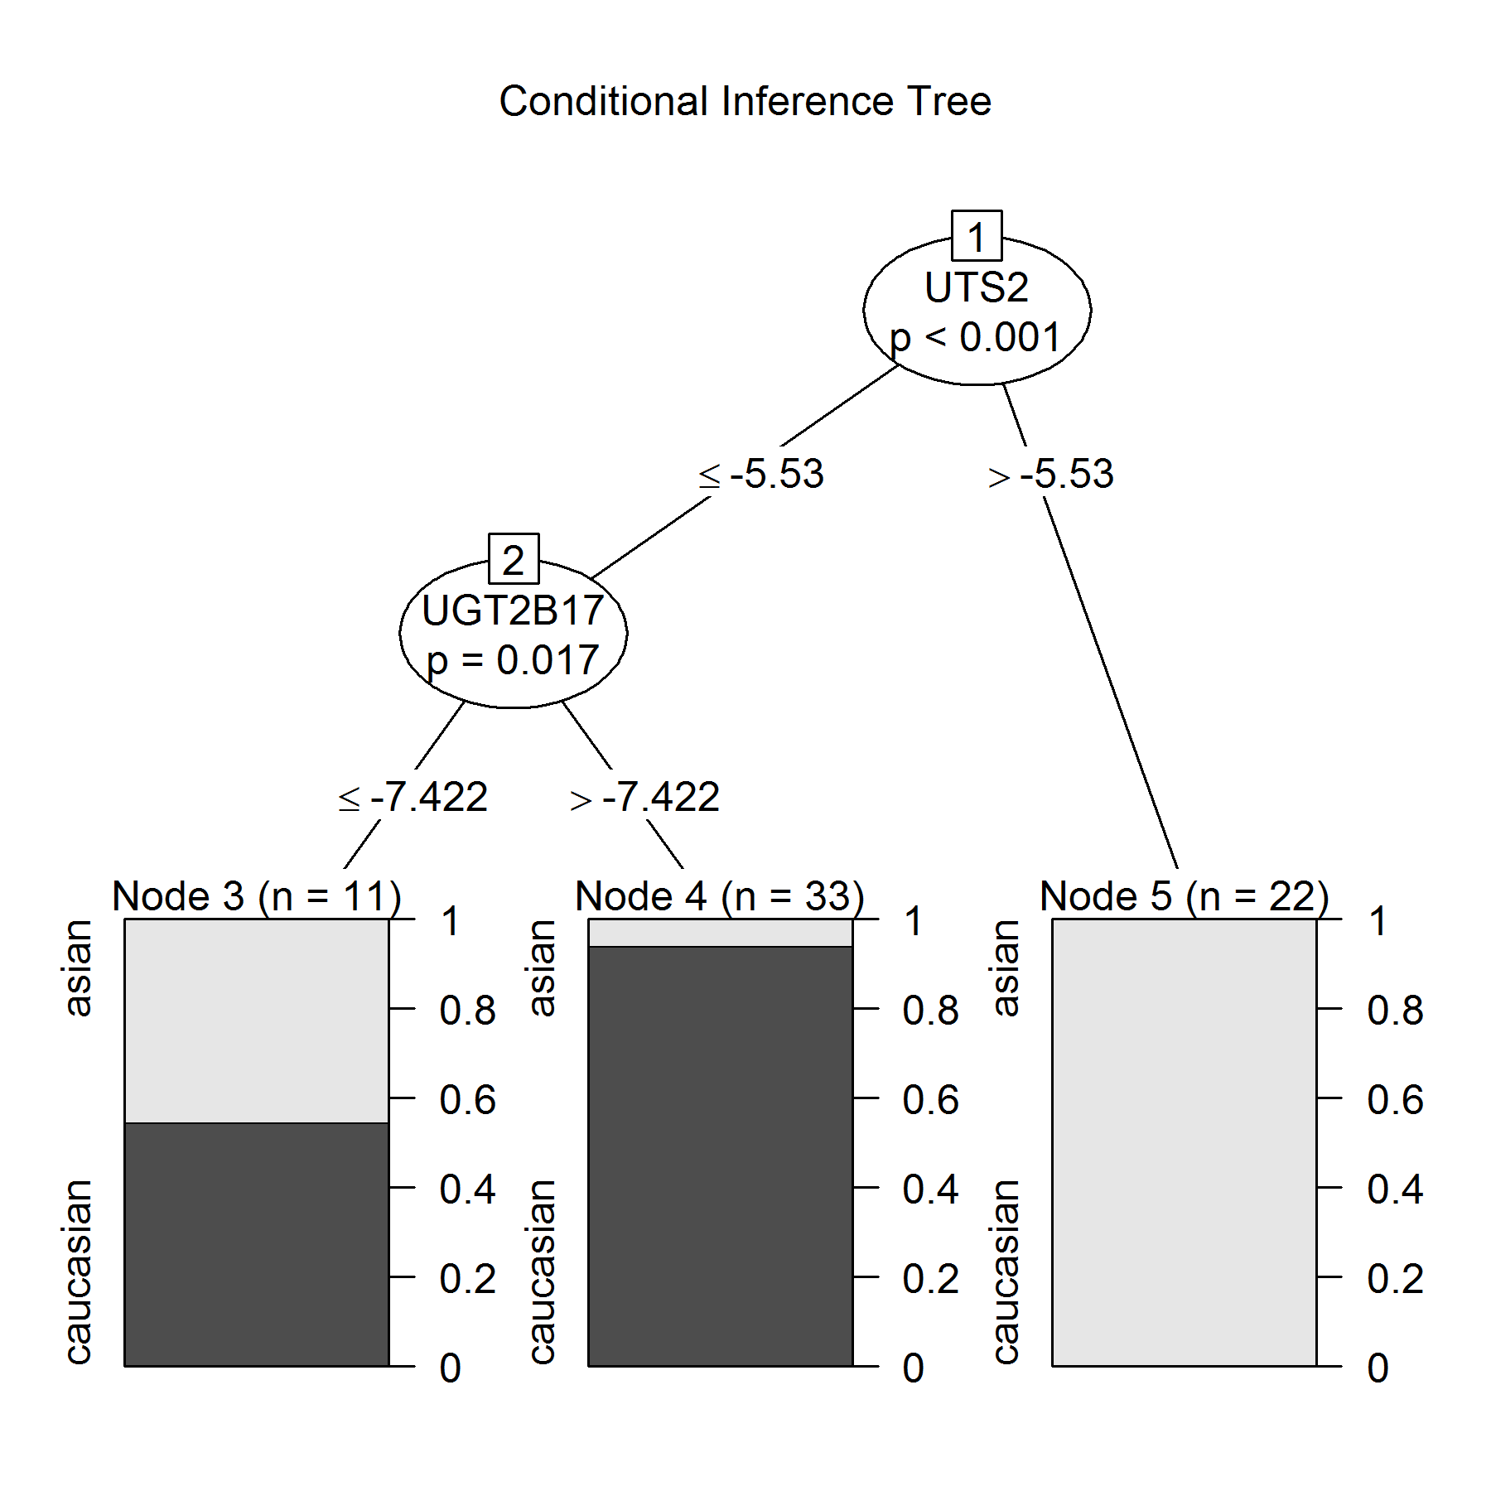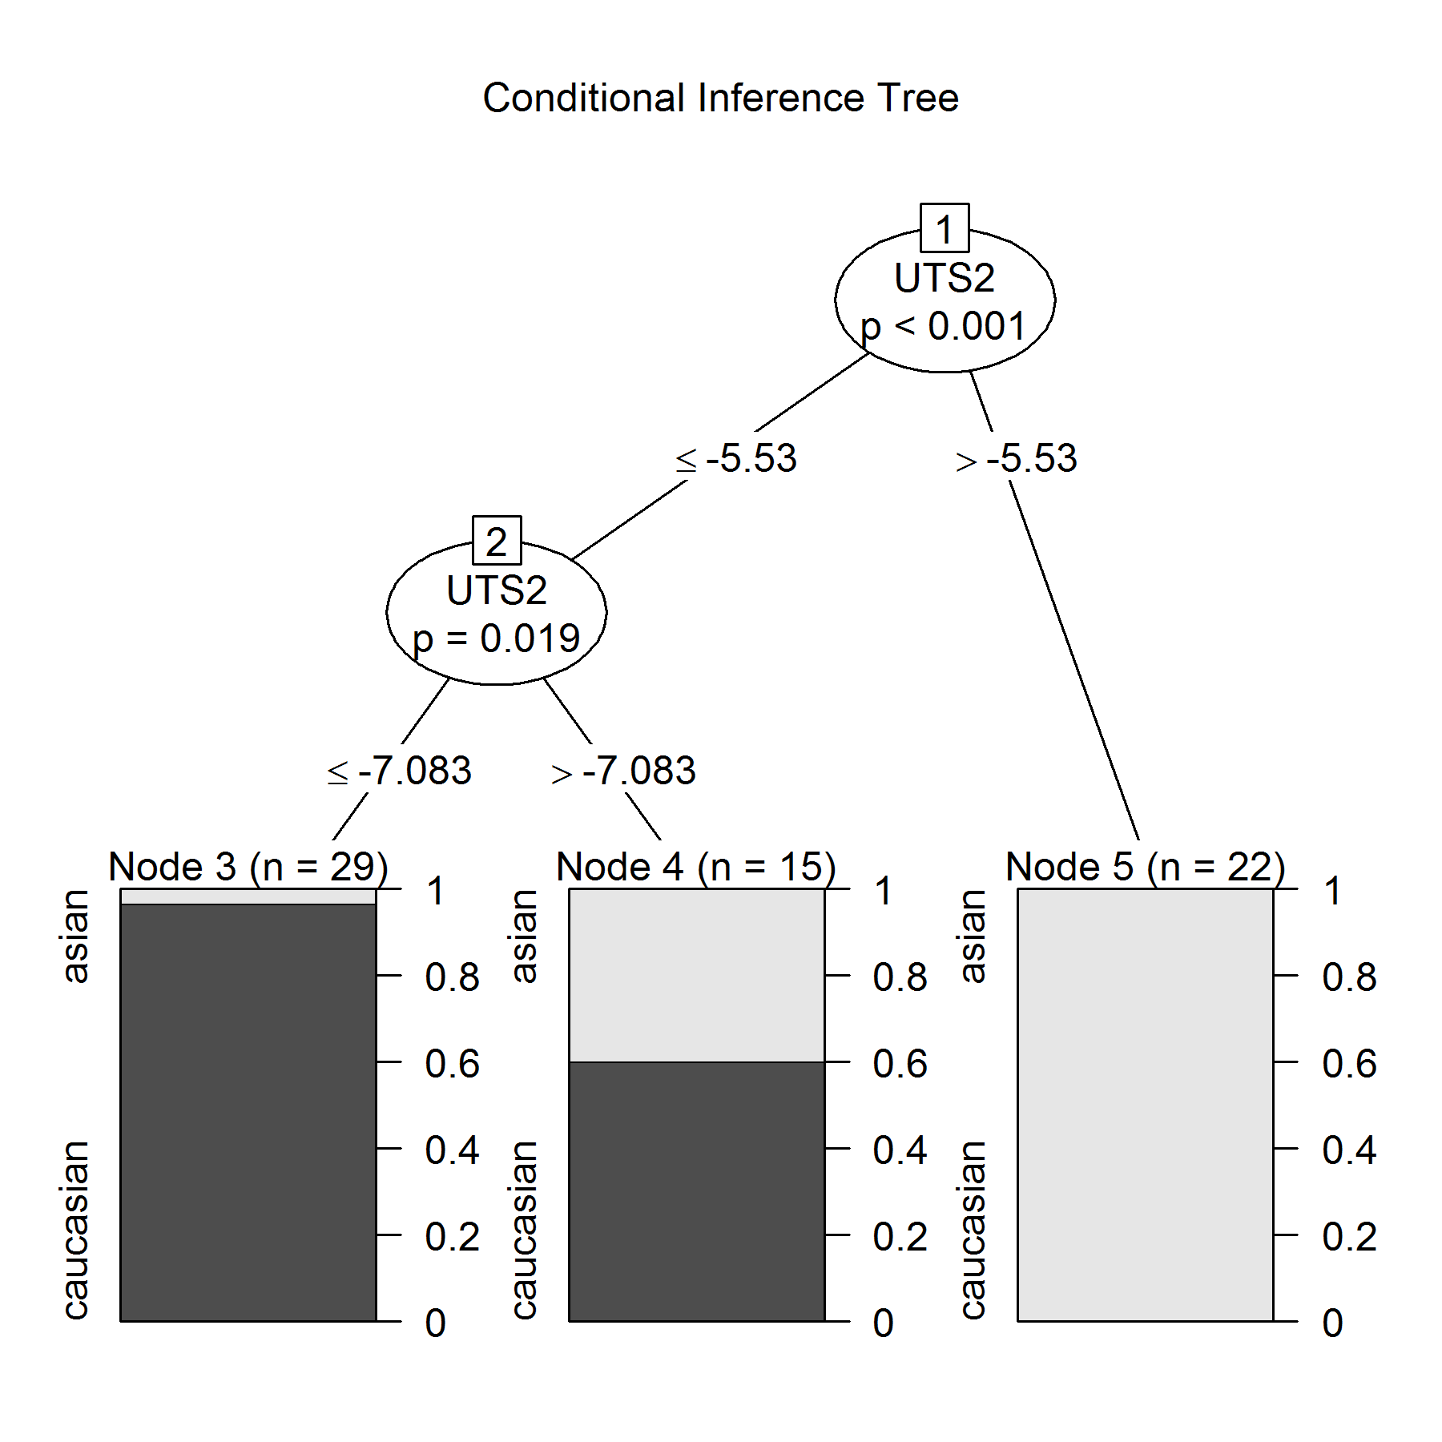
Additional file 3: Figure S2. A binary Decision-Tree classifier built based on UTS2 and UGT2B17 data (left Panel) and for UTS2 (Right Panel) obtained from Caucasian (n=37), and Chinese (n= 29) blood samples. Caucasian population denotes black color; Chinese population is presented in bright color.

