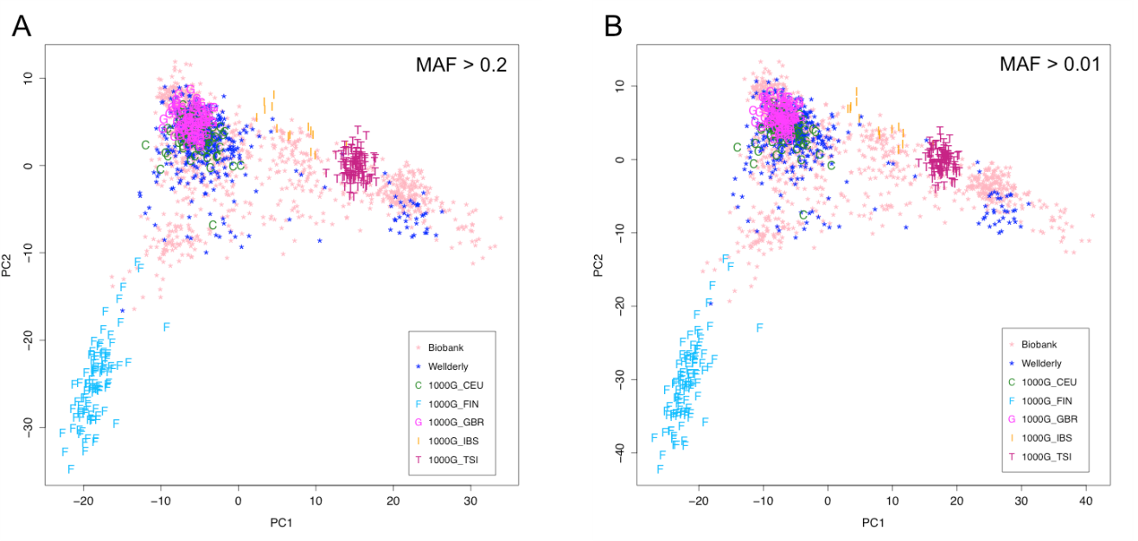

Additional file 1: Figure S1. Population structures of the Biobank and Wellderly individuals compared to the European populations of 1000 Genomes. A) PCA based on the SNPs with MAF > 0.2. B) PCA based on the SNPs with MAF > 0.01.

