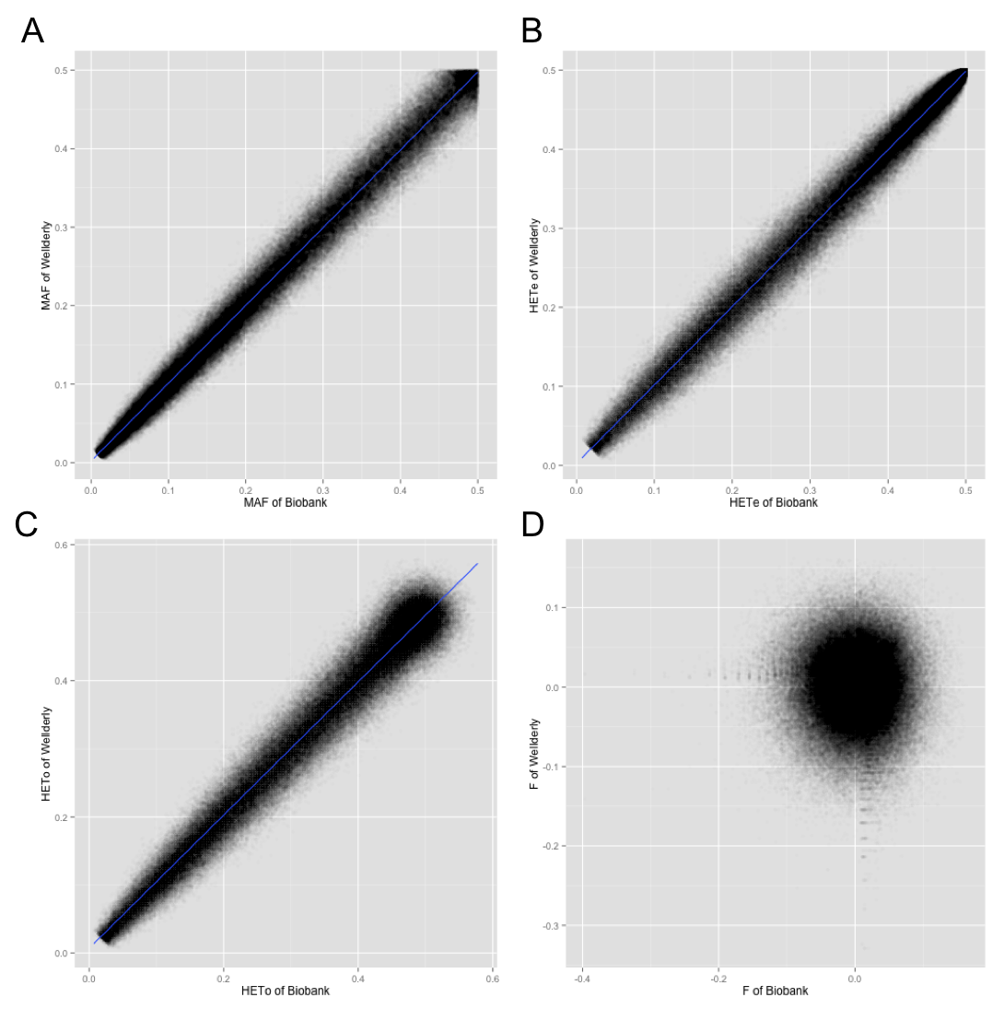

Additional file 3: Figure S3. Relationship between genetically matched Biobank cohort and Wellderly cohort on A) minor allele frequency (MAF), B) expected heterozygosity (HET_{E}), C) observed heterozygosity (HET_{O}), and D) excess of heterozygosity (F).

