Supplementary
Table S1 Marker list
Marker | Contig L10642 (contig length) | Forward primer  5‘ 3‘ | Reverse primer  5‘ 3‘ | Marker detection | Length of PCR product in bp according to L10642 | Polymorphisms mophead parent | Polymorphisms lacecap parent | Linkage with the INF locus
A099A100 | 276104  (12,539 nt) | A099: CACGAGAGC  ATTGATAGTACTG | A100: GTAAGTTTAAT  TRAGAAAAAGACTCG | PCR at 94°C, 3' + [(94°, 30'' + 60°C, 30'' + 72°C, 30'') x 32] + 72°C, 5';  sequencing with A100 | 118 | A099:  23 A/G  48 T/C | A099:  23 A/G  48 T/C | n.d.
A103A104 | 1152358  (248 nt) | A103: GTTGTACACA  TTGACCAATTAC | A104: CAACAAGAAA  TGCTTTATGTACAC | PCR at 94°C, 3' + [(94°, 30'' + 56°C, 30'' + 72°C, 30'') x 32] + 72°C, 5';  sequencing with A104 | 227 | A103:  26^27 A/A  27 A/A  34 G/G  100 T/T | A103:  27 A/C  34 G/-  100 T/C  141^142 -/A | n.d.
A109A110 | 16908  (5,295 nt) | A109: GTAGGGGTGT  ATATAAGCCGAG | A110: GCTTGATAAATG  GCTTATATACGAAC | PCR at 94°C, 3' + [(94°, 30'' + 62°C, 30'' + 72°C, 30'') x 32] + 72°C, 5';  sequencing with A110 | 272 | A109:  101 T/T  117 C/C  128 A/A  168 T/T  169 T/T  196 A/A | A109:  101 T/C  117 C/G  128 A/C  168 T/G  169 T/C  196 A/G | yes
A123A124 | 534403  (2,246 nt) | A123: GTTGCTGAC  CTTTAAATCTTTC | A124: GGAATAGAAA  ACAAAACTATCG | PCR at 94°C, 3' + [(94°, 30'' + 55°C, 30'' + 72°C, 30'') x 32] + 72°C, 5';  sequencing with A124 | 185 | A123:  95 A/T  126 G/A  135 A/T | A123:  95 A/A  126 G/G  135 A/A | no
A125A126 | 229528  (2,205 nt) | A125: GTAGGTTTGC  CGTCACTTAG | A126: CTTAGACTGTA  AAATACAATTC | PCR at 94°C, 3' + [(94°, 30'' + 55°C, 30'' + 72°C, 30'') x 32] + 72°C, 5';  sequencing with A125 | 105 | A126:  23 C/T  24 G/A  50 A/G | A126:  23 C/T  24 G/A  50 A/G | n.d.
A129A130 | 1146015  (1,404 nt) | A129: GTGCTGGGTT  GCTCCTTGATG | A130: CGATAGAGGG  TGGATAATCCTG | PCR at 94°C, 3' + [(94°, 30'' + 62°C, 30'' + 72°C, 30'') x 32] + 72°C, 5';  sequencing with A129 | 128 | A130:  33 G/A  76 T/C | A130:  33 G/G  76 T/T | n.d.
A133A134 | 1287540  (667 nt) | A133: CTCAACTTCA  CTAGATCTTGC | A134: GATAGTACAGT  GATATTGGTG | PCR at 94°C, 3' + [(94°, 30'' + 55°C, 30'' + 72°C, 30'') x 32] + 72°C, 5';  2% agarose gel (sequencing with A133) | 173 | 159 bp PCR fragment  A134:  24 -/-  44 T/T  45 A/A  68 T/T  70 T/T  77 -/-  85 G/G  97 -/-  99^100 G/G  133^145 12 bp deletion | 173+159bp PCR fragment  A134:  24 -/G  44 T/G  45 A/G  68 T/C  70 T/G  77 -/G  85 G/A  97 -/C  99^100 G/-  133^145  -/ATTGGGGG  GGTT | yes

Table S2 2C DNA content, inflorescence type and SSR marker fingerprint of 12 H. macrophylla cultivars
Cultivar | 2C DNA content [pg] | Inflorescence type | Binary index matrix of SSR markers*  #1__#2___#3___#4_____#5____#6_____#7____#8______#9_______#10______#11_____#12 | SSR fingerprint ID**
Choco Bleu | 4.50 | mophead | 0001_10_00001_00001_10100_01001_1000010_00001_10000100_000001000_0110000_001100000 | G068
Little Prince | 4.37 | lacecap | 0001_10_00001_00101_00001_01100_0000010_00001_00100000_001001000_0100001_100100000 | G069
Paris | 4.42 | mophead | 0001_10_00001_00101_10000_01100_0010010_00001_00100000_001001000_0100000_000100001 | G070
Sheila | 4.43 | lacecap | 0001_11_00001_00100_10000_01000_0000010_00001_01100000_000011000_0010001_000100000 | G071
Dark Angel | 4.48 | lacecap | 0001_11_00001_00100_10001_01100_0000010_00001_00100000_001010000_0100001_000100001 | G072
Forever Pink | 4.61 | mophead | 0001_11_00001_00101_10100_01000_0010010_uuuuu_10100000_000001000_0110000_001000001 | G073
Mak20 | n.d. | lacecap | 0001_11_00011_00011_10000_00101_0000010_00101_00100001_000100001_0010010_000000101 | G074
Baby Blue | 4.44 | mophead | 0101_10_00001_00001_10001_01000_0010010_10001_00100000_000001000_0100000_000100000 | G075
Early Blue | n.d. | mophead | 0101_10_00001_00001_10001_01000_0010010_10001_00100000_000001000_0100000_000100000 | G076
Diva fiore | 4.55 | mophead | 0101_11_00001_00001_10000_01001_0010010_00001_00100100_000001100_0110000_000000001 | G077
Sweet Dreams | 4.48 | lacecap | 0101_11_00001_00100_00101_00100_0000010_00001_00100000_000001000_0011000_000100000 | G078
R.F. Felton | 6.97 | mophead | 0101_11_10001_00001_10100_01001_0100010_00001_10100000_000001000_0011000_000100001 | G079
* Markers according to Hempel et al. [11], allele-specific PCR fragment lengths for marker #1: 155/146/143/140 bp, for marker #2: 167/161 bp, for marker #3: 162/159/153/150/147 bp, for marker #4: 186/180/174/170/168 bp, for marker #5: 155/152/149/148/146 bp, for marker #6: 156/153/150/147/138 bp, for marker #7: 153/150/147/143/139/137/134 bp, for marker #8: 158/147/144/141/138 bp, for marker #9: 150/147/143/140/138/135/130/124 bp, for marker #10: 180/177/172/167/161/152/143/134/128 bp, for marker #11: 135/132/129/126/123/120/118 bp, and for marker #12: 126/123/120/117/113/110/107/104/101 bp
** continued according to Hempel et al. [11]

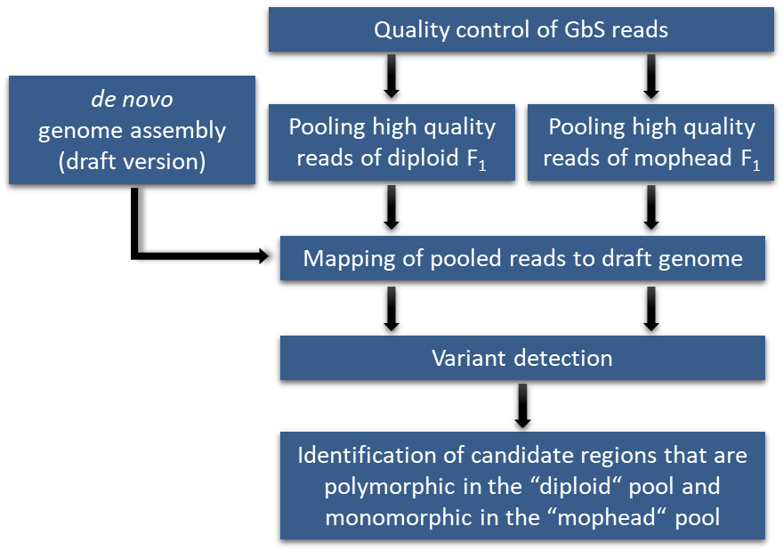

Figure S1 Pipeline for INF marker development using RAD GbS data of diploid and triploid F₁ plants

