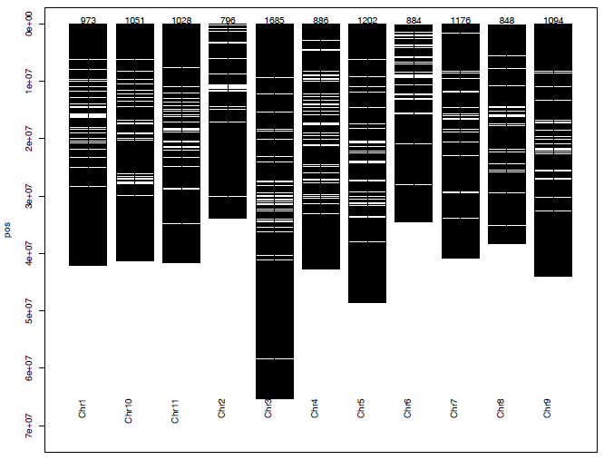
Additional file 7. Chromosomal distribution of the 14,166 SNPs used to evaluate 90 cowpea genotypes

