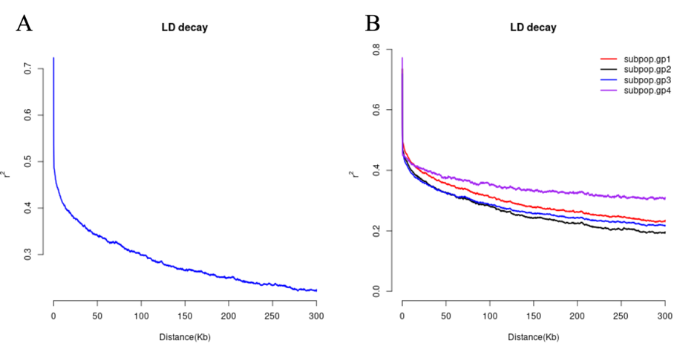
Supplementary Figure 1 (A) Linkage disequilibrium of all accessions across 12 chromosomes. (B) Linkage disequilibrium differences between four groups predicted by population structure analysis when K=4.
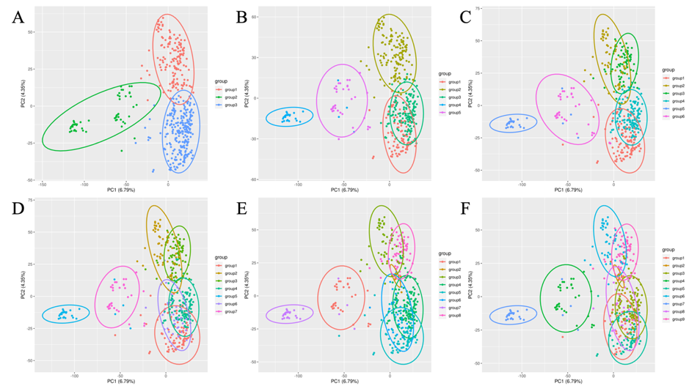
Supplementary Figure 2 Plots of the first two principal components in PCA with data points divided into 3 (A) and 5 to 9 (B-F) groups by faststructure.
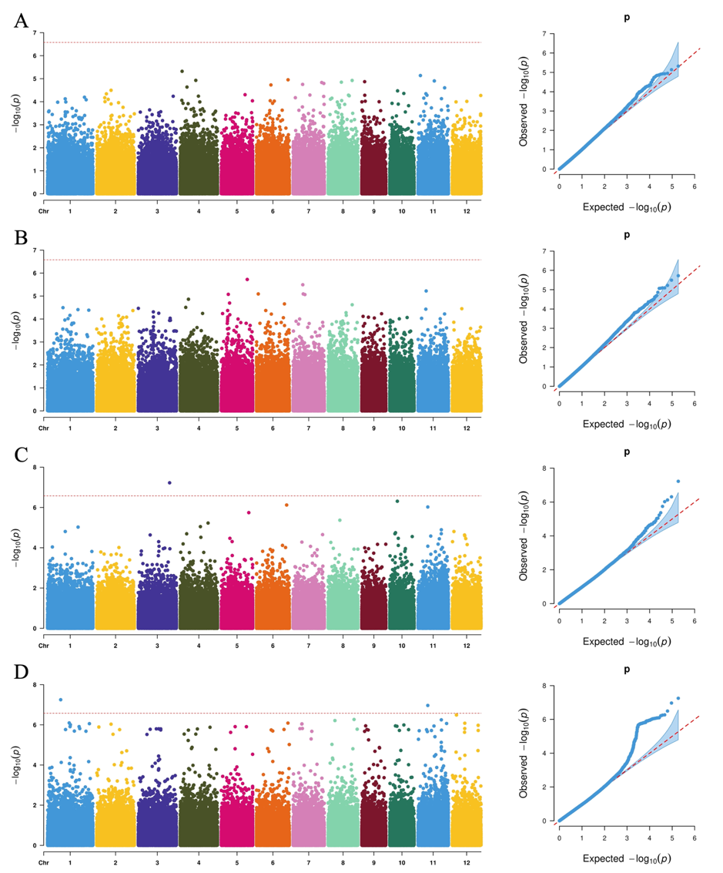

Supplementary Figure 3 Manhattan plots and QQ plots for the four traits in Harbin by MLM. (A) Days to heading. (B) Plant height. (C) Panicle weight. (D) Tiller number.

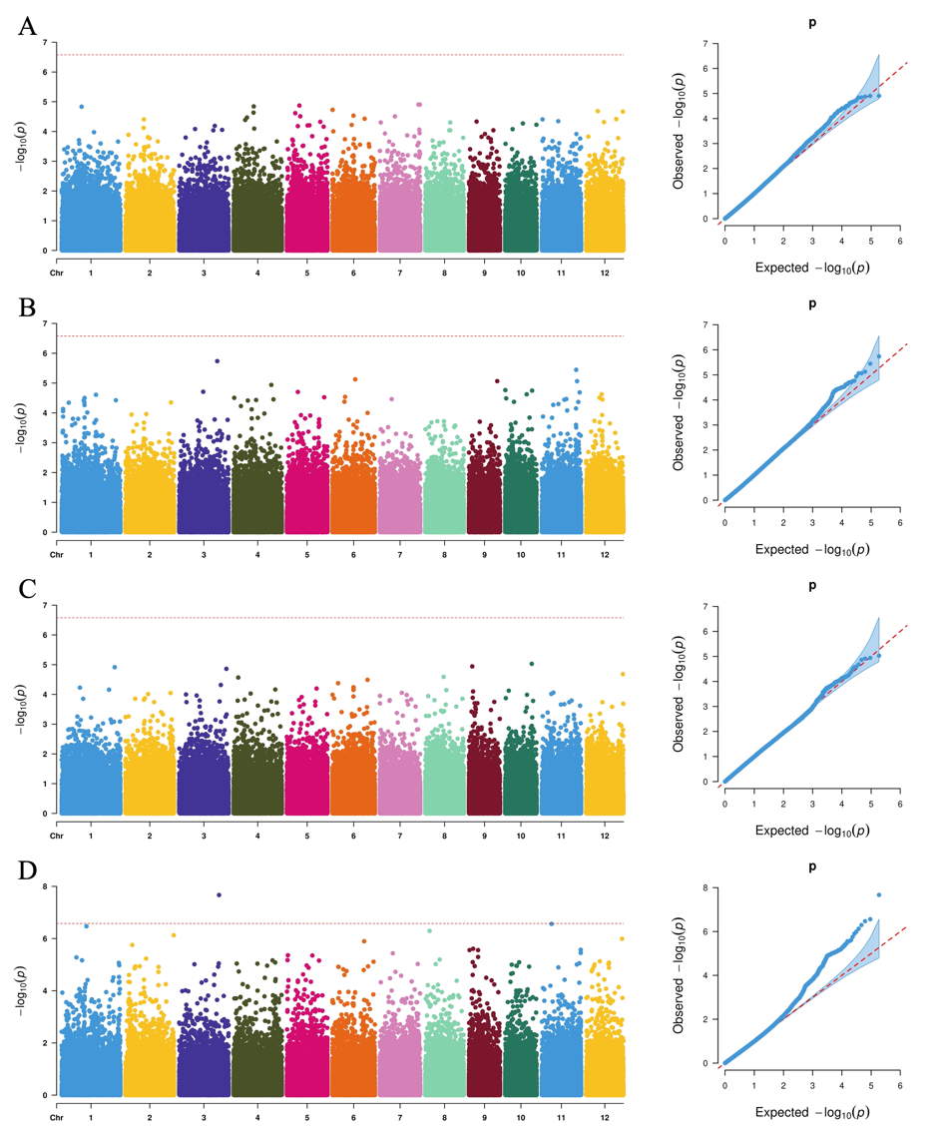
Supplementary Figure 4 Manhattan plots and QQ plots for the four traits in Jiamusi by MLM. (A) Days to heading. (B) Plant height. (C) Panicle weight. (D) Tiller number.

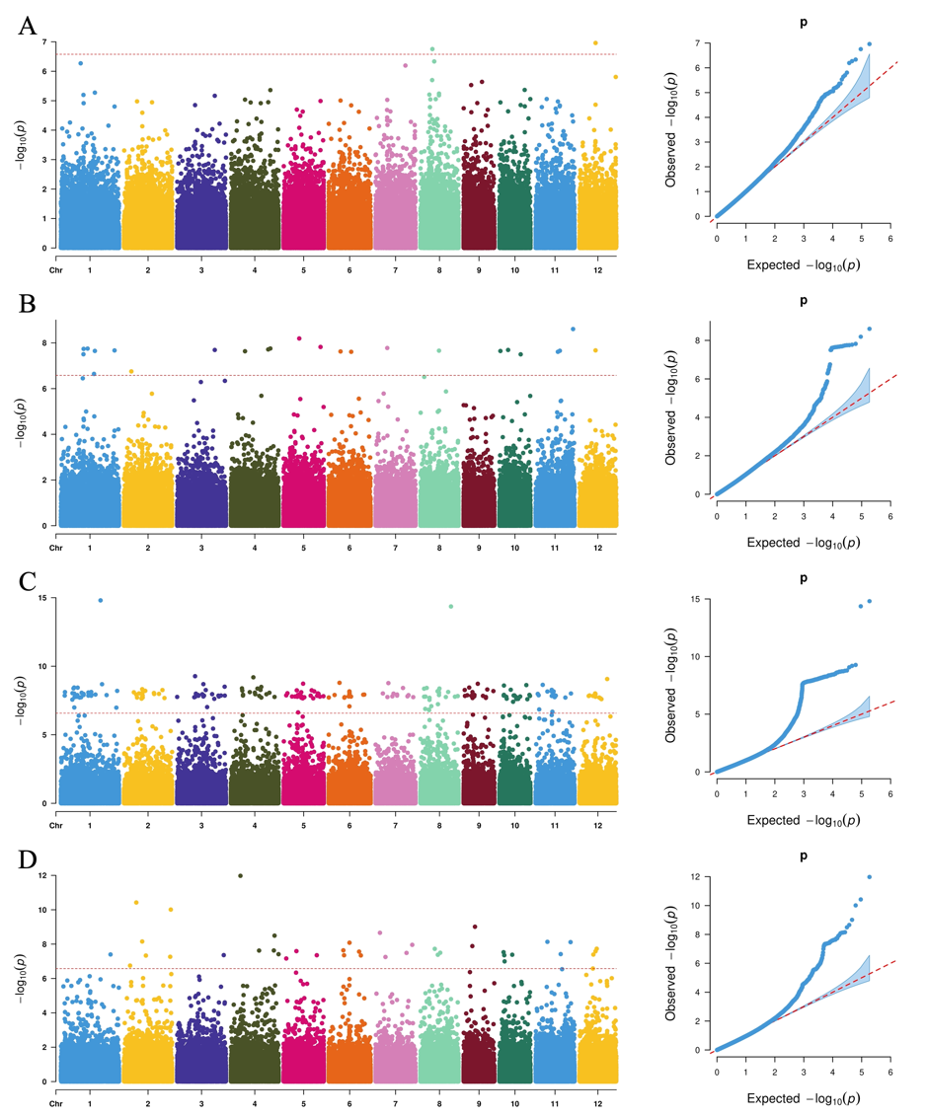
Supplementary Figure 5 Manhattan plots and QQ plots for the four traits in Wuchang by MLM. (A) Days to heading. (B) Plant height. (C) Panicle weight. (D) Tiller number.

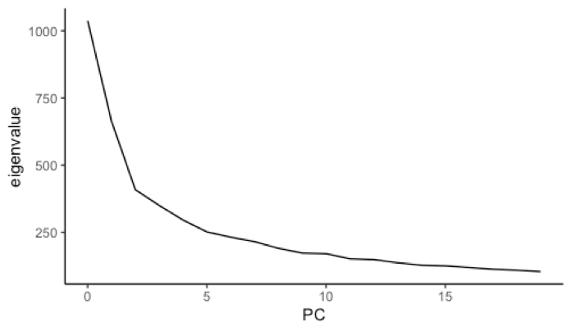
Supplementary Figure 6 Line plot of eigenvalues with the first 20 principal components. A significant downward trend was shown for the first 5 principal components.

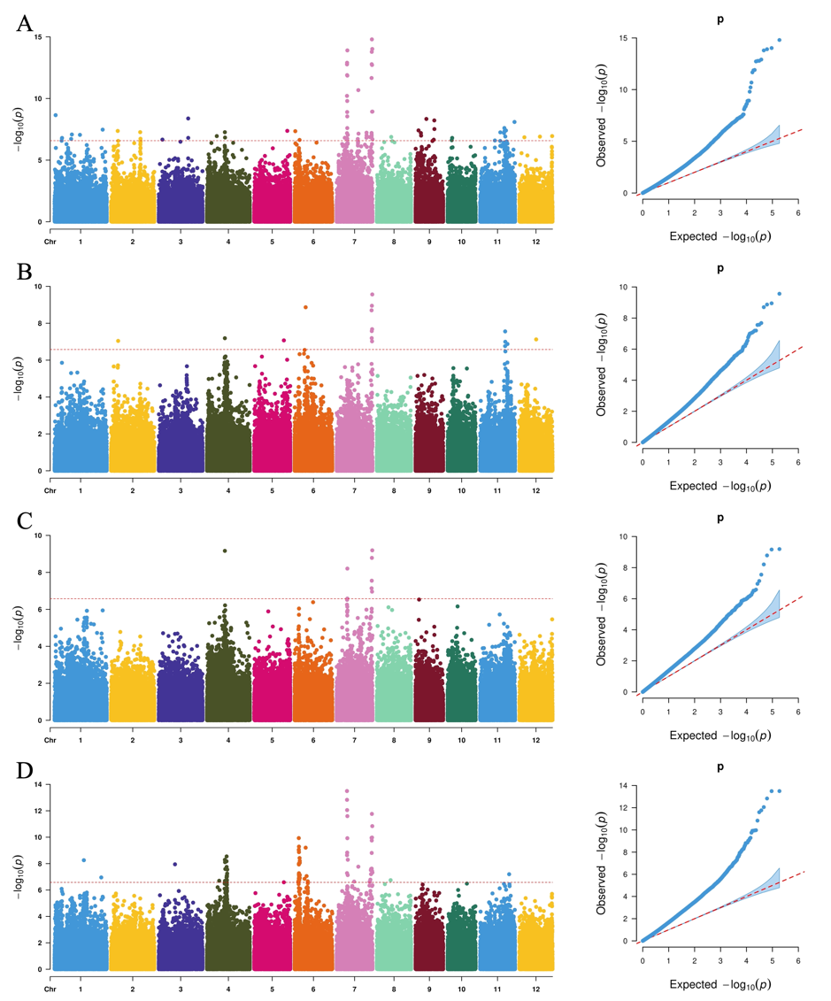
Supplementary Figure 7 Manhattan plots and QQ plots for Days to heading in four locations by GLM. (A) Heihe. (B) Jiamusi. (C) Harbin. (D) Wuchang.

