Supplementary Figures

Phylogenetic tree of mature sequences of hsa-mir-548 family members
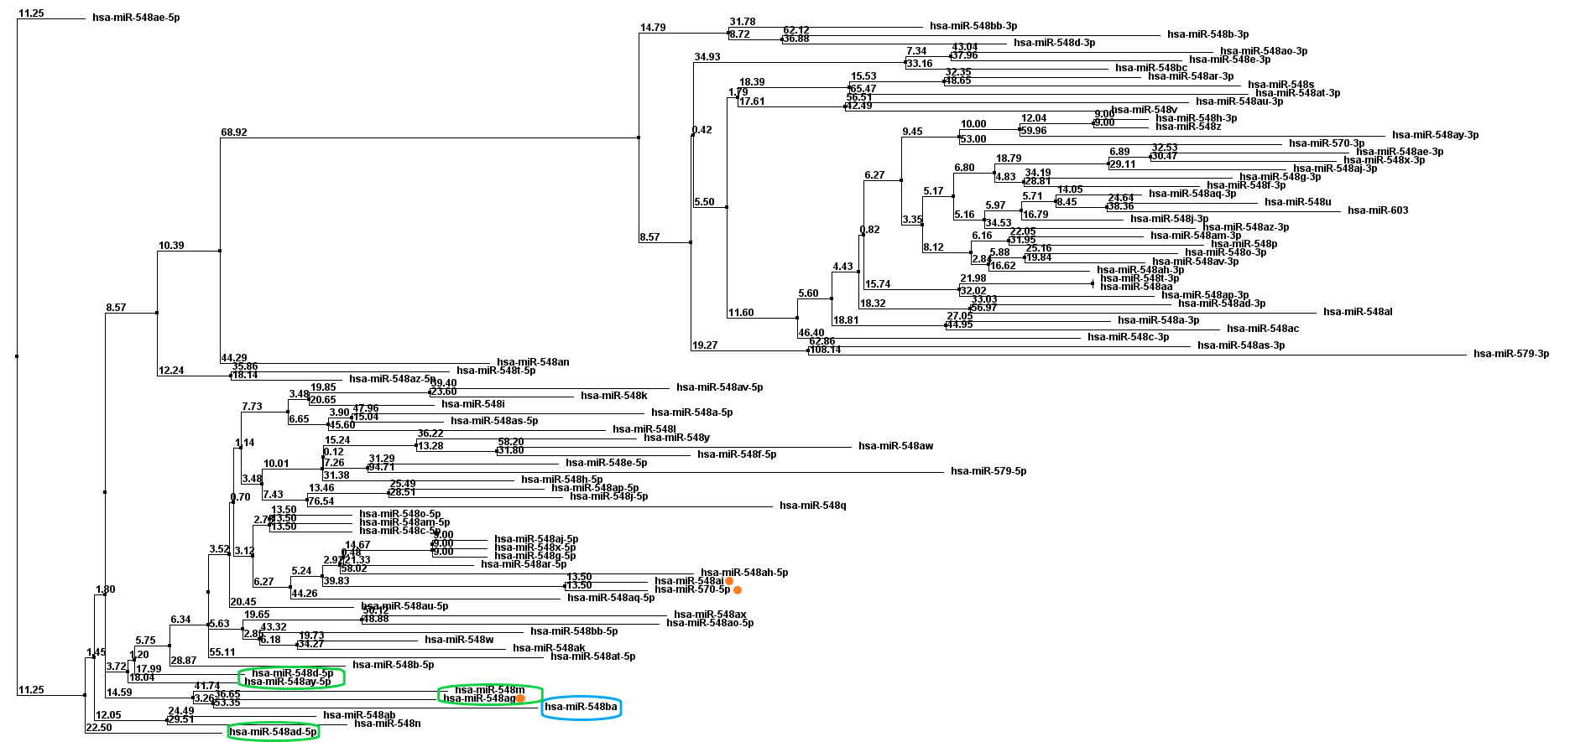
Supplementary Figure 1. Phylogenetic tree of mature sequences of hsa-mir-548 family members. The location of hsa-miR-548ba is marked in blue, closest members to the hsa-miR-548ba are marked in green and members which share same seed sequence with hsa-miR-548ba are marked with an orange dot.

Phylogenetic tree of pre-miRNA sequences of miR-548 family members
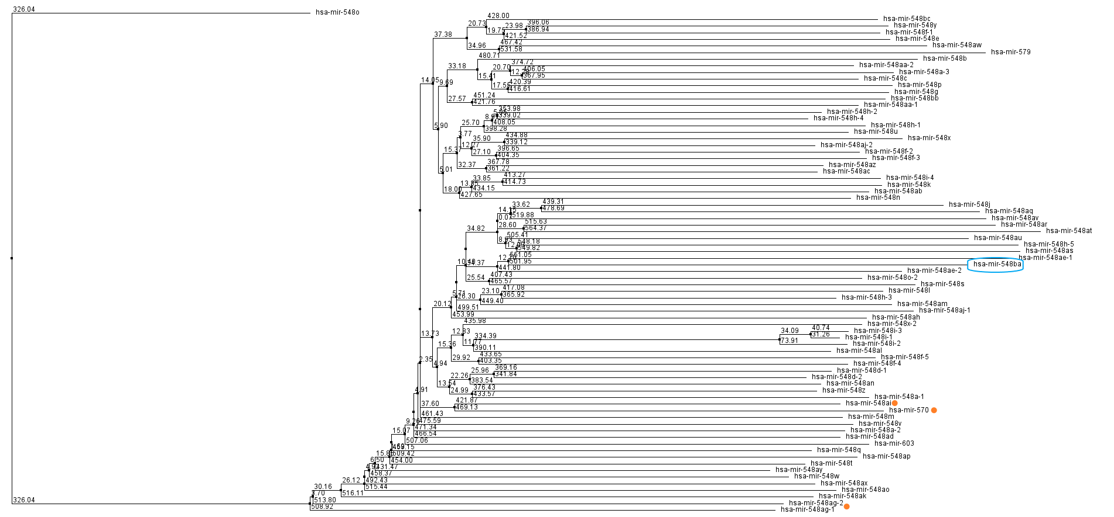
Supplementary Figure 2. Phylogenetic tree of pre-miRNA sequences of miR-548 family members. The location of hsa-miR-548ba is marked in blue and members which share the same seed sequence with hsa-miR-548ba are marked with orange dot.

Phylogenetic tree of Made1 and hsa-mir-548 family members
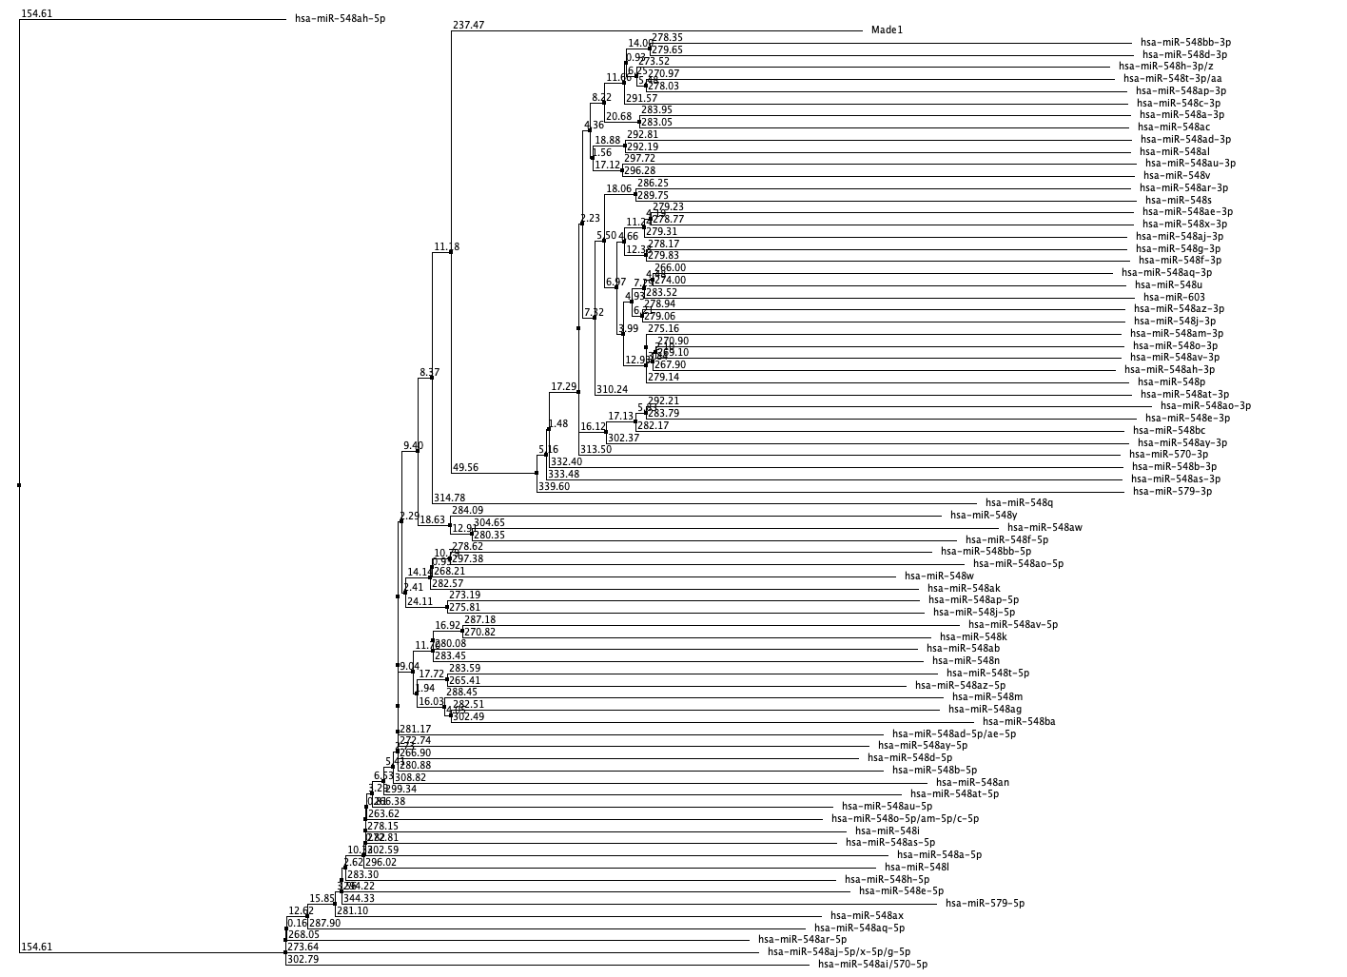

Supplementary Figure 3. Phylogenetic tree of Made1 and mature sequences of hsa-mir-548 family members.

The alignment of Made1 and hsa-mir-548 family mature sequences

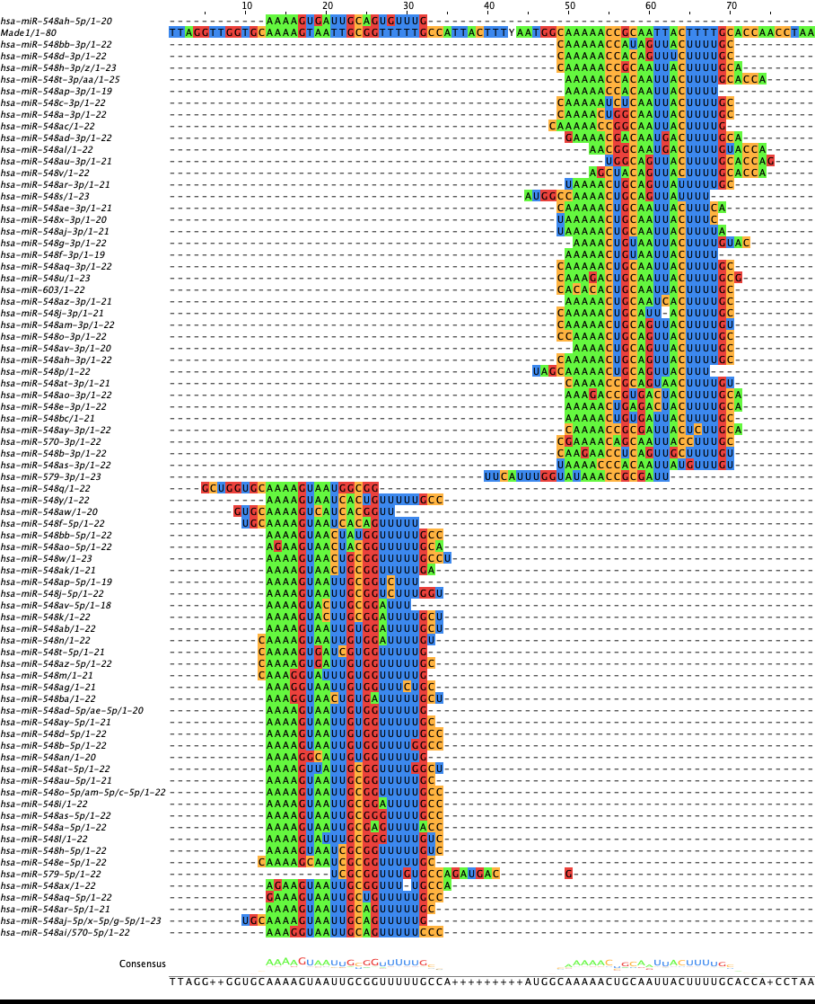

Supplementary Figure 4. The alignment of Made1 and hsa-mir-548 family mature sequences. Sequences are sorted by phylogenetic tree and miRNAs with the same mature sequences are collapsed together.

