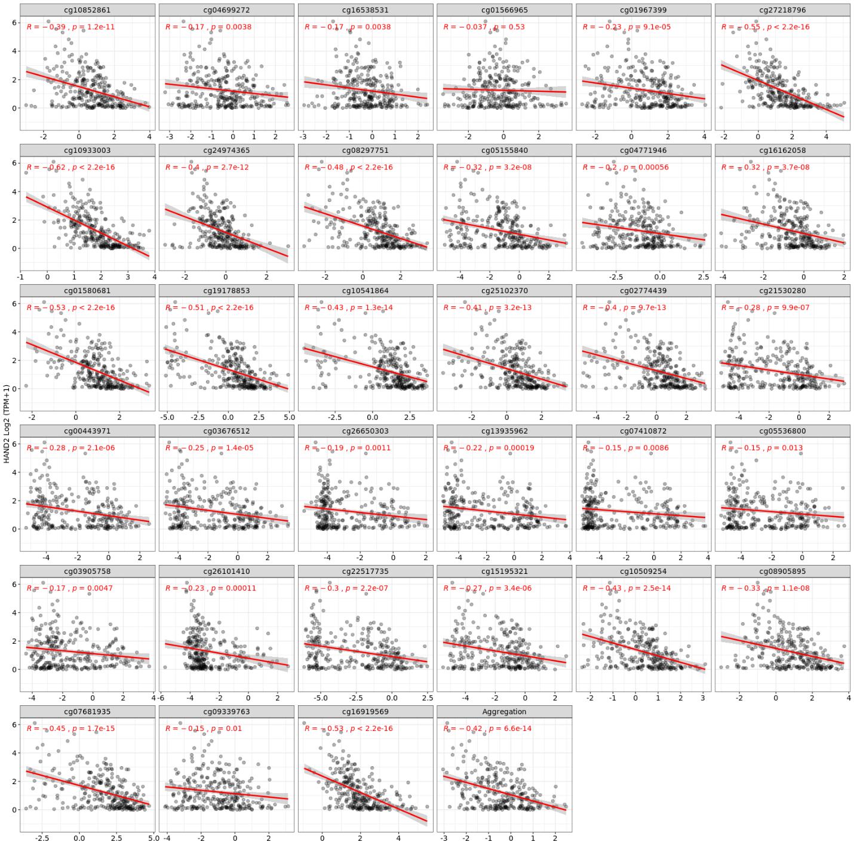
Supplementary Figure 1. Hypermethylated Regions of HAND2 CpG Islands and Their Correlation with HADN2 Expression in CRC Samples Obtained from SMART Database. The methylated data is expressed with M-value, and expression data is based on _{log2}(TPM+1). The aggregation of all methylated regions compared to expression revealed that HAND2 significantly (R = -0.44, p= 6.6e-14 for colon cancer) hypermethylated and downregulated colon adenocarcinoma. The aggregation method is expressed as the mean of thirty-three founded probs for HAND2. Correlation between gene expression and methylation (Number of samples in COAD: 288), COAD: Colon adenocarcinoma.

