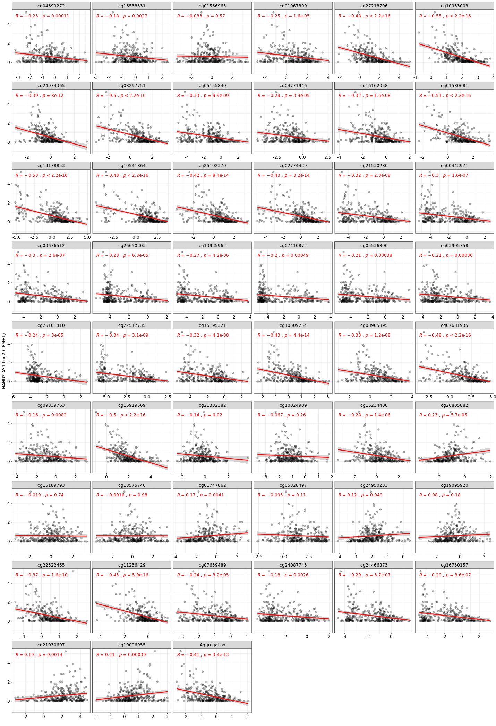
Supplementary Figure 2. Hypermethylated Regions of HAND2-AS1 CpG Islands and Their Correlation with HADN2-AS1 Expression in CRC Samples Obtained from SMART Database. The methylated data is expressed with M-value, and expression data is based on _{log2}(TPM+1). Compared to expression, the aggregation of all methylated regions revealed that HAND2-AS1 significantly (R = -0.41, p= 3.4e-13 for colon cancer) hypermethylated and downregulated colon adenocarcinoma. The aggregation method is the mean of thirty-three founded probs for HAND2-AS1. Correlation between gene expression and methylation (Number of samples in COAD: 288), COAD: Colon adenocarcinoma.

