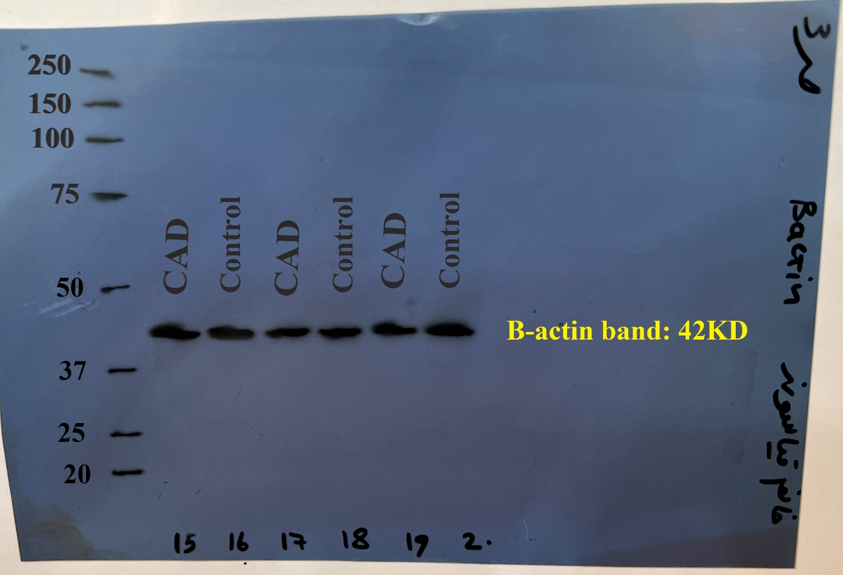

Figure 1. displays the β-actin bands at 42 kDa for patients with CAD and control samples.

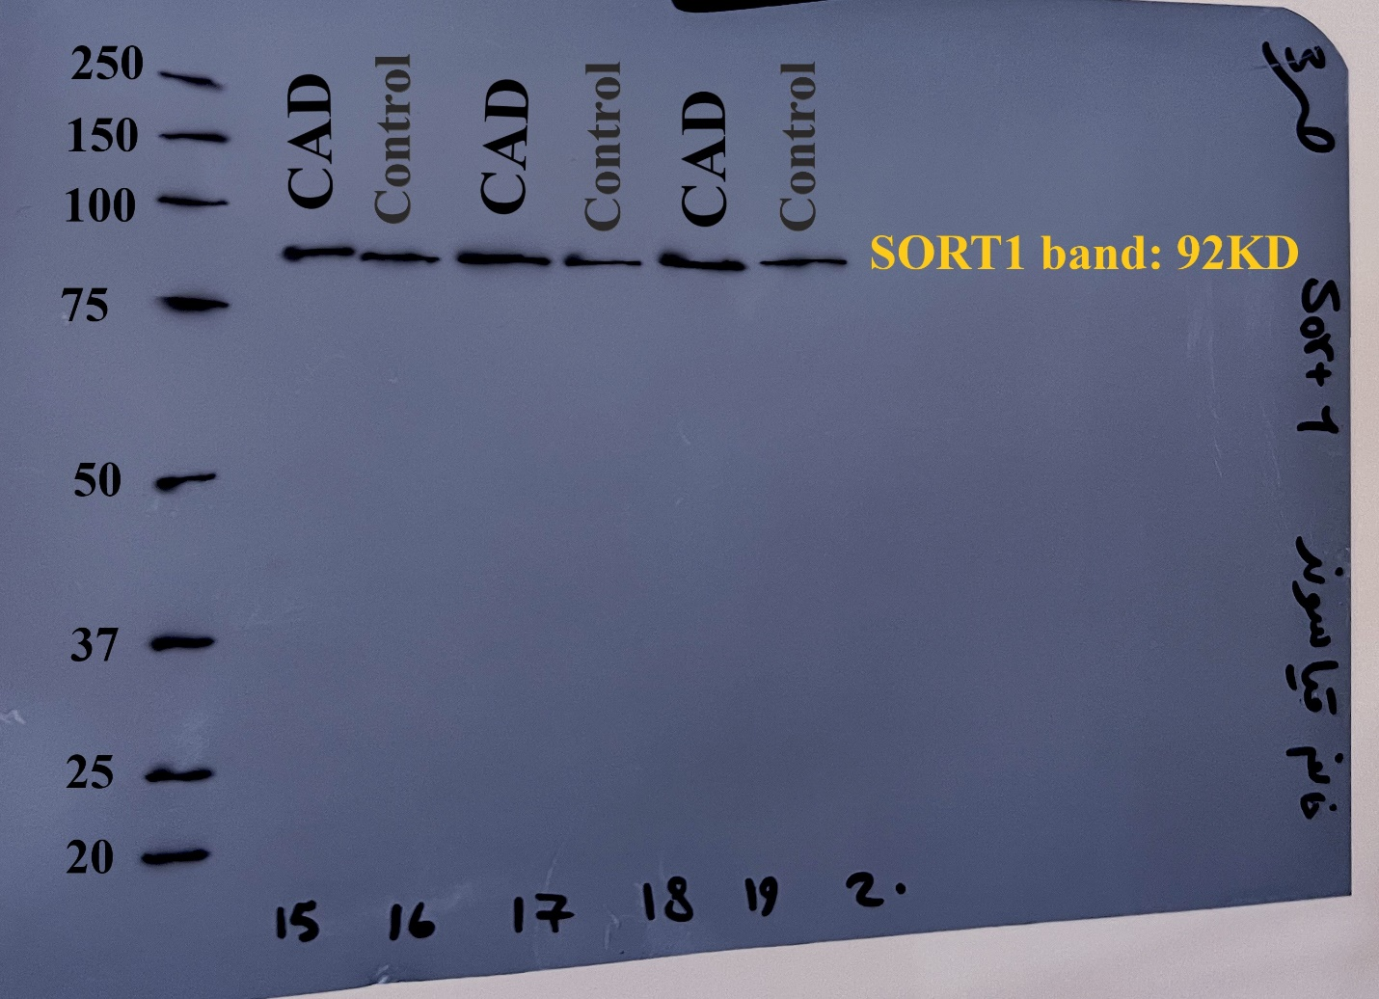

Figure 2. displays the SORT1 bands at 92 kDa for patients with CAD and control samples.

