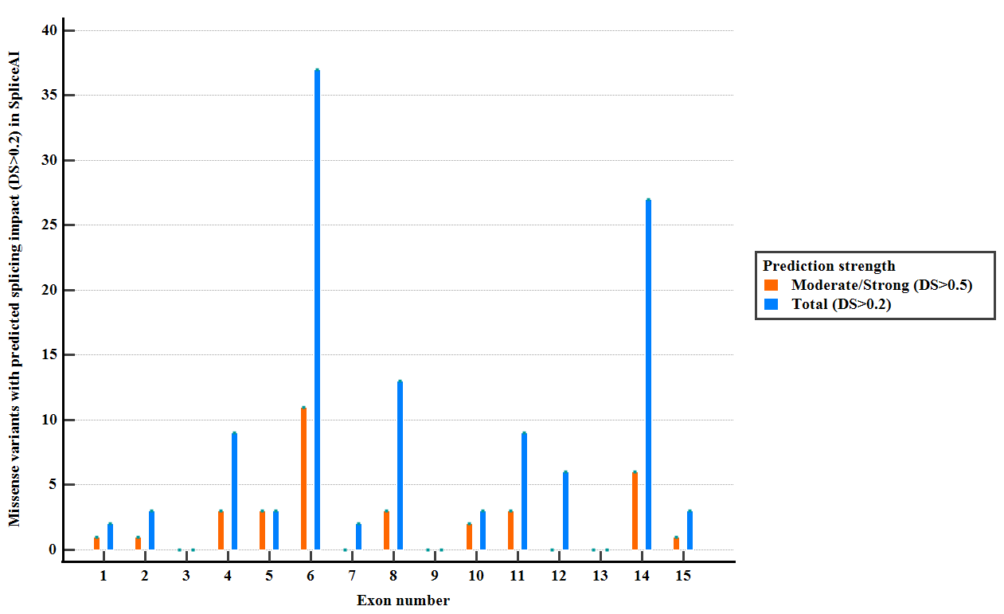

Figure S1. Distribution of reported PMS2 missense variants (ClinVar, LOVD) with predicted splicing impact (DS > 0.2) in SpliceAI

Exon 2
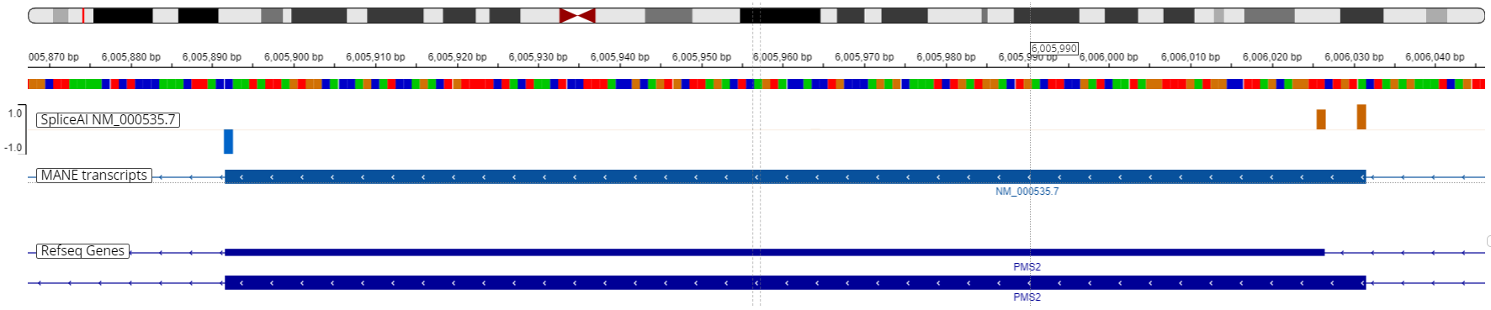

Exon 5
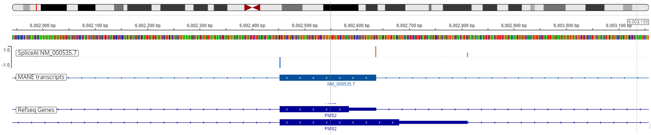
Exon 6
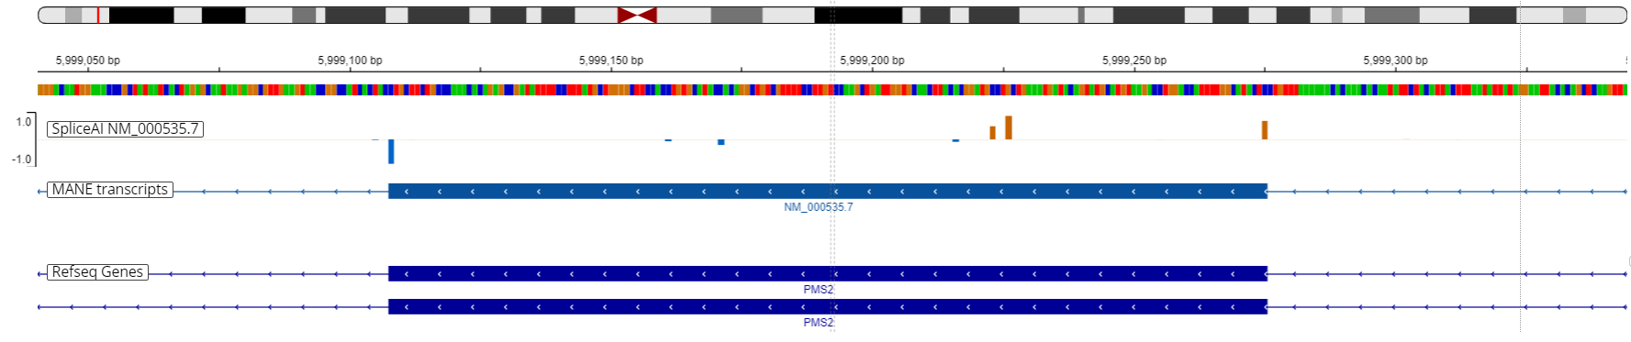

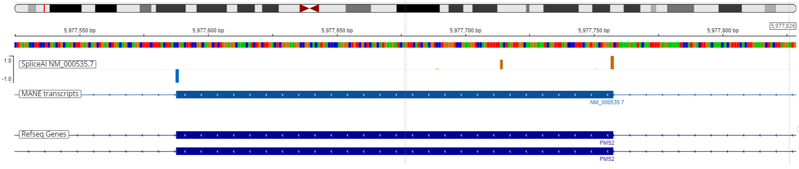
Exon 14

Figure S2. SpliceAI-visual predictions (IGV interface, MobiDetails) for PMS2 wild type sequence. Canonical and cryptic splice sites are depicted as vertical bars: blue bars denote donor splice sites, orange bars denote acceptor splice sites.

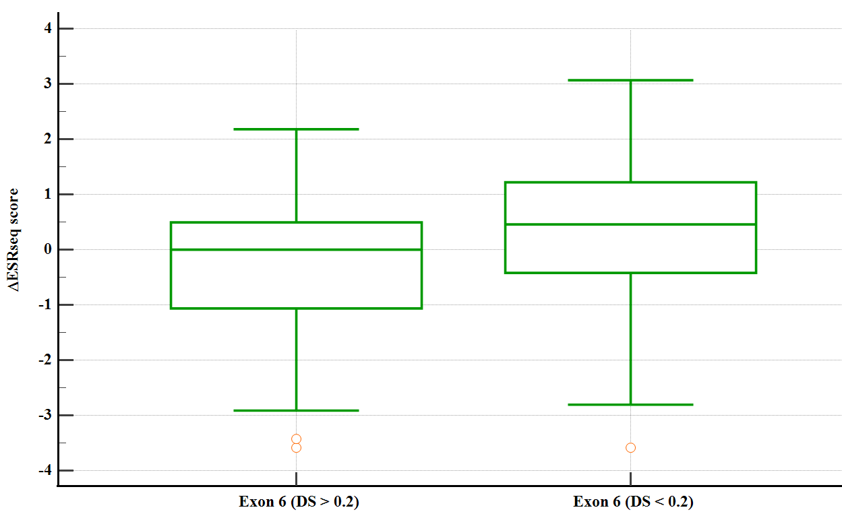

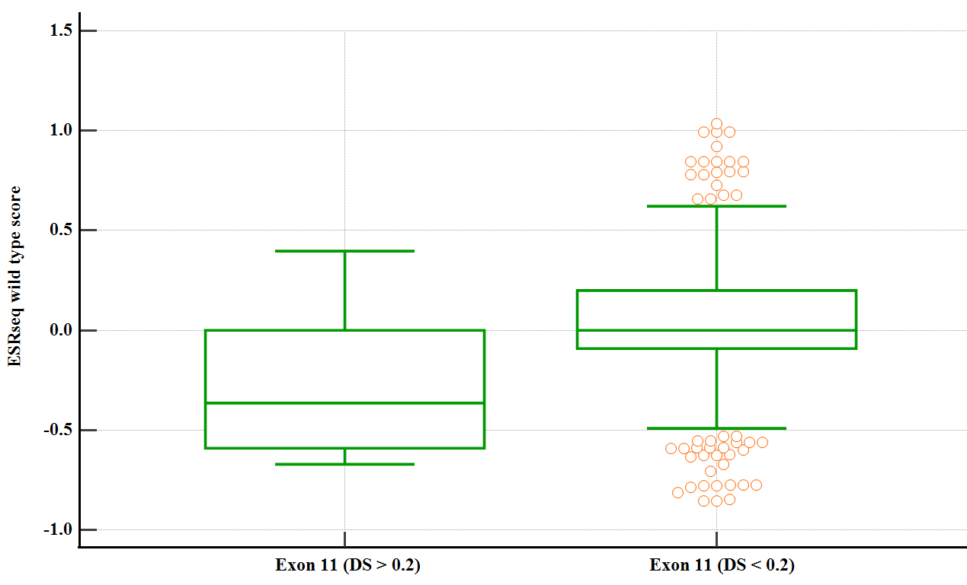

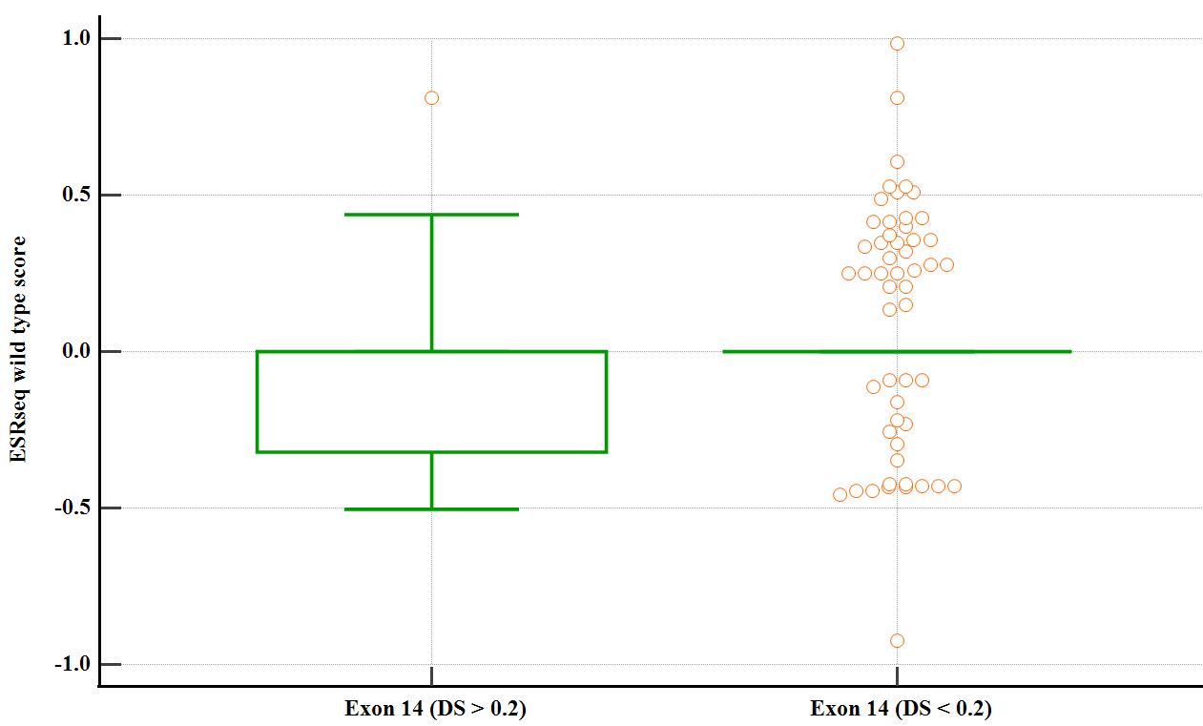

Figure S3. Wild-type ESRseq and ΔESRseq scores comparison between predicted splicing variants (DS > 0.2) and variants with no predicted splicing impact (DS < 0.2) in exons 6, 11 and 14 with significant difference between splicing and non-splicing variant-associated ESRseq or ΔESRseq scores

Table S1. PMS2 short intronic variants (< 50 bp) with predicted splicing impact (SpliceAI and SpliceAI-visual). AG – acceptor gain, AL – acceptor loss, DG – donor gain, DL – donor loss, DS – delta score
Variant nomenclature | Clinical significance | SpliceAI-visual | SpliceAI-50nt (DS) |  |  |  | Functional data
Variant nomenclature | Clinical significance | SpliceAI-visual | AG | AL | DG | DL
NM_000535.7:c.164-9_178delinsGATCC | Conflicting | Acceptor loss, novel acceptor site | 0.98 | 1 | 0 | 0 |  | No
NM_000535.7:c.251-6_251-3del | VUS | Acceptor loss | 0 | 0.72 | 0 | 0 |  | No
NM_000535.7:c.251-11CT[2] | Conflicting | Acceptor loss | 0 | 0.36 | 0 | 0 |  | Yes
NM_000535.7:c.251-15dup | LB | Acceptor gain | 0.12 | 0.01 | 0 | 0 |  | No
NM_000535.7:c.354-18_354-15dup | LB | Cryptic acceptor site | 0 | 0.01 | 0 | 0 |  | No
NM_000535.7:c.538-5_538-4del | LB | Acceptor loss | 0 | 0.28 | 0.01 | 0 |  | No
NM_000535.7:c.538-12dup | Conflicting | Acceptor gain | 0.12 | 0 | 0 | 0 |  | No
NM_000535.7:c.706-2dup | Conflicting | Acceptor loss | 0.02 | 0.28 | 0 | 0 |  | No
NM_000535.7:c.706-4_706-3delinsA | LB | Acceptor loss | 0.01 | 0.32 | 0 | 0 |  | No
NM_000535.7:c.706-10_706-4del | VUS | Acceptor loss | 0.01 | 0.1 | 0 | 0 |  | No
NM_000535.7:c.1145-31_1145-13del | VUS | Acceptor loss, novel acceptor site | 0.5 | 0.85 | 0 | 0 |  | No
NM_000535.7:c.1145-2_1145-1del | VUS | Acceptor loss, cryptic acceptor site | 0.59 | 0.98 | 0 | 0 |  | No
NM_000535.7:c.1970_2006+9dup | VUS | Novel donor site | 0 | 0 | 0.27 | 0.07 |  | No
NM_000535.7:c.2007-2_2007-1delinsCA | Conflicting | Cryptic acceptor site | 0.94 | 0.99 | 0 | 0 |  | No

Table S2. In silico prediction tools (ESEfinder 3.0, FSplice, MaxEntScan, NetGene2, NNSplice, SpliceAI, Spliceator, SpliceRover) assessing canonical splice site strength of PMS2 exons
Exon number | ESEfinder 3.0 |  | FSplice |  | MaxEntScan |  | NetGene2
Exon number | Donor | Acceptor | Donor | Acceptor | Donor | Acceptor | Donor | Acceptor
1 | 11.9703 | - | 10.72 | - | 8.70 | - | 0.81 | -
2 | 8.8481 | 7.7962 | 14.92 | 4.97 | 10.47 | 4.33 | 0.83 | 0.44
3 | 7.2524 | 0 | 12.4 | 5.42 | 8.07 | 5.91 | 0.90 | 0.19
4 | 0 | 8.2679 | 0 | 6.80 | 3.13 | 9.15 | 0 | 0.71
5 | 0 | 0 | 10.86 | 9.25 | 8.04 | 8.59 | 0.69 | 0.20
6 | 6.7284 | 6.8515 | 8.76 | 7.62 | 6.13 | 9.96 | 0.81 | 0.71
7 | 0 | 12.5959 | 9.88 | 11.60 | 7.79 | 11.6 | 0 | 0.56
8 | 0 | 0 | 9.04 | 0 | 7.64 | 3.54 | 0 | 0
9 | 11.1192 | 9.1049 | 15.06 | 9.30 | 10.86 | 9.01 | 0.93 | 0.96
10 | 9.6691 | 8.7348 | 14.92 | 11.70 | 10.57 | 10 | 1 | 0.64
11 | 7.3820 | 0 | 13.24 | 6.47 | 9.06 | 7.77 | 0.81 | 0
12 | 0 | 7.4782 | 8.34 | 9.72 | 8.20 | 8.61 | 0.93 | 0.85
13 | 8.3829 | 10.2591 | 15.62 | 11.75 | 11.01 | 10.75 | 0.99 | 0.96
14 | 0 | 9.4881 | 15.62 | 4.88 | 11.78 | 6.62 | 0.94 | 0.23
15 | - | 6.7994 | - | 9.30 | - | 8.57 | - | 0.76
Exon number | SpliceRover |  | Spliceator |  | SpliceAI |  | NNSplice
 | Donor | Acceptor | Donor | Acceptor | Donor | Acceptor | Donor | Acceptor
1 | 0 | - | 0.9902176 | - | 0.99 | - | 0.99 | -
2 | 0.951675 | 0.97624 | 0.9977319 | 0.9912317 | 0.97 | 0.98 | 1 | 0.45
3 | 0.989035 | 0.999805 | 0.9971898 | 0.9962182 | 0.99 | 0.99 | 0.99 | 0.71
4 | 0.437242 | 0.984756 | 0 | 0.9970701 | 0.84 | 0.73 | 0.48 | 0.80
5 | 0.994171 | 0.987907 | 0.9939558 | 0 | 0.99 | 0.98 | 0.8 | 0.68
6 | 0.768978 | 0.936303 | 0.98945916 | 0.9938370 | 0.88 | 0.67 | 0.46 | 0.66
7 | 0.742711 | 0.994592 | 0 | 0.9861491 | 0.98 | 0.97 | 0.94 | 1
8 | 0.989721 | 0.724279 | 0.9960614 | 0 | 0.73 | 0.58 | 0.83 | 0
9 | 0.85223 | 0.999107 | 0.99839705 | 0.9878899 | 0.99 | 0.99 | 1 | 0.98
10 | 0.999429 | 0.999356 | 0.99913824 | 0.9975751 | 0.99 | 0.99 | 1 | 0.98
11 | 0.966332 | 0.96125 | 0.99981886 | 0 | 0.94 | 0.98 | 0.94 | 0.63
12 | 0.88322 | 0.998669 | 0 | 0.9903571 | 0.99 | 0.98 | 0.95 | 0.54
13 | 0.982607 | 0.999193 | 0.99083436 | 0.9846749 | 0.99 | 0.99 | 1 | 0.99
14 | 0.997962 | 0.997972 | 0.99820495 | 0.9898764 | 0.99 | 0.98 | 1 | 0.90
15 | - | 0.991014 | - | 0.9880558 | - | 0.93 | - | 0

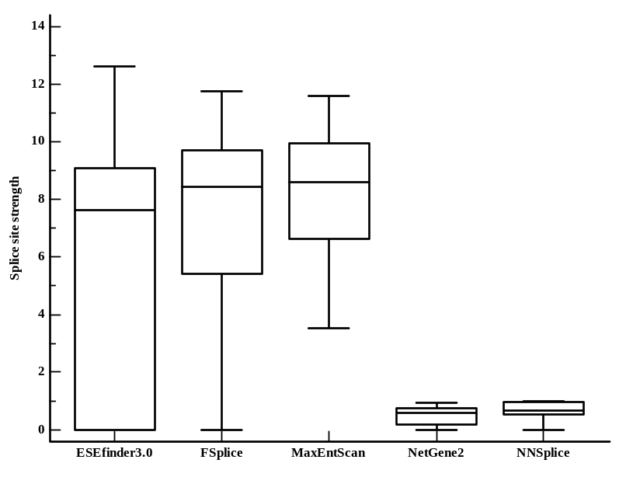
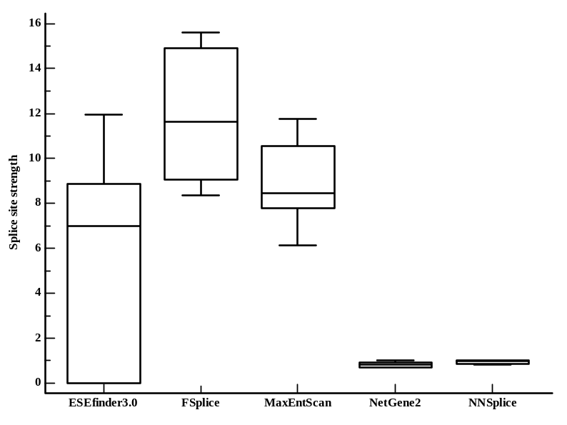
A

B

Figure S4. Canonical acceptor (A) and donor (B) splice sites strength determined using splicing prediction tools (ESEfinder 3.0, FSplice, MaxEntScan, NetGene2, NNSplice)

Table S3. Exonic density of SR proteins motifs identified using ESEfinder 3.0 software
Exon | SRp55% | SRp40% | SF2/ASF% | SF2/ASF(IgM-BRCA1)% | SC35%
2 | 2.857143 | 5 | 2.142857 | 2.857143 | 2.857143
3 | 1.149425 | 4.597701 | 1.149425 | 2.298851 | 2.298851
4 | 1.941748 | 3.883495 | 2.912621 | 6.796117 | 3.883495
5 | 1.630435 | 6.521739 | 3.804348 | 7.608696 | 3.26087
6 | 4.166667 | 4.166667 | 2.380952 | 3.571429 | 3.571429
7 | 2.040816 | 2.040816 | 0 | 2.040816 | 2.040816
8 | 1 | 3 | 7 | 9 | 2
9 | 3.529412 | 5.882353 | 7.058824 | 3.529412 | 4.705882
10 | 1.282051 | 5.769231 | 1.282051 | 1.282051 | 3.205128
11 | 2.784223 | 4.292343 | 4.408353 | 5.916473 | 3.596288
12 | 4.166667 | 4.166667 | 3.571429 | 3.571429 | 3.571429
13 | 0 | 1.980198 | 0.990099 | 1.980198 | 1.980198
14 | 1.764706 | 4.705882 | 4.117647 | 9.411765 | 4.705882

Table S4. Splicing Regulatory Elements (SREs) prediction for PMS2 exons using ESEfinder 3.0, HExoSplice and HOT-SKIP
Exon | ESEfinder 3.0 | HExoSplice |  |  | HOT-SKIP
 | ESE% | ESS% | ESE% | ESS/ESE*100 | ESS% | ESE% | ESS/ESE*100
2 | 15.71429 | 38.57143 | 17.14286 | 225 | 52.14286 | 81.42857 | 64.03509
3 | 11.49425 | 0 | 0 | 0 | 52.87356 | 93.10345 | 56.79012
4 | 19.41748 | 26.21359 | 20.38835 | 128.5714 | 51.45631 | 80.58252 | 63.85542
5 | 22.82609 | 27.71739 | 26.63043 | 104.0816 | 47.82609 | 93.47826 | 51.16279
6 | 17.85714 | 40.47619 | 19.64286 | 206.0606 | 67.2619 | 76.19048 | 88.28125
7 | 8.163265 | 32.65306 | 29.59184 | 110.3448 | 72.44898 | 76.53061 | 94.66667
8 | 22 | 20 | 24 | 83.33333 | 60 | 72 | 83.33333
9 | 24.70588 | 27.05882 | 17.64706 | 153.3333 | 60 | 52.94118 | 113.3333
10 | 12.82051 | 33.33333 | 17.94872 | 185.7143 | 75.64103 | 79.48718 | 95.16129
11 | 20.99768 | 25.52204 | 27.4942 | 92.827 | 46.2877 | 86.89095 | 53.27103
12 | 19.04762 | 27.38095 | 30.35714 | 90.19608 | 54.7619 | 85.71429 | 63.88889
13 | 6.930693 | 28.71287 | 24.75248 | 116 | 70.29703 | 79.20792 | 88.75
14 | 24.70588 | 18.82353 | 30 | 62.7451 | 39.41176 | 85.88235 | 45.89041

Table S5. Exonic distribution of SREs motifs in HExoSplice software in exons with concordant high density of ESEs or ESSs
Exon | R² | Intercept (CI 95%) | p | Slope (CI 95%) | p
Exon 5 | 0.1142 | 0.2242 (0.0881;0.3602) | 0.0015 | -0.0023 (-0.0036;-0.0010) | 0.0005
Exon 6 | 0.0067 | -0.1557 (-0.3020;-0.0093) | 0.0373 | 0.0005 (-0.0008;0.0019) | 0.4135
Exon 7 | 0.0244 | 0.0584 (-0.1797;0.2967) | 0.6251 | -0.0024 (-0.0064;0.0015) | 0.2288
Exon 10 | 0.0007 | -0.0917 (-0.2675;0.0840) | 0.3019 | -0.0002 (-0.0020;0.0016) | 0.8135
Exon 11 | 0.0046 | 0.0860 (0.0107;0.1614) | 0.0253 | -0.0001 (-0.0002;0.00004) | 0.1474
Exon 14 | 0.0904 | -0.0972 (-0.2713;0.0768) | 0.2698 | 0.0025 (0.0007;0.0043) | 0.0057

Table S6. Exon expression (median read count per base) for PMS2 gene (ENSG00000122512.14) in Lynch syndrome-related tissues. Data Source: GTEx Analysis Release V8 (dbGaP Accession phs000424.v8.p2)
Exons | Whole blood | Pancreas | Stomach | Bladder | Kidney - Medulla | Prostate | Skin - Sun exposed (lower leg) | Brain - Cortex | Uterus | Colon - Transverse | Colon - Sigmoid | Ovary | Breast - Mamary tissue
1 | 0.069 | 0.012 | 0.017 | 0.029 | 0.038 | 0.021 | 0.052 | 0.035 | 0.027 | 0.023 | 0.025 | 0.028 | 0.034
2 | 0.031 | 0.047 | 0.074 | 0.143 | 0.103 | 0.088 | 0.216 | 0.142 | 0.121 | 0.106 | 0.106 | 0.125 | 0.144
3 | 0.035 | 0.057 | 0.096 | 0.204 | 0.119 | 0.117 | 0.278 | 0.186 | 0.163 | 0.131 | 0.137 | 0.159 | 0.180
4 | 0.033 | 0.052 | 0.087 | 0.152 | 0.133 | 0.111 | 0.257 | 0.182 | 0.148 | 0.118 | 0.124 | 0.150 | 0.177
5 | 0.038 | 0.060 | 0.097 | 0.174 | 0.130 | 0.128 | 0.273 | 0.185 | 0.165 | 0.133 | 0.141 | 0.161 | 0.183
6 | 0.042 | 0.061 | 0.105 | 0.189 | 0.162 | 0.131 | 0.293 | 0.221 | 0.167 | 0.139 | 0.149 | 0.177 | 0.189
7 | 0.038 | 0.055 | 0.104 | 0.171 | 0.150 | 0.125 | 0.251 | 0.206 | 0.166 | 0.128 | 0.134 | 0.153 | 0.168
8 | 0.042 | 0.062 | 0.108 | 0.187 | 0.159 | 0.143 | 0.268 | 0.237 | 0.172 | 0.138 | 0.144 | 0.166 | 0.184
9 | 0.044 | 0.062 | 0.108 | 0.165 | 0.155 | 0.158 | 0.302 | 0.255 | 0.169 | 0.138 | 0.155 | 0.187 | 0.198
10 | 0.050 | 0.070 | 0.122 | 0.210 | 0.235 | 0.192 | 0.363 | 0.264 | 0.192 | 0.154 | 0.174 | 0.212 | 0.220
11 | 0.077 | 0.094 | 0.160 | 0.294 | 0.310 | 0.254 | 0.465 | 0.385 | 0.270 | 0.217 | 0.244 | 0.275 | 0.286
12 | 0.051 | 0.060 | 0.103 | 0.191 | 0.206 | 0.179 | 0.296 | 0.219 | 0.168 | 0.136 | 0.155 | 0.162 | 0.180
13 | 0.094 | 0.093 | 0.162 | 0.356 | 0.394 | 0.301 | 0.438 | 0.351 | 0.258 | 0.213 | 0.243 | 0.262 | 0.277
14 | 0.098 | 0.092 | 0.169 | 0.307 | 0.296 | 0.296 | 0.448 | 0.357 | 0.275 | 0.220 | 0.24 | 0.269 | 0.272
15 | 0.042 | 0.044 | 0.071 | 0.134 | 0.138 | 0.134 | 0.212 | 0.170 | 0.110 | 0.095 | 0.103 | 0.106 | 0.133

Table S7. PMS2 alternative RefSeq transcripts available on UCSC genome browser (December 2023)
 | RefSeq transcript | Splicing | Transcript type | CDS start | Protein | Chromosome | Strand | Start (g.) | End  (g.) | Start (c.) | End (c.) | Total
1 | NM_001322003.2 | Δ2p | splice acceptor shift | exon 5 | NP_001308932.1 | 7p22.1 | - | 5970925 | 6009049 | 1 | 5088 | 5088
2 | NM_001406903.1 | Δ12 | cassette | exon 1 | NP_001393832.1 | 7p22.1 | - | 5970925 | 6009049 | 1 | 4822 | 4822
3 | NM_001322004.2 | Δ2 | cassette | exon 5 | NP_001308933.1 | 7p22.1 | - | 5970925 | 6009049 | 1 | 4953 | 4953
4 | NM_001322005.2 | ▼1q | splice donor shift | exon 5 | NP_001308934.1 | 7p22.1 | - | 5970925 | 6009049 | 1 | 5283 | 5283
5 | NM_001322006.2 | Δ10 | cassette | exon 3 | NP_001308935.1 | 7p22.1 | - | 5970925 | 6009049 | 1 | 4937 | 4937
6 | NM_001322008.2 | Δ2, Δ4 | cassette | exon 3 | NP_001308937.1 | 7p22.1 | - | 5970925 | 6009049 | 1 | 4850 | 4850
7 | NM_001322008.2 | ▼1q, Δ2p, ▼14p | splice donor shift + splice acceptor shift | exon 5 | NP_001308938.1 | 7p22.1 | - | 5970925 | 6009049 | 1 | 5311 | 5311
8 | NM_001322010.2 | Δ2, Δ10 | cassette | exon 5 | NP_001308939.1 | 7p22.1 | - | 5970925 | 6009049 | 1 | 4797 | 4797
9 | NM_001322011.2 | Δ6p | splice acceptor shift | exon 1 | NP_001308940.1 | 7p22.1 | - | 5970925 | 6009049 | 1 | 5044 | 5044
10 | NM_001322012.2 | Δ2p, Δ6p | splice acceptor shift | exon 9 | NP_001308941.1 | 7p22.1 | - | 5970925 | 6009049 | 1 | 5039 | 5039
11 | NM_001322013.2 | Δ2p, Δ6 | splice acceptor shift + cassette | exon 5 | NP_001308942.1 | 7p22.1 | - | 5970925 | 6009049 | 1 | 4920 | 4920
12 | NM_001322014.2 | ▼14p | splice acceptor shift | exon 1 | NP_001308943.1 | 7p22.1 | - | 5970925 | 6009049 | 1 | 5126 | 5126
13 | NM_001322015.2 | Δ2p, ▼5p | splice acceptor shift | exon 5 | NP_001308944.1 | 7p22.1 | - | 5970925 | 6009049 | 1 | 5263 | 5263
14 | NM_001406866.1 | intron 1 inclusion | intron inclusion | exon 1 | NP_001393795.1 | 7p22.1 | - | 5970925 | 6009049 | 1 | 5279 | 5279
15 | NM_001406868.1 |  |  | exon 1 | NP_001393797.1 | 7p22.1 | - | 5970925 | 6009049 | 1 | 5117 | 5117
16 | NM_001406869.1 | Δ6q | splice acceptor shift | exon 1 | NP_001393798.1 | 7p22.1 | - | 5970925 | 6009049 | 1 | 4985 | 4985
17 | NM_001406870.1 | Δ10, ▼14p | cassette + splice acceptor shift | exon 1 | NP_001393799.1 | 7p22.1 | - | 5970925 | 6009049 | 1 | 4970 | 4970
18 | NM_001406871.1 | Δ13_14p | cassette + splice acceptor shift | exon 1 | NP_001393800.1 | 7p22.1 | - | 5970925 | 6009049 | 1 | 4949 | 4949
19 | NM_001406871.1 | Δ12 | cassette | exon 1 | NP_001393800.1 | 7p22.1 | - | 5970925 | 6009049 | 1 | 4949 | 4949
20 | NM_001406873.1 | Δ7_8 | multi-cassette | exon 1 | NP_001393802.1 | 7p22.1 | - | 5970925 | 6009049 | 1 | 4895 | 4895
21 | NM_001406874.1 | Δ6 | cassette | exon 1 | NP_001393803.1 | 7p22.1 | - | 5970925 | 6009049 | 1 | 4925 | 4925
22 | NM_001406875.1 | ▼1q, ▼5p, ▼14p | splice donor shift + splice acceptor shift | exon 5 | NP_001393804.1 | 7p22.1 | - | 5970925 | 6009049 | 1 | 5491 | 5491
23 | NM_001406876.1 | Δ4, ▼14p | cassette + splice acceptor shift | exon 3 | NP_001393805.1 | 7p22.1 | - | 5970925 | 6009049 | 1 | 5023 | 5023
24 | NM_001406877.1 | ▼1q, ▼5p, intron 1 inclusion | splice donor shift + splice acceptor shift + intron inclusion | exon 5 | NP_001393806.1 | 7p22.1 | - | 5970925 | 6009049 | 1 | 5625 | 5625
25 | NM_001406878.1 | ▼5p | splice acceptor shift | exon 5 | NP_001393807.1 | 7p22.1 | - | 5970925 | 6009049 | 1 | 5268 | 5268
26 | NM_001406879.1 | Δ2, ▼5p | cassette + splice acceptor shift | exon 5 | NP_001393808.1 | 7p22.1 | - | 5970925 | 6009049 | 1 | 5128 | 5128
27 | NM_001406880.1 | Δ4q, ▼5p | splice donor shift + splice acceptor shift | exon 5 | NP_001393809.1 | 7p22.1 | - | 5970925 | 6009049 | 1 | 5215 | 5215
28 | NM_001406881.1 | Δ2, Δ4, ▼5p | cassette + splice acceptor shift | exon 5 | NP_001393810.1 | 7p22.1 | - | 5970925 | 6009049 | 1 | 5025 | 5025
29 | NM_001406882.1 | ▼1q, ▼5p | splice donor shift + splice acceptor shift | exon 5 | NP_001393811.1 | 7p22.1 | - | 5970925 | 6009049 | 1 | 5458 | 5458
30 | NM_001406883.1 | Δ2p, Δ4 | splice acceptor shift + cassette | exon 3 | NP_001393812.1 | 7p22.1 | - | 5970925 | 6009049 | 1 | 4985 | 4985
31 | NM_001406884.1 | Δ6, Δ10 | cassette | exon 1 | NP_001393813.1 | 7p22.1 | - | 5970925 | 6009049 | 1 | 4769 | 4769
32 | NM_001406885.1 | Δ4_6p | multi-cassette + splice acceptor shift | exon 1 | NP_001393814.1 | 7p22.1 | - | 5970925 | 6009049 | 1 | 4757 | 4757
33 | NM_001406886.1 | Δ6_8 | multi-cassette | exon 1 | NP_001393815.1 | 7p22.1 | - | 5970925 | 6009049 | 1 | 4727 | 4727
34 | NM_001406887.1 | Δ2p, ▼14p | splice acceptor shift | exon 5 | NP_001393816.1 | 7p22.1 | - | 5970925 | 6009049 | 1 | 5121 | 5121
35 | NM_001406888.1 | Δ4q, ▼14p | splice donor shift + splice acceptor shift | exon 5 | NP_001393817.1 | 7p22.1 | - | 5970925 | 6009049 | 1 | 5073 | 5073
36 | NM_001406889.1 | Δ2p, Δ4q | splice donor shift + splice acceptor shift | exon 5 | NP_001393818.1 | 7p22.1 | - | 5970925 | 6009049 | 1 | 5035 | 5035
37 | NM_001406890.1 | Δ4q | splice donor shift | exon 5 | NP_001393819.1 | 7p22.1 | - | 5970925 | 6009049 | 1 | 5083 | 5083
38 | NM_001406891.1 | intron 1 inclusion | intron inclusion | exon 5 | NP_001393820.1 | 7p22.1 | - | 5970925 | 6009049 | 1 | 5260 | 5260
39 | NM_001406892.1 | Δ4q | splice donor shift | exon 5 | NP_001393821.1 | 7p22.1 | - | 5970925 | 6009049 | 1 | 5040 | 5040
40 | NM_001406893.1 | intron 1 inclusion | intron inclusion | exon 5 | NP_001393822.1 | 7p22.1 | - | 5970925 | 6009049 | 1 | 5333 | 5333
41 | NM_001406894.1 | ▼1q, Δ4q | splice donor shift | exon 5 | NP_001393823.1 | 7p22.1 | - | 5970925 | 6009049 | 1 | 5230 | 5230
42 | NM_001406895.1 | Δ2, Δ4q | cassette + splice donor shift | exon 5 | NP_001393824.1 | 7p22.1 | - | 5970925 | 6009049 | 1 | 4900 | 4900
43 | NM_001406896.1 | Δ3_4 | multi-cassette | exon 5 | NP_001393825.1 | 7p22.1 | - | 5970925 | 6009049 | 1 | 4903 | 4903
44 | NM_001406897.1 | ▼1q, Δ2p | splice donor shift + splice acceptor shift | exon 5 | NP_001393826.1 | 7p22.1 | - | 5970925 | 6009049 | 1 | 5278 | 5278
45 | NM_001406898.1 | ▼1q | splice donor shift | exon 5 | NP_001393827.1 | 7p22.1 | - | 5970925 | 6009049 | 1 | 5265 | 5265
46 | NM_001406899.1 | Δ4q, intron 1 inclusion | splice donor shift + intron inclusion | exon 5 | NP_001393828.1 | 7p22.1 | - | 5970925 | 6009049 | 1 | 5226 | 5226
47 | NM_001406900.1 | Δ4, ▼5p, Δ10 | cassette + splice acceptor shift | exon 5 | NP_001393829.1 | 7p22.1 | - | 5970925 | 6009049 | 1 | 5009 | 5009
48 | NM_001406901.1 | Δ4, Δ10 | cassette | exon 3 | NP_001393830.1 | 7p22.1 | - | 5970925 | 6009049 | 1 | 4834 | 4834
49 | NM_001406902.1 | Δ2p, Δ4, Δ10 | splice acceptor shift + cassette | exon 3 | NP_001393831.1 | 7p22.1 | - | 5970925 | 6009049 | 1 | 4829 | 4829
50 | NM_001406903.1 | Δ4 | cassette | exon 3 | NP_001393832.1 | 7p22.1 | - | 5970925 | 6009049 | 1 | 4822 | 4822
51 | NM_001406904.1 | Δ2p, Δ4q, Δ6q | splice donor shift + splice acceptor shift | exon 5 | NP_001393833.1 | 7p22.1 | - | 5970925 | 6009049 | 1 | 4927 | 4927
52 | NM_001406905.1 | Δ2p, Δ6q | splice donor shift + splice acceptor shift | exon 5 | NP_001393834.1 | 7p22.1 | - | 5970925 | 6009049 | 1 | 4980 | 4980
53 | NM_001406906.1 | Δ2p, Δ10 | splice acceptor shift + cassette | exon 5 | NP_001393835.1 | 7p22.1 | - | 5970925 | 6009049 | 1 | 4932 | 4932
54 | NM_001406907.1 | Δ4q, Δ10 | splice donor shift + cassette | exon 5 | NP_001393836.1 | 7p22.1 | - | 5970925 | 6009049 | 1 | 4884 | 4884
55 | NM_001406908.1 | Δ2p, Δ12 | splice acceptor shift + cassette | exon 5 | NP_001393837.1 | 7p22.1 | - | 5970925 | 6009049 | 1 | 4920 | 4920
56 | NM_001406909.1 | Δ4q, Δ6 | splice donor shift + cassette | exon 5 | NP_001393838.1 | 7p22.1 | - | 5970925 | 6009049 | 1 | 4872 | 4872
57 | NM_001406910.1 | Δ2p, Δ12_14p | splice acceptor shift + cassette | exon 5 | NP_001393839.1 | 7p22.1 | - | 5970925 | 6009049 | 1 | 4776 | 4776
58 | NM_001406911.1 | Δ2, Δ6_8 | multi-cassette | exon 5 | NP_001393840.1 | 7p22.1 | - | 5970925 | 6009049 | 1 | 4587 | 4587
59 | NM_001406912.1 | Δ8_11 | multi-cassette | exon 1 | NP_001393841.1 | 7p22.1 | - | 5970925 | 6009049 | 1 | 3890 | 3890
60 | NM_000535.7 |  | MANE Select | exon 1 | NP_000526.2 | 7p22.1 | - | 5970925 | 6009049 | 1 | 5093 | 5093

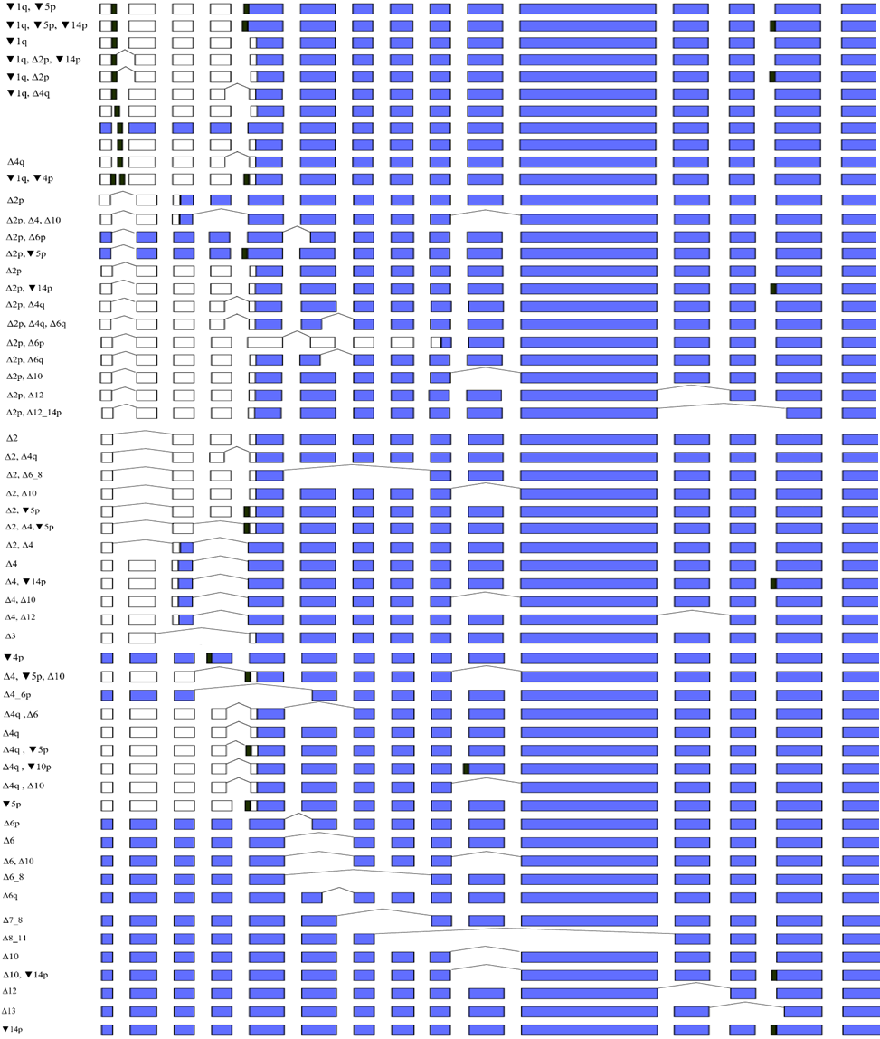

Figure S5. Visual representation of PMS2 protein coding transcripts reported in RefSeq. Δ – complete or partial (adjacent to canonical splice sites) exonic deletion, ▼ – intronic sequence inclusion (adjacent to canonical splice sites), p – acceptor site shift, q – donor site shift. Black rectangles denote intronic regions included in in the final transcripts. White rectangles denote noncoding regions. Colored rectangles mark the coding regions. 5’-UTRs, 3’-UTRs and MANE Select transcript were not figured.
Table S8. Default parameters utilized for the in silico prediction tools applied in this study

ESEfinder 3.0 default specifications
Parameter | Value
SF2/ASF | 1.956
SF2/ASF (IgM-BRCA1) | 1.867
SC35 | 2.383
SRp40 | 2.670
SRp55 | 2.676
FSplice default specifications
Search in chain | Both
Search for GC donor site | No
Output splice site sequence | Yes
Output splice site sequence length | 5
Splice site threshold | 90
MaxEntScan::score5ss for human 5' splice sites default specifications
Use Maximum Entropy Model to score | No
Use Maximum Dependence Decomposition Model to score | No
Use First-order Markov Model to score | No
Use Weight Matrix Model to score | No
MaxEntScan::score3ss for human 3' splice sites default specifications
Use Maximum Entropy Model to score | No
Use First-order Markov Model to score | No
Use Weight Matrix Model to score | No
NNSplice default specifications
Organism | Human or other
Search for 5’, 3’ or both splice sites? | Both
Include reverse strand | No
Minimum score for 5' splice site (between 0 and 1) | 0.4
Minimum score for 3' splice site (between 0 and 1) | 0.4
Spliceator default specifications
Reliability donor | 98%
Reliability acceptor | 98%
Model | 200
Splice site | both

