Supplementary fig1: Minor allele frequency of the variants `tiled on SNP array in the WGS data downloaded from public repository.

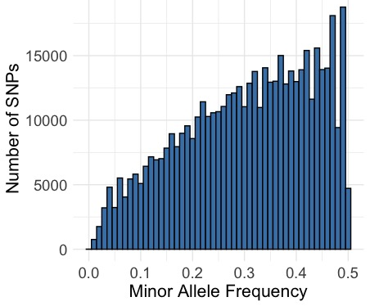
Supplementary fig2: The linkage disequilibrium decay between the variants tiled on SNP array
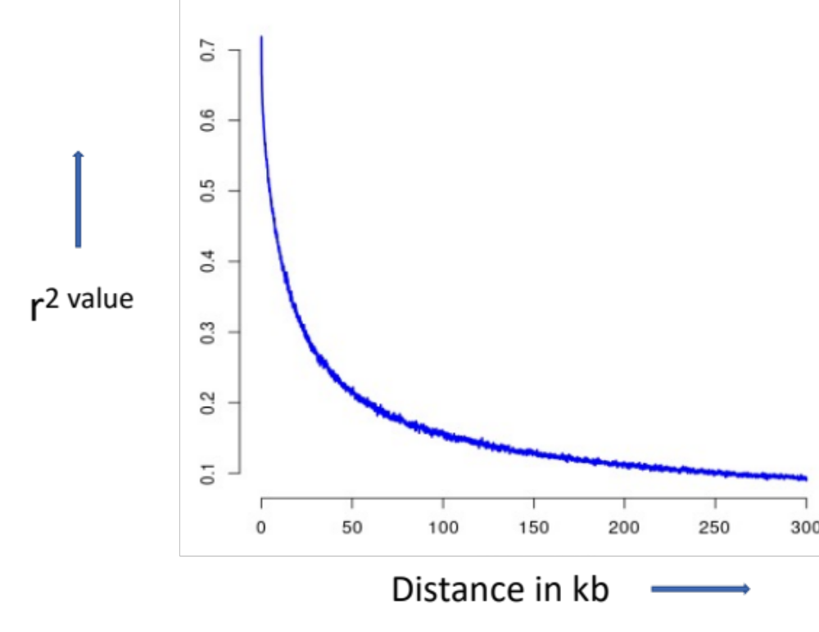
Supplementary fig3: The distribution of minor allele frequency (MAF) of array SNPs across Indian, Chinese, and Wild yak populations.
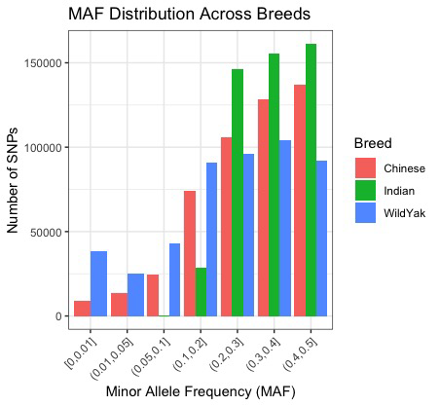
Supplementary Table 1: Annotation of variants tiled on developed SNP array.
Sr No. | Region | Percent
1 | DOWNSTREAM | 4.26%
2 | EXON | 1.22%
3 | INTERGENIC | 33.94%
4 | INTRON | 56.22%
5 | SPLICE_SITE_ACCEPTOR | 0.00%
6 | SPLICE_SITE_DONOR | 0.00%
7 | SPLICE_SITE_REGION | 0.11%
8 | TRANSCRIPT | 0.00%
9 | UPSTREAM | 3.94%
10 | UTR_3_PRIME | 0.22%
11 | UTR_5_PRIME | 0.09%

Supplementary Table 2: Sample flow table showing number of samples processed at different steps.
Sr. No. | STEP | No. of samples
1. | Genotyped | 347
2. | Failed dish QC | 02
3. | Failed call-rate QC | 07
4. | Final number per analysis | 338

Supplementary Table 3: Flow chart showing filter criteria or threshold for SNP selection
Sr. No. | Step/Filtration | No. of SNPs
1. | Raw SNPs | 3,10,85,959
2. | MAF (≥ 0.2) and INDELS Filtering | 24,00,385
3. | 21bp Gap Filtering | 11,04,693
4. | ±35 bp Unique Flanking Regions | 8,82,302
5. | Affymetrix's proprietary software for calculation of p-convert value  (includes binding energy, SNPs with no wobbles and a zero polycount) | 6,27,377
6. | Final tiling of SNP | 6,27,377

Supplementary table 4: Summary of chromosome-wise array spacing: Mean and Median per chromosome.
Chromosome | Mean | Median
1 | 5103.245 | 2220
2 | 5474.761 | 2422.5
3 | 5506.123 | 2409
4 | 5095.194 | 2253
5 | 5737.617 | 2494
6 | 4856.303 | 2022
7 | 5105.29 | 2252
8 | 5467.294 | 2250
9 | 5665.523 | 2400.5
10 | 5189.33 | 2254
11 | 5240.641 | 2355.5
12 | 6118.602 | 2691
13 | 5082.232 | 2050
14 | 5541.685 | 2282
15 | 5784.139 | 2464.5
16 | 5486.64 | 2347
17 | 5837.797 | 2439
18 | 4917.241 | 2129
19 | 6935.986 | 3031.5
20 | 5806.944 | 2314
21 | 5267.02 | 2299.5
22 | 5273.74 | 2167
23 | 5557.754 | 2503
24 | 4957.358 | 2078.5
25 | 5347.517 | 2384
26 | 4954.625 | 2086.5
27 | 4817.779 | 2136
28 | 5883.643 | 2389
29 | 6431.633 | 2244
30 | 14012.463 | 5987
31 | 9960.35 | 3265

