SUPPLEMENTARY INFORMATION

Cetacean evolution: insights from the genome sequences of common minke whales

Jung Youn Park, Yong-Rock An, Naohisa Kanda, Chul-Min An, Hye-suk An, Jung-Ha Kang, Eun Mi Kim, Du-Hae An, Hojin Jung, Myunghee Joung, Myung Hum Park, Sook Hee Yoon, Bo-Young Lee, Taeheon Lee, Kyu-Won Kim, WonCheoul Park, DongHyun Shin, YoungSub Lee, Jaemin Kim, Woori Kwak, Hyeon Jeong Kim, Young-Jun Kwon, Sunjin Moon, Yuseob Kim, David W Burt, Seoae Cho, Heebal Kim

TABLE OF CONTENTS
- Supplementary Figures …………………………………………………p.3
  - Supplementary Figure 1. ………………………………………p.3
  - Supplementary Figure 2. ………………………………………p.4
  - Supplementary Figure 3. ………………………………………p.5
  - Supplementary Figure 4. ………………………………………p.6
  - Supplementary Figure 5. ………………………………………p.7
- Supplementary Tables……………………………………………………p.8
  - Supplementary Table 1. ………………………………………..p.8
  - Supplementary Table 2. ………………………………………..p.9
  - Supplementary Table 3. ………………………………………..p.10
  - Supplementary Table 4. ………………………………………..p.11
  - Supplementary Table 5. ………………………………………..p.12
  - Supplementary Table 6. ………………………………………..p.13
  - Supplementary Table 7. ………………………………………..p.14
  - Supplementary Table 8. ………………………………………..p.15
  - Supplementary Table 9. ………………………………………..p.16
  - Supplementary Table 10. ………………………………………p.17
  - Supplementary Table 11. …………………………………….....p.18
  - Supplementary Table 12. …………………………………….....p.19

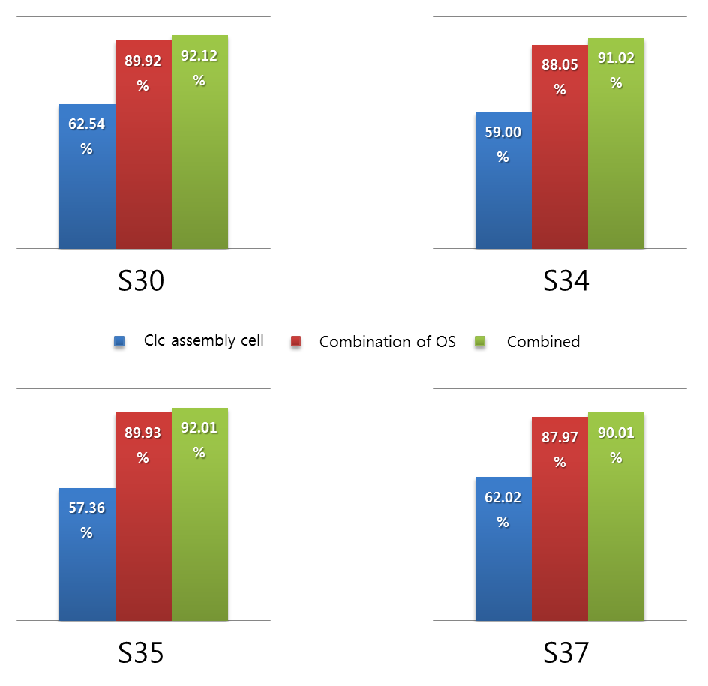
Supplementary Figure 1. Summary of read mapping to three assembled genomes using Bowtie2.

Supplementary Figure 2. BI tree using the partitioned model approach. Here the complete mitochondrial genome sequences were divided into 18 partitions.

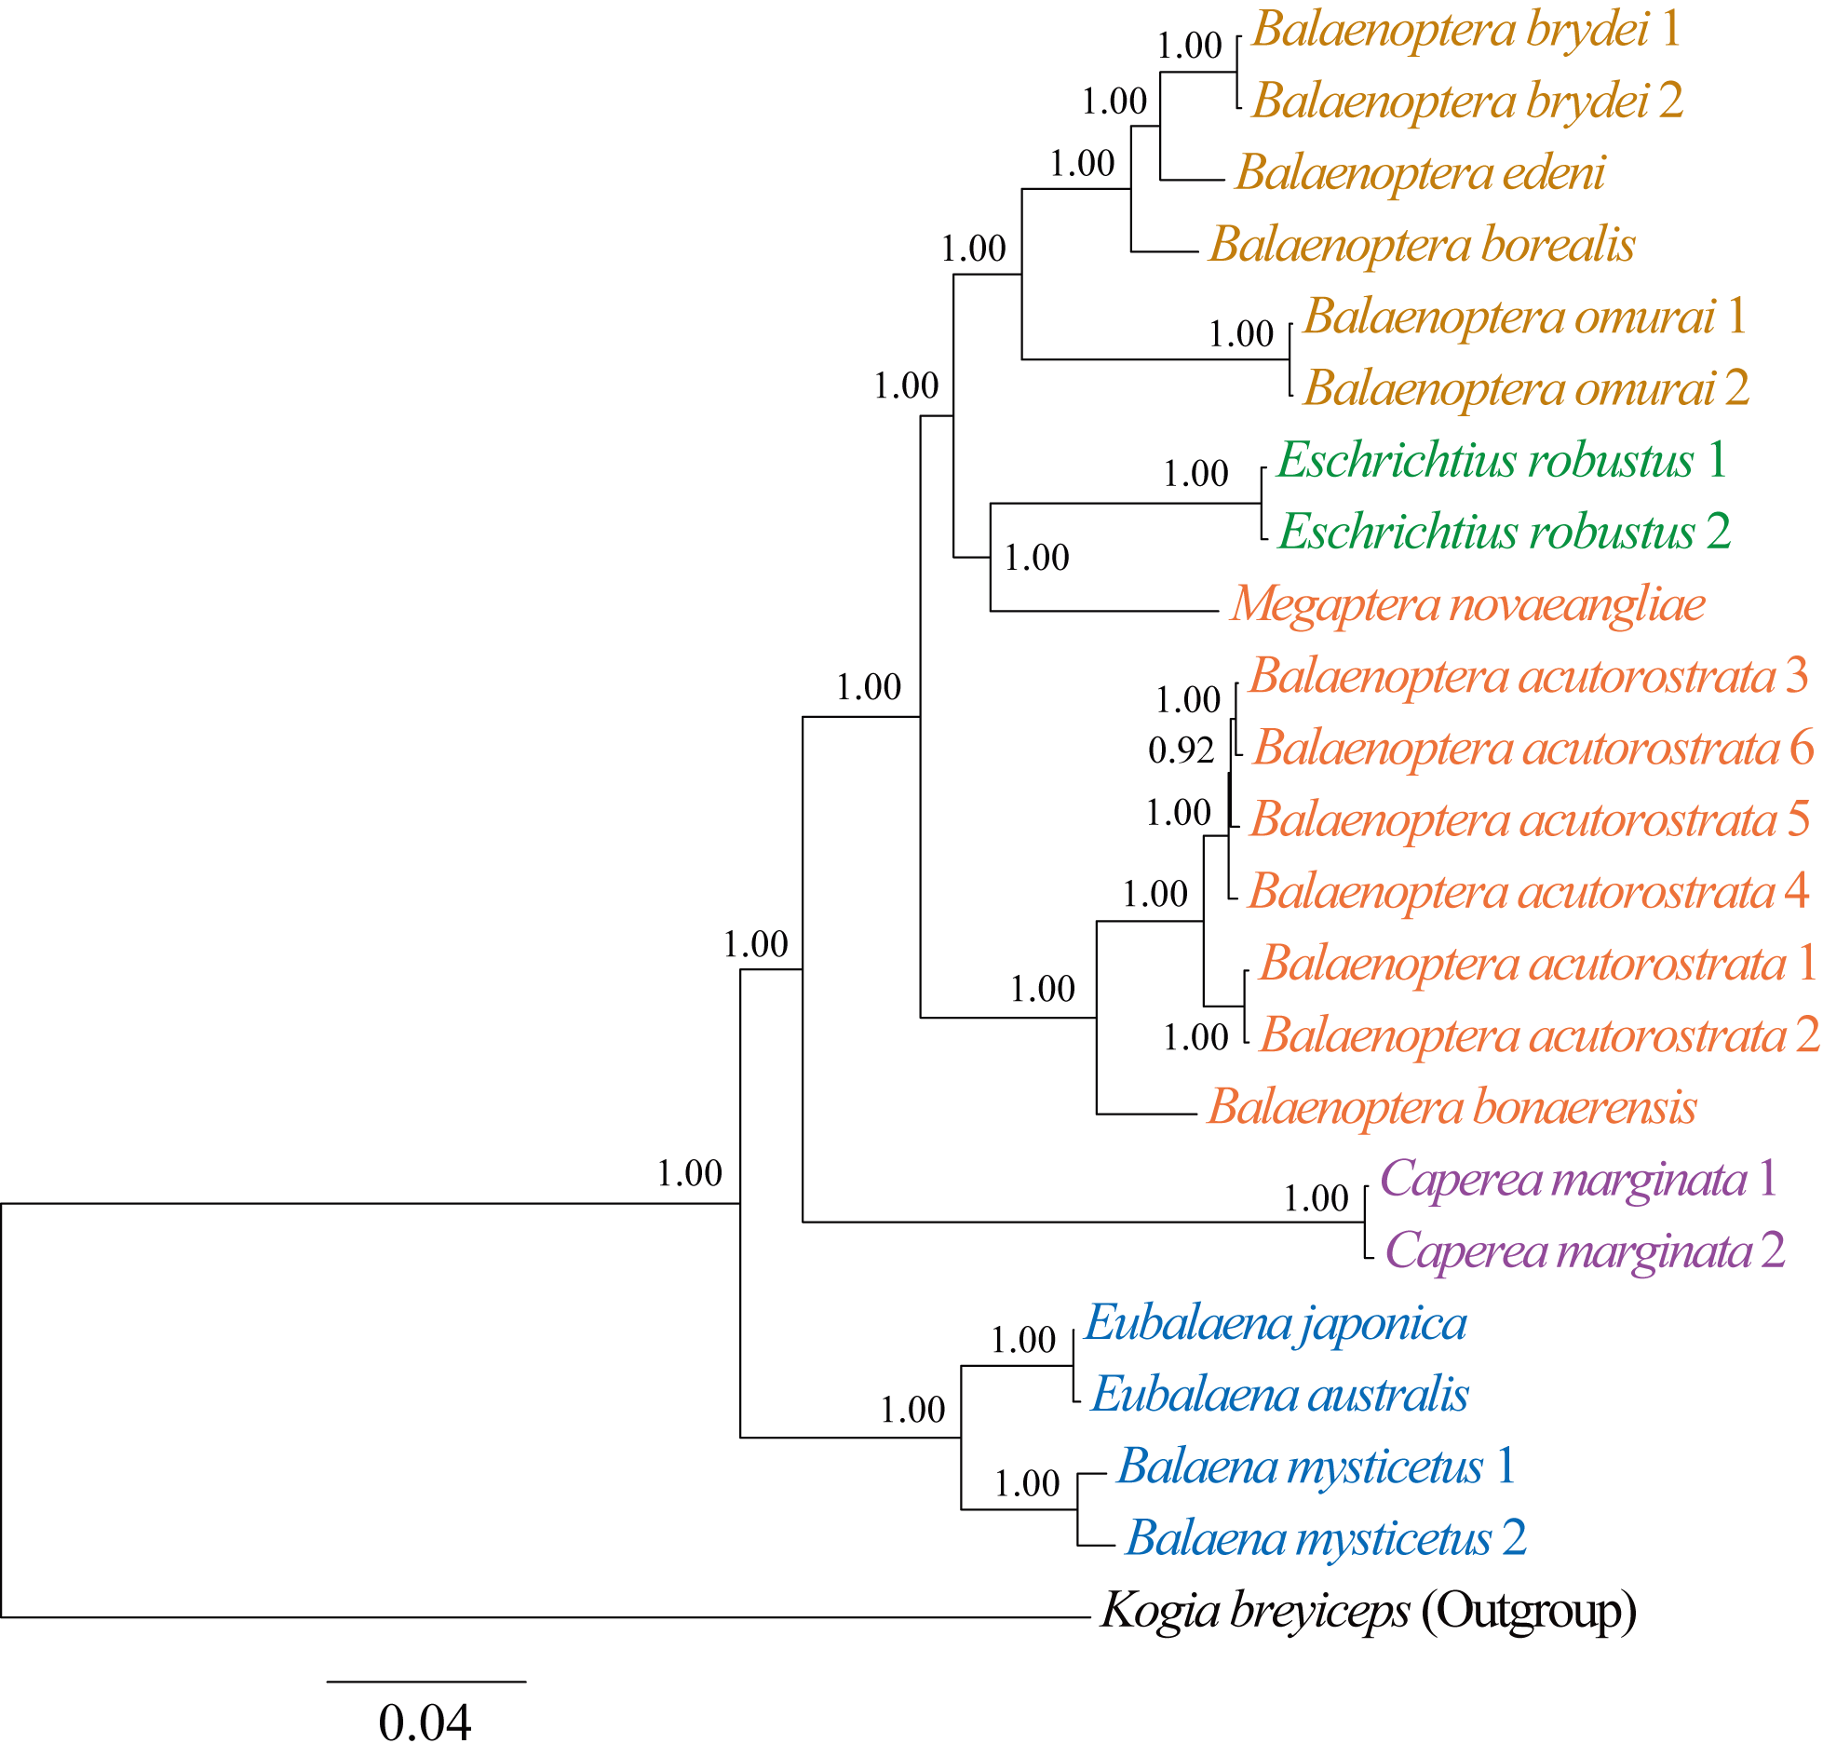

Supplementary Figure 3. Biological Process of Gene Ontology of common minke whale showing 249 accelerated genes among 8 mammals

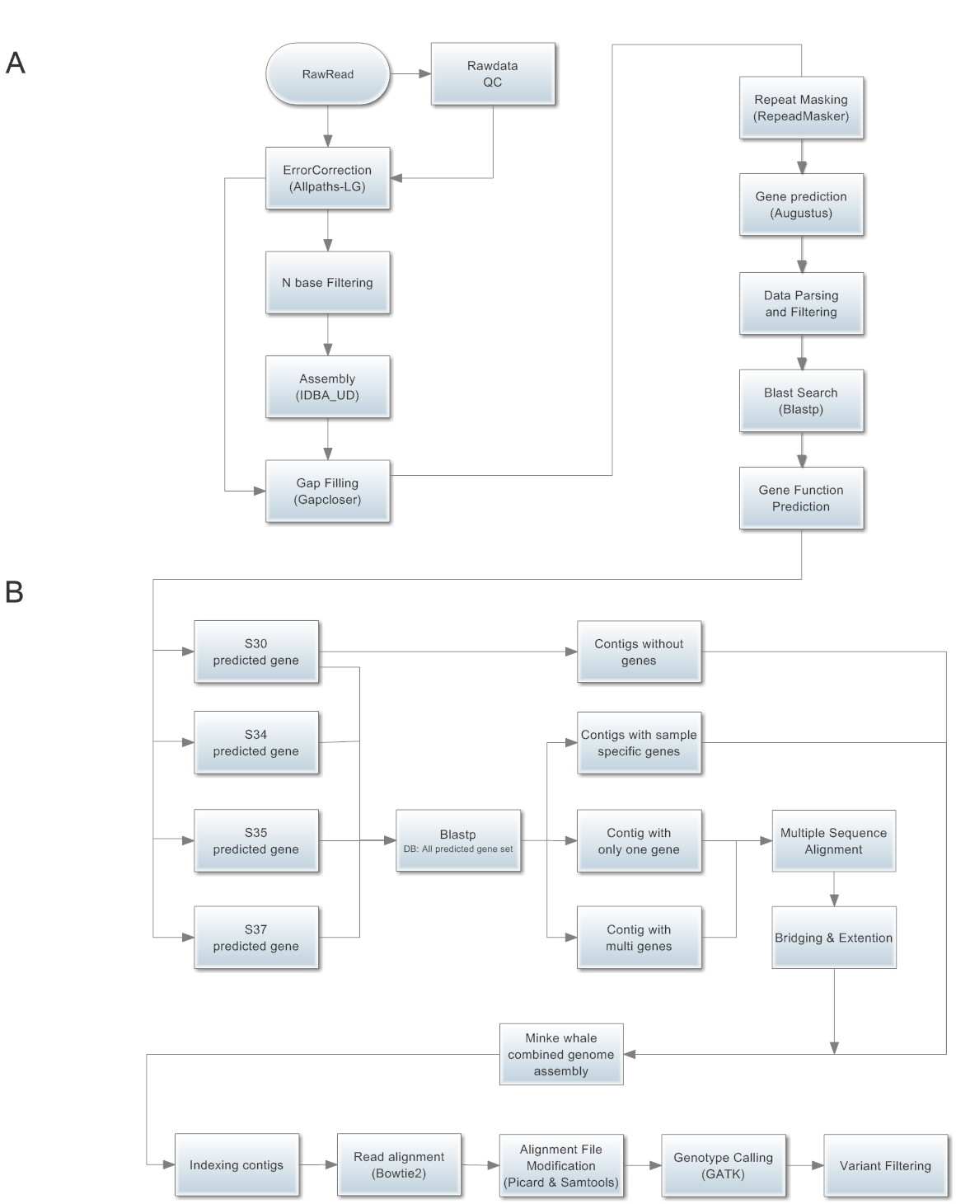
Supplementary Figure 4. Overview of the assembly, gene prediction and variant calling process.
A. Genome assembly and gene prediction process. B. Assembly building process.

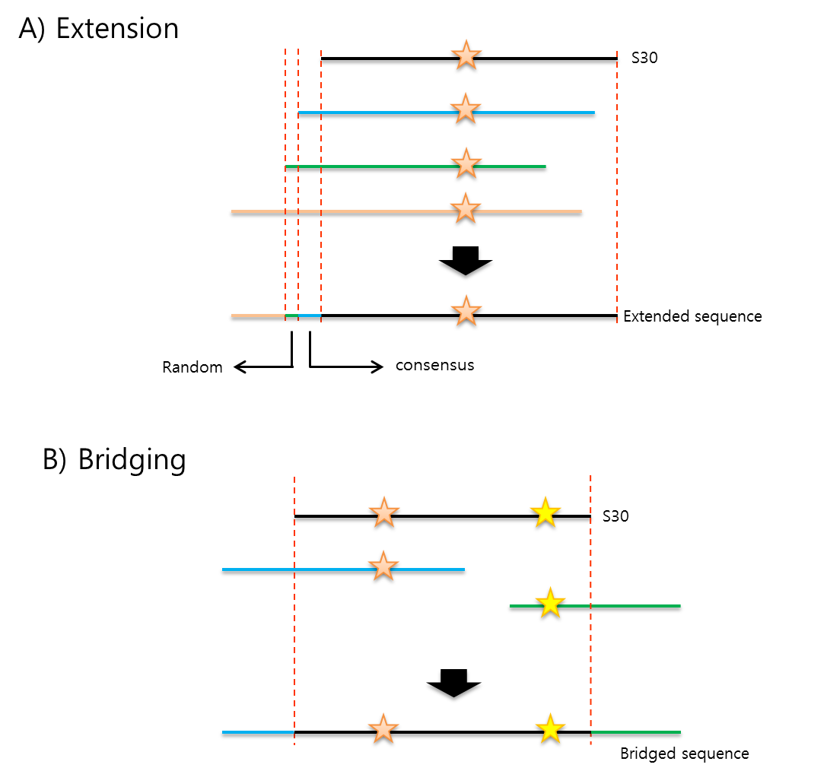
Supplementary Figure 5. Process of contig extention and bridging.
- Process of Extension. The star shows the same gene between clusters.
- Process of bridging. The stars show multiple genes in the S30 contig.

- Supplementary Tables
Supplementary Table 1. Summary statistics of common minke whale genome assembly by sample.
Sample name | S30 | S34 | S35 | S37
Number of contigs | 262,747 | 313,490 | 282,736 | 294,439
Sequence length
Minimum length | 2,000 | 2,000 | 2,000 | 2,000
Maximum length | 105,339 | 61,954 | 53,070 | 68,378
Average length | 7,651 | 4,719 | 3,985 | 6,286
N50 length | 10,321 | 5,359 | 4,236 | 7,810
Residue information
Total residue count (bp) | 2,010,222,571 | 1,479,651,607 | 1,126,905,396 | 1,851,132,035
N contents | 17,875 | 303,142 | 4,484,941 | 2,988,329
Closed N by Gapcloser | 15,243 | 239,309 | 727,324 | 1,298,712
GC content (%) | 40.51 | 38.58 | 43.21 | 40.59
*Considered contigs with length > 2,000 bp

Supplementary Table 2. Summary of RepeatMasker results by sample.
Sample name | S30 |  | S34 |  | S35 |  | S37
Elements | No. | Length | No. | Length | No. | Length | No. | Length
Sine | 1,015,281 | 150,800,833  (6.77%) | 742,339 | 105,477,583  (6.31%) | 123,993 | 17,666,179  (1.66%) | 861,733 | 125,495,334  (6.01%)
Line | 1,280,241 | 456,915,337  (20.52%) | 1,017,906 | 344,636,222  (20.61%) | 186,869 | 59,040,424  (5.54%) | 1,203,118 | 415,185,547  (19.87%)
LTR elements | 455,514 | 144,478,462  (6.49%) | 369,818 | 110,307,049  (6.60%) | 74,671 | 24,543,226  (2.30%) | 435,092 | 139,417,009  (6.67%)
DNA elements | 369,942 | 78,295,071  (3.52%) | 292,067 | 60,486,743  (3.62%) | 56,988 | 11,114,767  (1.04%) | 358,544 | 74,122,957  (3.55%)
Unclassified | 5,055 | 956,831  (0.04%) | 4,024 | 751,816  (0.04%) | 771 | 134,971  (0.01%) | 4,968 | 927,640  (0.04%)
Small RNA | 5,272 | 575,413  (0.03%) | 3,936 | 429,088  (0.03%) | 787 | 84,733  (0.01%) | 4,931 | 547,234  (0.03%)
Satellites | 183,837 | 62,416,759  (2.80%) | 140,168 | 46,115,494  (2.76%) | 29,359 | 10,183,045  (0.96%) | 169,308 | 55,462,818  (2.65%)

Supplementary Table 3. Summary of gene prediction results using Augustus and Blastp.
 | S30 | S34 | S35 | S37
Number of genes | 41,098 | 28,348 | 30,383 | 37,422
Number of Exons | 131,164 | 62,167 | 73,950 | 113,794
Total gene length | 229,649,018 | 82,573,850 | 84,286,704 | 178,879,019
Average length | 5587.84 | 2912.86 | 2774.14 | 4780.05

* Over 100 peptide length and 70% gene coverage.

Supplementary Table 4. Contig classification of the four samples.

Source | S30 | S35 | S34 | S37
Number of contigs | 628,081 | 938,541 | 994,603 | 668,188
Number of genes | 41,098 | 30,383 | 28,348 | 37,422
Contig with genes | 27,635 | 18,268 | 14,849 | 24,506
Contig with one gene | 14,285 | 11,065 | 8,057 | 14,296
Contig with multi genes | 600 | 542 | 212 | 637
Contig with sample specific gene | 12,750 | 6,661 | 6,580 | 9,573
Contig without gene | 600,446 | 920,273 | 979,754 | 643,682

Supplementary Table 5. Summary statistics of the combined common minke whale genome assembly.

Source | Value
Number of Contigs | 286,129
Sequence Length
Minimum length | 2,000
Maximum length | 105,339
Average length | 7,727
N50 length | 10,400
Residue information
Total residue count (bp) | 2,211,014,055
N content | 524,763(0.02%)
GC content (%) | 40.92%
*Considered contigs with length > 2,000 bp

Supplementary Table 6. Summary of repeat masking results using RepeatMask.

Source | Number of elements | Length occupied (%)
Total length | - | 2,226,669,555
SINE | 1,015,281 | 150,800,833  (6.77%)
LINE | 1,280,241 | 456,915,337  (20.52%)
LTR elements | 455,514 | 144,478,462  (6.49%)
DNA elements | 369,942 | 78,295,071  (3.52%)
Unclassified | 5,055 | 956,831  (0.04%)
Small RNA | 5,272 | 575,413  (0.03%)
Satellites | 183,837 | 62,416,759  (2.80%)
Total Masked |  | 893,922,896 (40.15%)

Supplementary Table 7. Summary of read mapping using Bowtie2.

Categories | Samples
Categories | 30 | 34 | 35 | 37
Total number of reads | 514,451,848  (100%) | 402,081,180  (100%) | 470,186,674  (100%) | 402,636,650  (100%)
Concordantly 1 time | 290,495,048  (56.4%) | 211,464,096  (52.5%) | 236,048,842  (50.2%) | 162,187,448  (40.2%)
Concordantly > 1 time | 85,699,662  (16.6%) | 76,771,800  (19.0%) | 79,939,174  (17.0%) | 34,242,644  (8.5%)
Discordantly 1 time | 14,322,176  (2.7%) | 6,252,922  (1.5%) | 19,396,744  (4.1%) | 55,572,032  (13.8%)
1 time in mixed mode (single reads) | 40,957,298  (7.9%) | 33,725,380  (8.3%) | 33,216,429  (7.0%) | 49,889,813  (12.3%)
> 1 time in mixed mode (single reads) | 31,097,230  (6.0%) | 25,804,959  (6.4%) | 54,233,679  (11.5%) | 52,303,191  (12.9%)
Overall mapping rate including singletons | 462,571,414  (89.9%) | 354,019,157  (88.0%) | 422,834,868  (89.9%) | 354,195,128  (87.9%)

Supplementary Table 8. Summary of variant calling results using GATK.

 | Categories | S30 | S34 | S35 | S37 | Total
INDEL | Raw | 306,761  (14,727) | 410,849  (32,206) | 370,877  (21,780) | 386,011  (20,128) | 554,937
INDEL | Pass | 214,531  (10,635) | 309,103  (28,352) | 277,948  (18,574) | 290,629  (18,434) | 414,932
INDEL | Missing filter | 198,957  (9,941) | 288,353  (25,443) | 272,358  (18,359) | 275,062  (17,744) | 389,542
SNV | Raw | 2,482,691  (213,821) | 3,266,565  (429,416) | 3,188,965  (395,933) | 3,225,149  (383,228) | 5,137,672
SNV | Pass SNV | 1,880,150  (184,309) | 2,625,283  (388,023) | 2,479,768  (341,658) | 2,543,039  (353,259) | 4,101,990
SNV | Biallele filter | 1,879,332  (184,309) | 2,624,524  (388,016) | 2,478,951  (341,646) | 2,542,204  (353,246) | 4,099,489
SNV | Missing filter | 1,673,581  (162,462) | 2,390,171  (352,689) | 2,344,185  (325,738) | 2,361,319  (333,604) | 3,730,122
* In the rows showing INDELs and SNPs, the number of sample specific variants are enclosed in parentheses

Supplementary Table 9. The result of SNP genotype concordance between using the reference of 1) reported draft genome and 2) assembled scaffolds of our study.

 | S30 | S32 | S34 | S37
Number of loci | 529,793 | 581,468 | 546,596 | 542,952
Matched genotype | 523,353 | 570,191 | 535,412 | 526,618
Genotype  Concordance | 98.78% | 98.06% | 97.95% | 96.99%

Supplementary Table 10. Species name of the sequences used in the present study with the GenBank accession numbers. New sequences obtained in this study are marked with an asterisk (*).
Classification | Species | Accession no.
- Mysticeti; Balaenidae | Balaena mysticetus 1 | AP006472
- Mysticeti; Balaenidae | Balaena mysticetus 2 | NC_005268
- Mysticeti; Balaenidae | Eubalaena australis | NC_006930
- Mysticeti; Balaenidae | Eubalaena japonica | NC_006931
- Mysticeti; Balaenopteridae | Balaenoptera acutorostrata 1 | AP006468
- Mysticeti; Balaenopteridae | Balaenoptera acutorostrata 2 | NC_005271
- Mysticeti; Balaenopteridae | Balaenoptera acutorostrata 3 | *Korea 30
- Mysticeti; Balaenopteridae | Balaenoptera acutorostrata 4 | *Korea 34
- Mysticeti; Balaenopteridae | Balaenoptera acutorostrata 5 | *Korea 35
- Mysticeti; Balaenopteridae | Balaenoptera acutorostrata 6 | *Korea37
- Mysticeti; Balaenopteridae | Balaenoptera bonaerensis | NC_006926
- Mysticeti; Balaenopteridae | Balaenoptera borealis | NC_006929
- Mysticeti; Balaenopteridae | Balaenoptera brydei 1 | AB201259
- Mysticeti; Balaenopteridae | Balaenoptera brydei 2 | NC_006928
- Mysticeti; Balaenopteridae | Balaenoptera edeni | NC_007938
- Mysticeti; Balaenopteridae | Balaenoptera omurai 1 | AB201257
- Mysticeti; Balaenopteridae | Balaenoptera omurai 2 | NC_007937
- Mysticeti; Balaenopteridae | Megaptera novaeangliae | NC_006927
- Mysticeti; Neobalaenidae | Caperea marginata 1 | AP006475
- Mysticeti; Neobalaenidae | Caperea marginata 2 | NC_005269
- Mysticeti; Eschrichtiidae | Eschrichtius robustus 1 | AP006471
- Mysticeti; Eschrichtiidae | Eschrichtius robustus 2 | NC_005270
- Odontoceti; Kogiidae | Kogia breviceps | NC_005272

Supplementary Table 11. Sequencing results of the four common minke whale samples.
Sample  Name | Insert  Size | Total Base  (bp) | Depth  (X) | Read Count | N  (%) | GC  (%) | Q20 ratio(%)  /depth(X) | Q30 ratio(%)  /depth(X)
S30 | 270bp | 51,959,636,648 | 17.32 | 514,451,848 | 1.98 | 39.89 | 92 / 15.9 | 87 / 15.0
S34 | 270bp | 40,610,199,180 | 13.54 | 402,081,180 | 2.54 | 39.72 | 92 / 12.3 | 87 / 11.8
S35 | 480bp | 47,488,854,074 | 15.83 | 470,186,674 | 1.82 | 42.4 | 90 / 14.2 | 83 / 13.1
S37 | 480bp | 40,666,301,650 | 13.56 | 402,636,650 | 2.17 | 40.98 | 89 / 12.1 | 82 / 11.1
Total |  | 180,724,991,552 | 60.25 | 1,789,356,352 | 2.13 | 40.75 | 90 / 54.5 | 85 / 51.0
* Estimated common minke whale genome size : 3 Gb
* Fastq Quality Encoding : Sanger Quality ( ASCII Character Code = Phred Quality Value + 33 )

Supplementary Table 12. Best fitted model of each MT genomic region of the whales.
Genomic region | Model
1. 12S rRNA | GTR+I+G, Nst=6, Rates=gamma
2. 16S rRNA | GTR+I+G, Nst=6, Rates=gamma
3. 2 STS | SYM+I, Nst=6, Rates=equal
4. NADH1 | TVM+I+G, Nst=6, Rates=gamma
5. NADH2 | HKY+G, Nst=2, Rates=gamma
6. COX1 | GTR+I+G, Nst=6, Rates=gamma
7. COX2 | TVM+G, Nst=6, Rates=gamma
8. ATPase8 | HKY+G, Nst=2, Rates=gamma
9. ATPase6 | HKY+I+G, Nst=2, Rates=gamma
10. COX3 | TVM+I+G, Nst=6, Rates=gamma
11. NADH3 | TVM+I, Nst=6, Rates=equal
12. NADH4L | HKY+G, Nst=2, Rates=gamma
13. NADH4 | TVM+I+G, Nst=6, Rates=gamma
14. NADH5 | K81uf+I+G, Nst=6, Rates=gamma
15. NADH6 | HKY+I+G, Nst=2, Rates=gamma
16. Cytb | TrN+G, Nst=6, Rates=gamma
17. Control region | TVM+I+G, Nst=6, Rates=gamma
18. 22 tRNAs | GTR+I+G, Nst=6, Rates=gamma

