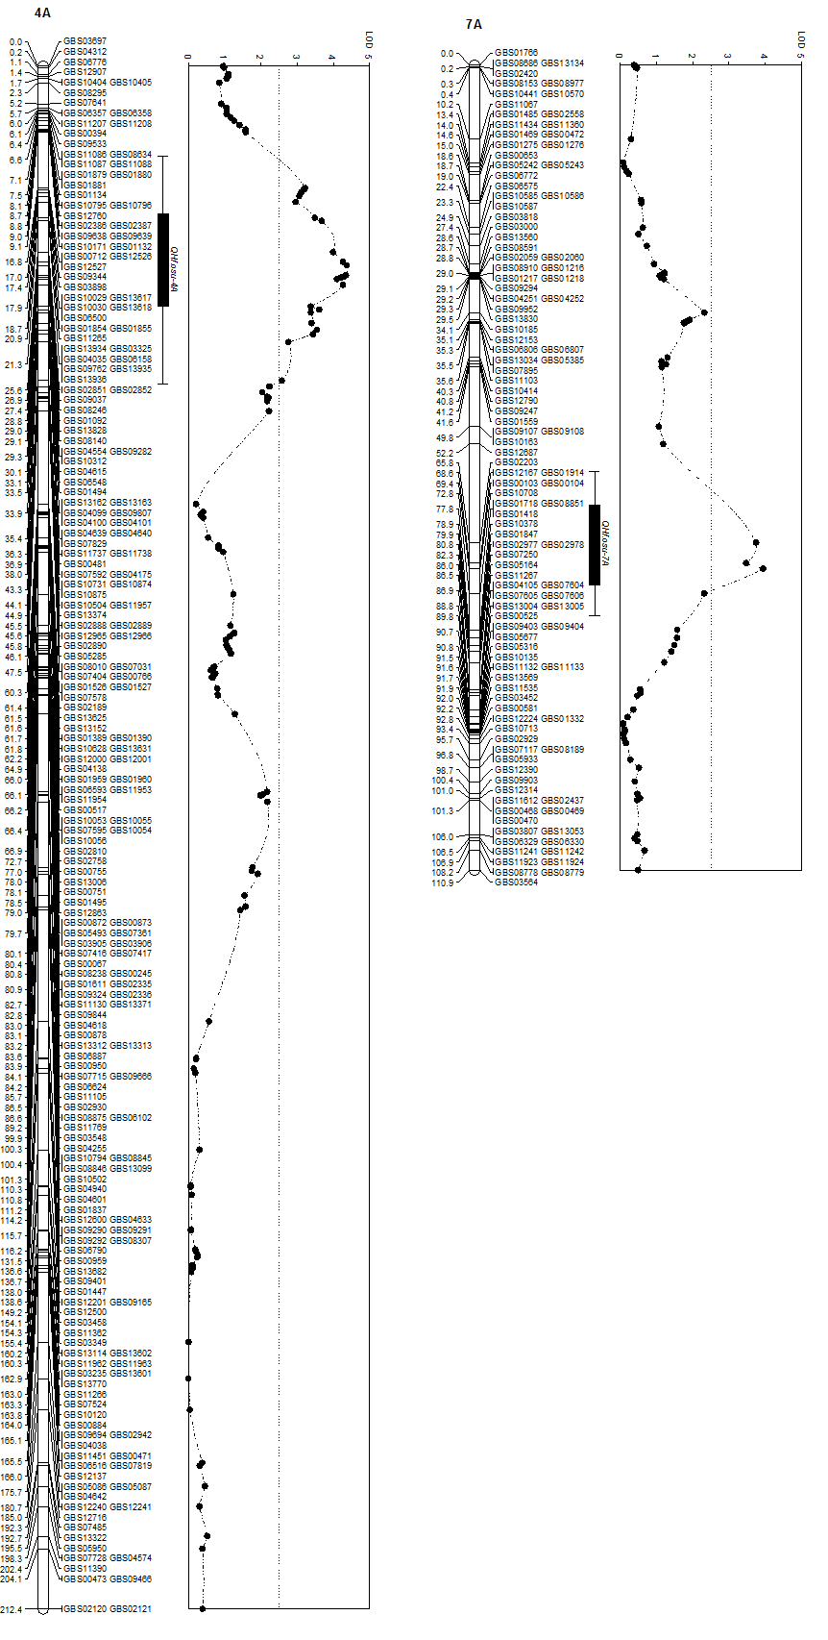
Fig. S2.
B
A
Fig.S2. Two minor QTLs for resistance to Hessian fly. A). QHf.osu-4A. QHf.osu-4A was mapped in the Duster × Billings DH population using 219 GBS markers. This QTL is centered in a 34.9 cM region flanked by GBS10171 and GBS10504. B). QHf.osu-7A. QHf.osu-7A was mapped in the Duster × Billings DH population was mapped using 116 SNP markers. This QTL is centered in a 25.6 cM region flanked by GBS12687 and GBS01718. The vertical dotted line indicates the LOD threshold of 2.5.

