Fig.S1
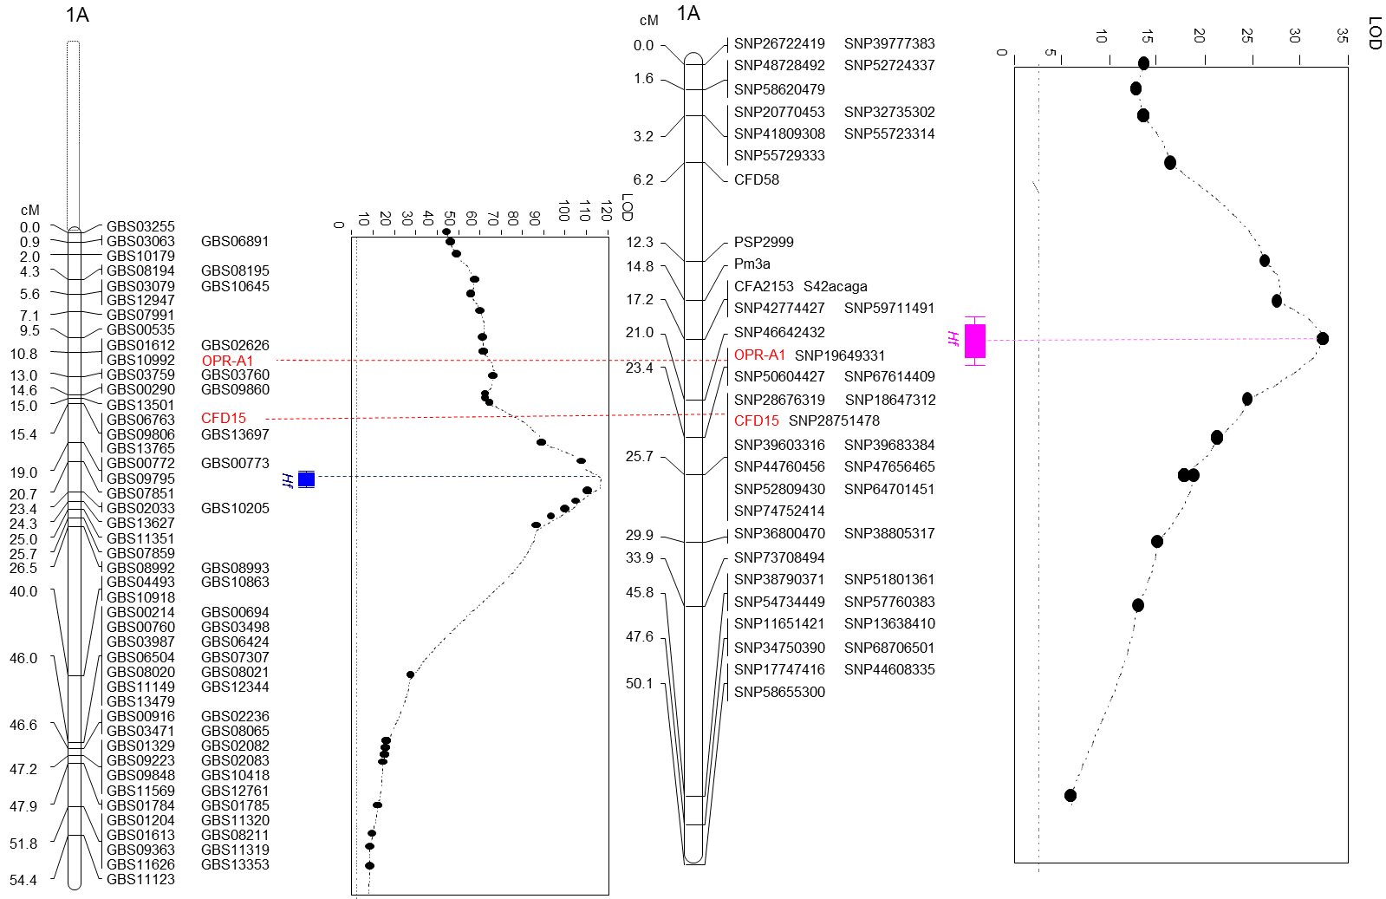
A Duster x Billings
B Jagger x 2174

Fig. S1. Comparison of two QTLs for resistance to Hessian fly. The part of Fig.2 was enlarged to show the regions containing the two QTLs and their neighboring markers.

