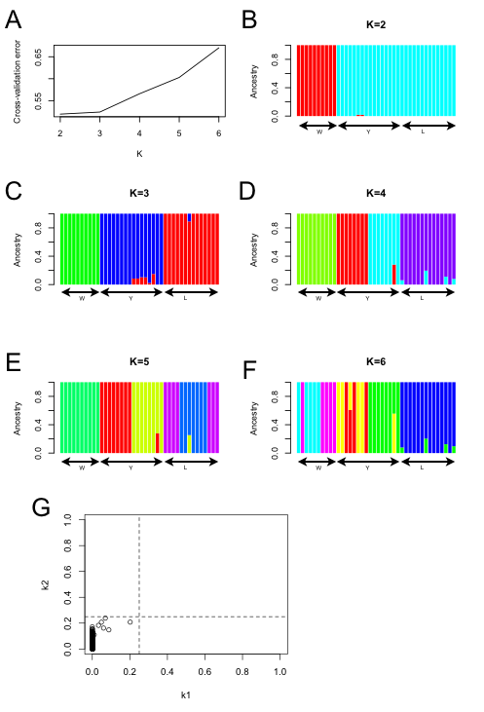
Supplementary Figure S1. Admixture analysis for three lineages. A cross validation procedure (10-fold CV) shows that K = 2 and 3 exhibit a low cross-validation error compared to other K values (A). Each individual is represented by a vertical bar, which is partitioned into K colored segments that represent the individual’s estimated membership fractions with 10,000 admixture runs at K=2~6 (B-F). For Admixture result for K = 2, Estimates of kinship coefficients (k), where k1 and k2 describe the fractions of the genome in which two individuals share 1 or 2 alleles IBD, from RelateAdmix, where dashed line depicts first cousins (k=0.25), showing unrelated relationship between samples (G).

