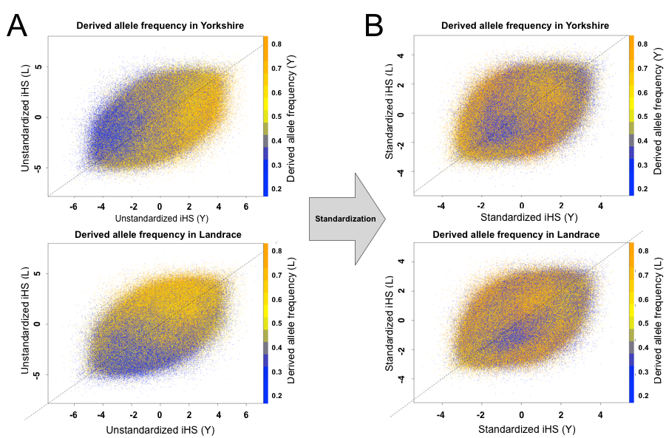
Supplementary Figure S3. Distribution of iHS scores between Yorkshire and Landrace. Low frequency derived allele (blue color) tend to have strong negative iHS_{unstd} values and high frequency derived allele (orange color) tend to have strong positive iHS_{unstd} values (A). The tendencies of allele frequency are neutralized after normalization (B).

