Additional file 4 Gene Ontology categories of unigenes with significant transcriptional changes during different stages of seed development.
S6/S3
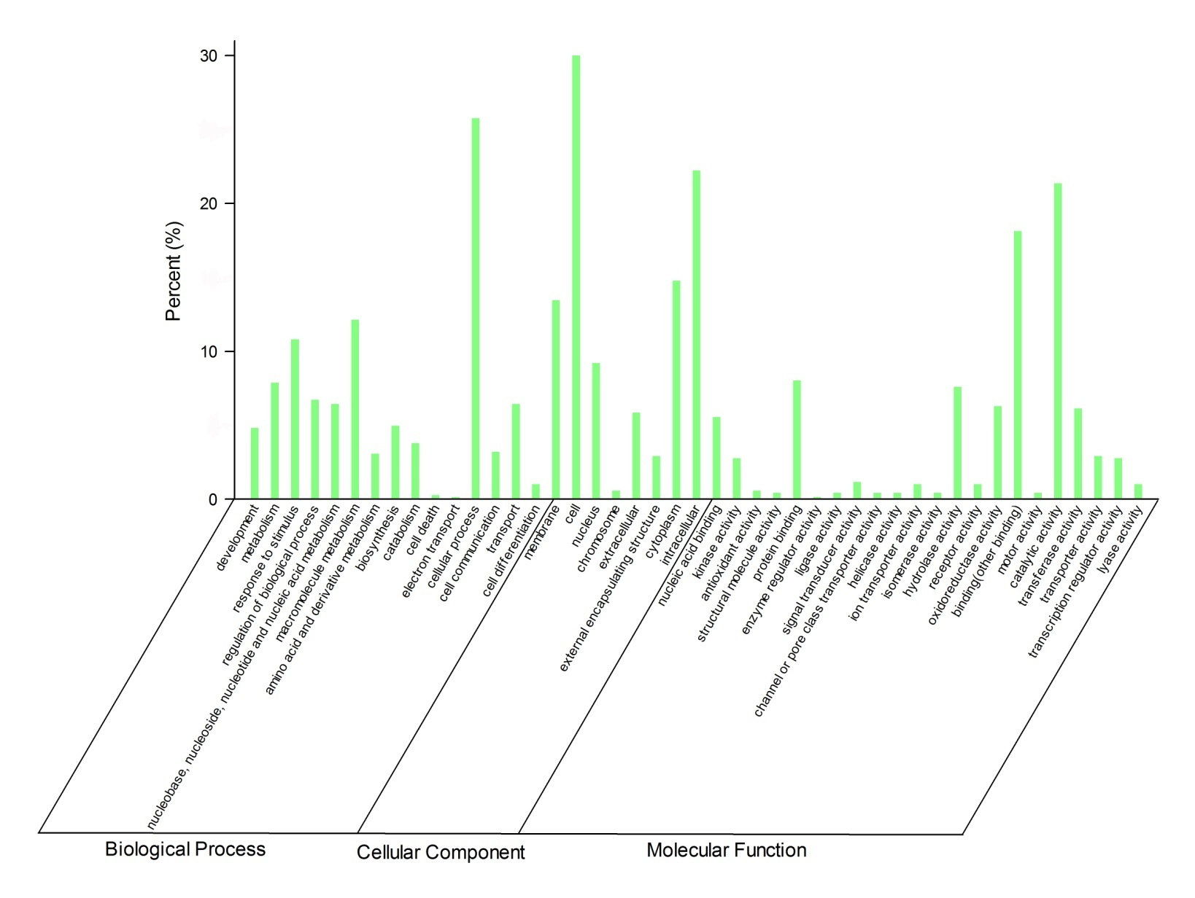
S9/S3
